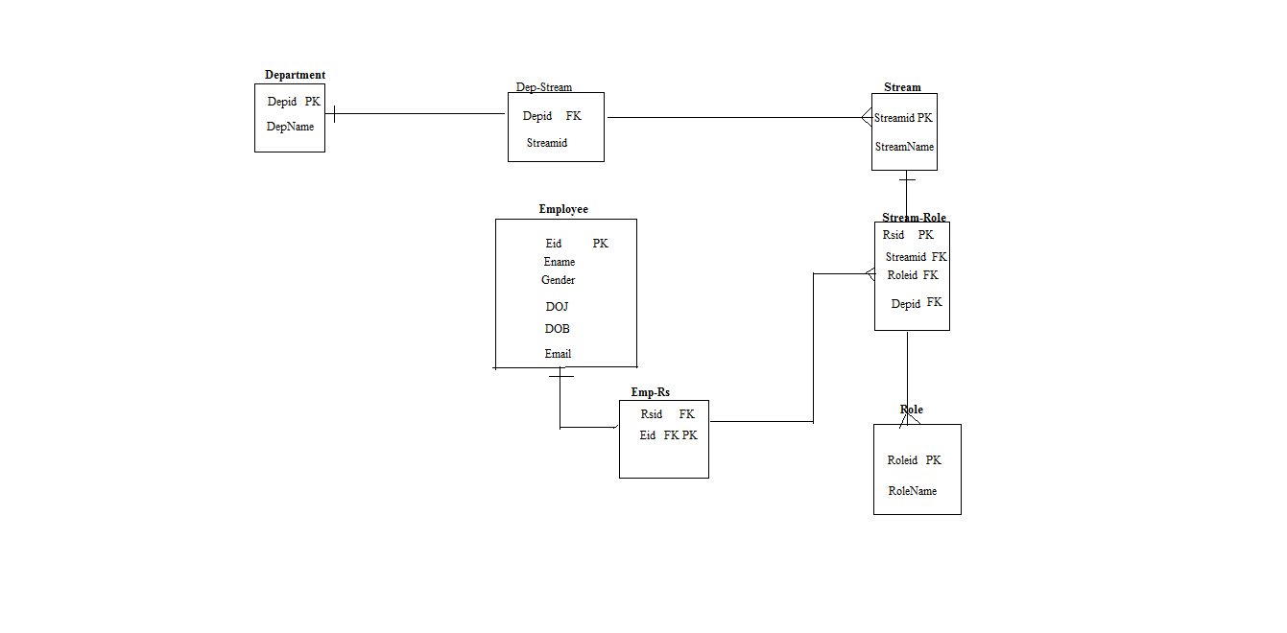

design

Queries:
Create table employee(
Eid int,
Ename varchar(70),
Gender char(1),
Doj date,
Dob date,
Email varchar(255)
Primary key(Eid)
}

Create table Department(
Depid int ,
DepName varchar(300),
Primary key(Depid)
)

Create table stream(
Sid int,
StreamName varchar(200),
Primary key (Sid)
)

Create table Role(
Roleid int ,
RoleName varchar(150),
Primary key(Roleid)
)

Stream-Role
Create table streamrole(
Rsid int,
Streamid int,
Role id int,
Depid int,
Primary key(Rsid),
Foreign key (Streamid) references Stream(Streamid),
Foreign key (Roleid) references Role(Roleid)
)

Department-Stream
Create table DepStream(
Depid int,
Streamid int,
Foreign key (Depid) references Department(Depid)
)
Employee-StreamRole
Create table Esr(
Rsid int,
Eid int.
Foreign key (Rsid) references streamrole(Rsid));
Foreign key (eid) references employee(eid));

