
CSC462 – ARTIFICIAL INTELLIGENCE
Lab Finals Report

Submitted By:
Muhammad Rizwan Shafiq
SP24-BCS-069
BCS-4B

Submitted To:
Dr. Muhammad Imran
Table of Contents
Introduction 2
Question 1: Genetic Algorithm for Traveling Salesperson Problem (TSP) 2
Problem Description 2
Genetic Algorithm Components 2
1. Chromosome Representation 2
2. Initial Population 2
3. Fitness Function 3
4. Selection Method (Tournament Selection) 3
5. Crossover Operator (PMX) 3
6. Mutation Operator (Swap Mutation) 3
7. Elitism 4
8. Termination Criteria 4
Implementation Details 4
Solution Code: 4
Sample Output 10
Final Result 12
Question 2: Wumpus World Knowledge Base (Prolog) 13
Problem Description 13
World Representation 13
Known Facts from the Diagram 13
Logical Rules Implemented 13
Adjacency 13
No-Pit Rule 13
No-Wumpus Rule 13
Pit and Wumpus Inference 13
Target Queries 14
Solution Code: 14
Sample Output 16
Conclusion 16
References 16

Artificial Intelligence Lab Final Project Report

Introduction
This lab final project consists of two independent problems designed to assess practical understanding of Artificial Intelligence concepts. The first problem implements a Genetic Algorithm (GA) to solve the Traveling Salesperson Problem (TSP) using Python. The second problem develops a knowledge-based agent for the Wumpus World using Prolog, based on logical inference from percepts.
The project includes complete source code implementations along with execution screenshots, as required.

Question 1: Genetic Algorithm for Traveling Salesperson Problem (TSP)

Problem Description
The Traveling Salesperson Problem (TSP) requires finding the shortest possible route that visits each city exactly once and returns to the starting city. Since TSP is NP-hard, a Genetic Algorithm is used to obtain a near-optimal solution efficiently.

Genetic Algorithm Components

Chromosome Representation
Each chromosome represents a tour, which is a permutation of city names.
Example:
[A, F, B, I, C, J, G, D, H, E]

Initial Population
An initial population of random permutations is generated to ensure diversity.
def initial_population(city_names, pop_size):
base = city_names[:]
population = []
for _ in range(pop_size):
chrom = base[:]
random.shuffle(chrom)
population.append(chrom)
return population

Fitness Function
The objective is to minimize total tour distance. Fitness is defined as:
Fitness = 1 / (1 + Tour Distance)
This converts a minimization problem into a maximization problem.
def tour_length(tour, dist, name_to_index):
total = 0.0
for i in range(len(tour)):
a = tour[i]
b = tour[(i + 1) % len(tour)] # return to start
total += dist[name_to_index[a]][name_to_index[b]]
return total

def fitness_from_length(L):
return 1.0 / (1.0 + L)

Selection Method (Tournament Selection)
Tournament selection randomly selects k individuals and chooses the one with the minimum tour distance as a parent.
def tournament_select(population, lengths, k):
indices = random.sample(range(len(population)), k)
best_index = min(indices, key=lambda idx: lengths[idx])
return population[best_index][:]

Crossover Operator (PMX)
Partially Mapped Crossover (PMX) is used to ensure valid permutations. It preserves relative city order while preventing duplicates.

Mutation Operator (Swap Mutation)
With a small probability, two cities in a tour are swapped to introduce diversity and avoid premature convergence.
def swap_mutation(tour, mutation_rate):
tour = tour[:]
if random.random() < mutation_rate:
i, j = random.sample(range(len(tour)), 2)
tour[i], tour[j] = tour[j], tour[i]
return tour

Elitism
The best elitism_size individuals are copied unchanged into the next generation to ensure solution quality never degrades.
elite_indices = sorted(range(len(population)), key=lambda idx: lengths[idx])[:elitism_size]
for idx in elite_indices:
new_population.append(population[idx][:])

Termination Criteria
The algorithm terminates when:
- A fixed number of generations is reached, or
- No improvement is observed for a given number of generations (patience).

Implementation Details
- Language: Python
- Libraries Used: random, math
- Key Functions:
  - tour_length()
  - fitness_from_length()
  - tournament_select()
  - pmx_crossover()
  - swap_mutation()
  - genetic_algorithm_tsp()

Solution Code:
import random
import math

# Define coordinates of each city
cities = {
"A": (10, 20),
"B": (20, 80),
"C": (80, 90),
"D": (90, 40),
"E": (50, 10),
"F": (30, 50),
"G": (60, 70),
"H": (70, 20),
"I": (15, 60),
"J": (40, 90),
}

def euclidean_distance(p1, p2):
# Euclidean distance between two (x,y) points.
return math.dist(p1, p2)

def compute_distance_matrix(cities):
# Build a distance matrix between all cities.
names = list(cities.keys())
n = len(names)
dist = [[0.0] * n for _ in range(n)]
for i in range(n):
for j in range(n):
if i != j:
dist[i][j] = euclidean_distance(cities[names[i]], cities[names[j]])
return names, dist

def tour_length(tour, dist, name_to_index):
# Total distance of a tour (including return to start).
total = 0.0
for i in range(len(tour)):
a = tour[i]
b = tour[(i + 1) % len(tour)]
total += dist[name_to_index[a]][name_to_index[b]]
return total

def fitness_from_length(L):
# Fitness = 1 / (1 + distance) so shorter tours have higher fitness.
return 1.0 / (1.0 + L)

def initial_population(city_names, pop_size):
# Create an initial random population of tours (permutations).
base = city_names[:]
population = []
for _ in range(pop_size):
chrom = base[:]
random.shuffle(chrom)
population.append(chrom)
return population

def tournament_select(population, lengths, k):
# Tournament selection: return best of k randomly chosen individuals.
indices = random.sample(range(len(population)), k)
best_index = min(indices, key=lambda idx: lengths[idx])
return population[best_index][:]

def pmx_child(parent1, parent2, c1, c2):
# Build one child using Partially Mapped Crossover (PMX).
size = len(parent1)
child = [None] * size

# 1) Copy middle segment from parent1
child[c1:c2+1] = parent1[c1:c2+1]

# 2) Mapping from parent2
for i in range(c1, c2+1):
if parent2[i] not in child:
pos = i
while True:
value = parent1[pos]
pos = parent2.index(value)
if child[pos] is None:
child[pos] = parent2[i]
break

# 3) Fill remaining positions from parent2
for i in range(size):
if child[i] is None:
child[i] = parent2[i]

return child

def pmx_crossover(parent1, parent2):
# Partially Mapped Crossover (PMX) for permutations. Returns two children.
size = len(parent1)
c1, c2 = sorted(random.sample(range(size), 2))
child1 = pmx_child(parent1, parent2, c1, c2)
child2 = pmx_child(parent2, parent1, c1, c2)
return child1, child2

def swap_mutation(tour, mutation_rate):
# Swap mutation: with given probability, swap two random cities.
tour = tour[:]
if random.random() < mutation_rate:
i, j = random.sample(range(len(tour)), 2)
tour[i], tour[j] = tour[j], tour[i]
return tour

def genetic_algorithm_tsp(
cities,
pop_size=30,
generations=50,
tournament_k=3,
crossover_rate=0.9,
mutation_rate=0.1,
elitism_size=2,
patience=20,
):

# Compute distance matrix once
city_names, dist = compute_distance_matrix(cities)
name_to_index = {name: i for i, name in enumerate(city_names)}

print("\n--- INITIALIZATION ---")
print("City order used internally:", city_names)
print("Showing first 3 rows of the distance matrix:")
for row in dist[:3]:
print(" ", row)

# 1) Initial population
population = initial_population(city_names, pop_size)
lengths = [tour_length(ch, dist, name_to_index) for ch in population]

print("\nInitial population (showing all tours with distance and fitness):")
for i, chrom in enumerate(population):
L = lengths[i]
F = fitness_from_length(L)
print(f" Chromosome {i}: {chrom} | Distance = {L:.2f}, Fitness = {F:.6f}")

# 2) Track best solution
best_idx = min(range(pop_size), key=lambda idx: lengths[idx])
best_tour = population[best_idx][:]
best_length = lengths[best_idx]
best_fitness = fitness_from_length(best_length)
no_improve = 0

print("\nBest individual in initial population:")
print(f" Tour: {best_tour}")
print(f" Distance: {best_length:.2f}, Fitness: {best_fitness:.6f}")

# GA main loop
for gen in range(generations):
print(f"\n=== GENERATION {gen} ===")

new_population = []

# --- Elitism: keep top 'elitism_size' individuals ---
elite_indices = sorted(range(len(population)), key=lambda idx: lengths[idx])[:elitism_size]
print("Elite individuals carried over:")
for e_i in elite_indices:
print(f" Elite {e_i}: {population[e_i]} | Distance = {lengths[e_i]:.2f}")

for idx in elite_indices:
new_population.append(population[idx][:])

# --- Create the rest of the new population ---
mating_logged = False # we will log details for the first mating event only (per generation)
while len(new_population) < pop_size:
# Selection
parent1 = tournament_select(population, lengths, tournament_k)
parent2 = tournament_select(population, lengths, tournament_k)

# Crossover
if random.random() < crossover_rate:
child1, child2 = pmx_crossover(parent1, parent2)
else:
child1, child2 = parent1[:], parent2[:]

# Mutation
child1 = swap_mutation(child1, mutation_rate)
child2 = swap_mutation(child2, mutation_rate)

# Log details for the first pair per generation
if not mating_logged:
print("\nExample mating in this generation:")
print(" Parent 1:", parent1)
print(" Parent 2:", parent2)
print(" Child 1 (after PMX + mutation):", child1)
print(" Child 2 (after PMX + mutation):", child2)
mating_logged = True

new_population.append(child1)
if len(new_population) < pop_size:
new_population.append(child2)

# Move to next generation
population = new_population
lengths = [tour_length(ch, dist, name_to_index) for ch in population]

# Compute stats for this generation
gen_best_idx = min(range(pop_size), key=lambda idx: lengths[idx])
gen_best_length = lengths[gen_best_idx]
gen_best_fitness = fitness_from_length(gen_best_length)
avg_length = sum(lengths) / len(lengths)

print("\nSummary of this generation:")
print(f" Best distance: {gen_best_length:.2f}")
print(f" Best fitness: {gen_best_fitness:.6f}")
print(f" Average distance: {avg_length:.2f}")

# Update global best
if gen_best_length < best_length - 1e-9:
best_length = gen_best_length
best_tour = population[gen_best_idx][:]
best_fitness = gen_best_fitness
no_improve = 0
print(" --> New global best found!")
else:
no_improve += 1
print(f" No improvement in this generation. (No-improve count = {no_improve})")

# Termination: no improvement for 'patience' generations
if no_improve >= patience:
print(f"\nStopping early: no improvement for {patience} generations.")
break

print("\n--- GA FINISHED ---")
print("Best tour found during run:")
print(" ", " -> ".join(best_tour) + " -> " + best_tour[0])
print(f"Best distance: {best_length:.2f}")
print(f"Best fitness: {best_fitness:.6f}")

return best_tour, best_length, best_fitness

# For reproducibility
random.seed(42)

best_tour, best_distance, best_fit = genetic_algorithm_tsp(
cities,
pop_size=20, # smaller pop & generations to keep output readable
generations=30,
tournament_k=3,
crossover_rate=0.9,
mutation_rate=0.1,
elitism_size=2,
patience=10,
)

print("\nFINAL RESULT (returned by function):")
print(" Best tour:", " -> ".join(best_tour) + " -> " + best_tour[0])
print(f" Total distance: {best_distance:.2f}")
print(f" Fitness: {best_fit:.6f}")

Sample Output
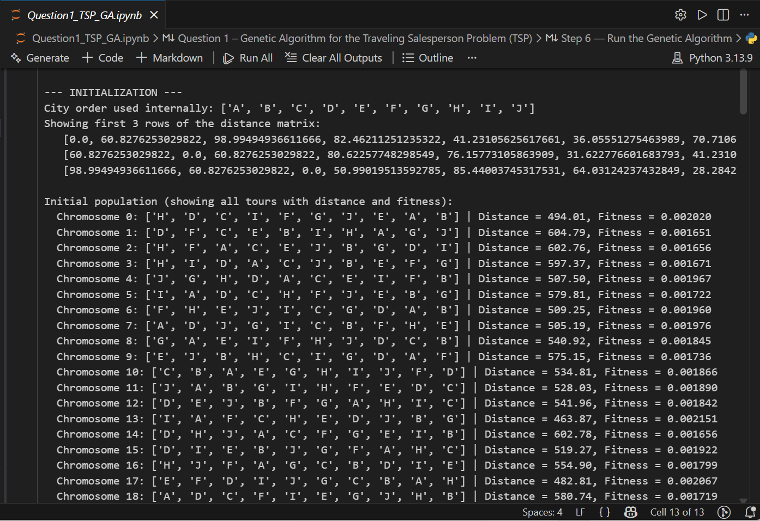
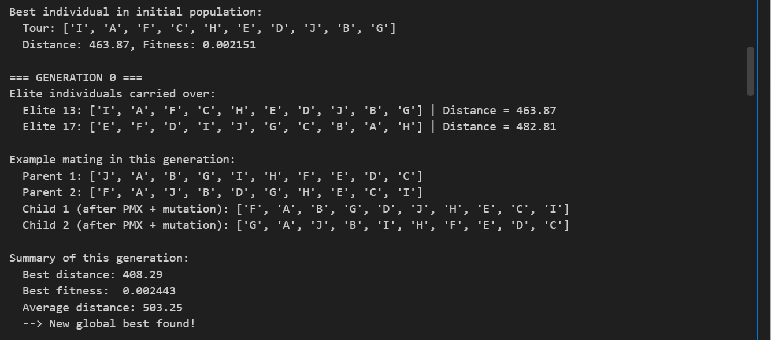
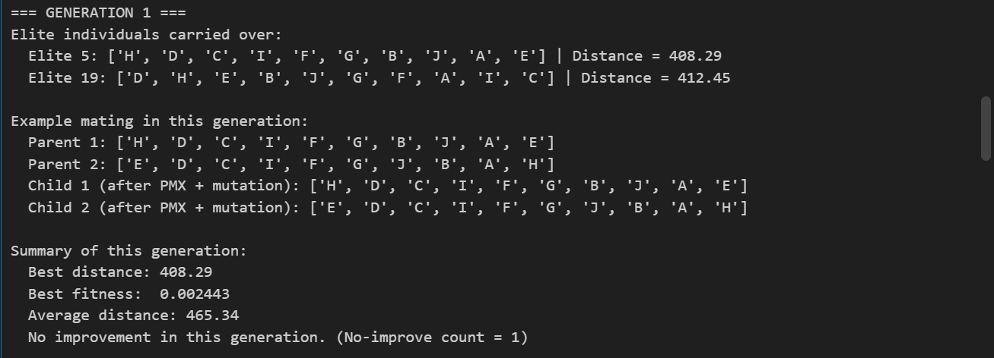
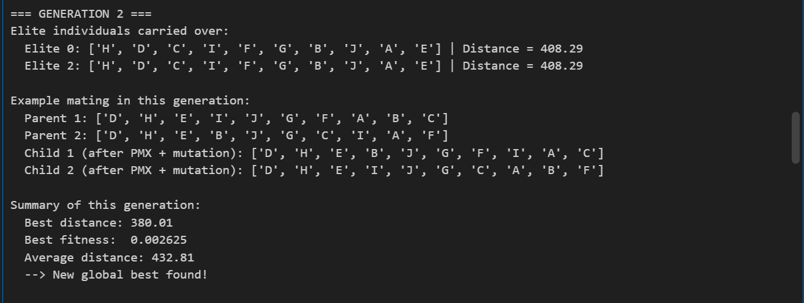
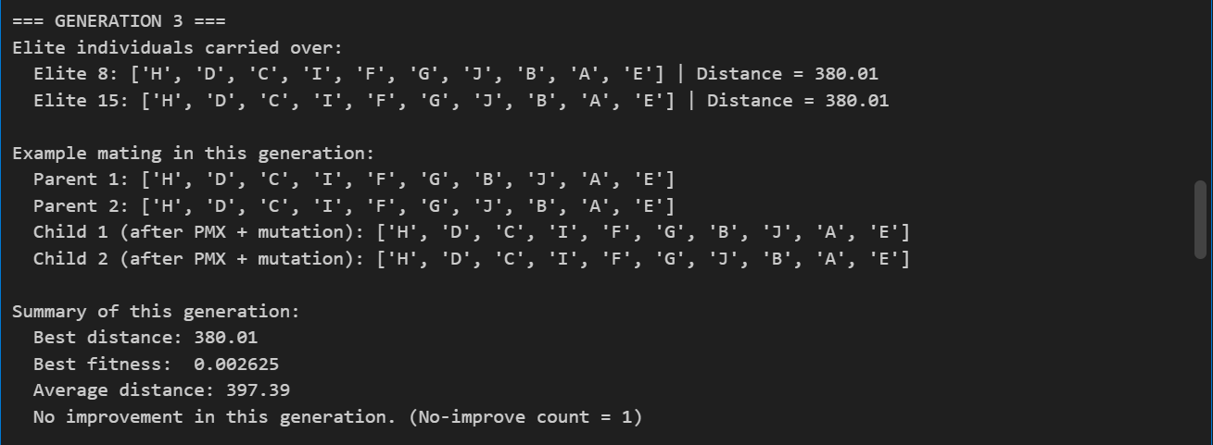
AND SO ON TILL GENERATION 12…
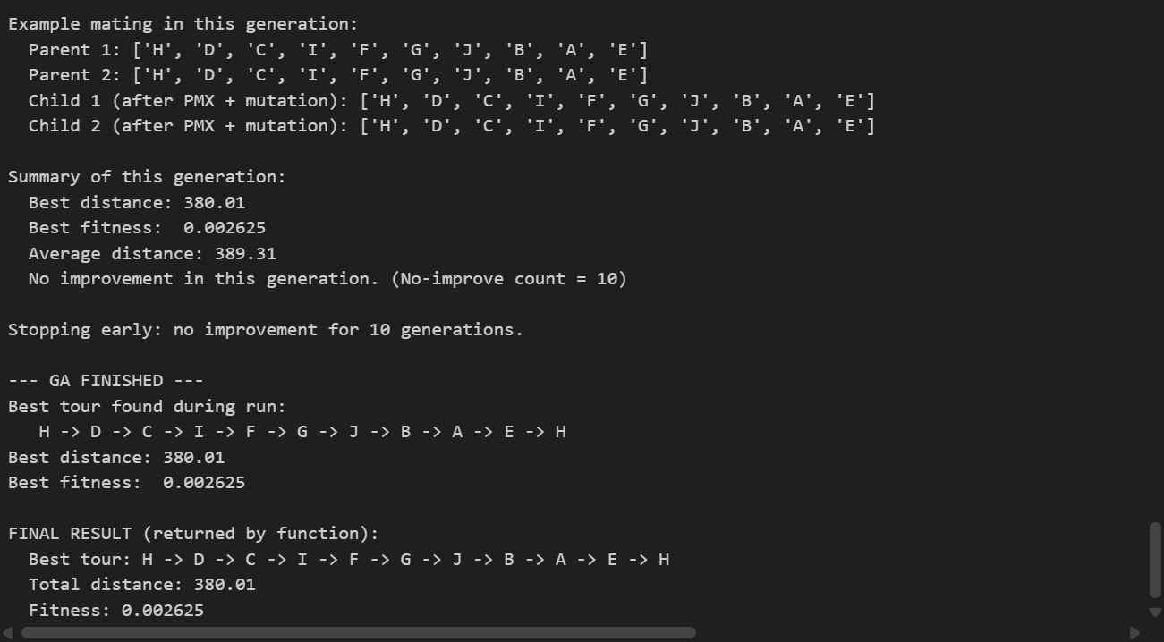

Final Result
Best Tour: H → D → C → I → F → G → J → B → A → E → H
Total Distance: 380.01
Fitness: 0.002625

Question 2: Wumpus World Knowledge Base (Prolog)

Problem Description
This problem models a Wumpus World agent using first-order logic. Based on percepts such as stench and breeze, the agent infers the presence or absence of pits and the Wumpus.

World Representation
- Grid size: 4 × 4
- Coordinates: (Column, Row)
- Rows decrease downward, columns increase left to right

Known Facts from the Diagram
- Stench: (1,2)
- Breeze: (2,1)
- Visited Cells: (1,1), (2,1)
- Safe (OK) Cells: (1,1), (2,1), (1,2), (2,2)

Logical Rules Implemented

Adjacency
Defines 4-directional neighbors (up, down, left, right).

No-Pit Rule
A cell has no pit if:
- It is known safe, OR
- It is adjacent to a safe cell with no breeze

No-Wumpus Rule
A cell has no Wumpus if:
- It is known safe, OR
- It is adjacent to a safe cell with no stench

Pit and Wumpus Inference
- A pit exists if adjacent to a breeze cell and not ruled out
- A Wumpus exists if adjacent to a stench cell and not ruled out

Target Queries
?- prove_no_pit_22_13.
?- prove_wumpus_13.
These queries verify:
- No pit exists at (2,2) and (1,3)
- The Wumpus is located at (1,3)

Solution Code:
% Wumpus World KB (Coordinates: (Col,Row))

% Grid
valid_cell(X,Y) :- between(1,4,X), between(1,4,Y).

% Percepts from the diagram (facts)
stench(1,2).
breeze(2,1).

% Visited V (facts)
visited(1,1).
visited(2,1).

% OK / Safe cells from the diagram (facts)
ok(1,1).
ok(2,1).
ok(1,2).
ok(2,2).

% Adjacency (4-neighbors)
adjacent((X,Y), (X,Y1)) :- Y1 is Y+1, valid_cell(X,Y1).
adjacent((X,Y), (X,Y1)) :- Y1 is Y-1, valid_cell(X,Y1).
adjacent((X,Y), (X1,Y)) :- X1 is X+1, valid_cell(X1,Y).
adjacent((X,Y), (X1,Y)) :- X1 is X-1, valid_cell(X1,Y).

% A cell has NO adjacent pit if it is known safe (visited/ok) and has NO breeze
no_adjacent_pit(X,Y) :-
(visited(X,Y) ; ok(X,Y)),
\+ breeze(X,Y).

% A cell has NO adjacent wumpus if it is known safe (visited/ok) and has NO stench
no_adjacent_wumpus(X,Y) :-
(visited(X,Y) ; ok(X,Y)),
\+ stench(X,Y).

% No pit if: The cell is OK, OR adjacent to a safe cell that has no breeze
no_pit(X,Y) :-
valid_cell(X,Y),
( ok(X,Y)
; ( adjacent((X,Y),(A,B)),
no_adjacent_pit(A,B)
)
).

% No wumpus if: The cell is OK, OR adjacent to a safe cell that has no stench
no_wumpus(X,Y) :-
valid_cell(X,Y),
( ok(X,Y)
; ( adjacent((X,Y),(A,B)),
no_adjacent_wumpus(A,B)
)
).

% Candidate pit: if adjacent to a breezy cell, unless ruled out as no_pit
pit(X,Y) :-
valid_cell(X,Y),
adjacent((X,Y),(BX,BY)),
breeze(BX,BY),
\+ no_pit(X,Y).

% Candidate wumpus: if adjacent to a stench cell, unless ruled out as no_wumpus
wumpus(X,Y) :-
valid_cell(X,Y),
adjacent((X,Y),(SX,SY)),
stench(SX,SY),
\+ no_wumpus(X,Y).

% Targets
prove_no_pit_22_13 :- no_pit(2,2), no_pit(1,3).
prove_wumpus_13 :- wumpus(1,3).

Sample Output
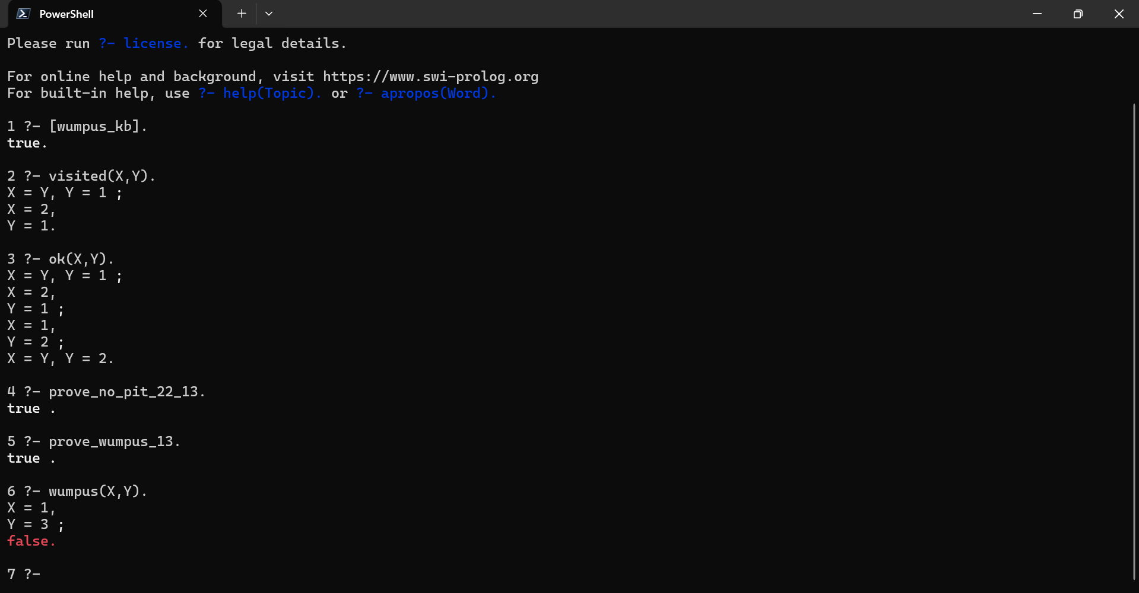

Conclusion
This project demonstrates the application of evolutionary algorithms and logic-based reasoning to solve classical AI problems. The Genetic Algorithm efficiently approximates optimal TSP solutions, while the Prolog knowledge base accurately infers hazards in the Wumpus World using logical rules. Both implementations satisfy the project requirements and illustrate core Artificial Intelligence techniques.

References
- Russell, S., & Norvig, P. (Artificial Intelligence: A Modern Approach)
- SWI-Prolog Documentation
- Python Official Documentation

