Lab Task 03: Using CrypTool 2

Objective:
To practice encryption, decryption, and cryptanalysis of the Vigenère cipher using CrypTool 2.

Procedure:
- Open CrypTool 2 and select the Vigenère cipher from the classical ciphers toolbox.
- Enter the plaintext and the key (example: DECLARATION).
- Run the tool to encrypt the message and record the ciphertext.
- Use CrypTool’s analysis functions (Kasiski, Friedman, frequency analysis).
- Attempt to recover the key and decrypt the ciphertext.
- Optionally, perform a known-plaintext attack for verification.

Results:

Vigenère Cipher Analysis
Vigenère Encryption Flow:
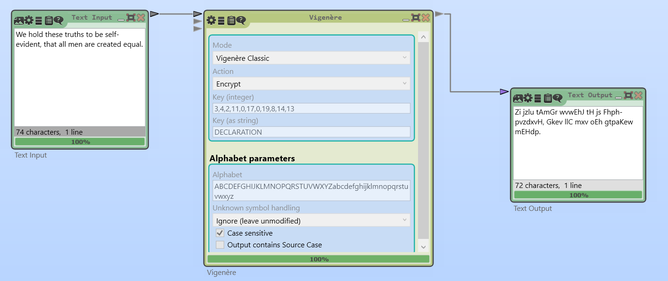

Decryption (using Vigenère Analysis )
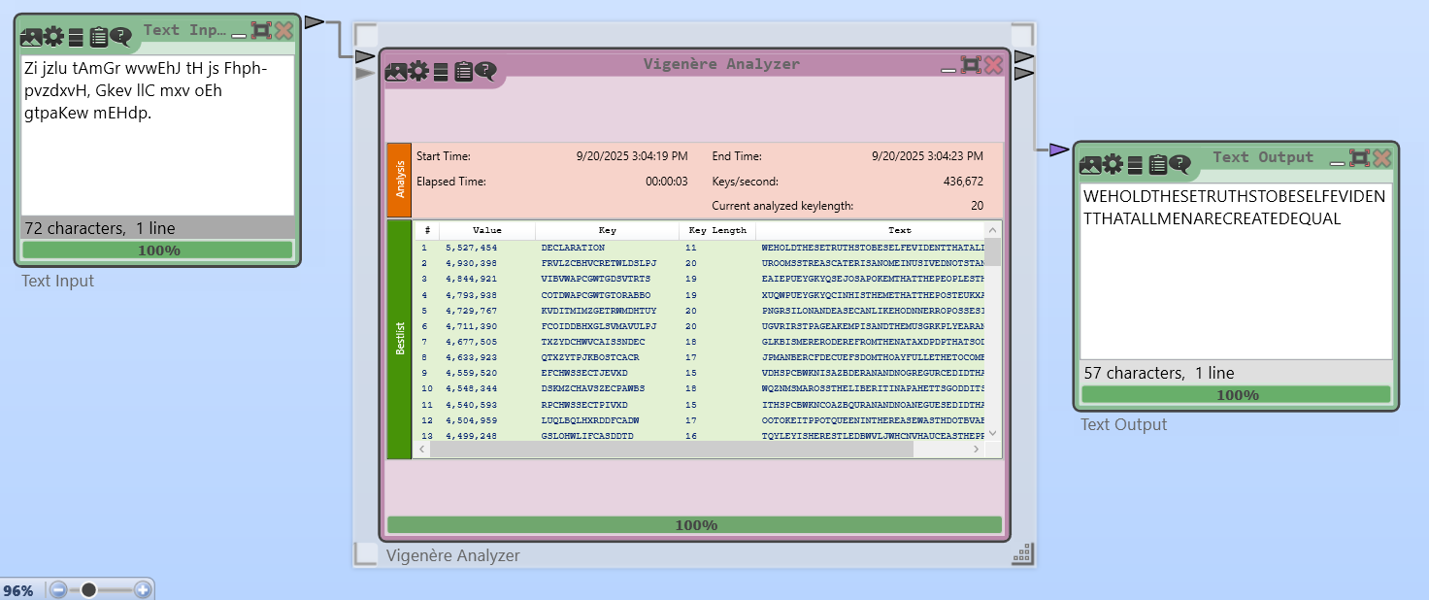

Frequency Analysis
Encrypted using Ceaser Cipher:
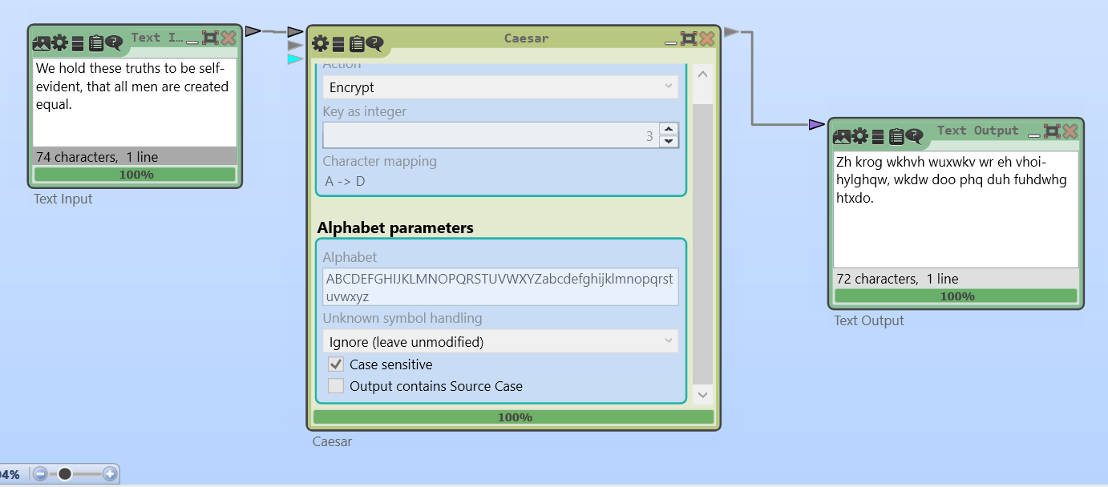
Ciphertext generated for sample plaintext and key

Frequency Analysis chart obtained:
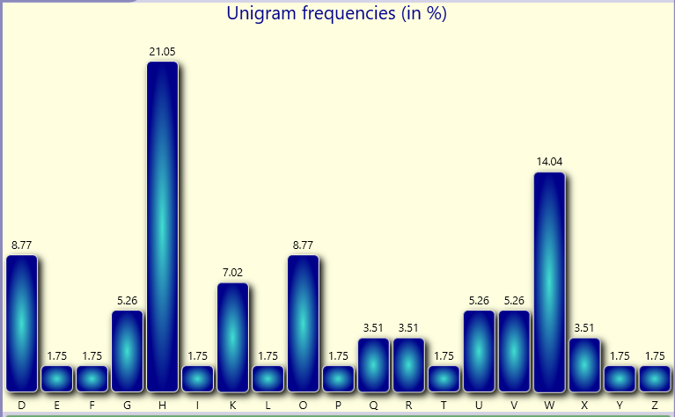
Frequency Analysis Flow:
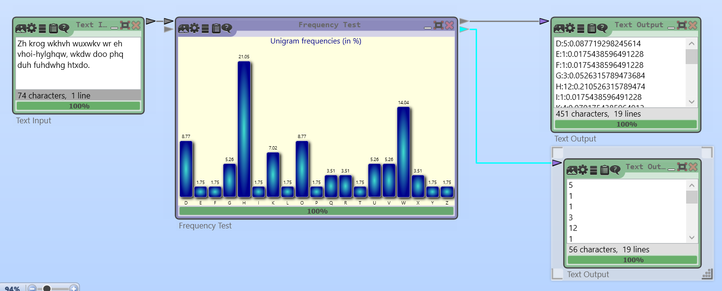
Frequency Analysis only provides hints or clues about the possible plaintext. To determine the exact keys, we still need manual observation and adjustments.

