

**Project**

**On**

**E-Commerce Website**

**Submitted By Submitted to**

**Rizwan Ahmad Dr. Nishant Agnihotri**

**Reg No.:- 12000740**

**INTRODUCTION**

This project is a web based shopping system for an existing shop. The project objective is to deliver the online shopping website. Online shopping is the process whereby consumers directly buy goods or services from a seller in real-time, without an intermediary service, over the Internet. It is a form of electronic commerce. This project is an attempt to provide the advantages of online shopping to customers. It helps buying the products anywhere through internet by using this website. Thus the customer will get the service of online shopping and home delivery.

**1.1** **PROJECT OBJECTIVE:**

The objective of the project is to make a website to purchase electronic items through this website. In order to build such a website complete web support need to be provided. A complete and efficient web page which can provide the online shopping experience is the basic objective of the project. The website can be implemented in the form of web view.

**1.2** **PROJECT OVER VIEW:**

The central concept of the website is to allow the customer to shop virtually using the Internet and allow customers to buy the electronic items of their desire from the website. The information pertaining to the products are stores on an RDBMS at the server side (store).

The Server process the customers and the items are shipped to the address submitted by them. The application was designed into two modules is for the customers who wish to buy the products. The website which is deployed at the customer database, the details of the items are brought forward from the database for the customer view based on the selection through the menu and the database of all the products are updated at the end of each transaction. Data entry into the website can be done through various screens designed for various levels of users. Once the authorized personnel feed the relevant data into the system, several reports could be generated as per the security.

1

**1.3** **STUDY OF THE SYSTEM**

**MANAGE PRODUCTS:**

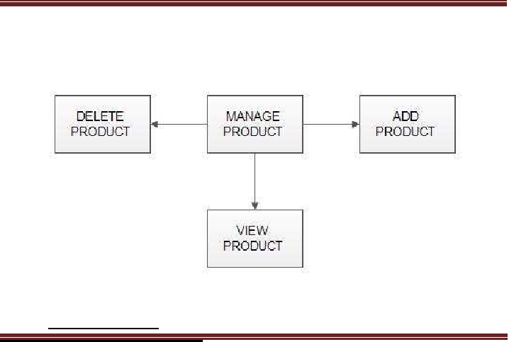

* Add Products

The shopping cart project contains different kind of products. The products can be classified into different categories by name. Admin can add new products into the existing system with all its details including an image.

* Delete Products

Administrator can delete the products based on the stock of that particular product.

* Search products

Admin will have a list view of all the existing products. He/she can also search for a particular product by name.

2

1.3.1 USERS:

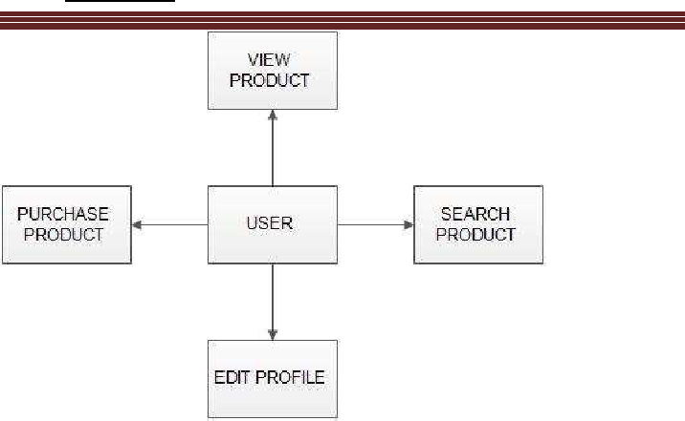

* Registration:

A new user will have to register in the website by providing essential details in order to view the products in the system. The admin must accept a new user by unblocking him.

* Login :

This feature used by the user to login into system. A user must loginwith his user name and password to the system after registration. If they are invalid, the user not allowed to enter the system.

* View Products:

User can view the list of products based on their names after successful login. A detailed description of a particular product with product name, products details, product image, price can be viewed by users.

* Search Product:

Users can search for a particular product in the list by name.

3

* Add to cart:

The user can add the desired product into his cart by clicking add to cart option on the product. He can view his cart by clicking on the cart button. All products added by cart can be viewed in the cart. User can edit an item from the cart by clicking edit.

**2. SYSTEM DESIGN:**

**2.1 INPUT AND OUTPUT DESIGN:**

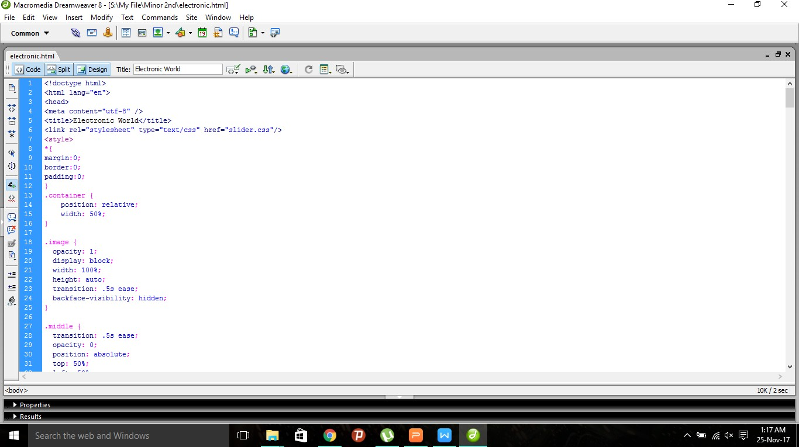 INPUT DESIGN:

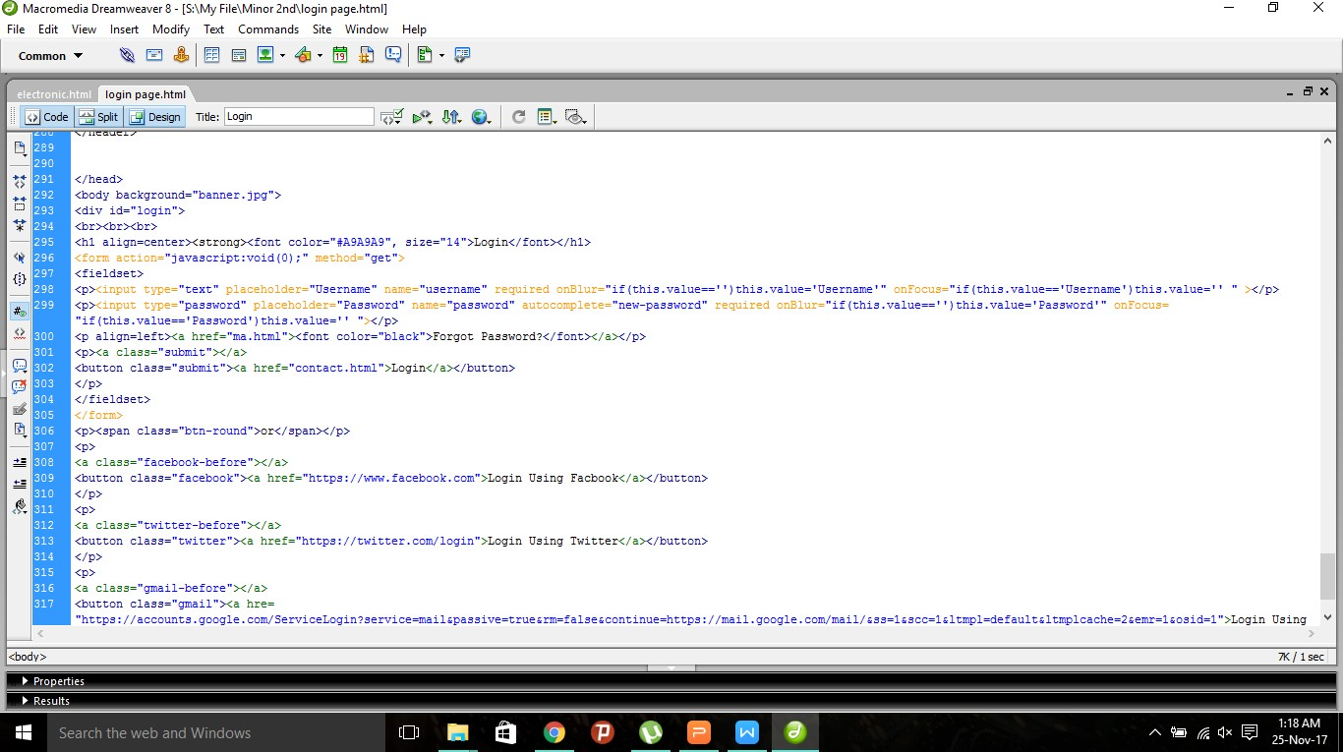

4

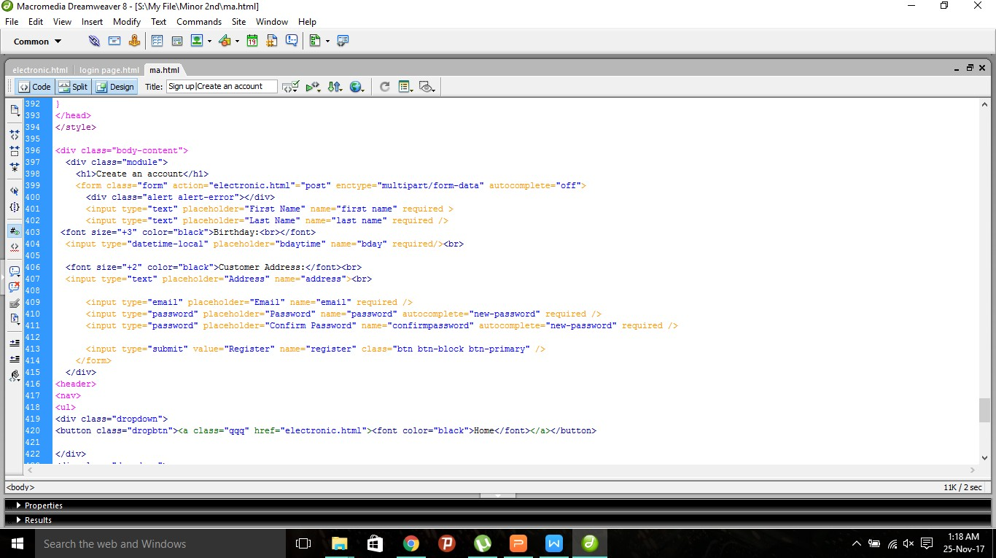

2.1.2 OUTPUT DESIGN:

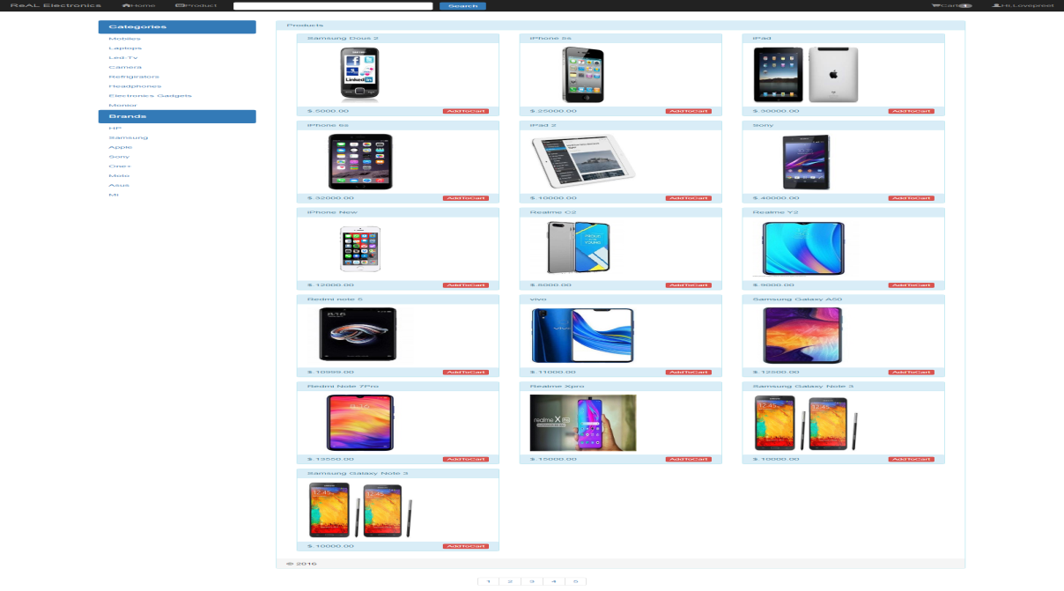

5

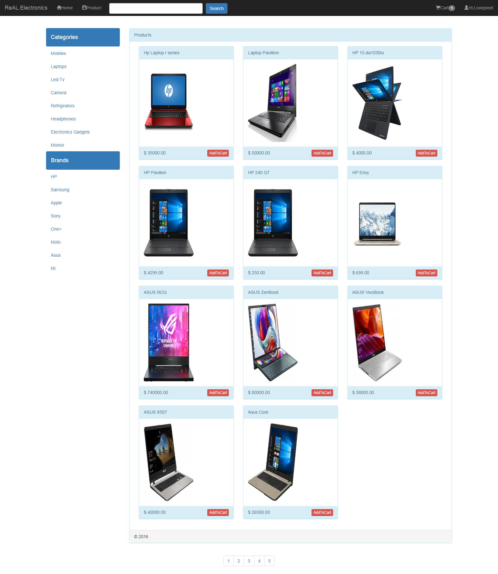

**2.2 DATABASE**

DATABASE DESIGN:

Databases are the storehouses of data used in the software systems. The data is stored in tables inside the database. Several tables are created for the manipulation of the data for thesystem 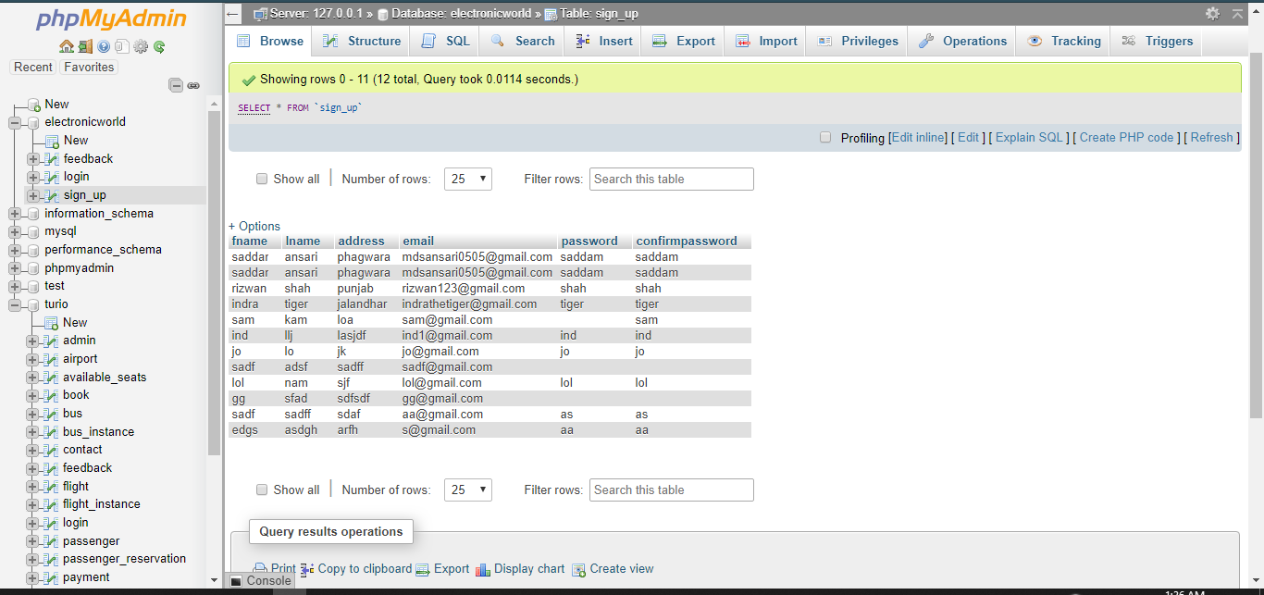

6

**3.3.1 FRONT END:**

HTML, CSS, JAVA SCRIPT,PHP are utilized to implement the frontend.HTML ,CSS and embedded JSP actions and commands. Using JS, one can collect input from users through web page.

HTML (Hyper Text Markup Language)

HTML is a syntax used to format a text document on the web.

CSS (Cascading Style Sheets)

CSS is a style sheet language used for describing the look and formatting of a document written in a markup language.

Java Script

JS is a dynamic computer programming language. It is most commonly used as part of web browsers, whose implementations allow client side scripts to interact with the user, control the browser, communicate asynchronously, and alter the document content that is displayed.

Java Script is used to create pop up windows displaying different alerts in the system like “User registered successfully”, ”Product added to cart” etc.

**3.3.2 BACK END:**

The back end is implemented using MySQL which is used to design thedatabases.

MySQL

MySQL is the world's second most widely used open source relational database management system (RDBMS). The SQL phrase stands for Structured Query Language.

7

**3.5 E-R DIAGRAMS**

* LOGIN

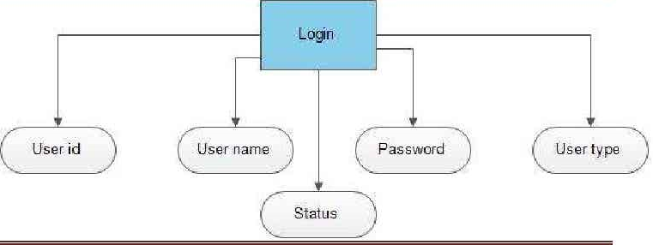

* USER DETAILS

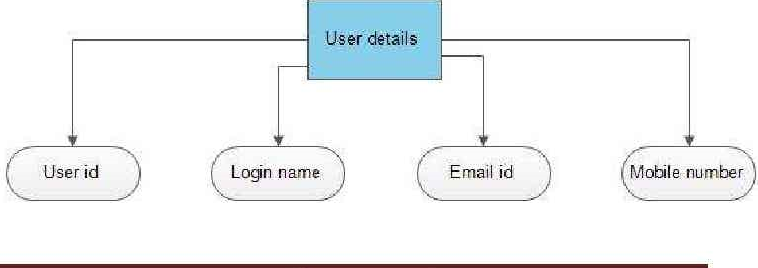

3**.6 DATA FLOW DIAGRAM**

A Data Flow Diagram (DFD) is a structured analysis and design tool that can be used for flowcharting. A DFD is a network that describes the flow of data and the processes that change or transform the data throughout a system. This network is constructed by using a set of symbols that do not imply any physical implementation. It has the purpose of clarifying system requirements and identifying major transformations. So it is the starting point of the design phase that functionally decomposes the requirements specifications down to the lowest level of detail. DFD can be considered to an abstraction of the logic of an information-oriented or a process-oriented system flow-chart. For these reasons DFD’s are Often referred to as logical data flow diagrams.

* LOGIN DFD

8

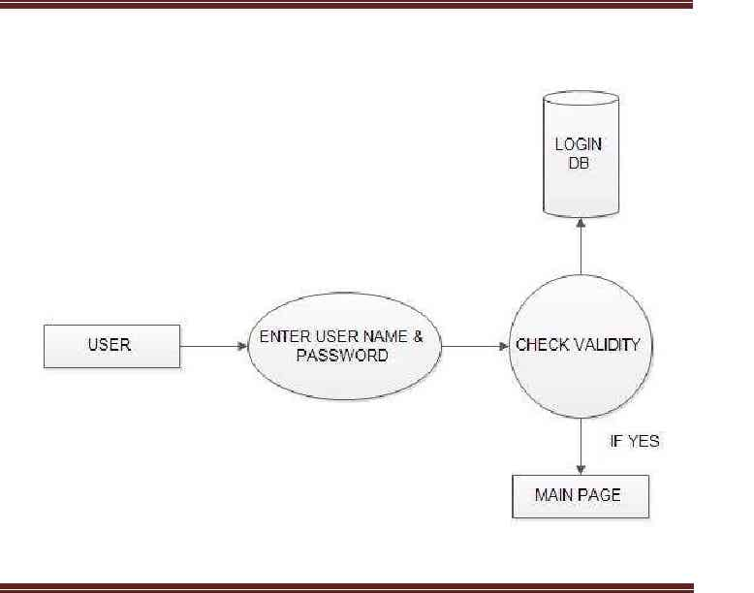

* REGISTRATION DFD

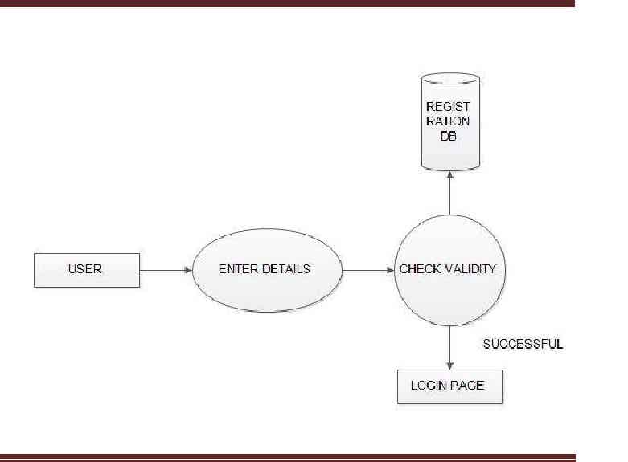

9

**CONCLUSION**

The project entitled **Electronic** **E commerce shopping website** was completed successfully. The system has been developed with much care and free of errors and at the same time it is efficient and less time consuming. The purpose of this project was to develop a website and for purchasing items from a website. This project helped us in gaining valuable information and practical knowledge on several topics like designing

web pages using html & css, usage of responsive templates, designing of website, and management of database using mysql. The entire system is secured. Also the project helped us understanding about the development phases of a project and software development life cycle. We learned how to test different features of a project. This project has given us great satisfaction in having designed an website. There is a scope for further development in our project to a great extend.

10

**BIBLIOGRAPHY**

https://www.w3schools.com/js/default.asp

https://www.w3schools.com/html/default.asp

https://www.w3schools.com/css/default.asp

https://www.w3schools.com/php/php_mysql_connect.asp

https://getbootstrap.com/docs/4.3/layout/overview/

https://www.youtube.com/watch?v=XwkzoBupLPM