**DECLARATION**

I hereby declare that the project work entitled ( Starks Innovation) is an authentic record of my own work carried out as requirements of Major Project for the award of diploma of computer science eng. from Lovely Professional University, Phagwara, under the guidance of (Amandeep Kaur,Devdatt Baresary), during January to April 2020).

(Signature of student)

Name of Student

Lovepreet (11717060)

Anoop thakur (11719697)

Rizwan Ahmad (11814043)

Mona Patel (1181558)

Date: 03-04-2020

This is to certify that the above statement made by the student is correct to the best of my

knowledge and belief.

**(Name , U.ID and Designation)**

**Faculty Mentor**

MAJOR PROJECT REPORT

(Project Term January – April 2020)

(Home Automation using with android app)

Submitted by

( Mona Patel:1181558 , Rizwan Ahmad:11814043

Lovepreet:11717060, Anoop Thakur:11719697 )

Programme & Section : Diploma(CSE) JK701

Under the Guidance of

(Amandeep Kaur,Devdatt Baresary)

Department of Computer Science & Engineering

Lovely School of Polytechnic

Lovely Professional University, Phagwara

January – April 2020

**Acknowledgement**

First and foremost, I would like to take this opportunity to thank our lecturer Ms. Amandeep Kaur and Mr.Devdatt Baresary for his guidance and advice on this project. At the same time I also won’t forget my group participant and also friends to because they quite good with sharing some of their information to complete this final year project successfully. Last but not least, I am very grateful to our College, lectures and friends where they gave us enough of time to complete this project and at the same time I would like to thank my friends and classmates who helps me a lot to complete this project.

Thank You.

**Index**

DECLARATION .................................................................................................. 1

ACKNOWLEDGEMENT…………………………………………………….……………………………..2

PROBLEM STATEMENT………………………................................................................3

EXSISTING SYSTEM….......................................................................................... 3

EXSISTING SOFTWARE……...................................................................................3

PROJECT SCOPE…………………………........................................................................3

PROBLEM DEFINITION……………….......................................................................5

PROJECT PLAN……………………..............................................................................6

SOFTWARE REQUIREMENT…………………………………………………………………………..……6

DATA FLOW DIAGRAM.........................................................................................7

ER DIAGRAM…………………..………………………………………………………………………….……..8

TABLE DESIGN.……………………………………………………………………………………………………9

CODE DESIGN………………………………………………………………………………………………………10

SNAPSHOT OF WORKING…………………………………………………………………………………….13

BIBLIOGRAPHY…………………………………………………………………………………………………….16

**Problem Statement:** There is a great energy crisis in current situation of our country. Moreover, people have become negligent in proper utilization of the available energy. People often forget to turn off the light sources and other home appliance while staying out from home. Even in those situations, application of home automation makes it possible to control them from a distant place in easy way with our smart phone. People are constantly running from place to place, working to accomplish everything on our never-ending “to-do” list. Because of the home automation system, we never have to worry about opening the door, switching off the appliances and so on. In short, we can save precious time and experience more daily productivity.

**Existing system**

Existing system means in our house, wall switches are located in different parts of a house and thus requires manual operation like to switch on or off these switches to control various appliances like light fan, washing machine etc. and some time we are busy in other works and we forget to switch off of other rooms light so in that situation for little time the energy is totally waist. The solution to this making one’s life easier is by means of automation household devices.

**Existing software**

Embedded C

Arduino- Ide

Android mobile

Android app

**Project scope**

This project work is complete on its own in remotely and automatically switching on or off of an electrical appliance not limited to household appliances and sends a feedback message indicating the new present state of the appliance.

**Problem definition**

To build a mobile application to control all the electric/electronic devices connected to switches to provide more flexibility of doing things and above that securing homes or workplace.

**Project plan**

In this project electronics appliances are controlled through remote control. This project is built on android software through which we develop an application that can control and show the status of the electronics appliances. Microcontroller ESP8266 is used in the project to act as an interface between the application and the hardware. The commands are given to the application from the user which then send the command to the microcontroller attached to the electronics appliances. Appliances work according to the command given by the user through touching the screen of application.

**Software Requirement**

* Arduino 1.6.9 IDE

The open-source Arduino Software (IDE) makes it easy to write code and upload it to the board. It runs on Windows, Mac OS X, and Linux. The environment is written in Java and based on Processing and other open-source software. This software can be used with any Arduino board.

* Sketchware

Sketchware is a integrated development environment (IDE) inspired from the language Scratch, which allows you to develop, compile, and build an Android application directly on your smartphone, without any help from a PC. ... It is an excellent starting point for you to familiarize yourself with Android App development.

* Android app

An Android app is a software application running on the Android platform. Because the Android - platform is built for mobile devices, a typical Android app is designed for a smartphone or a tablet PC running on the Android OS.

**Data Flow diagram**

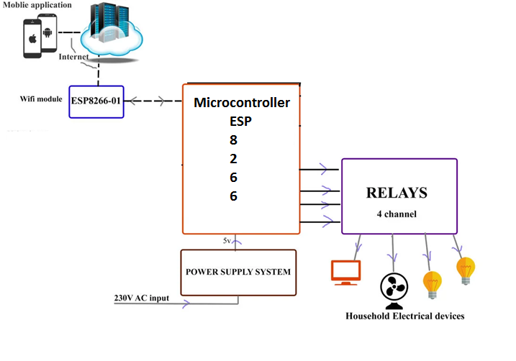

**ER Diagram**

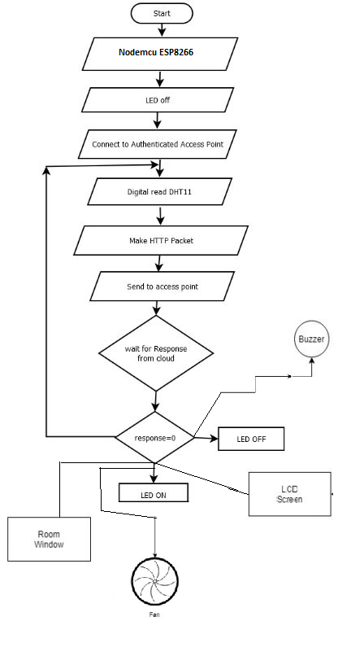

**Table design**

|  |  |  |  |  |  |
| --- | --- | --- | --- | --- | --- |
| **Name** | **Number** | **Price** | | | **Power** |
| **NodeMcu(8266)** | **1** | **600** | | | **5V** |
| **BreadBoard** | **1** | **50** | | |  |
| **Jumper** | **1 pkt** | **20** | | |  |
| **Relay** | **4** | **30 per piece** | | | **6V** |
| **LED** | **2** | **2** | | | **1W** |
| **Servo Motor** | **2** | **300** | | | **5-10V** |
| **Buzzer** | **1** | | **8** | **5V-12V** | |
| **Register** | **1 pkt** | | **30** |  | |
| **Fan** | **2** | | **120** | **8.88W** | |
| **DHT11** | **1** | | **100** | **3-5V** | |
| **LCD Display** | **1** | | **150** | **4-5V** | |
| **Power Adapter Supply** | **1** | | **200** | **IN-VOL 100-240VAC** | |

**Code design**

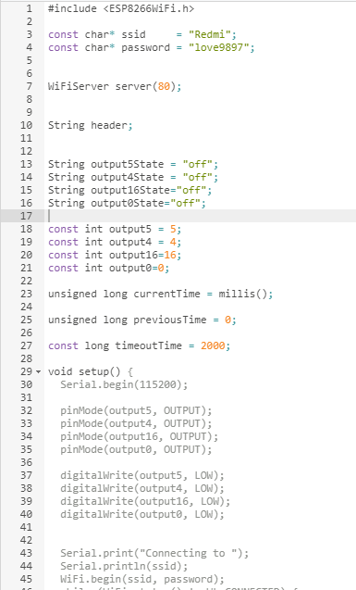

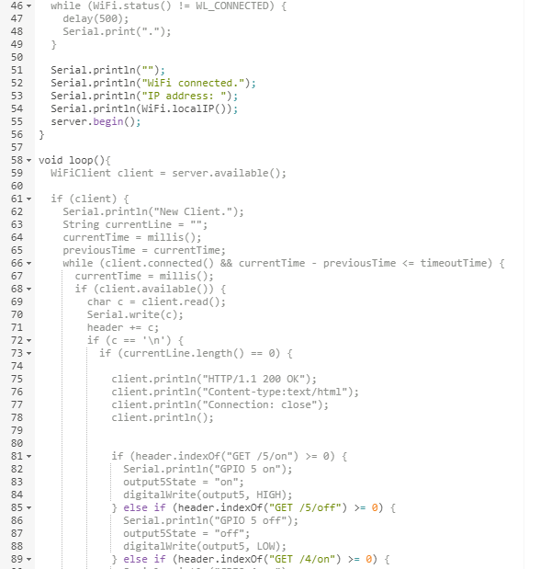

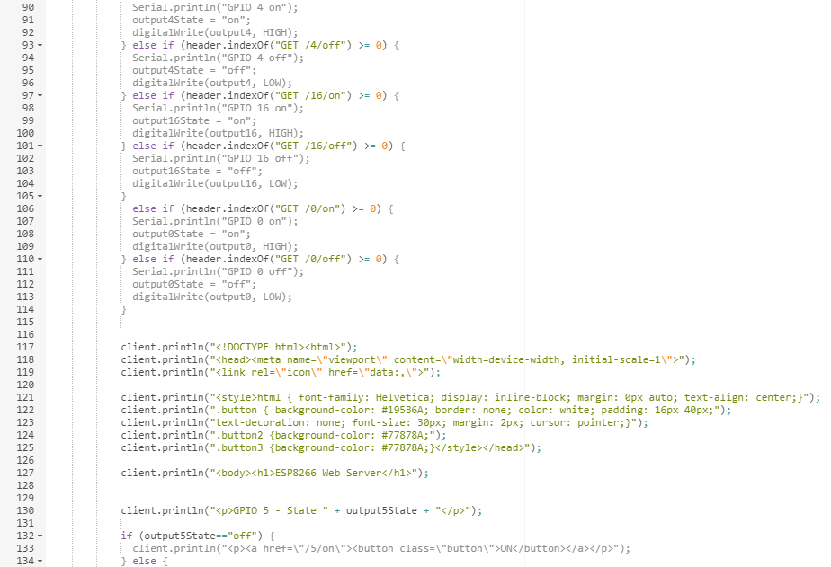

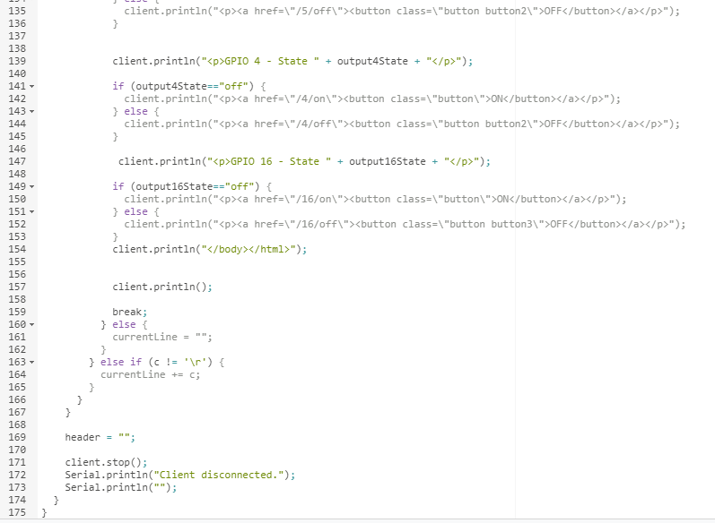

**Android app code**

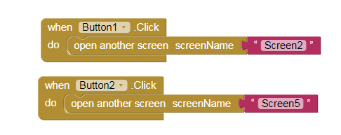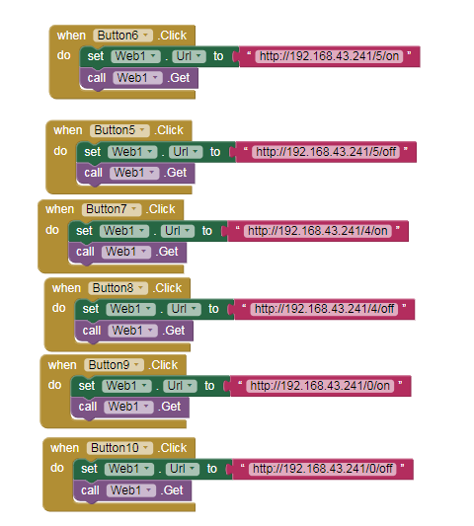

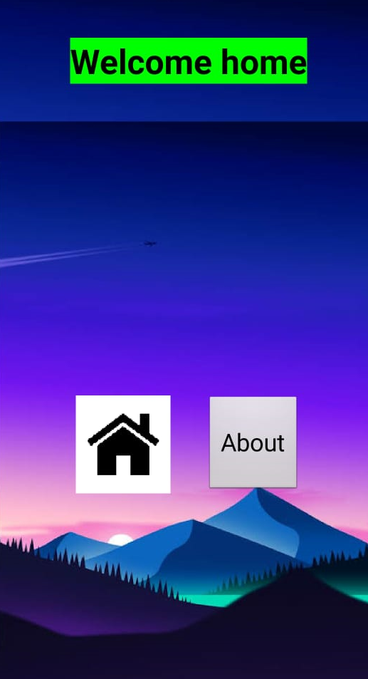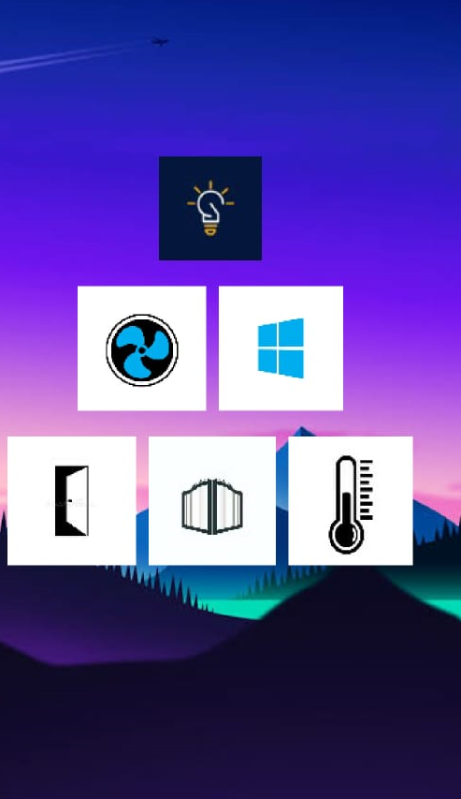

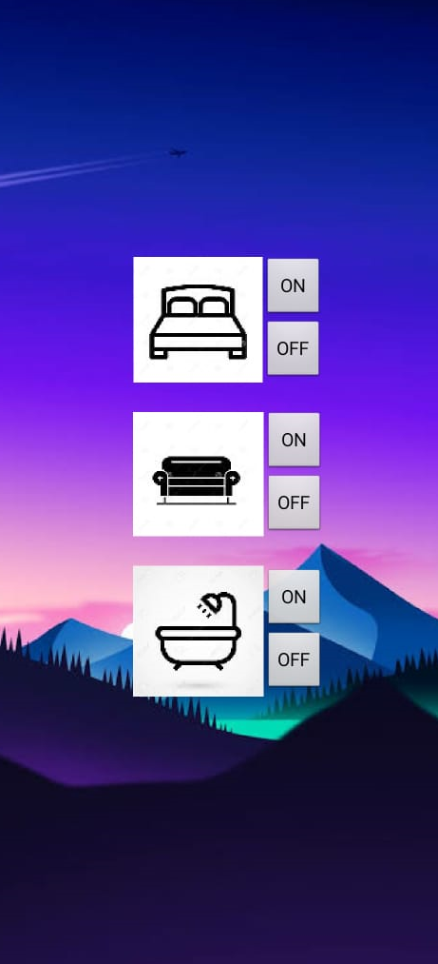

**Bibliography**:

<https://www.electronics-lab.com/project/home-automation-using-nodemcu-esp8266-board/>

<http://appinventor.mit.edu/>

<https://www.youtube.com/watch?v=DlG6LY84MUU>

<https://www.youtube.com/watch?v=jlB377wzpM&t=141s>

<https://www.researchgate.net/deref/http%3A%2F%2Felectronics.howstuffworks.com%2F>