**Project Report**

**On**

**Hospital Management System**



***Submitted By:***

**BUSHRA RAFIQUE MALIK**

**RIZWAN ULLAH**

**SHOIAB AHMED**

**ACKNOWLEDGEMENT**

We are very thankful to our God on this occasion, God made our way to success and our efforts and on this occasion, we are also thankful to our teachers **Mr. Tanveer Zahid Khan** especially **Mr. Muhammad Marouf** who taught us happiness and passion and their lectures proved to be very helpful for us. On this occasion, we had a lot of trouble but we succeeded in our objective. We would like to thank the other faculty members also. Last but not the least, we would like to thank our friends and family for the support and encouragement they have given us during the course of our work.

# ABSTRACT

Hospital Management System is developed to support the Hospital clinic daily operation before this is done manually. This system will involve all the clinic operation starting from patient registration until billing the patient. The important thing is it will become easier for the data record and retrieval. This system will be able to generate report regarding the clinic operation. For example, the number of patient per day and total collection per day. This system is able to check the inventory for the medicine in the Hospital and clinic. The target user for this system is staff of the clinic, doctor and also the management. Prototyping approach is applied while developing this system. This will involve an iterative process to make this system is usable and easy to use by the user.

# INTRODUCTION

This chapter gives an overview about the aim, objectives, background and operation environment of the system.

## PROJECT AIMS AND OBJECTIVES

The Hospital management system software is user-friendly software. The main objectives of the system is which shows and helps you to collect most of the information about Clinic and Medical Services. The system is very simple in design and to implement. The main objectives of the proposed system can be enumerated as follows:

1. Patients are easily allocated to the doctors.
2. Doctors Search is possible.
3. Today’s patient list help doctors to search their patients.
4. Generating bills.

It maintains two levels of users:-

* Administrator Level
* User Level

## BACKGROUND OF PROJECT

The Hospital management system is designed for any Clinic to replace existing manual paper based system. The help human Clinic is used to provide the patient information, doctor information and the medicine information. These services are provided in an efficient, cost effective manner with the goal of reducing the time and more complicated paper work.

Clinic Management System is powerful, flexible, and easy to use and is designed and developed to deliver real conceivable benefits to Clinic and clinics and more importantly it is backed by reliable and dependable.

Clinic Management System enables you to develop your organization and improve its effectiveness and quality of work. Managing the key processes efficiently is critical to the success of the Clinic helps you manage your processes.

Good medical care also relies on good record keeping. Good records care also ensures the Clinic administration runs smoothly; unneeded records are transferred or destroyed regularly, keeping storage areas clear and accessible; and key records can be found quickly, saving time and resources.

The problems that occurred before having computerized system includes:

* File lost when computerized system is not implemented file is always lost because of human environment. Sometimes due to some human error there may be a loss of records.
* File damaged when a computerized system is not there file is always lost due to some accident like spilling of water by some member on file accidentally. Besides some natural disaster like floods or fires may also damage the files.

**Grant Privileges to User:**

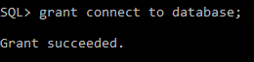



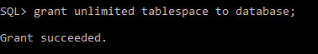

**NORMAILZATION:**

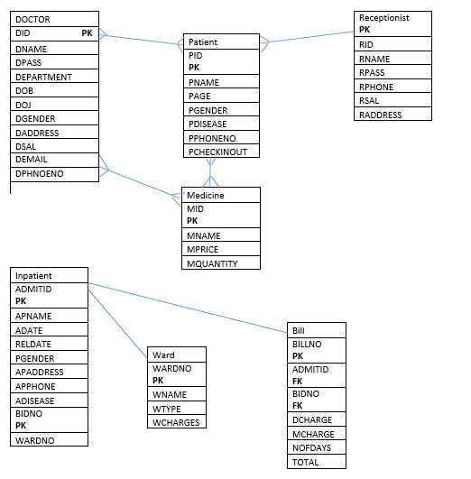

**Tables Patient:**

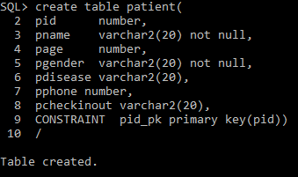

**Doctor:**

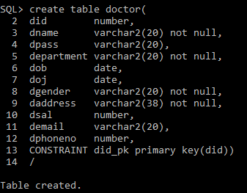

**Receptionist:**

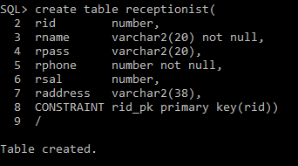

**Ward:**

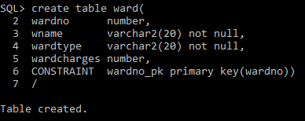

**Medicine:**

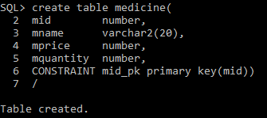

**Inpatient:**

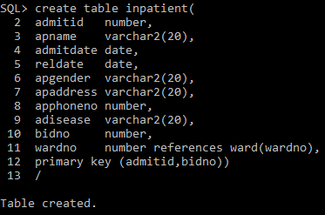

**Bill:**

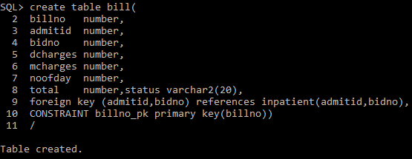

**OPD:**

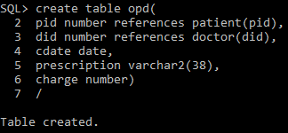

**Admin:**

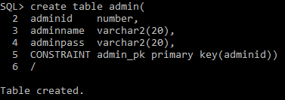

**Triggers:**

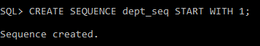

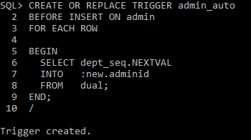

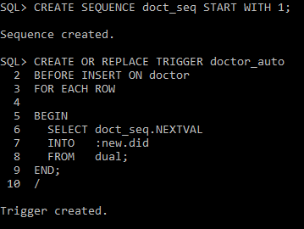

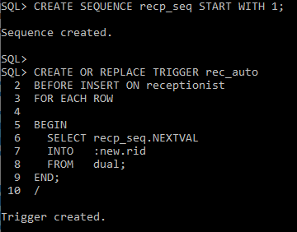

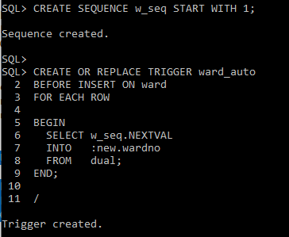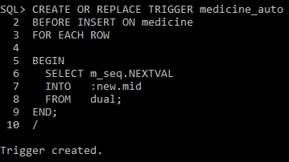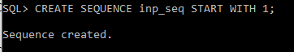

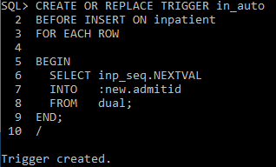

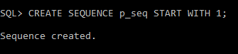

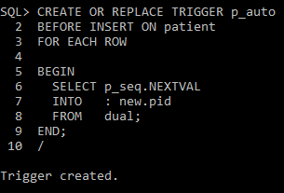

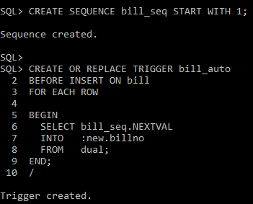

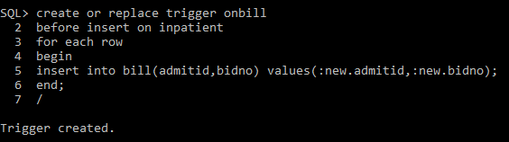

Procedure:

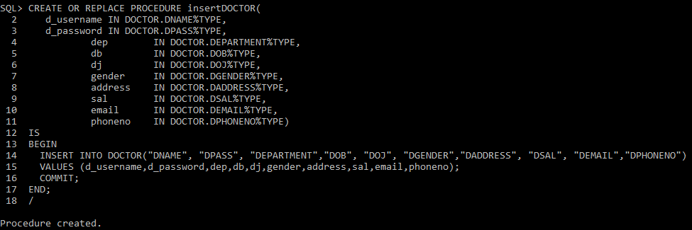

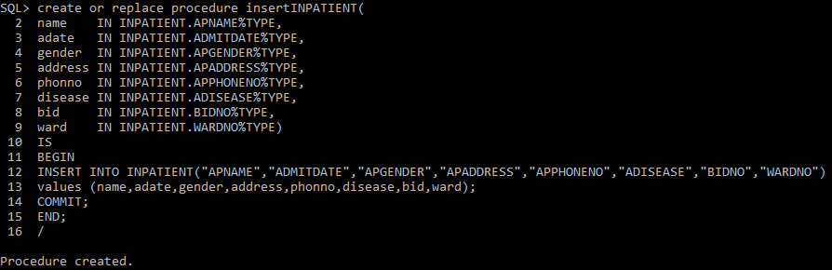

**CONCLUSION & FUTURE SCOPE**

This Program provides a computerized version of Hopital Management System which will benefit employees and Patient. It makes the entire process easy to use and very simple to work with. It can store customer information as well as Clinic, medicine information and has a page for queries of customers. The code of this program will be free to use for everyone. This will hopefully make it easier for anyone working with such code to experiment and gain ideas.

