Evaluate heuristic:
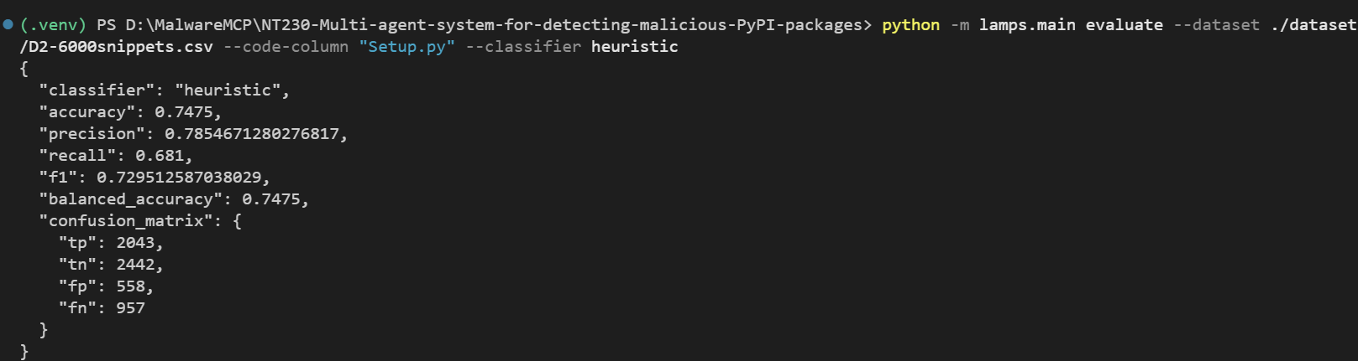
Train TF-IDF:
Evaluate TF-IDF:
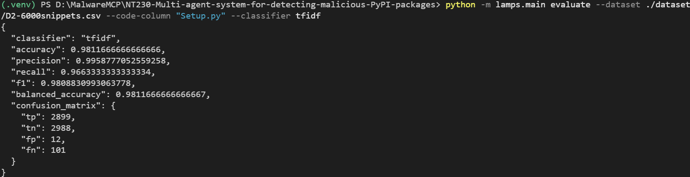

Train CodeBERT:
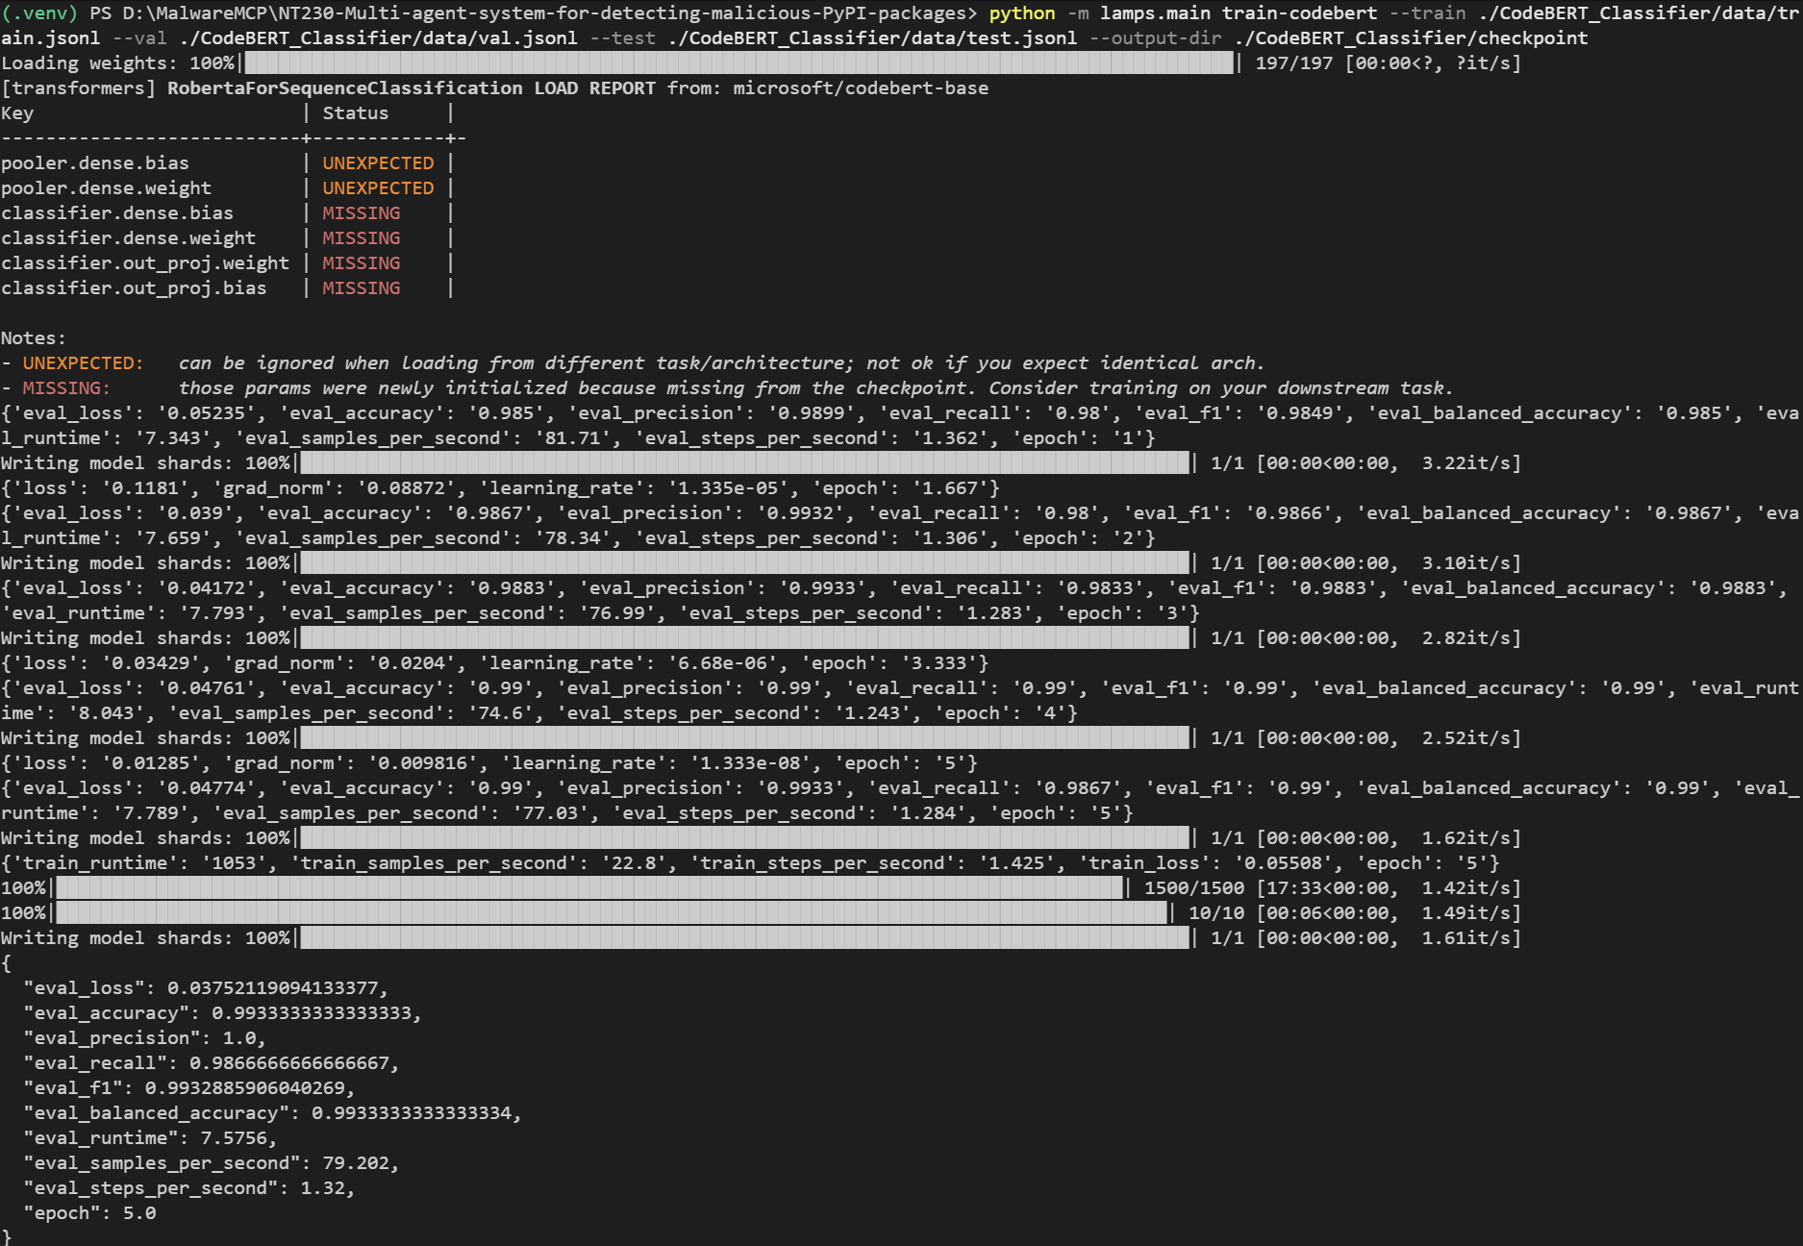
Evaluate CodeBERT:
