KAIROS — Kernel-Aware Intelligent Resource Orchestration System
1. Problem Statement
Modern operating systems continuously manage core hardware resources such as CPU, memory, disk, and I/O. Traditional operating-system tools provide basic monitoring dashboards, while classical algorithms (such as FCFS, SJF, Priority Scheduling, Round Robin, Banker's Algorithm, and page replacement strategies) operate strictly on predefined theoretical rules.
However, these traditional approaches lack a unified, adaptive system that can monitor live workloads, analyze historical behavior, and intelligently recommend optimal resource-management strategies based on real-time system context. Consequently, developers and administrators lack an accessible analytical tool to understand dynamic system pressure before critical failures occur.
2. Proposed Solution
KAIROS is an enterprise-grade, decoupled analytics platform built with a high-performance FastAPI backend and a React + Vite + Tailwind CSS frontend. It continuously gathers real-time system telemetry (CPU, memory, disk, and running processes) via asynchronous loops. This telemetry is stored locally in SQLite and evaluated using a dual approach: classical operating-system algorithms and a machine-learning recommendation engine.
Rather than attempting to replace the underlying host operating system's kernel scheduler or memory manager, the platform acts as an intelligent advisory and simulation layer. It analyzes system workloads, simulates scheduling strategies, detects deadlocks, and presents actionable insights via WebSockets to a centralized, responsive web dashboard.
3. Main Objectives
Primary Objectives
- Real-Time Asynchronous Monitoring: Build a high-throughput telemetry engine using FastAPI and WebSockets to capture CPU, memory, disk, and process metrics with near-zero latency.
- ML-Driven Scheduling: Develop a machine-learning classification model to recommend the most suitable CPU scheduling algorithm based on current workload traits.
- Core Algorithm Simulation: Integrate essential classical OS modules: CPU Scheduling (FCFS, SJF, Round Robin) and Deadlock Detection (Banker's Algorithm).
- Decoupled Dashboard: Deliver a clean, reactive visualization interface using React, Vite, Tailwind CSS, and Recharts.
Secondary Objectives
- Store historical telemetry inside a lightweight SQLite database managed via SQLAlchemy.
- Provide interactive process controls (such as safe process termination or priority adjustment via psutil).
4. Features to Be Implemented
To keep the project elite and robust without being overwhelmingly vast, we are retaining the enterprise tech stack while compressing the feature set down to the 4 most critical pillars:
1. Real-Time Process & System Monitoring (with Interactive Controls)
- Tracks CPU utilization, memory usage, disk I/O, process ID, process name, status, priority, and thread counts.
- Interactive Control: Process control actions allowing users to safely inspect, renice, or terminate rogue processes directly from the UI.
2. Core Classical OS Algorithm Simulation
- CPU Scheduling Simulation: Implements FCFS, SJF, and Round Robin to calculate turnaround and waiting times based on active queue data.
- Deadlock Detection Module: Implements the Banker's Algorithm framework to evaluate current resource allocation states as either SAFE or DEADLOCK RISK.
3. ML-Driven CPU Scheduling Advisor (Random Forest Classifier)
- Analyzes live metrics (process count, burst variations, priorities) and uses a Random Forest Classifier to recommend the optimal scheduling algorithm for the current workload, outputting confidence metrics.
4. Real-Time Interactive Dashboard (SPA)
- Unified React/Tailwind web interface displaying live streaming charts (via WebSockets), metrics cards, tabular process views, and simulation outputs without layout re-renders.

5. Technological Approach
Layer | Technology | Purpose
Backend & Telemetry API | FastAPI (Python 3.x) | Asynchronous REST endpoints and WebSocket channels for high-throughput live data streaming.
System Telemetry & Control | psutil | Cross-platform extraction of hardware and process metrics.
Data Processing & Analytics | Pandas & NumPy | Historical data manipulation, feature engineering, and statistical processing.
Machine Learning | Scikit-Learn & XGBoost | Training and inference for Random Forest classification, XGBoost regression.
Database & ORM | SQLite + SQLAlchemy | Lightweight local structured storage for metrics, logs, and historical trends.
Frontend UI | React + Vite + Tailwind CSS | High-performance single-page application framework with modern styling.
Data Visualization | Recharts or Chart.js | Optimized rendering engine for live-updating telemetry charts.

6. Machine Learning & Algorithm Mapping
Task: CPU Scheduling Recommendation (Classification)
- Inputs: Number of processes, average burst time, burst variance, CPU utilization, and average priority.
- Model: Random Forest Classifier
- Why: Cleanly handles multi-class outputs (FCFS, SJF, Priority, Round Robin) while supplying interpretability through feature importance scores.

7. High-Performance System Architecture Flow
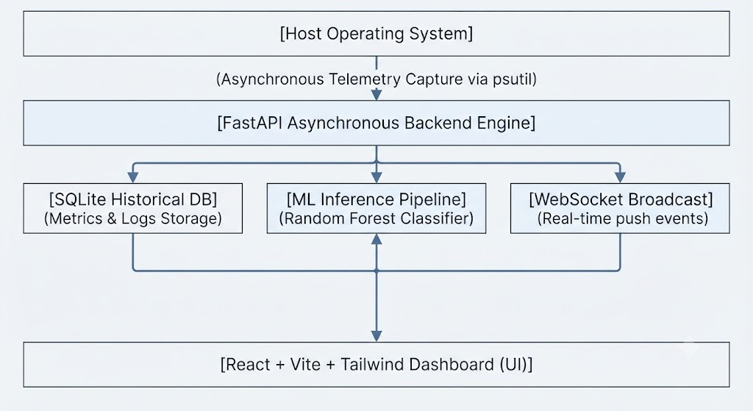
8. Database Design (SQLite / SQLAlchemy Tables)
- process_history: id, pid, process_name, cpu_usage, memory_usage, priority, status, timestamp
- cpu_history: id, cpu_usage, process_count, timestamp
- memory_history: id, memory_usage, available_memory, timestamp
- predictions: id, prediction_type, predicted_value, model_name, confidence, timestamp
- recommendations: id, recommendation_type, recommendation, reason, confidence, timestamp

9. Scope & Boundaries
- Included: Asynchronous real-time telemetry via WebSockets, core classical OS simulations (Scheduling & Banker's Algorithm), Random Forest scheduling recommendations, local SQLite storage, interactive process management, and a decoupled React/Vite dashboard.
- Not Included: Page replacement simulations, time-series memory regression models, and unsupervised anomaly detection (cut to streamline the build). Direct modification of kernel structures is also excluded; the platform functions strictly as an analytical advisor and simulator.
10. One-Line Project Synopsis
KAIROS is an enterprise-grade OS analytics platform combining asynchronous real-time telemetry, core classical OS simulations, and a Random Forest machine learning advisor to evaluate workload behaviour and recommend optimal scheduling strategies through a decoupled React dashboard.

