PROJECT REPORT
BCSE316L – Design of Smart Cities · Course Project (Review 3) · IMRaD format
Trust-Weighted Federated Learning for Privacy-Preserving City-Wide Air Pollution Mapping in Delhi
Rishit Chaudhary (23BCT0157)^{1,*}, Siddharth Verma (23BCT0159)¹, Jashan Sahasrabudhe (23BCT0022)¹, Adarsh Narayan (23BCT0155)¹
¹ School of Computer Science and Engineering, Vellore Institute of Technology, Vellore, 632014, India
* Corresponding author: rishit.chaudhary2023@vitstudent.ac.in
Team 10 · Project 9 · Case city: Delhi, India
Abstract
We implemented AirTrust, a federated learning (FL) simulation for Delhi pollution prediction under heterogeneous sensor quality. Real reference observations generate explicitly labelled virtual low-cost sensor errors. Eight geographic clients train a spatial graph neural network (GNN) or a temporal long short-term memory (LSTM) learner and exchange parameter updates. Calibration confidence uses early sensor/reference pairs at identical coordinates, avoiding spatial-gradient confounding.
Delhi sources contain 966,067 hourly pollutant observations in 2024; the primary PM2.5 experiment retains 300,355 valid labels at 36 distinct stations. Three seeds and five leave-stations-out folds compare centralised learning, FedAvg, trust weighting, robust aggregation, ordinary kriging and inverse distance weighting. On unseen stations, trust FL achieved mean absolute error 68.01 ± 8.83 µg/m³, root-mean-square error 96.69 ± 11.35 µg/m³ and R² 0.465 ± 0.172; FedAvg RMSE was 96.16 ± 12.11 µg/m³.
Trust weighting did not establish an accuracy advantage. In a separate fixed-holdout experiment, early linear input correction reduced trust-model RMSE from 99.92 to 78.67 µg/m³ (21.27%). Literature-anchored sensor sensitivity, temporal reputation, a named membership-inference probe and logical communication accounting quantify remaining tradeoffs. The public dashboard provides historical model inference, sensor controls and exports; 29 automated checks pass. This is a single-computer research simulation with no deployed sensor hardware, secure aggregation or formal privacy guarantee.
Keywords: federated learning; low-cost sensor simulation; sensor calibration; data privacy; spatio-temporal prediction; kriging; smart cities

1. Introduction
Urban pollution monitoring requires observations distributed across time and space [1–3]. Delhi reference monitors provide reliable evaluation locations but do not observe every point on a map. AirTrust tests prediction at stations excluded from fitting. Figure 1 shows the actual coordinates of the retained monitoring network, replacing the earlier illustrative coverage map; no unsensed neighbourhood is assigned verified ground truth.
Existing studies examine federated air-quality prediction [2–5], calibration [11] and graph-based prediction [12]. Our question is whether co-located calibration confidence improves a shared predictor when sensor clients have different biases and drift. The relevance to Sustainable Development Goals 3, 11.6 and 13 is environmental monitoring; health, policy and climate benefits are potential applications, not measured outcomes.

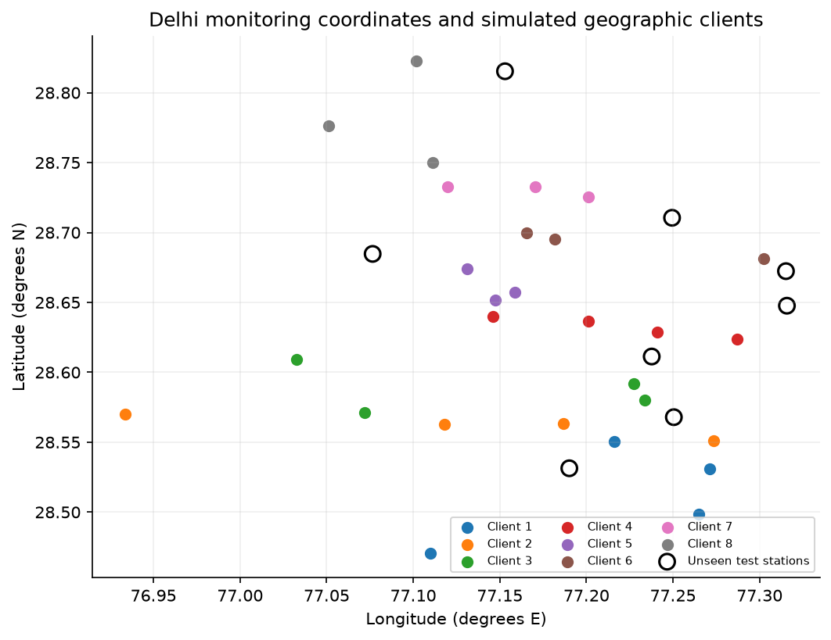

Figure 1. Actual coordinates of 36 retained Delhi reference locations, grouped into eight simulated geographic clients. Open circles mark the eight primary unseen stations. Client strips are computational partitions, not administrative districts. This plot does not claim complete coverage of Delhi’s monitoring network or city boundary.

Sensor response and calibration can vary with environment and time. Biased local readings may distort both learned updates and the donor inputs used for mapping. Downweighting an update does not directly repair those inputs. We therefore distinguish calibration-aware aggregation from input correction and measure both separately.

Our objective is to evaluate pollution prediction across sensor groups of heterogeneous quality while keeping raw records out of the aggregation interface. We test future times and entirely unseen locations, using common data boundaries and executed baselines.

The principal contributions of this work are as follows:

● An implemented calibration-weighted aggregator with an early, co-located reference prefix, a confidence floor and explicit comparison with sample-weighted FedAvg and equal averaging.

● A reproducible Delhi benchmark with three seeds, five station folds, graph and temporal learners, centralised and kriging alternatives, robust and reputation baselines, and documented sensor-error sensitivity.

● Executed input-calibration, privacy-probe and communication evaluations, source/derived dataset exports, data-drawn figures and a publicly hosted interactive simulation.

The federation is simulated on one computer; independent protected organisations and physical low-cost hardware are not deployed. A public dashboard is available at https://airtrust.vercel.app and code at https://github.com/rizzit17/airtrust. Section 2 reviews related work, Section 3 specifies the implementation, Section 4 reports measured results, Section 5 discusses interpretation and limitations, and Section 6 concludes.

2. Literature Review

2.1 Sensor calibration and spatio-temporal pollution prediction

Calibration studies show why a physical sensing error must be separated from a true spatial concentration difference. Cavaliere et al. [11] study low-cost gas-sensor calibration; their NO₂/O₃ results are not PM2.5 error coefficients. Zheng et al. [16] evaluate particulate sensors in several environments, including Kanpur, and report site- and condition-dependent calibration performance. Our virtual sensor is paired with its own reference coordinate rather than the nearest different station.

Jin et al. [12] model spatial and temporal dependence using a graph network. Their work motivates spatial learning, but our model is a smaller inductive star-graph implementation rather than a replication of their architecture. A temporal LSTM uses the target station’s own history, while our mapping learner excludes that history. These information sets require separate evaluation.

2.2 Federated learning for air-quality monitoring

Abimannan et al. [1] review air-quality FL and edge computing. Hu et al. [3] evaluate FedDeep across stations in 13 Jiangsu cities, motivating a strong forecasting comparator. Alwabli [2] and Beriwal and Ayeelyan [4] examine IoT air-quality and multi-country pollution prediction. Their reported tasks, metrics and health analyses cannot be equated with our unseen-station concentration RMSE. We retain common local baselines instead of importing incompatible published scores.

Putra et al. [5] study federated compressed learning; Feng [6] considers participant incentives; Nguyen et al. [7] address wireless resource allocation; Ramadan et al. [15] combine blockchain and industrial pollution monitoring. These address efficiency, incentives and security at different levels. None supplies a privacy or bandwidth guarantee for our unencrypted single-machine implementation.

2.3 Clustered, personalised and privacy-aware federated learning

Ye et al. [8] and Mengistu et al. [23] distinguish statistical, model, device and communication heterogeneity. Personalisation approaches [9,10,13,14,27,32] preserve client-specific patterns; their classification or energy datasets do not validate outdoor PM calibration. Wu et al. [22] examine topology, and Liu et al. [24] examine multiparty computation. Our study consequently evaluates accuracy, robustness, update exposure and logical payload as distinct questions.

The extended review covers 25 peer-reviewed journal/conference works in Table 1, including the foundational Zheng study. Twenty of the 24 non-foundational works are from 2022 onward (83.3%); this conservative recency count excludes all 2021 works. Placeholder publication records and preprint-only drafts are excluded. Further studies [25,26,28–31,33] cover health integration, forecasting, environmental robustness, drones, edge sensing and industrial delay. Their limitations concern transfer to this project, not necessarily defects in the original papers.

2.4 Research gap
The gap is an evaluated combination of co-located calibration, shared learning and completely withheld pollution-monitor locations. Table 1 compares sensing, heterogeneity and deployment assumptions. We do not claim universal novelty or that all previous FL systems ignore quality. The resulting experiments compare sample count, physical calibration residuals, robust updates and project-defined reputation, while a separate ablation tests whether repairing the inputs matters more than reweighting the updates.

Table 1. Comparison of 25 reviewed works and the implemented study. Approach cells identify the principal method; concentration error, classification accuracy and communication metrics in the cited papers are not interchangeable. Full parameter comparisons are retained in docs/LITERATURE_COMPARISON.csv.
Study | Approach | Dataset / setting | Limitation
Rentero-Trejo et al. (2021) [33] | Context-aware IoT FL | 165 generated user datasets | Synthetic user behavior; no pollution calibration
Ramadan et al. (2025) [15] | Blockchain and IoT FL | Industrial indoor pollutant measurements across three floors | Industrial exposure setting differs from unseen outdoor stations
Ye et al. (2023) [8] | Heterogeneous FL survey | Published heterogeneous FL studies | Survey taxonomy; no common Delhi benchmark
Mishra and Gupta (2023) [13] | Personalization, distillation and early halting | MNIST, HAR, CIFAR-10, LMR and SHL | Personalization on classification does not establish spatial interpolation
Wu et al. (2024) [22] | Topology-aware FL survey | Star, tree, decentralized and hybrid edge networks | Survey; requires workload-specific network validation
Feng (2024) [6] | Incentive-weighted air prediction | Six pollutant concentration series | Incentive scores are not co-located calibration residuals
Le et al. (2022) [26] | Multi-model AQI forecasting survey | Reviewed AQI datasets and FL benchmarks | Survey/proposed direction rather than a new shared benchmark
Hu et al. (2024) [3] | FedDeep multi-urban deep FL | Stations in 13 prefecture-level cities | Multi-city forecasting differs from unseen-station transfer
Nguyen et al. (2021) [7] | Weighted proximal FL and resource allocation | Unbalanced learning data and wireless IoT simulation | Wireless energy findings require an explicit radio model
Beriwal and Ayeelyan (2025) [4] | VGG-19 FL and causal impact analysis | India, Nepal and China datasets | Accuracy endpoints cannot be equated with concentration RMSE; observational health analysis
Kim et al. (2025) [27] | Personalized transfer, ensemble and masking | Campus building energy observations | Building energy transfer is indirect evidence for pollution sensors
Khan (2025) [9] | Sign-entropy regularization | FEMNIST, Shakespeare, CIFAR-10 | Classification optimization; no calibration-error model
Alwabli (2024) [2] | IoT air-quality FL | Multi-sensor AQI observations described in paper | Published comparisons include RMSE below MAE; metric definitions require caution
Neo et al. (2022) [25] | Systematic review of pollution and health FL | Published environmental and health prediction studies | Proposes integration; not an independent deployed FL trial
Zakzouk and Said (2025) [28] | Lightweight CNN FL robustness | WHIN weather network, 144 stations | Soil moisture response differs from optical PM sensor response
Akram et al. (2025) [29] | Personalized conditional FedAvg | Concrete Crack Images for Classification | Drone image classification does not validate air pollution mapping
Liu et al. (2024) [24] | Multi-party computation and FL survey | Published cryptographic FL protocols | Survey; no privacy guarantee for an unencrypted implementation
Moursi et al. (2021) [30] | NARX hybrid edge prediction | PM2.5, wind and rain; PC and Raspberry Pi | Edge prediction is not federated aggregation
Chen et al. (2025) [31] | Delay-constrained wireless FL | Standardized salt-spray test data | Industrial corrosion testbed; no PM calibration transfer
Shawkat et al. (2025) [32] | Adaptive clustered personalized distillation | CIFAR-10/100, Fashion-MNIST and Enron | Classification datasets; adaptive clustering differs from geographic client strips
Putra et al. (2021) [5] | Federated compressed LSTM | AirBox sequences from 1000 nodes | Compression changes utility; privacy needs an explicit attack evaluation
Mengistu et al. (2024) [23] | IoT/WSN heterogeneity and security survey | Published sensor-network FL studies | Survey mechanisms do not certify a particular implementation
Khan (2025) [10] | Entropy-guided FedEmerge | CIFAR-10, Federated EMNIST and Shakespeare | Data entropy is not physical calibration reliability
Abimannan et al. (2023) [1] | Air-quality FL and edge-computing review | Published air-quality monitoring studies | Review-level evidence; no standardized unseen-station comparison
Zheng et al. (2018) [16] | Field sensor calibration; linear, quadratic and RH models | PMS3003 paired with E-BAM/T640 in Durham, RTP and Kanpur | Foundational calibration study; coefficients are site-specific, paired data available on request
This work | Co-located trust FL; GNN/LSTM | Delhi reference labels; simulated errors; separate Beijing check | No hardware validation; trust does not consistently beat FedAvg

3. Methodology

3.1 Problem formulation
Consider K = 8 simulated geographic clients. Client k holds nₖ training windows, and the shared model has parameters w. The client groups approximate distributed ownership without claiming physical or legal isolation. With pₖ = nₖ/n, n = Σ nₖ, and squared prediction loss, the optimisation objective is
min_{w} F(w) = Σ_{k=1}^{K} p_{k} F_{k}(w), F_{k}(w) = (1/n_{k}) Σ_{i∈k} ℓ( f(x_{i}; w), y_{i} ) (1)
where Fₖ is the local loss, xᵢ contains past pollutant readings and time/location features, and yᵢ is the simulated sensor label. Delhi meteorological inputs are not used. Evaluation uses original, unimputed reference concentrations. Standard FedAvg weights local states by nₖ; Section 3.3 multiplies this by calibration confidence. The target is one-hour-ahead prediction using six strictly past hourly readings.

3.2 Data / materials
The primary source is CPCB Continuous Ambient Air Quality Monitoring data compiled by the India Air Quality Database, XKDR Forum [17]. Delhi 2024 downloads contain 317,627 PM2.5, 323,061 PM10 and 325,379 NO₂ rows at 39 catalog entries: 966,067 pollutant observations. PM2.5 supplies the FL reference target; PM10/NO₂ supply contextual monthly trends and are not extra PM2.5 labels. The UCI Beijing dataset [18] contains 420,768 station-hour rows at 12 reference-grade stations during March 2013–February 2017, used only for an independent temporal persistence check. Both compilations are CC BY 4.0. OpenAQ and sensor.community were proposal candidates and are not used in the executed experiments.

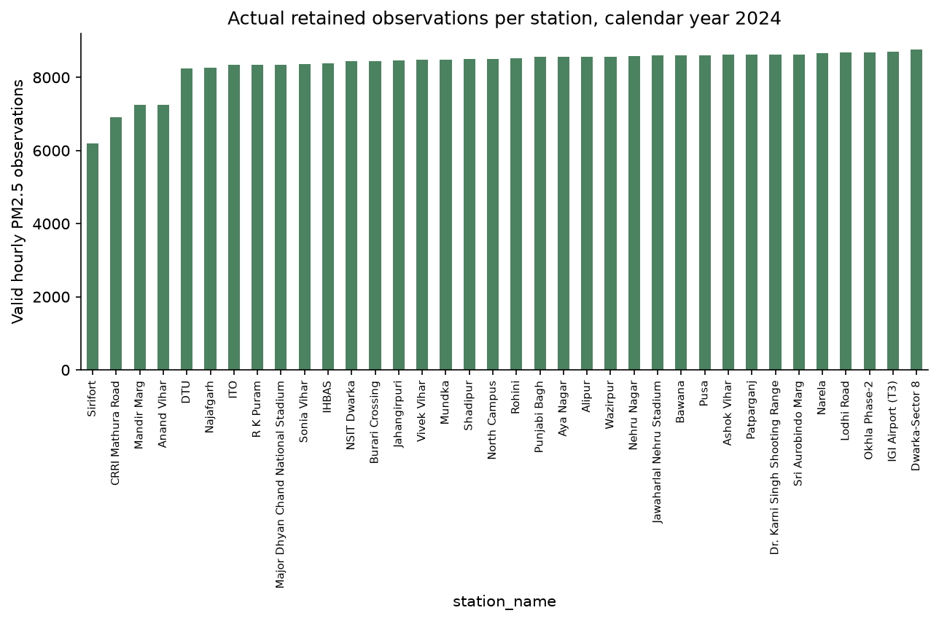

Figure 2. Actual retained hourly PM2.5 observations per Delhi station in 2024, totalling 300,355 valid labels. Source downloads contain 317,627 PM2.5 rows, with the contextual PM10/NO₂ and independent Beijing counts stated in Section 3.2. Archive duplicates and simulated readings are not additional source observations.

Delhi data are aligned to the 8,784 hours of leap year 2024 in IST. Duplicate station-hours are averaged; concentrations below zero or above 2,000 µg/m³ are excluded. Stations require at least 70% hourly coverage. Catalog coordinates within 50 m are consolidated by retaining the more complete entry, leaving 36 distinct locations. Input histories alone are forward-filled for at most three hours; reference targets are never filled or backfilled. PM inputs/labels are scaled by 100 and relative coordinates by 50 km. Geographic strips define eight clients; full-year coverage filtering is a retrospective benchmark choice. No new human or animal data are collected.

Sensor-error model and provenance. For the primary engineering stress test, virtual PM2.5 is max(0, gain × reference + bias + annual drift × elapsed-year fraction + Gaussian noise). Mild clients use bias 1.5 µg/m³, gain 1.02, annual drift 2 µg/m³, noise SD 3 µg/m³ and 1% dropout. Severe clients use bias 35, gain 1.25, annual drift 30, noise SD 12, 4% dropout and 12 random six-hour stuck blocks, each repeating the preceding value. Three of eight clients (37.5%) are severe in the primary run. These coefficients are disclosed assumptions, not fitted Zheng coefficients.
Literature-anchored sensitivity. Zheng et al. [16] report one-hour calibrated concentration-ratio error SDs of 35% and 46% in Kanpur post-monsoon and monsoon conditions. A separate scenario uses mean-one lognormal multiplicative error with these SDs: log-scale SD is √ln(1 + s²), and log-scale mean is −½ln(1 + s²). Choosing that distribution and assigning s = 0.35/0.46 to clients are our assumptions. This sensitivity has zero added bias, drift, dropout and stuck blocks. The primary annual-drift model remains a stress test; no Delhi hardware response or humidity model is claimed.

3.3 Proposed approach
Figure 3 describes the implemented round. The server broadcasts the current state, each client runs local optimisation, and the aggregator combines parameter states using scalar weights. Model training and public-data evaluation share a simulator process; the aggregator itself accepts no raw-record argument.
- Local training. The spatial GNN uses up to three local seen-station donors, each with six past PM2.5 readings and relative coordinates. Shared 8→24→16 message layers, attention pooling and a 20→24→1 residual head produce the target prediction. Two available donors are padded by repeating the last; this changes effective multiplicity and is a limitation. The LSTM has 16 hidden units and uses a known target’s own six-hour history plus cyclic time features. It is not scored at a location without sensor history.
- Calibration confidence. A virtual sensor and its reference share identical coordinates. First-10%-period paired residuals at seen locations determine one confidence score per client. Held-out locations contribute no calibration data. For round t the fixed confidence is
c_{k}^{t} = max( exp( −RMSE_{k}^{t} / τ ), c_{min} ) (2)
where RMSEₖᵗ is the same early co-located residual at every round, τ = 35 µg/m³ and cmin = 0.05. These settings are fixed scenario choices. The time superscript does not imply a recalculated round-by-round reference score. Identical-coordinate pairing avoids penalising real gradients between different monitoring sites.
- Quality-weighted aggregation. The aggregator normalises the product of each client’s training-window count and fixed calibration confidence, then combines local parameter states:
α_{k}^{t} = n_{k} c_{k}^{t} / Σ_{j=1}^{K} n_{j} c_{j}^{t}, w^{t+1} = Σ_{k=1}^{K} α_{k}^{t} w_{k}^{t+1} (3)
where wₖᵗ⁺¹ is the locally updated model. Setting every confidence to one yields sample-weighted FedAvg; equal client averaging is a separate ablation. Graph comparisons also include coordinate median, one-tail-per-side trimmed mean [19], Krum with f = 1 [20], and instantaneous update consistency. Krum’s theoretical condition does not cover three or five corrupted clients among eight; its results here are empirical.
Temporal reputation. A separate project-defined history baseline uses r(t) = 0.8r(t−1) + 0.2exp(−d(t)/median(d(t))), initialised at one. Here d is client-update distance from the coordinate median; the scale is floored at 10⁻⁶. Weights are nₖ × max(r, 0.05). This differs from instantaneous consistency, whose weights are nₖ divided by distance to the median update. The two heuristics are labelled separately in the result files.
- Iteration and mapping. We run 20 rounds and select the global checkpoint with the lowest clean known-station validation RMSE. For a query coordinate, the selected client uses its available donor histories. The dashboard evaluates 784 points on a 28 × 28 coordinate grid. Grid cells have no observed truth or administrative-boundary mask, so the surface is a model demonstration, not certified street-level accuracy.

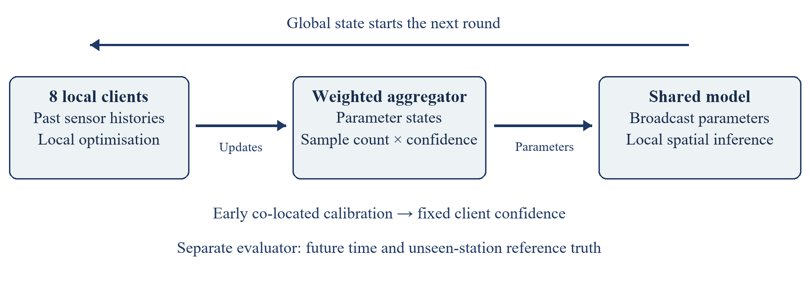

Figure 3. Implemented simulation flow. Eight local clients return parameter states; early co-located calibration supplies confidence weights; aggregation returns the next global state. Reference scoring is separate from training. The diagram describes software logic and does not imply encrypted, independent physical clients.

Training stays client-local at the algorithmic interface, while the public-data simulator and evaluator can access all reference records. The system does not implement secure aggregation or differential privacy. The hosted NumPy graph evaluator uses exported trained parameters; checkpoint-equivalence tests verify that it preserves PyTorch inference within numerical tolerance.

3.4 Experimental setup

Experiments use CPU PyTorch 2.13.0, Python 3.13.7 and seeds 17, 29 and 43. Adam uses learning rate 0.002, batch size up to 128, gradient clipping norm 5 and 12 minibatch steps per client per round, with local optimiser state reset. Centralised training uses the same noisy task and eight times the local step budget. The first 10% of hours are calibration-only, the next 60% training, then 15% validation and 15% test. Test starts 7 November 2024 at 02:00 IST. Windows use six strictly past hours and a three-hour stride. Clean known-station reference validation selects checkpoints for every neural method; its deployment cost is not modelled.

Spatial validation. The original split withholds eight whole stations, one per client. In the added five-fold leave-stations-out cross-validation, folds contain 8, 8, 8, 8 and 4 stations; each of the 36 locations is unseen once per seed. A withheld station is excluded from training labels, validation labels, calibration and donor inputs for its fold. Fifteen fold-seed runs per method are averaged equally, with SD describing fold/seed variability rather than a confidence interval over independent datasets.

Classical baselines. IDW uses inverse squared distance. Ordinary kriging uses exponential spatial covariance, a 0.05 normalised nugget and range selected from 5, 10, 20, 40 and 80 km using early seen-station semivariances. Both receive the same available client-local previous-hour donors as the spatial GNN, not the target’s reading. A previous-value persistence baseline is included for the known-station task.

Privacy attack and threat model. An honest-but-curious aggregator observes individual final-round client updates and tests candidate-window membership. Our named individual-update loss-improvement probe ranks candidates by the decrease in noisy-label squared loss before versus after an update, motivated by loss-based membership inference [21]. Ten percent of training-era eligible windows are reserved as nonmembers and never optimised on. Attack metrics are receiver-operating-characteristic area under the curve (AUC) and maximum true-positive rate minus false-positive rate (advantage). This heuristic is not a literal reproduction of Yeom’s threshold attack; overlapping windows and limited attack strength constrain interpretation.

Input-calibration ablation. For each seen station, early co-located pairs fit a least-squares slope and intercept using only the first 10% of hours. Those coefficients correct later donor inputs and noisy training labels. Reference test truth and withheld stations remain untouched. This is a separate three-seed experiment on the original eight-station holdout, not a five-fold calibration result.

4. Results

All primary comparisons and extensions have executed. We report mean ± sample standard deviation over three seeds for mean absolute error (MAE), root-mean-square error (RMSE) and coefficient of determination (R²). Tables 2–5 distinguish the original station holdout, rotating station folds, input correction and sensor sensitivity. Windows are correlated observations, not independent experimental replications.

4.1 Early findings from data exploration

The retained network has 36 distinct sites, with 28 seen and eight unseen locations in the primary split. For seed 17, the exported audit records 35,463 training windows, 10,081 validation windows, 11,506 known-station test windows, 3,254 unseen-station windows and 3,982 reserved nonmember windows. Figures 1–2 use actual coordinates and valid record counts. Added PM10/NO₂ rows expand contextual analysis; they do not increase primary PM2.5 labels. Beijing remains a reference-grade persistence benchmark, not low-cost field data or cross-city FL.

4.2 Evaluation design and expected outcomes
The proposed outcomes are now evaluated rather than assumed. Table 2 reports all original model families and additional graph aggregators on three seeds. Trust GNN unseen-station RMSE is 99.92 ± 7.05 µg/m³ versus FedAvg 98.11 ± 3.98, a 1.85% increase; the paired Wilcoxon p-value is 0.5. LSTM scores use the target’s own history and cannot be interpreted as unseen-location mapping. The five-fold validation in Table 3 extends the original fixed split.

Table 2. Executed primary comparison, mean ± sample SD over seeds 17, 29 and 43. MAE/RMSE are in µg/m³. “Unseen” excludes whole target locations; “known” scores future hours at fitted locations. GNN/spatial baselines exclude target histories; LSTM and persistence use them.
System / task | MAE ± SD | RMSE ± SD | R² ± SD
Centralised GNN / unseen | 78.02 ± 5.20 | 108.95 ± 9.77 | 0.441 ± 0.103
Centralised GNN / known | 67.52 ± 3.06 | 93.19 ± 5.76 | 0.505 ± 0.060
Equal FL GNN / unseen | 69.58 ± 5.39 | 97.52 ± 4.57 | 0.554 ± 0.042
Equal FL GNN / known | 65.68 ± 2.00 | 93.60 ± 0.45 | 0.502 ± 0.005
FedAvg GNN / unseen | 69.99 ± 4.98 | 98.11 ± 3.98 | 0.548 ± 0.037
FedAvg GNN / known | 65.83 ± 2.00 | 93.71 ± 0.80 | 0.500 ± 0.009
Krum (f = 1) GNN / unseen | 69.86 ± 4.82 | 97.50 ± 4.83 | 0.554 ± 0.044
Krum (f = 1) GNN / known | 67.10 ± 2.40 | 94.85 ± 1.36 | 0.488 ± 0.015
Median GNN / unseen | 69.59 ± 5.93 | 97.53 ± 5.34 | 0.553 ± 0.049
Median GNN / known | 65.75 ± 2.20 | 93.85 ± 0.51 | 0.499 ± 0.006
Update consistency GNN / unseen | 69.59 ± 5.59 | 97.44 ± 4.96 | 0.554 ± 0.045
Update consistency GNN / known | 65.80 ± 2.26 | 93.74 ± 0.94 | 0.500 ± 0.010
Trimmed mean GNN / unseen | 69.66 ± 5.64 | 97.61 ± 4.95 | 0.553 ± 0.045
Trimmed mean GNN / known | 65.73 ± 2.27 | 93.71 ± 0.80 | 0.500 ± 0.009
Trust FL GNN / unseen | 70.87 ± 7.50 | 99.92 ± 7.05 | 0.531 ± 0.066
Trust FL GNN / known | 65.44 ± 1.74 | 94.74 ± 2.18 | 0.489 ± 0.023
Centralised LSTM / known | 46.43 ± 1.58 | 62.92 ± 1.67 | 0.774 ± 0.012
FedAvg LSTM / known | 49.73 ± 1.93 | 69.68 ± 2.77 | 0.722 ± 0.022
Trust FL LSTM / known | 49.52 ± 2.52 | 69.61 ± 4.10 | 0.722 ± 0.032
IDW SPATIAL / unseen | 72.64 ± 6.03 | 100.72 ± 9.02 | 0.522 ± 0.083
IDW SPATIAL / known | 85.00 ± 6.18 | 118.85 ± 2.35 | 0.196 ± 0.032
Ordinary kriging SPATIAL / unseen | 71.52 ± 7.10 | 99.03 ± 9.93 | 0.537 ± 0.089
Ordinary kriging SPATIAL / known | 83.28 ± 6.08 | 116.52 ± 1.99 | 0.227 ± 0.027
Persistence TEMPORAL / known | 60.78 ± 2.43 | 86.17 ± 3.32 | 0.577 ± 0.032

Spatial cross-validation. Table 3 contains the completed five-fold results, with all 36 locations withheld once per seed. Trust GNN obtains MAE 68.01 ± 8.83, RMSE 96.69 ± 11.35 and R² 0.465 ± 0.172, compared with FedAvg RMSE 96.16 ± 12.11. The difference is small relative to fold variability and does not establish a trust-weighting benefit.
Table 3. Future-time unseen-station results over five station folds × three seeds. Means/SDs weight the 15 fold-seed runs equally. Concentration errors are in µg/m³.
System / task | MAE ± SD | RMSE ± SD | R² ± SD
Centralised GNN / unseen | 71.20 ± 9.53 | 99.25 ± 11.35 | 0.434 ± 0.190
FedAvg GNN / unseen | 68.20 ± 9.47 | 96.16 ± 12.11 | 0.466 ± 0.195
Krum (f = 1) GNN / unseen | 68.69 ± 9.12 | 97.22 ± 11.82 | 0.453 ± 0.202
Median GNN / unseen | 68.62 ± 9.50 | 96.75 ± 11.55 | 0.458 ± 0.200
Update consistency GNN / unseen | 68.32 ± 9.32 | 96.19 ± 11.72 | 0.466 ± 0.191
Trimmed mean GNN / unseen | 68.55 ± 9.38 | 96.71 ± 11.70 | 0.459 ± 0.196
Trust FL GNN / unseen | 68.01 ± 8.83 | 96.69 ± 11.35 | 0.465 ± 0.172
IDW SPATIAL / unseen | 81.69 ± 19.24 | 111.07 ± 24.95 | 0.224 ± 0.504
Ordinary kriging SPATIAL / unseen | 80.84 ± 19.19 | 109.80 ± 25.11 | 0.241 ± 0.500
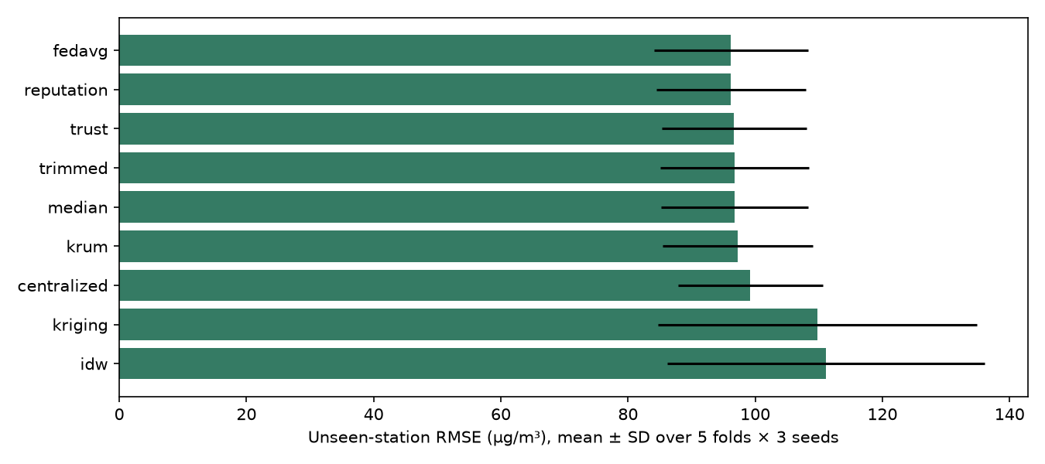
Figure 4. Actual unseen-station RMSE from five station folds and three seeds; error bars are fold-seed SDs, not confidence intervals. Source: results/spatial_cv/summary.csv.
Input correction. Table 4 reports the independent calibration ablation. Trust GNN unseen RMSE decreases from 99.92 ± 7.05 to 78.67 ± 2.02 µg/m³ (21.27%), while corrected FedAvg reaches 78.49 ± 2.05. Corrected trust LSTM reaches 40.93 ± 0.51 at known locations. These results support early input correction under the assumed errors without establishing superiority of trust aggregation.
Table 4. Early input-calibration results on the original fixed holdout, three seeds. Reference targets remain unimputed and unchanged; all errors are in µg/m³.
System / task | MAE ± SD | RMSE ± SD | R² ± SD
Centralised GNN / unseen | 69.12 ± 5.86 | 100.49 ± 9.28 | 0.524 ± 0.086
FedAvg GNN / unseen | 53.68 ± 2.03 | 78.49 ± 2.05 | 0.711 ± 0.015
Trust FL GNN / unseen | 53.79 ± 2.00 | 78.67 ± 2.02 | 0.710 ± 0.015
Centralised LSTM / known | 28.41 ± 1.07 | 42.45 ± 1.19 | 0.897 ± 0.006
FedAvg LSTM / known | 27.26 ± 0.56 | 40.95 ± 0.44 | 0.904 ± 0.002
Trust FL LSTM / known | 27.25 ± 0.60 | 40.93 ± 0.51 | 0.904 ± 0.002
Sensor sensitivity and reputation. Table 5 reports unseen-station scores under the separate Kanpur-relative-noise scenario and the original stress scenario. For relative noise, FedAvg RMSE is 100.29 ± 5.97, temporal reputation 100.38 ± 5.87 and trust FL 101.86 ± 5.36 µg/m³. The temporal reputation stress result is 97.93 ± 4.26. These comparisons do not establish that either history weighting or calibration weighting universally improves accuracy.
Table 5. Sensor-scenario sensitivity over three seeds, unseen-station GNN task. “Relative” denotes the Kanpur-magnitude multiplicative-noise assumption; “stress” denotes the original bias/gain/drift scenario.
System / task | MAE ± SD | RMSE ± SD | R² ± SD
Relative / Centralised | 76.96 ± 6.78 | 113.03 ± 9.54 | 0.399 ± 0.102
Relative / FedAvg | 68.87 ± 3.73 | 100.29 ± 5.97 | 0.528 ± 0.057
Relative / Temporal reputation | 68.93 ± 3.67 | 100.38 ± 5.87 | 0.527 ± 0.056
Relative / Median | 68.17 ± 4.81 | 99.32 ± 7.69 | 0.536 ± 0.073
Relative / Trust FL | 69.96 ± 3.57 | 101.86 ± 5.36 | 0.513 ± 0.051
Stress / Temporal reputation | 69.88 ± 5.08 | 97.93 ± 4.26 | 0.550 ± 0.039
Robustness. The corruption sweep uses actual severe-client shares of 0%, 25%, 37.5% and 62.5%, comparing FedAvg, trust, median and trimmed mean over all three seeds. Severity is fixed while the corrupted share changes. Figure 5 reports the executed spatial errors; Krum’s f = 1 guarantee is not asserted for the larger corruption levels.
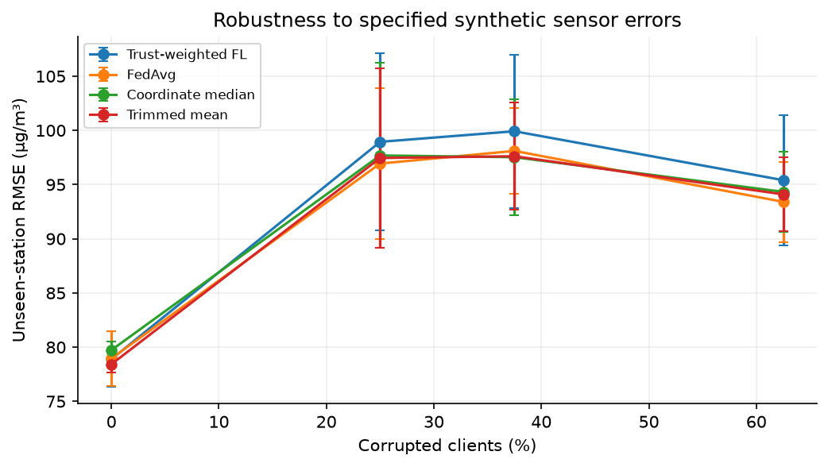
Figure 5. Executed unseen-station error versus actual corrupted-client percentage. Error bars show SD across three seeds. Source: results/robustness.csv. This varies assumed corruption, not observed failure rates of deployed devices.
Privacy and communication. Trust GNN membership AUC is 0.502 ± 0.005 versus FedAvg 0.505 ± 0.004 for the specified probe. AUC near 0.5 indicates near-random ranking for this attack, not a general privacy guarantee. The 1,162-parameter graph model exchanges 743,680 upload bytes plus 743,680 broadcast bytes over eight clients and 20 rounds: 1,487,360 logical float32 bytes (1.49 MB). Protocol, calibration and inference traffic are excluded. The 4.1 MB prepared-window comparator repeats raw readings across histories; no saving over a once-only raw-data upload or measured radio energy is claimed.
Reproducibility and deployed demonstration. GitHub retains source code, dependency versions, model states, split audits and per-run metrics; public-source restoration verifies SHA-256 before extraction. The Vercel site provides the complete interactive dashboard without a login. Its inference-only NumPy implementation is checked against all 12 saved graph checkpoints; the full suite passes 29 tests. Hosted sensor calculations match local values and map predictions agree within 0.001 µg/m³. Static exports include dataset and project ZIPs. Hosting is an evaluation interface rather than evidence of a physical distributed network.

5. Discussion

Calibration confidence can identify the specified synthetic error levels, but update weighting alone does not fix the donor readings used at inference. This explains why trust weighting did not consistently improve the spatial outcome. The independent input-correction ablation improved both trust and FedAvg, while leaving reference test labels unchanged. The evidence supports testing the calibration mechanism rather than claiming that a desirable result was guaranteed.

The comparison addresses more than equal weighting versus trust: median, trimmed mean, Krum, instantaneous update consistency and a temporal reputation baseline are executed. Temporal reputation is explicitly project-defined, rather than a claimed named-paper replication. Literature-anchored relative noise is distinguished from an assumed drift stress test. Three seeds and 36 locations limit statistical power and transfer to a different deployment.

The hosted FastAPI dashboard exposes historical maps, station histories, client confidence, convergence, model comparisons, robustness, privacy, dataset exports and the Simulation Lab. Bias, gain, drift, noise and dropout controls run sensor diagnostics and an early linear correction; they do not retrain FL. At CRRI Mathura Road, the default scenario yields raw RMSE 59.37 and calibrated RMSE 18.09 µg/m³ on 1,213 future paired hours; increasing annual drift from 20 to 80 raises these to 114.05 and 64.11. Zero-error controls yield zero error. These sensor scores are separate from model scores in Tables 2–5.

Limitations include one Delhi year, a small station network, synthetic sensor faults without paired Delhi hardware calibration, no humidity covariates, clean-reference checkpoint selection and retrospectively chosen coverage. Geographic strips are simulated ownership, not protected organisations. Beijing tests persistence only. Station folds share observations and cannot establish independent deployment replication. Near-chance attack AUC, logical payload counts and an unmasked coordinate surface establish no formal privacy, network saving or street-level field accuracy.

6. Conclusion

We completed a reproducible trust-weighted FL simulation, expanded and documented the public datasets, executed all proposed model families and extended validation to five station folds over three seeds. On unseen locations, trust GNN RMSE was 96.69 ± 11.35 µg/m³ and FedAvg RMSE was 96.16 ± 12.11. Trust superiority is not established.

Early input correction reduced trust-model RMSE by 21.27% in the separate original-holdout ablation. Co-located confidence, robust and reputation comparators, literature-anchored sensor sensitivity, named privacy measurement and real-data figures make the calibration hypothesis testable. The source data, checkpoints, results and hosted simulation are available for evaluation.

Future work should collect paired low-cost/reference measurements, model humidity and temporally correlated errors, refresh calibration across seasons, evaluate additional cities/years, and test stronger attacks and privacy protocols. Physical sensor deployment, formal privacy and publication acceptance remain outside the completed evidence. The current manuscript has not been submitted to a venue; no submission or acceptance is claimed.

Declarations
Acknowledgements. The authors thank Dr. Kalaavathi B, faculty for Design of Smart Cities (BCSE316L), for her guidance and review feedback.
Funding. This research received no specific grant from any funding agency.
Conflict of interest. The authors declare no conflict of interest.
Data availability. Delhi reference observations are attributed to CPCB CAAQM and India Air Quality Database, XKDR Forum [17]; Beijing data are attributed to Song Chen/UCI [18]. Both compilations use CC BY 4.0. Cleaning and synthetic modifications are disclosed. Raw sources, processed samples, exact split audits, checksums, checkpoints and per-run measurements are supplied in the separate dataset and project archives. Code: https://github.com/rizzit17/airtrust. Public simulation: https://airtrust.vercel.app.
Author contributions. Conceptualisation, methodology, investigation and writing: R.C., S.V., J.S. and A.N. The authors are responsible for reviewing the code, analysis and manuscript. Generative AI assisted development, debugging, dataset discovery, drafting and interface design. All report plots are drawn from source data or executed results; Figure 3 is a programmatic architecture diagram. No image generator or invented experimental measurement is used.

References
[1] Abimannan, S., El-Alfy, E.-S.M., Hussain, S., Chang, Y.-S., Shukla, S., Satheesh, D., Breslin, J.G. (2023). Towards federated learning and multi-access edge computing for air quality monitoring: literature review and assessment. Sustainability, 15(18): 13951. https://doi.org/10.3390/su151813951
[2] Alwabli, A. (2024). Federated learning for privacy-preserving air quality forecasting using IoT sensors. Engineering, Technology & Applied Science Research, 14(4): 16069-16076. https://doi.org/10.48084/etasr.7820
[3] Hu, Y., Cao, N., Guo, W., Chen, M., Rong, Y., Lu, H. (2024). FedDeep: a federated deep learning network for edge assisted multi-urban PM2.5 forecasting. Applied Sciences, 14(5): 1979. https://doi.org/10.3390/app14051979
[4] Beriwal, S., Ayeelyan, J. (2025). Decoding pollution: a federated learning-based pollution prediction study with health ramifications using causal inferences. Electronics, 14(2): 350. https://doi.org/10.3390/electronics14020350
[5] Putra, K.T., Chen, H.-C., Prayitno, Ogiela, M.R., Chou, C.-L., Weng, C.-E., Shae, Z.-Y. (2021). Federated compressed learning edge computing framework with ensuring data privacy for PM2.5 prediction in smart city sensing applications. Sensors, 21(13): 4586. https://doi.org/10.3390/s21134586
[6] Feng, Y. (2024). Application of a federated learning model with incentive mechanism in air prediction. In Proceedings of the 4th International Conference on Big Data, Artificial Intelligence and Risk Management (ICBAR 2024), Chengdu, China. ACM. https://doi.org/10.1145/3718751.3718873
[7] Nguyen, V.-D., Sharma, S.K., Vu, T.X., Chatzinotas, S., Ottersten, B. (2021). Efficient federated learning algorithm for resource allocation in wireless IoT networks. IEEE Internet of Things Journal, 8(5): 3394-3409. https://doi.org/10.1109/JIOT.2020.3022534
[8] Ye, M., Fang, X., Du, B., Yuen, P.C., and Tao, D. (2023). Heterogeneous Federated Learning: State-of-the-art and Research Challenges. ACM Computing Surveys. https://doi.org/10.1145/3625558.
[9] Khan, K. (2025). Sign-entropy regularization for personalized federated learning. Entropy, 27(6): 601. https://doi.org/10.3390/e27060601
[10] Khan, K. (2025). FedEmerge: an entropy-guided federated learning method for sensor networks and edge intelligence. Sensors, 25(12): 3728. https://doi.org/10.3390/s25123728
[11] Cavaliere, A., Brilli, L., Andreini, B.P., Carotenuto, F., Gioli, B., Giordano, T., Stefanelli, M., Vagnoli, C., Zaldei, A., Gualtieri, G. (2023). Development of low-cost air quality stations for next-generation monitoring networks: calibration and validation of NO2 and O3 sensors. Atmospheric Measurement Techniques, 16(20): 4723-4740. https://doi.org/10.5194/amt-16-4723-2023
[12] Jin, X.-B., Wang, Z.-Y., Kong, J.-L., Bai, Y.-T., Su, T.-L., Ma, H.-J., Chakrabarti, P. (2023). Deep spatio-temporal graph network with self-optimization for air quality prediction. Entropy, 25(2): 247. https://doi.org/10.3390/e25020247
[13] Mishra, R., and Gupta, H.P. (2023). A Model Personalization-based Federated Learning Approach for Heterogeneous Participants with Variability in the Dataset. ACM Transactions on Sensor Networks. https://doi.org/10.1145/3629978.
[14] Ma, X., Zhang, J., Guo, S., Xu, W. (2022). Layer-wised model aggregation for personalized federated learning. In Proceedings of the IEEE/CVF Conference on Computer Vision and Pattern Recognition (CVPR), pp. 10092-10101.
[15] Ramadan, M.N.A., Ali, M.A.H., Jaber, H., and Alkhedher, M. (2025). Blockchain-secured IoT-federated learning for industrial air pollution monitoring: A mechanistic approach to exposure prediction and environmental safety. Ecotoxicology and Environmental Safety. https://doi.org/10.1016/j.ecoenv.2025.118442.
[16] Zheng, T., et al. (2018). Field evaluation of low-cost particulate matter sensors in high- and low-concentration environments. Atmospheric Measurement Techniques, 11, 4823–4846. https://doi.org/10.5194/amt-11-4823-2018.
[17] India Air Quality Database, XKDR Forum. CPCB CAAQM source observations and station metadata, Delhi 2024 snapshot. https://github.com/xKDR/Air-Quality-Database. Compilation licence: CC BY 4.0.
[18] Chen, S. (2017). Beijing Multi-Site Air Quality [Dataset]. UCI Machine Learning Repository. https://doi.org/10.24432/C5RK5G. CC BY 4.0.
[19] Yin, D., Chen, Y., Kannan, R., and Bartlett, P. (2018). Byzantine-Robust Distributed Learning: Towards Optimal Statistical Rates. ICML, PMLR 80, 5650–5659. https://proceedings.mlr.press/v80/yin18a.html.
[20] Blanchard, P., El Mhamdi, E.M., Guerraoui, R., and Stainer, J. (2017). Machine Learning with Adversaries: Byzantine Tolerant Gradient Descent. Advances in Neural Information Processing Systems, 30. https://arxiv.org/abs/1703.02757.
[21] Yeom, S., Giacomelli, I., Fredrikson, M., and Jha, S. (2018). Privacy Risk in Machine Learning: Analyzing the Connection to Overfitting. IEEE Computer Security Foundations Symposium. https://arxiv.org/abs/1709.01604.
[22] Wu, J., et al. (2024). Topology-aware Federated Learning in Edge Computing: A Comprehensive Survey. ACM Computing Surveys. https://doi.org/10.1145/3659205.
[23] Mengistu, T.M., Kim, T., and Lin, J.-W. (2024). A Survey on Heterogeneity Taxonomy, Security and Privacy Preservation in the Integration of IoT, Wireless Sensor Networks and Federated Learning. Sensors, 24, 968. https://doi.org/10.3390/s24030968.
[24] Liu, F., Zheng, Z., Shi, Y., Tong, Y., and Zhang, Y. (2024). A survey on federated learning: a perspective from multi-party computation. Frontiers of Computer Science. https://doi.org/10.1007/s11704-023-3282-7.
[25] Neo, E.X., et al. (2022). Towards Integrated Air Pollution Monitoring and Health Impact Assessment Using Federated Learning: A Systematic Review. Frontiers in Public Health, 10, 851553. https://doi.org/10.3389/fpubh.2022.851553.
[26] Le, D.-D., et al. (2022). Insights into Multi-Model Federated Learning: An Advanced Approach for Air Quality Index Forecasting. Algorithms, 15, 434. https://doi.org/10.3390/a15110434.
[27] Kim, H., Dorjgochoo, S., Park, H., and Lee, S. (2025). Personalized Federated Transfer Learning for Building Energy Forecasting via Model Ensemble with Multi-Level Masking in Heterogeneous Sensing Environment. Electronics, 14, 1790. https://doi.org/10.3390/electronics14091790.
[28] Zakzouk, S., and Said, L.A. (2025). Federated Learning for Soil Moisture Prediction: Benchmarking Lightweight CNNs and Robustness in Distributed Agricultural IoT Networks. Machine Learning and Knowledge Extraction, 7, 132. https://doi.org/10.3390/make7040132.
[29] Akram, J., et al. (2025). Privacy-Preserving Spatial Crowdsourcing Drone Services for Postdisaster Infrastructure Monitoring: A Conditional Federated Learning Approach. IEEE JSTARS, 18. https://doi.org/10.1109/JSTARS.2025.3577648.
[30] Moursi, A.S., El-Fishawy, N., Djahel, S., and Shouman, M.A. (2021). An IoT enabled system for enhanced air quality monitoring and prediction on the edge. Complex & Intelligent Systems, 7, 2923–2947. https://doi.org/10.1007/s40747-021-00476-w.
[31] Chen, L., et al. (2025). Wireless federated learning for salt-spray prediction in industrial IoT networks with delay constraint. Scientific Reports. https://doi.org/10.1038/s41598-025-28569-3.
[32] Shawkat, M., Ali, Z.H., Salem, M., and El-desoky, A. (2025). A robust and personalized privacy-preserving approach for adaptive clustered federated distillation. Scientific Reports. https://doi.org/10.1038/s41598-025-96468-8.
[33] Rentero-Trejo, R., et al. (2021). Using Federated Learning to Achieve Proactive Context-Aware IoT Environments. Journal of Web Engineering. https://doi.org/10.13052/jwe1540-9589.2113.

