PROJECT REPORT
BCSE316L – Design of Smart Cities · Course Project (DA-1) · IMRaD format
Trust-Weighted Federated Learning for Privacy-Preserving City-Wide Air Pollution Mapping in Delhi
Rishit Chaudhary (23BCT0157)^{1,*}, Siddharth Verma (23BCT0159)¹, Jashan Sahasrabudhe (23BCT0022)¹, Adarsh Narayan (23BCT0155)¹
¹ School of Computer Science and Engineering, Vellore Institute of Technology, Vellore, 632014, India
* Corresponding author: rishit.chaudhary2023@vitstudent.ac.in
Team 10 · Project 9 · Case city: Delhi, India
Abstract
Sensor owners can collaborate on air-quality prediction through federated learning (FL), but differences in calibration quality may affect the shared model. We implemented a single-machine simulation using real Delhi reference observations and explicitly simulated low-cost sensor errors.
The retained dataset contains 300,355 valid hourly PM2.5 observations at 36 distinct Delhi monitoring locations in 2024. Eight geographic clients train a spatial graph neural network (GNN) or a temporal long short-term memory (LSTM) model. We compare trust weighting with standard FedAvg, equal averaging, robust aggregation, centralized training, ordinary kriging and inverse distance weighting (IDW), using three random seeds.
At eight entirely unseen stations in the future test period, trust-weighted graph FL obtained root-mean-square error (RMSE) 99.92 ± 7.05 µg/m³, compared with 98.11 ± 3.98 for FedAvg. Trust weighting therefore did not improve this primary outcome. A limited update-based membership probe produced near-chance ranking, which does not establish a privacy guarantee. The results document the implemented system and its limitations rather than an expected accuracy gain.
Keywords: federated learning; low-cost sensor simulation; sensor calibration; data privacy; spatio-temporal prediction; kriging; smart cities

1. Introduction
Urban pollution monitoring requires spatially distributed observations. Delhi has reference monitors operated through the Central Pollution Control Board (CPCB) network, including the Delhi Pollution Control Committee (DPCC). Such monitors provide a basis for evaluating prediction at locations withheld from training. Figure 1 uses actual monitoring coordinates rather than a schematic coverage claim.
Prior work studies federated air-quality prediction [1–5], sensor calibration [11] and graph-based pollution prediction [12]. Our implemented experiment tests calibration-aware aggregation under controlled sensor errors. It does not establish that public low-cost sensors already provide dense Delhi coverage.
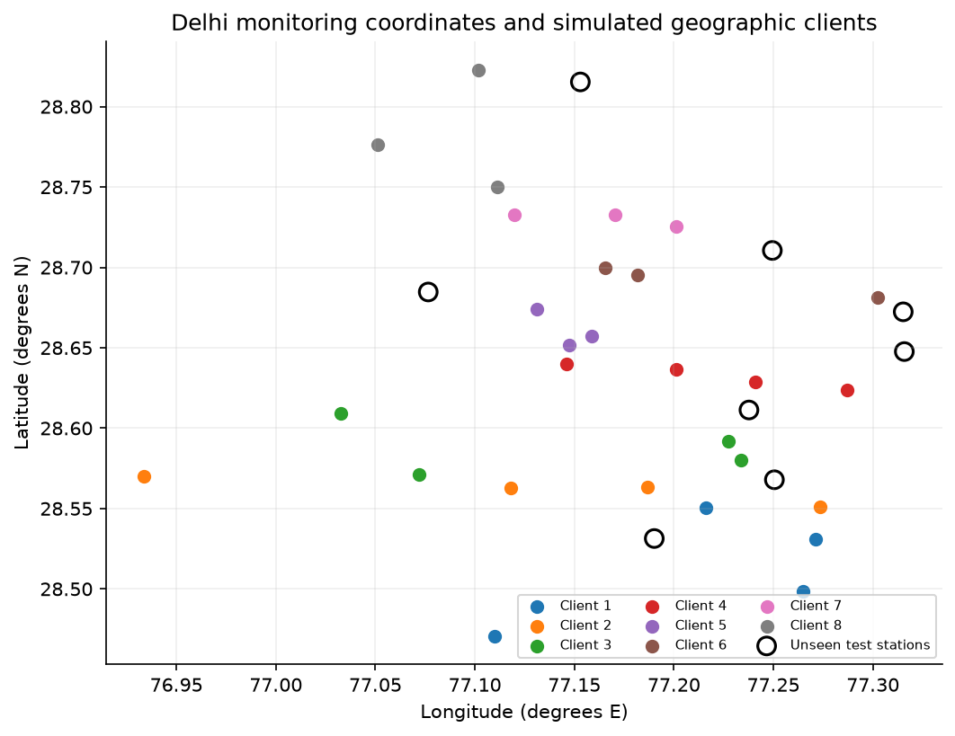
Figure 1. Actual coordinates of 36 retained Delhi monitoring locations, grouped into eight simulated geographic clients. Open circles identify eight locations excluded from fitting, calibration and donor inputs. Administrative boundaries and unsensed-area accuracy are not inferred from this plot.
Low-cost sensor readings can vary with device response, environment and calibration. If clients contribute differently biased observations, sample-weighted aggregation need not yield an unbiased shared predictor. Conversely, reducing a client’s update weight does not directly recalibrate its inputs.
Our objective is to evaluate whether co-location-based calibration confidence improves a shared pollution predictor under specified heterogeneous sensor errors, while avoiding raw-record inputs to the aggregation function.
The implemented contributions are:
• A calibration-weighted aggregation implementation, using a separate co-located calibration prefix and a confidence floor.
• A reproducible Delhi simulation with temporal and spatial prediction tasks, three seeds, centralized and geostatistical comparisons, and robust-aggregation baselines.
• An explicit individual-update membership probe, communication-payload accounting, data-derived figures and a local model-driven visualization.
The federation is simulated in one Python process. The simulator and evaluator load public reference data, while the aggregator accepts parameter states and scalar weights. There are no physical sensor deployments, independent client security boundaries, secure aggregation or formal differential-privacy guarantees. The local dashboard is an added demonstration interface.

2. Literature Review

2.1 Sensor calibration and spatio-temporal pollution prediction
Sensor-calibration studies demonstrate that environmental conditions and instrument response influence low-cost measurements [11]. Zheng et al. [16] evaluated Plantower PMS3003 sensors against reference instruments in environments including Kanpur, emphasizing calibration and relative humidity. This motivates a calibration study, but does not validate our chosen synthetic drift parameters.
Spatial prediction also requires information from other monitoring locations. Jin et al. [12] studied graph-based pollution prediction. Our smaller inductive star-graph model uses donor histories and relative coordinates; it is not a reproduction of their architecture. The separate LSTM requires a target station’s own history and cannot establish prediction at an unsensed location.

2.2 Federated learning for air-quality monitoring
Federated air-quality studies [1–5] motivate distributed learning across heterogeneous sites. Their reported tasks and metrics differ from the present one-hour-ahead spatial task, so their headline numbers are not directly comparable with our measured regression errors.
Incentive and resource-allocation work [6,7] addresses additional aspects of federation. We do not claim to reproduce an incentive-based malicious-client elimination mechanism. Industrial pollution work [15] provides related context; it does not validate this single-machine deployment.

2.3 Clustered, personalised and privacy-aware federated learning
Client distributions are not independent and identically distributed (non-IID) because locations and simulated instrument errors differ. Clustered and personalized approaches [8–10,13,14] motivate alternatives, but they do not by themselves demonstrate calibration-aware reliability. We distinguish our implemented update-consistency heuristic from a reproduction of a published reputation mechanism.
Model updates may expose information even when raw records are not uploaded. We therefore name the attacker, candidate-window score and evaluation metrics explicitly in Section 3.4, with membership-inference work [20] as motivation.

2.4 Research gap
Table 1 summarizes representative related approaches. We examine the combination of calibration-aware weighting, target-excluding spatial prediction and empirical update leakage in one controlled experiment. This comparison does not establish that no prior work anywhere has studied such a combination.

Table 1. Comparison of related work and the gap addressed by this study.
Study | Approach | Dataset / setting | Limitation
Jin et al., 2023 [12] | GraphSAGE + BGraphGRU | Beijing PM2.5 | Centralised training; assumes data can be pooled
Hu et al., 2024 [3] | FedDeep + ESTNet (federated) | 13 Jiangsu cities, PM2.5 | No weighting by sensor calibration quality
Beriwal & Ayeelyan, 2025 [4] | FL with VGG-19 and causal inference | India, Nepal, China | Clients treated as equally reliable
Putra et al., 2021 [5] | Federated compressed learning | PM2.5, smart-city sensing | Focus on data reduction, not sensor quality
Matsuda et al., 2024 [8] | Benchmark of personalised FL | Vision and NLP tasks | Not applied to sensor calibration
This work | Trust-weighted FL (LSTM / GNN) | Delhi CPCB reference observations; simulated low-cost errors | Five spatial folds; assumed sensor errors; no certified privacy

3. Methodology

3.1 Problem formulation
Let K=8 simulated geographic clients hold noisy local training records. Client k has n_k eligible training windows and local squared-error loss F_k(w). The goal is to learn shared parameters w from model updates. PM2.5 denotes particulate matter with aerodynamic diameter at most 2.5 µm. The federated objective is
min_{w} F(w) = Σ_{k=1}^{K} p_{k} F_{k}(w), F_{k}(w) = (1/n_{k}) Σ_{i∈k} ℓ( f(x_{i}; w), y_{i} ) (1)
where x_i contains strictly past sensor histories and permitted spatial/time features, y_i is a simulated noisy training target, and f is the prediction model. Clean reference targets are used separately for calibration, validation checkpoint selection and final evaluation; held-out stations are excluded from the first two uses.

3.2 Data / materials
The primary data are 317,627 hourly Delhi PM2.5 source rows from 39 station catalog entries during 2024, downloaded from India Air Quality Database, XKDR Forum, using CPCB observations [17]. After coverage and co-location checks, 300,355 valid observations remain at 36 distinct locations. The compilation is CC BY 4.0. The UCI Beijing Multi-Site Air Quality archive [18] contains 420,768 station-hour rows from 12 reference sites during 2013–2017 and is also CC BY 4.0. It supports a separate persistence benchmark, not a second federated evaluation. OpenAQ and sensor.community are not used in the measured experiments; neither is claimed to supply Delhi low-cost coverage.
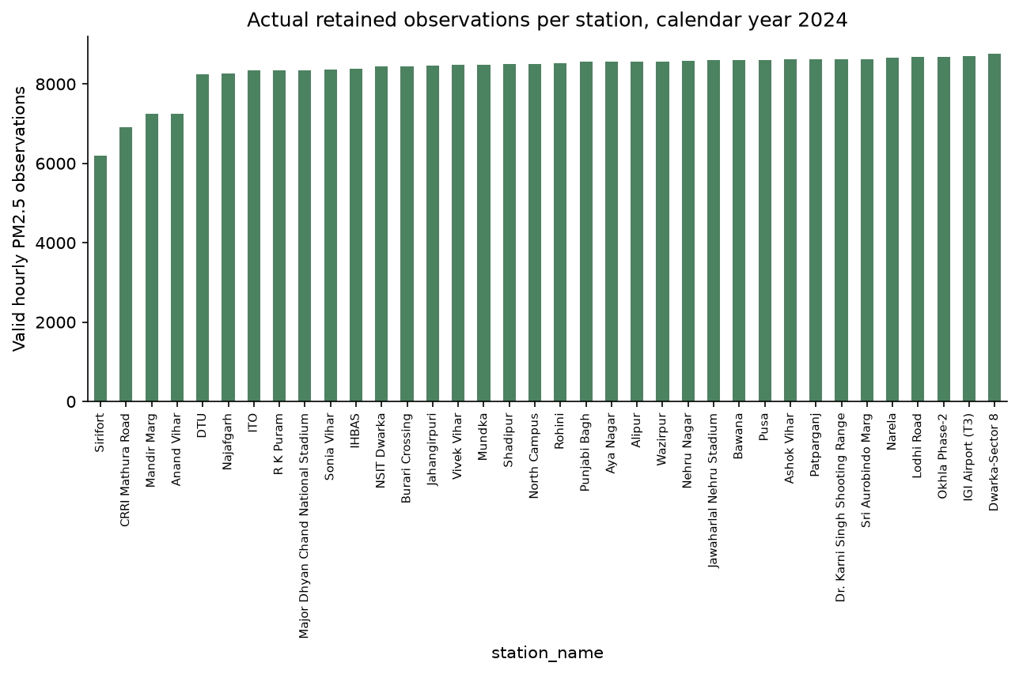
Figure 2. Actual valid PM2.5 record counts at each retained Delhi station during 2024. The bars sum to 300,355 observations; missing reference values are not filled. Source response chunks and nested archives are duplicate representations, not additional independent observations.
Delhi timestamps are aligned to 8,784 local hours. Negative and above-2,000 µg/m³ values are excluded; stations require 70% valid coverage. Catalog entries within 50 m are consolidated by retaining the more complete entry. Input histories are forward-filled for at most three hours; reference labels remain unimputed. Fixed scaling divides concentrations by 100 and relative coordinates in kilometers by 50. Full-year availability is used to construct the benchmark network, which is a limitation for prospective evaluation.

Sensor-error model and parameter provenance
Virtual PM2.5 = max(0, gain × reference + bias + drift × elapsed-year fraction + Gaussian noise). Mild clients use gain 1.02, bias 1.5 µg/m³, annual drift 2 µg/m³, noise SD 3 µg/m³ and 1% dropout. Severe clients use gain 1.25, bias 35 µg/m³, annual drift 30 µg/m³, noise SD 12 µg/m³, 4% dropout and 12 randomly placed six-hour stuck blocks. A stuck block repeats the preceding value. Seeds determine corruption identities and errors. These coefficients are transparent stress-test assumptions, not coefficients reported by Zheng et al. [16]. That field study motivates environmental calibration; reproducing its calibrated humidity-dependent response is still outstanding.

3.3 Proposed approach
One training round broadcasts a global parameter state to each client, performs local optimization and aggregates returned states. Calibration uses only seen locations and a separate prefix, so no nearest-station spatial gradient enters the trust residual.
Local training. The spatial GNN uses up to three other seen stations in the same client: six past PM2.5 values plus relative x/y coordinates per donor, shared 8→24→16 messages, attention pooling and cyclic time features. A residual head predicts the next hourly target. Two donors are padded by repeating the last donor. The LSTM has 16 hidden units and uses six past values from its own target station; it is evaluated only at known locations.
Calibration confidence. Each virtual sensor is at its reference monitor’s exact coordinates. Client RMSE is calculated over valid virtual/reference pairs at seen stations during the first 10% of hours. The confidence is fixed for a run:
c_{k}^{t} = max( exp( −RMSE_{k}^{t} / τ ), c_{min} ) (2)
where RMSE_k is the co-located calibration residual in µg/m³, τ=35 µg/m³ and c_min=0.05. These are fixed scenario settings, not test-tuned estimates or instrument specifications. Held-out stations contribute no calibration data.
Quality-weighted aggregation. Normalize each client’s training count multiplied by its calibration confidence:
α_{k}^{t} = n_{k} c_{k}^{t} / Σ_{j=1}^{K} n_{j} c_{j}^{t}, w^{t+1} = Σ_{k=1}^{K} α_{k}^{t} w_{k}^{t+1} (3)
where w_k is the locally updated parameter state. Setting every confidence to one gives sample-weighted FedAvg. Equal averaging is a separate ablation. Additional graph comparators are coordinate median, one-tail-per-side trimmed mean, Krum with assumed f=1, and a sample-weighted inverse-distance-to-median-update consistency heuristic [19]. The heuristic is an explicit reputation-style comparator, not a replication of an established reputation algorithm.
Iteration and mapping. Train for 20 rounds and select the checkpoint with the lowest clean known-station validation RMSE. For a query coordinate, a local client applies the saved graph model to donor histories. Grid locations have no reference truth; the surface is a demonstration, not evidence of street-level accuracy.
Client-local histories → local optimization → model parameter states
Co-located calibration prefix → confidence scores → weighted aggregator
Shared checkpoint → client-local spatial predictions → held-out evaluation
Figure 3. Implemented data flow: local sensor histories produce client model updates; co-located calibration produces scalar confidence scores; aggregation returns shared parameters. Clean held-out references are available only to the evaluator. The blocks describe a single-machine simulation rather than protected independent organizations.
The aggregation interface receives model parameters and scalar weights, not raw training records. The simulator/evaluator can access public data. The claimed separation is algorithmic, not an implemented cryptographic or operating-system security guarantee.

3.4 Experimental setup
Experiments use CPU PyTorch 2.13.0, Python 3.13.7 and seeds 17, 29 and 43. Adam uses learning rate 0.002, batches up to 128, gradient clipping norm 5 and 12 steps per client per round; optimizer state resets each local call. Centralized training uses the same noisy features/labels and eight times the per-client step count per round. The first 10% of hours are calibration-only; training targets occupy 10–70%, validation 70–85%, and test 85–100%. Test starts 7 November 2024 at 02:00 IST. Samples use six strictly past hours at a three-hour stride. Eight entire stations, one per client, are excluded from fitting, validation, calibration and donor inputs. The primary table retains this fixed holdout. An additional five-fold station cross-validation rotates through all 36 locations over three seeds, excluding each fold from training, validation, calibration and donors. Appendix A reports the completed evaluation. IDW uses inverse squared distance. Ordinary kriging uses exponential covariance, a 0.05 normalized nugget and range selected from 5–80 km using calibration-period semivariances; both use the same previous-hour local donor set as the graph task.
Privacy protocol. The honest-but-curious aggregator sees each final-round individual client update. It ranks candidate windows by the decrease in noisy-label squared loss from before to after that update. Ten percent of eligible training-era windows are reserved as nonmembers and never optimized on. AUC and maximum true-positive minus false-positive rate (advantage) summarize this loss-improvement membership heuristic [20]. It is not a literal reproduction of a fixed-threshold attack. Correlated overlapping histories, limited attack strength and threshold selection limit interpretation; there is no differential-privacy guarantee.

4. Results
All primary comparisons have been executed across three seeds. We report mean ± sample standard deviation for mean absolute error (MAE), RMSE and coefficient of determination (R²). Table 2 distinguishes known-station forecasting from entirely unseen-station prediction. Results are computed from unimputed reference targets.

4.1 Dataset and sensor-error diagnostics
The real network has 36 retained locations, 28 available for fitting and eight entirely unseen. Seed 17 contains 35,463 training windows, 10,081 validation windows, 11,506 known-station test windows, 3,254 unseen-station windows and 3,982 reserved training-era nonmember windows. In the primary scenario three of eight clients have severe synthetic errors. These are derived simulations of real reference data, not independent low-cost observations.

4.2 Model comparisons and robustness
Table 2 gives actual results for the proposed and baseline systems. The graph and geostatistical tasks exclude the target’s own history; LSTM and persistence use it. The LSTM therefore has a different information set and is not assigned an unseen-station score. On the spatial test, trust weighting has RMSE 99.92 ± 7.05 µg/m³ versus 98.11 ± 3.98 for FedAvg, a 1.85% increase. The paired seed-level Wilcoxon p-value is 0.5; three seeds have limited statistical power.
Table 2. Measured prediction errors across three seeds. MAE and RMSE are in µg/m³; entries are mean ± sample standard deviation. “Known” denotes future targets at fitted locations; “unseen” denotes future targets at entirely excluded locations. LSTM is not applicable to unseen locations.
System / task | MAE ± SD | RMSE ± SD | R² ± SD
Centralized graph / unseen | 78.02 ± 5.20 | 108.95 ± 9.77 | 0.441 ± 0.103
Centralized graph / known | 67.52 ± 3.06 | 93.19 ± 5.76 | 0.505 ± 0.060
Equal FL graph / unseen | 69.58 ± 5.39 | 97.52 ± 4.57 | 0.554 ± 0.042
Equal FL graph / known | 65.68 ± 2.00 | 93.60 ± 0.45 | 0.502 ± 0.005
FedAvg graph / unseen | 69.99 ± 4.98 | 98.11 ± 3.98 | 0.548 ± 0.037
FedAvg graph / known | 65.83 ± 2.00 | 93.71 ± 0.80 | 0.500 ± 0.009
Krum (f=1) graph / unseen | 69.86 ± 4.82 | 97.50 ± 4.83 | 0.554 ± 0.044
Krum (f=1) graph / known | 67.10 ± 2.40 | 94.85 ± 1.36 | 0.488 ± 0.015
Median graph / unseen | 69.59 ± 5.93 | 97.53 ± 5.34 | 0.553 ± 0.049
Median graph / known | 65.75 ± 2.20 | 93.85 ± 0.51 | 0.499 ± 0.006
Update consistency graph / unseen | 69.59 ± 5.59 | 97.44 ± 4.96 | 0.554 ± 0.045
Update consistency graph / known | 65.80 ± 2.26 | 93.74 ± 0.94 | 0.500 ± 0.010
Trimmed mean graph / unseen | 69.66 ± 5.64 | 97.61 ± 4.95 | 0.553 ± 0.045
Trimmed mean graph / known | 65.73 ± 2.27 | 93.71 ± 0.80 | 0.500 ± 0.009
Trust FL graph / unseen | 70.87 ± 7.50 | 99.92 ± 7.05 | 0.531 ± 0.066
Trust FL graph / known | 65.44 ± 1.74 | 94.74 ± 2.18 | 0.489 ± 0.023
Centralized lstm / known | 46.43 ± 1.58 | 62.92 ± 1.67 | 0.774 ± 0.012
FedAvg lstm / known | 49.73 ± 1.93 | 69.68 ± 2.77 | 0.722 ± 0.022
Trust FL lstm / known | 49.52 ± 2.52 | 69.61 ± 4.10 | 0.722 ± 0.032
IDW spatial / unseen | 72.64 ± 6.03 | 100.72 ± 9.02 | 0.522 ± 0.083
IDW spatial / known | 85.00 ± 6.18 | 118.85 ± 2.35 | 0.196 ± 0.032
Ordinary kriging spatial / unseen | 71.52 ± 7.10 | 99.03 ± 9.93 | 0.537 ± 0.089
Ordinary kriging spatial / known | 83.28 ± 6.08 | 116.52 ± 1.99 | 0.227 ± 0.027
Persistence temporal / known | 60.78 ± 2.43 | 86.17 ± 3.32 | 0.577 ± 0.032

4.3 Privacy and spatial diagnostics
For graph trust FL the mean membership AUC is approximately 0.502 (sample SD 0.005), versus approximately 0.505 (SD 0.004) for FedAvg. Both are near chance for this probe. Detailed AUC and advantage values are retained in results/privacy.csv. The attack uses final-round local updates; prediction metrics use the validation-selected global checkpoint.
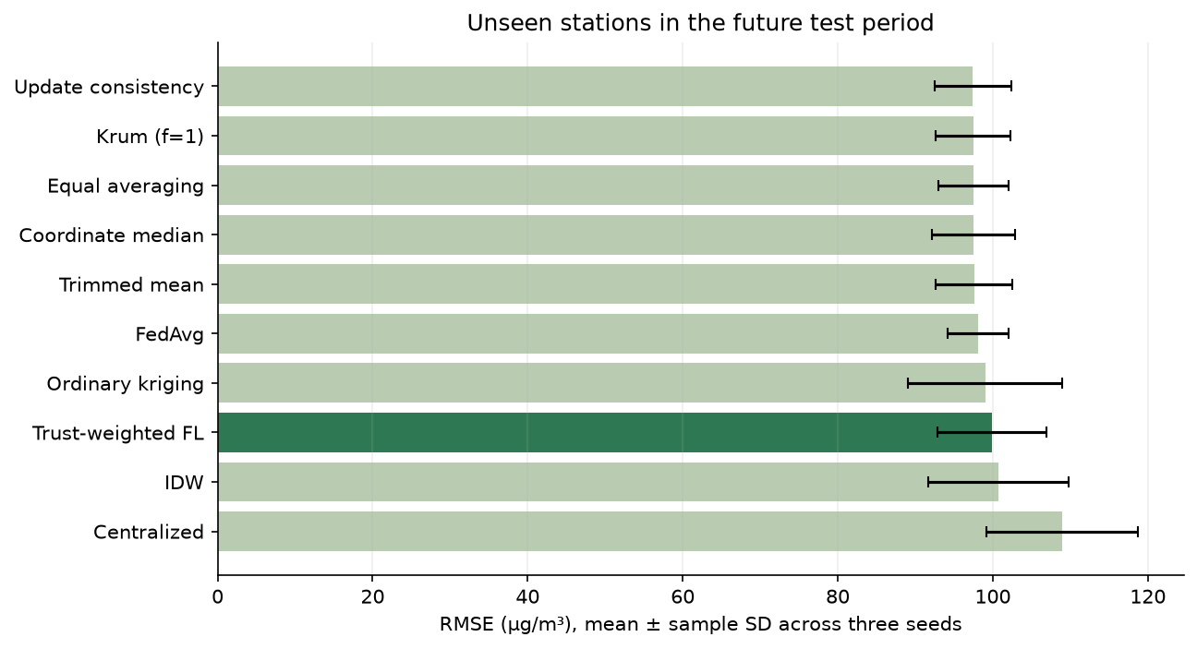
Figure 4. Unseen-station RMSE across methods; error bars show sample SD across three simulation seeds.
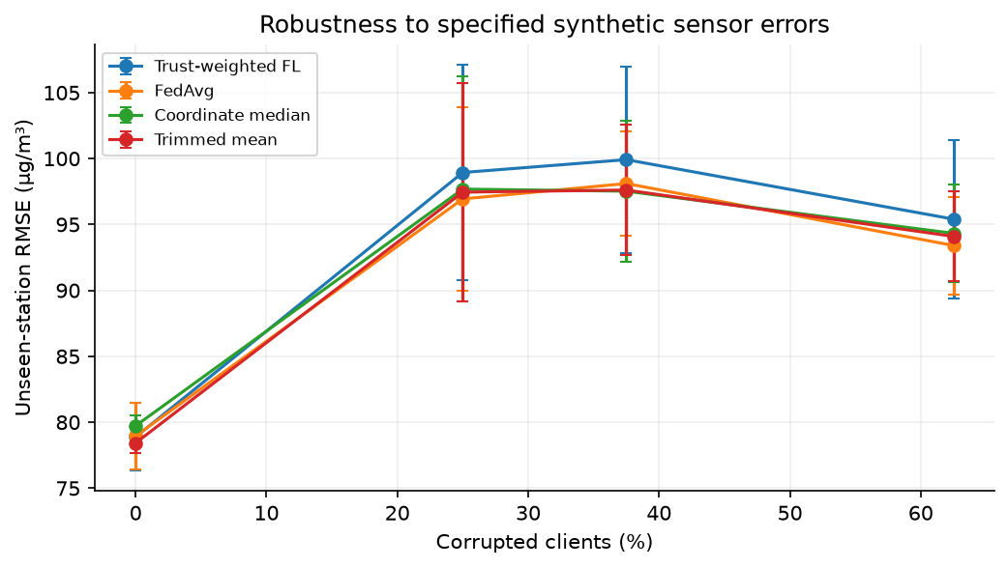
Figure 5. Unseen-station robustness as the actual share of severely corrupted clients changes; error bars summarize three seeds.

5. Discussion
Calibration confidence distinguishes our synthetic mild and severe errors, but aggregation weights alone do not remove biased donor inputs. A client may receive a better global model while still generating predictions from its own biased sensors. Initial winter calibration can also become stale as synthetic drift grows and seasonal conditions change. The observed lack of spatial improvement is therefore a relevant result rather than a reason to omit the baseline.
Robustness experiments vary the actual corrupted-client share across 0%, 25%, 37.5% and 62.5%, comparing FedAvg, trust weighting, median and trimmed mean over all three seeds. Error severity is held fixed. Krum is included in the primary comparison, but its theoretical Byzantine guarantee does not cover the actual three-of-eight corruption; its result is empirical only. A temporal reputation comparator additionally smooths update agreement across rounds; its formula and results are given in Appendix A. It is project-defined rather than a named-paper reproduction.
The graph network contains 1,162 float32 parameters. Twenty rounds across eight clients imply 0.744 MB of logical uploads and 1.487 MB including broadcasts per run, excluding protocol, calibration and inference overhead. These are tensor-payload counts rather than measured network traffic. The prepared graph training-tensor comparator is approximately 4.1 MB, including repeated window features; it is not the size of a once-only upload of unique raw readings.
Limitations include one Delhi year, a small station network, small donor groups, synthetic error coefficients without paired hardware validation, no humidity inputs, clean-reference checkpoint selection and no independently isolated clients. Beijing is only a separate persistence check. No formal privacy, bandwidth advantage, city-boundary coverage or street-level accuracy is established. Five-fold station cross-validation is now complete. A separate Kanpur relative-error sensitivity study and early input-calibration ablation are reported in Appendix A. Field validation remains necessary.

6. Conclusion
We implemented an end-to-end federated pollution-prediction simulation, measured centralized, geostatistical and federated comparisons, and exported reproducible datasets and figures. Trust-weighted graph FL did not improve unseen-station RMSE in the primary experiment: 99.92 µg/m³ versus FedAvg’s 98.11 µg/m³.
The contribution is a testable calibration-weighting experiment and evidence of its limits. A near-chance score for the specified membership probe does not demonstrate privacy against other attacks. Real reference observations and clearly labeled virtual sensor errors must remain distinct in interpreting the results.
The extended evaluation now includes early input correction, five rotating station folds and literature-anchored relative-error sensitivity (Appendix A). Future work should obtain paired low-cost/reference hardware measurements and meteorology, test seasonal calibration refresh and additional years, and evaluate stronger privacy attacks and secure aggregation.

Declarations
Acknowledgements. The authors thank the faculty of the Design of Smart Cities (BCSE316L) course, Dr. Kalaavathi B for her guidance and feedback.
Funding. This research received no specific grant from any funding agency.
Conflict of interest. The authors declare no conflict of interest.
Data availability. Delhi data: India Air Quality Database, XKDR Forum, from CPCB CAAQM observations [17]. Beijing: UCI reference-monitor dataset [18]. Both source compilations are CC BY 4.0; attribution and modifications are recorded in datasets/README.md. Source and processed files, exact splits, checksums, model checkpoints and measured outputs are retained in the project submission package.
Author contributions. The authors are responsible for reviewing the implementation, analysis and final manuscript. Generative AI assisted code development, dataset discovery, report drafting and interface design. All revised figures are drawn programmatically from the data or from explicit architecture blocks; reported results come from executed code. The numerical sensor simulator generates the disclosed synthetic errors. No image generator or fabricated experimental measurements are used.

References
[1] Abimannan, S., El-Alfy, E.-S.M., Hussain, S., Chang, Y.-S., Shukla, S., Satheesh, D., Breslin, J.G. (2023). Towards federated learning and multi-access edge computing for air quality monitoring: literature review and assessment. Sustainability, 15(18): 13951. https://doi.org/10.3390/su151813951
[2] Alwabli, A. (2024). Federated learning for privacy-preserving air quality forecasting using IoT sensors. Engineering, Technology & Applied Science Research, 14(4): 16069-16076. https://doi.org/10.48084/etasr.7820
[3] Hu, Y., Cao, N., Guo, W., Chen, M., Rong, Y., Lu, H. (2024). FedDeep: a federated deep learning network for edge assisted multi-urban PM2.5 forecasting. Applied Sciences, 14(5): 1979. https://doi.org/10.3390/app14051979
[4] Beriwal, S., Ayeelyan, J. (2025). Decoding pollution: a federated learning-based pollution prediction study with health ramifications using causal inferences. Electronics, 14(2): 350. https://doi.org/10.3390/electronics14020350
[5] Putra, K.T., Chen, H.-C., Prayitno, Ogiela, M.R., Chou, C.-L., Weng, C.-E., Shae, Z.-Y. (2021). Federated compressed learning edge computing framework with ensuring data privacy for PM2.5 prediction in smart city sensing applications. Sensors, 21(13): 4586. https://doi.org/10.3390/s21134586
[6] Feng, Y. (2024). Application of a federated learning model with incentive mechanism in air prediction. In Proceedings of the 4th International Conference on Big Data, Artificial Intelligence and Risk Management (ICBAR 2024), Chengdu, China. ACM. https://doi.org/10.1145/3718751.3718873
[7] Nguyen, V.-D., Sharma, S.K., Vu, T.X., Chatzinotas, S., Ottersten, B. (2021). Efficient federated learning algorithm for resource allocation in wireless IoT networks. IEEE Internet of Things Journal, 8(5): 3394-3409. https://doi.org/10.1109/JIOT.2020.3022534
[8] Matsuda, K., Sasaki, Y., Xiao, C., Onizuka, M. (2024). Benchmark for personalized federated learning. IEEE Open Journal of the Computer Society. https://doi.org/10.1109/OJCS.2023.3332351
[9] Khan, K. (2025). Sign-entropy regularization for personalized federated learning. Entropy, 27(6): 601. https://doi.org/10.3390/e27060601
[10] Khan, K. (2025). FedEmerge: an entropy-guided federated learning method for sensor networks and edge intelligence. Sensors, 25(12): 3728. https://doi.org/10.3390/s25123728
[11] Cavaliere, A., Brilli, L., Andreini, B.P., Carotenuto, F., Gioli, B., Giordano, T., Stefanelli, M., Vagnoli, C., Zaldei, A., Gualtieri, G. (2023). Development of low-cost air quality stations for next-generation monitoring networks: calibration and validation of NO2 and O3 sensors. Atmospheric Measurement Techniques, 16(20): 4723-4740. https://doi.org/10.5194/amt-16-4723-2023
[12] Jin, X.-B., Wang, Z.-Y., Kong, J.-L., Bai, Y.-T., Su, T.-L., Ma, H.-J., Chakrabarti, P. (2023). Deep spatio-temporal graph network with self-optimization for air quality prediction. Entropy, 25(2): 247. https://doi.org/10.3390/e25020247
[13] Long, G., Xie, M., Shen, T., Zhou, T., Wang, X., Jiang, J. (2020). Multi-center federated learning: clients clustering for better personalization. arXiv:2005.01026.
[14] Ma, X., Zhang, J., Guo, S., Xu, W. (2022). Layer-wised model aggregation for personalized federated learning. In Proceedings of the IEEE/CVF Conference on Computer Vision and Pattern Recognition (CVPR), pp. 10092-10101.
[15] Ramadan, M.N.A., Ali, M.A.H., Jaber, H., and Alkhedher, M. (2025). Blockchain-secured IoT-federated learning for industrial air pollution monitoring: A mechanistic approach to exposure prediction and environmental safety. Ecotoxicology and Environmental Safety. Supplied article: 1-s2.0-S0147651325007821-main.pdf.
[16] Zheng, T., et al. (2018). Field evaluation of low-cost particulate matter sensors in high- and low-concentration environments. Atmospheric Measurement Techniques, 11, 4823–4846. https://doi.org/10.5194/amt-11-4823-2018.
[17] India Air Quality Database, XKDR Forum. CPCB CAAQM source observations and station metadata. https://github.com/xKDR/Air-Quality-Database. Compilation license: CC BY 4.0.
[18] Chen, S. (2017). Beijing Multi-Site Air Quality [Dataset]. UCI Machine Learning Repository. https://doi.org/10.24432/C5RK5G. CC BY 4.0.
[19] Yin, D., et al. (2018). Byzantine-Robust Distributed Learning: Towards Optimal Statistical Rates. ICML, PMLR 80, 5650–5659. https://proceedings.mlr.press/v80/yin18a.html. Krum: Blanchard et al., Machine Learning with Adversaries: Byzantine Tolerant Gradient Descent, NeurIPS 2017.
[20] Yeom, S., Giacomelli, I., Fredrikson, M., and Jha, S. (2018). Privacy Risk in Machine Learning: Analyzing the Connection to Overfitting. IEEE CSF. https://arxiv.org/abs/1709.01604.

Appendix A Extended implementation and evaluation
The additional evaluation preserves the original three-seed benchmark while adding spatial cross-validation, input calibration, literature-anchored sensor sensitivity and temporal reputation. All numerical summaries below come from saved experiment outputs.

Expanded public observations
Delhi now contains 966,067 pollutant observations: 317,627 PM2.5, 323,061 PM10 and 325,379 NO2 rows at 39 source catalog entries in 2024. The added 648,440 rows support contextual exploration. PM2.5 learning still uses 300,355 valid observations at 36 retained locations. Beijing contains 420,768 station-hour rows across 12 reference stations, used for an independent persistence check. Duplicate archive representations and synthetic readings are excluded from these counts. Both source datasets use CC BY 4.0.

Five-fold spatial cross-validation
Each station is held out once per seed across five deterministic geographic folds. Four folds contain eight unseen stations and one contains four. Three seeds yield 15 fold-seed runs per method. Reported means and standard deviations weight folds equally and are not confidence intervals over independent data. Trust-weighted graph FL obtains MAE 68.01 ± 8.83 µg/m³, RMSE 96.69 ± 11.35 µg/m³ and R² 0.465 ± 0.172. FedAvg obtains MAE 68.20 ± 9.47, RMSE 96.16 ± 12.11 and R² 0.466 ± 0.195. Thus the expanded test still does not establish a trust-weighting advantage.
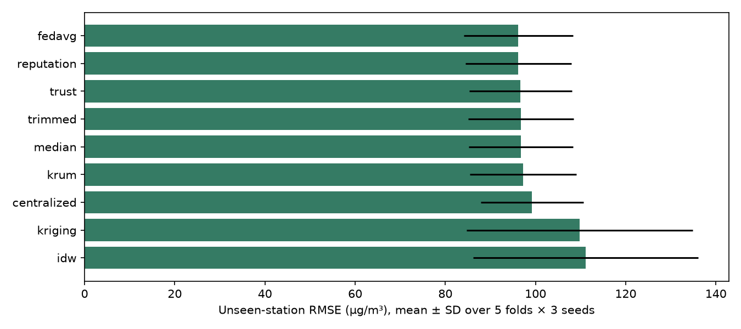
Figure A1. Actual unseen-station RMSE with fold-seed standard deviations across five station folds and three seeds. All folds exclude test locations from fitting and calibration.

Input calibration and sensor sensitivity
A separate ablation fits a least-squares linear correction per seen station using only the first 10% of co-located noisy/reference pairs, then corrects later inputs and noisy labels. The original fixed holdout is retained. Trust-model unseen-station RMSE falls from 99.92 ± 7.05 to 78.67 ± 2.02 µg/m³, a 21.27% reduction; corrected FedAvg reaches 78.49 ± 2.05. This supports input correction under the simulation, not superiority of trust weighting.
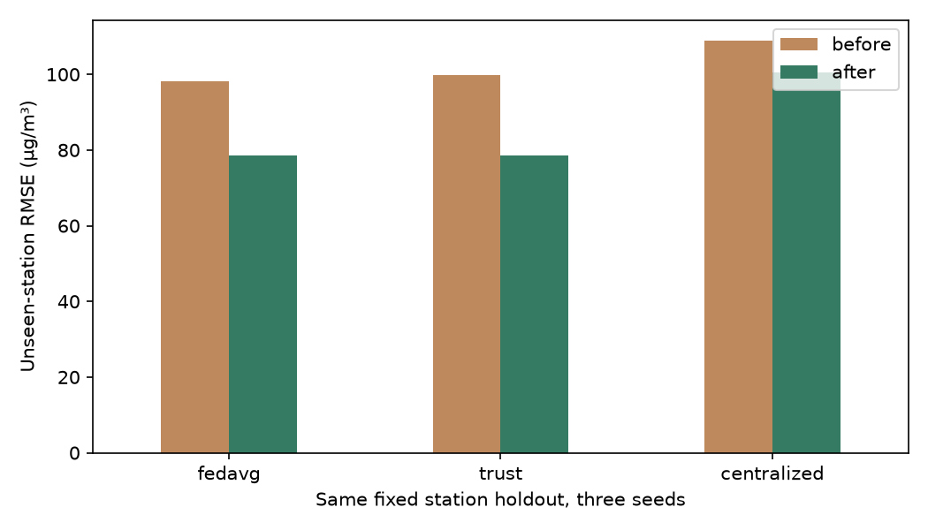
Figure A2. Executed early input-calibration ablation on the original station holdout, averaged over three seeds.
Zheng et al. [16] reports one-hour calibrated Kanpur ratio-error standard deviations of 35% and 46%. A separate sensitivity experiment uses mean-one lognormal multipliers with these SDs: log SD = sqrt(log(1 + relative SD squared)), log mean = minus one half of log variance. The distribution and client assignment are explicit modeling assumptions, not fitted hardware traces. This scenario has zero drift, dropout and stuck blocks. The original annual-drift stress test remains an engineering assumption. Co-located Delhi hardware validation and temporally correlated sensor errors remain outside the evaluated scope.
Temporal reputation maintains r(t) = 0.8r(t−1) + 0.2exp(−d(t)/median(d(t))), initialized at one. Distance d is measured from the coordinate-median client update; the median scale is floored at 10⁻⁶. Aggregation weights are sample count times max(r, 0.05). This project-defined history baseline complements the instantaneous consistency heuristic and robust baselines; it is not a reproduction of a named reputation algorithm.
scenario | method | split | rmse_mean | mae_mean | r2_mean
kanpur_relative | centralized | spatial | 113.032 | 76.956 | 0.399
kanpur_relative | centralized | test | 95.655 | 65.371 | 0.478
kanpur_relative | fedavg | spatial | 100.286 | 68.873 | 0.528
kanpur_relative | fedavg | test | 99.293 | 67.465 | 0.439
kanpur_relative | history_reputation | spatial | 100.383 | 68.930 | 0.527
kanpur_relative | history_reputation | test | 99.327 | 67.481 | 0.438
kanpur_relative | median | spatial | 99.316 | 68.172 | 0.536
kanpur_relative | median | test | 99.189 | 67.350 | 0.440
kanpur_relative | trust | spatial | 101.859 | 69.957 | 0.513
kanpur_relative | trust | test | 99.734 | 67.763 | 0.434
stress | history_reputation | spatial | 97.929 | 69.883 | 0.550
stress | history_reputation | test | 93.727 | 65.848 | 0.500
Table A1. Sensitivity means across seeds 17, 29 and 43. Concentration errors are in µg/m³. Standard deviations and per-seed outputs are available in results/sensitivity/summary.csv and metrics.csv.

Reproducibility and assessment status
The repository includes saved models, raw-source bundle, checksums, per-run metrics, station-fold predictions, a dashboard and automated tests. Simulation controls are labelled diagnostics and do not silently retrain FL. Publication status is not submitted; no submission ID or acceptance is claimed. A live team demonstration and prospective field validation remain separate from software completion.

Appendix B Literature comparison and research gaps
The comparison includes 25 peer-reviewed journal/conference works from the supplied publisher papers and the foundational Zheng calibration study. Preprint-only copies and the benchmark manuscript with placeholder publication metadata are excluded. Twenty of the 24 non-foundational papers are from 2022 onward (83.3%), satisfying the 70% recency floor even when all 2021 entries are conservatively excluded. Limitations below describe applicability to our project. Indexing status has not been separately certified.

B1 Rentero-Trejo et al. (2021)
Method | Context-aware IoT FL
Dataset or testbed | 165 generated user datasets
Parameters | Action prediction accuracy
Limitation | Synthetic user behavior; no pollution calibration
Source | 10.13052/jwe1540-9589.2113

B2 Ramadan et al. (2025)
Method | Blockchain and IoT FL
Dataset or testbed | Industrial indoor pollutant measurements across three floors
Parameters | MAE, RMSE, R², security overhead
Limitation | Industrial exposure setting differs from unseen outdoor stations
Source | 10.1016/j.ecoenv.2025.118442

B3 Ye et al. (2023)
Method | Heterogeneous FL survey
Dataset or testbed | Published heterogeneous FL studies
Parameters | Statistical, model, device and communication heterogeneity
Limitation | Survey taxonomy; no common Delhi benchmark
Source | 10.1145/3625558

B4 Mishra and Gupta (2023)
Method | Personalization, distillation and early halting
Dataset or testbed | MNIST, HAR, CIFAR-10, LMR and SHL
Parameters | Accuracy and communication rounds
Limitation | Personalization on classification does not establish spatial interpolation
Source | 10.1145/3629978

B5 Wu et al. (2024)
Method | Topology-aware FL survey
Dataset or testbed | Star, tree, decentralized and hybrid edge networks
Parameters | Topology, latency and communication tradeoffs
Limitation | Survey; requires workload-specific network validation
Source | 10.1145/3659205

B6 Feng (2024)
Method | Incentive-weighted air prediction
Dataset or testbed | Six pollutant concentration series
Parameters | AQI prediction and training time
Limitation | Incentive scores are not co-located calibration residuals
Source | 10.1145/3718751.3718873

B7 Le et al. (2022)
Method | Multi-model AQI forecasting survey
Dataset or testbed | Reviewed AQI datasets and FL benchmarks
Parameters | Forecast error, models and dataset availability
Limitation | Survey/proposed direction rather than a new shared benchmark
Source | 10.3390/a15110434

B8 Hu et al. (2024)
Method | FedDeep multi-urban deep FL
Dataset or testbed | Stations in 13 prefecture-level cities
Parameters | MAE, RMSE, R², training time, GPU memory
Limitation | Multi-city forecasting differs from unseen-station transfer
Source | 10.3390/app14051979

B9 Nguyen et al. (2021)
Method | Weighted proximal FL and resource allocation
Dataset or testbed | Unbalanced learning data and wireless IoT simulation
Parameters | Convergence, completion time and energy
Limitation | Wireless energy findings require an explicit radio model
Source | 10.1109/JIOT.2020.3022534

B10 Beriwal and Ayeelyan (2025)
Method | VGG-19 FL and causal impact analysis
Dataset or testbed | India, Nepal and China datasets
Parameters | Prediction and health-impact accuracy
Limitation | Accuracy endpoints cannot be equated with concentration RMSE; observational health analysis
Source | 10.3390/electronics14020350

B11 Kim et al. (2025)
Method | Personalized transfer, ensemble and masking
Dataset or testbed | Campus building energy observations
Parameters | Forecast accuracy and comparison to FedAvg/FedProx
Limitation | Building energy transfer is indirect evidence for pollution sensors
Source | 10.3390/electronics14091790

B12 Khan (2025)
Method | Sign-entropy regularization
Dataset or testbed | FEMNIST, Shakespeare, CIFAR-10
Parameters | Client accuracy, convergence and variability
Limitation | Classification optimization; no calibration-error model
Source | 10.3390/e27060601

B13 Alwabli (2024)
Method | IoT air-quality FL
Dataset or testbed | Multi-sensor AQI observations described in paper
Parameters | MAE and RMSE
Limitation | Published comparisons include RMSE below MAE; metric definitions require caution
Source | 10.48084/etasr.7820

B14 Neo et al. (2022)
Method | Systematic review of pollution and health FL
Dataset or testbed | Published environmental and health prediction studies
Parameters | Prediction methods and health integration
Limitation | Proposes integration; not an independent deployed FL trial
Source | 10.3389/fpubh.2022.851553

B15 Zakzouk and Said (2025)
Method | Lightweight CNN FL robustness
Dataset or testbed | WHIN weather network, 144 stations
Parameters | Soil moisture RMSE, MAPE and robustness
Limitation | Soil moisture response differs from optical PM sensor response
Source | 10.3390/make7040132

B16 Akram et al. (2025)
Method | Personalized conditional FedAvg
Dataset or testbed | Concrete Crack Images for Classification
Parameters | Classification and communication performance
Limitation | Drone image classification does not validate air pollution mapping
Source | 10.1109/JSTARS.2025.3577648

B17 Liu et al. (2024)
Method | Multi-party computation and FL survey
Dataset or testbed | Published cryptographic FL protocols
Parameters | Privacy, security and computation costs
Limitation | Survey; no privacy guarantee for an unencrypted implementation
Source | 10.1007/s11704-023-3282-7

B18 Moursi et al. (2021)
Method | NARX hybrid edge prediction
Dataset or testbed | PM2.5, wind and rain; PC and Raspberry Pi
Parameters | RMSE, NRMSE, R², agreement and runtime
Limitation | Edge prediction is not federated aggregation
Source | 10.1007/s40747-021-00476-w

B19 Chen et al. (2025)
Method | Delay-constrained wireless FL
Dataset or testbed | Standardized salt-spray test data
Parameters | Prediction and delay constraints
Limitation | Industrial corrosion testbed; no PM calibration transfer
Source | 10.1038/s41598-025-28569-3

B20 Shawkat et al. (2025)
Method | Adaptive clustered personalized distillation
Dataset or testbed | CIFAR-10/100, Fashion-MNIST and Enron
Parameters | Accuracy, convergence and communication
Limitation | Classification datasets; adaptive clustering differs from geographic client strips
Source | 10.1038/s41598-025-96468-8

B21 Putra et al. (2021)
Method | Federated compressed LSTM
Dataset or testbed | AirBox sequences from 1000 nodes
Parameters | MAE, RMSE and communication rounds
Limitation | Compression changes utility; privacy needs an explicit attack evaluation
Source | 10.3390/s21134586

B22 Mengistu et al. (2024)
Method | IoT/WSN heterogeneity and security survey
Dataset or testbed | Published sensor-network FL studies
Parameters | Heterogeneity taxonomy and privacy mechanisms
Limitation | Survey mechanisms do not certify a particular implementation
Source | 10.3390/s24030968

B23 Khan (2025)
Method | Entropy-guided FedEmerge
Dataset or testbed | CIFAR-10, Federated EMNIST and Shakespeare
Parameters | Accuracy, convergence and client disparity
Limitation | Data entropy is not physical calibration reliability
Source | 10.3390/s25123728

B24 Abimannan et al. (2023)
Method | Air-quality FL and edge-computing review
Dataset or testbed | Published air-quality monitoring studies
Parameters | Methods, deployment and monitoring tradeoffs
Limitation | Review-level evidence; no standardized unseen-station comparison
Source | 10.3390/su151813951

B25 Zheng et al. (2018)
Method | Field sensor calibration; linear, quadratic and RH models
Dataset or testbed | PMS3003 paired with E-BAM/T640 in Durham, RTP and Kanpur
Parameters | R² and concentration-ratio error by averaging interval
Limitation | Foundational calibration study; coefficients are site-specific, paired data available on request
Source | 10.5194/amt-11-4823-2018
The air-quality forecasting studies motivate a common unseen-station test. Heterogeneity studies distinguish information diversity from physical sensor quality, motivating robust and reputation comparators. Zheng motivates co-location and cautions against universal calibration coefficients. Privacy and topology surveys motivate explicit attack and payload measurements rather than presumed security or network benefits. These gaps determine the implemented comparisons.

