PROJECT REPORT
BCSE316L – Design of Smart Cities · Course Project (Review 3) · IMRaD format
A Reproducible Delhi Benchmark of Calibration and Aggregation in Federated PM2.5 Mapping
Rishit Chaudhary (23BCT0157)^{1,*}, Siddharth Verma (23BCT0159)¹, Jashan Sahasrabudhe (23BCT0022)¹, Adarsh Narayan (23BCT0155)¹
¹ School of Computer Science and Engineering, Vellore Institute of Technology, Vellore, 632014, India
* Corresponding author: rishit.chaudhary2023@vitstudent.ac.in
Team 10 · Project 9 · Case city: Delhi, India
Abstract
Federated learning (FL) lets sensor owners train a shared predictor by exchanging model updates. This study asks whether weighting those updates by early calibration quality improves PM2.5 prediction at unseen locations. AirTrust simulates eight geographic clients using 300,355 valid hourly reference observations from 36 Delhi stations in 2024. Bias, gain, drift, noise and missingness are imposed as illustrative sensor stress tests; they are not fitted models of deployed low-cost devices.
A spatial graph neural network (GNN) is evaluated with five leave-stations-out folds and fifteen random seeds. Comparators include centralised training, FedAvg, robust aggregators, update-consistency weighting, ordinary kriging and inverse distance weighting. Trust-weighted FL achieves root-mean-square error (RMSE) 96.81 ± 11.10 µg/m³, compared with 96.08 ± 11.01 for FedAvg; these standard deviations describe 75 fold-seed scores. Paired analysis averages the five folds within each seed. The results do not establish an advantage from trust weighting or prove the methods equivalent.
In a separate three-seed, fixed-holdout experiment, early linear calibration reduces trust-model RMSE from 99.92 to 78.67 µg/m³ (21.27%); calibrated FedAvg reaches 78.49 µg/m³. The gain therefore concerns input correction, not trust aggregation. A long short-term memory (LSTM) comparator uses each target station’s own history and evaluates known-station forecasting only. Code, split audits, results and an interactive dashboard are available. The experiments run on one machine without deployed sensors, secure aggregation or a formal privacy guarantee.
Keywords: federated learning; PM2.5 mapping; sensor calibration; spatial validation; synthetic sensor errors; reproducibility; smart cities

1. Introduction
Urban air-quality mapping requires observations distributed across time and space [1–3]. Reference monitors provide reliable evaluation targets, but they do not measure every neighbourhood. We evaluate prediction at monitoring locations excluded from training, rather than assume that a smooth map is accurate between monitors. Figure 1 shows the retained Delhi station coordinates.
Prior studies examine federated air-quality prediction [2–5], calibration [11] and graph-based prediction [12]. We study whether calibration confidence is useful as an aggregation weight, and whether correcting the observations themselves has a different effect. Environmental monitoring relates to Sustainable Development Goals 3, 11.6 and 13; this experiment does not measure health or policy outcomes.

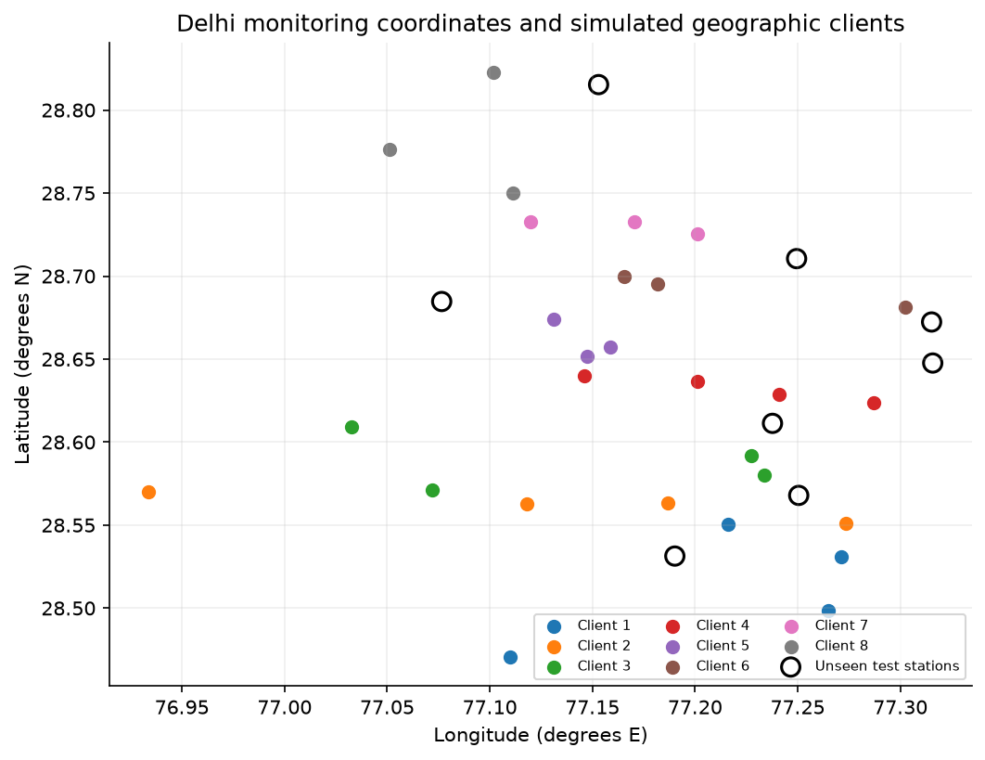

Figure 1. Actual coordinates of 36 retained Delhi reference locations, grouped into eight simulated geographic clients. Open circles mark the eight primary unseen stations. Client strips are computational partitions, not administrative districts. This plot does not claim complete coverage of Delhi’s monitoring network or city boundary.

Sensor response and calibration can vary with environment and time. Biased local readings may distort both learned updates and the donor inputs used for mapping. Downweighting an update does not directly repair those inputs. We therefore distinguish calibration-aware aggregation from input correction and measure both separately.

The objective is to compare calibration-based weighting, standard aggregation and input correction under a shared evaluation protocol. The spatial task withholds entire stations. A separate temporal task forecasts future observations at known stations. Raw records are excluded from the aggregation function, although the single-machine simulator can access the complete public dataset.

The study makes three contributions:

● A reproducible Delhi mapping benchmark with fixed station folds, fifteen stochastic replications, common training settings and paired comparisons of all nine spatial methods.

● A calibration-versus-aggregation ablation showing that early input correction helps both trust weighting and FedAvg under the specified synthetic faults.

● An openly documented negative finding, together with robust baselines, illustrative sensor sensitivity, a limited membership probe and a public demonstration.

The implementation is a research simulator. It does not connect independent sensor owners or deploy physical low-cost devices. The dashboard is available at https://airtrust.vercel.app and the code at https://github.com/rizzit17/airtrust. The following sections describe related work, methods, results, limitations and conclusions.

2. Literature Review

2.1 Sensor calibration and spatio-temporal pollution prediction

Calibration studies show why a physical sensing error must be separated from a true spatial concentration difference. Cavaliere et al. [11] study low-cost gas-sensor calibration; their NO₂/O₃ results are not PM2.5 error coefficients. Zheng et al. [16] evaluate particulate sensors in several environments, including Kanpur, and report site- and condition-dependent calibration performance. Our virtual sensor is paired with its own reference coordinate rather than the nearest different station.

Jin et al. [12] model spatial and temporal dependence using a graph network. Their work motivates spatial learning, but our model is a smaller inductive star-graph implementation rather than a replication of their architecture. A temporal LSTM uses the target station’s own history, while our mapping learner excludes that history. These information sets require separate evaluation.

2.2 Federated learning for air-quality monitoring

Abimannan et al. [1] review air-quality FL and edge computing. Hu et al. [3] evaluate FedDeep across stations in 13 Jiangsu cities, motivating a strong forecasting comparator. Alwabli [2] and Beriwal and Ayeelyan [4] examine IoT air-quality and multi-country pollution prediction. Their reported tasks, metrics and health analyses cannot be equated with our unseen-station concentration RMSE. We retain common local baselines instead of importing incompatible published scores.

Putra et al. [5] study federated compressed learning; Feng [6] considers participant incentives; Nguyen et al. [7] address wireless resource allocation; Ramadan et al. [15] combine blockchain and industrial pollution monitoring. These address efficiency, incentives and security at different levels. None supplies a privacy or bandwidth guarantee for our unencrypted single-machine implementation.

2.3 Clustered, personalised and privacy-aware federated learning

Ye et al. [8] and Mengistu et al. [23] distinguish statistical, model, device and communication heterogeneity. Personalisation approaches [9,10,13,14,27,32] preserve client-specific patterns; their classification or energy datasets do not validate outdoor PM calibration. Wu et al. [22] examine topology, and Liu et al. [24] examine multiparty computation. Our study consequently evaluates accuracy, robustness, update exposure and logical payload as distinct questions.

Table 1 compares 25 peer-reviewed journal and conference studies. Twenty of the 24 non-foundational works were published from 2022 onward; the foundational Zheng study is retained because it reports field sensor evaluation. The table identifies differences in tasks, data and deployment assumptions. Published classification, forecasting and concentration-error scores are not treated as interchangeable.

2.4 Research gap
The benchmark separates two mechanisms: reweighting local model updates and correcting noisy inputs before training and inference. Both are plausible responses to sensor faults, but their effects need not be the same. We compare them under disclosed assumptions and test prediction at completely withheld locations. The contribution is the comparison and its reproducible outcome, rather than a claim that calibration weighting is universally novel or superior.

Table 1. Comparison of 25 reviewed works and the implemented study. Approach cells identify the principal method; concentration error, classification accuracy and communication metrics in the cited papers are not interchangeable. Full parameter comparisons are retained in docs/LITERATURE_COMPARISON.csv.
Study | Approach | Dataset / setting | Limitation
Rentero-Trejo et al.  (2021) [33] | Context-aware IoT FL | 165 generated user datasets | Synthetic user behavior; no pollution calibration
Ramadan et al.  (2025) [15] | Blockchain and IoT FL | Industrial indoor pollutant measurements across three floors | Industrial exposure setting differs from unseen outdoor stations
Ye et al.  (2023) [8] | Heterogeneous FL survey | Published heterogeneous FL studies | Survey taxonomy; no common Delhi benchmark
Mishra and Gupta  (2023) [13] | Personalization, distillation and early halting | MNIST, HAR, CIFAR-10, LMR and SHL | Personalization on classification does not establish spatial interpolation
Wu et al.  (2024) [22] | Topology-aware FL survey | Star, tree, decentralized and hybrid edge networks | Survey; requires workload-specific network validation
Feng  (2024) [6] | Incentive-weighted air prediction | Six pollutant concentration series | Incentive scores are not co-located calibration residuals
Le et al.  (2022) [26] | Multi-model AQI forecasting survey | Reviewed AQI datasets and FL benchmarks | Survey/proposed direction rather than a new shared benchmark
Hu et al.  (2024) [3] | FedDeep multi-urban deep FL | Stations in 13 prefecture-level cities | Multi-city forecasting differs from unseen-station transfer
Nguyen et al.  (2021) [7] | Weighted proximal FL and resource allocation | Unbalanced learning data and wireless IoT simulation | Wireless energy findings require an explicit radio model
Beriwal and Ayeelyan  (2025) [4] | VGG-19 FL and causal impact analysis | India, Nepal and China datasets | Accuracy endpoints cannot be equated with concentration RMSE; observational health analysis
Kim et al.  (2025) [27] | Personalized transfer, ensemble and masking | Campus building energy observations | Building energy transfer is indirect evidence for pollution sensors
Khan  (2025) [9] | Sign-entropy regularization | FEMNIST, Shakespeare, CIFAR-10 | Classification optimization; no calibration-error model
Alwabli  (2024) [2] | IoT air-quality FL | Multi-sensor AQI observations described in paper | Published comparisons include RMSE below MAE; metric definitions require caution
Neo et al.  (2022) [25] | Systematic review of pollution and health FL | Published environmental and health prediction studies | Proposes integration; not an independent deployed FL trial
Zakzouk and Said  (2025) [28] | Lightweight CNN FL robustness | WHIN weather network, 144 stations | Soil moisture response differs from optical PM sensor response
Akram et al.  (2025) [29] | Personalized conditional FedAvg | Concrete Crack Images for Classification | Drone image classification does not validate air pollution mapping
Liu et al.  (2024) [24] | Multi-party computation and FL survey | Published cryptographic FL protocols | Survey; no privacy guarantee for an unencrypted implementation
Moursi et al.  (2021) [30] | NARX hybrid edge prediction | PM2.5, wind and rain; PC and Raspberry Pi | Edge prediction is not federated aggregation
Chen et al.  (2025) [31] | Delay-constrained wireless FL | Standardized salt-spray test data | Industrial corrosion testbed; no PM calibration transfer
Shawkat et al.  (2025) [32] | Adaptive clustered personalized distillation | CIFAR-10/100, Fashion-MNIST and Enron | Classification datasets; adaptive clustering differs from geographic client strips
Putra et al.  (2021) [5] | Federated compressed LSTM | AirBox sequences from 1000 nodes | Compression changes utility; privacy needs an explicit attack evaluation
Mengistu et al.  (2024) [23] | IoT/WSN heterogeneity and security survey | Published sensor-network FL studies | Survey mechanisms do not certify a particular implementation
Khan  (2025) [10] | Entropy-guided FedEmerge | CIFAR-10, Federated EMNIST and Shakespeare | Data entropy is not physical calibration reliability
Abimannan et al.  (2023) [1] | Air-quality FL and edge-computing review | Published air-quality monitoring studies | Review-level evidence; no standardized unseen-station comparison
Zheng et al.  (2018) [16] | Field sensor calibration; linear, quadratic and RH models | PMS3003 paired with E-BAM/T640 in Durham, RTP and Kanpur | Foundational calibration study; coefficients are site-specific, paired data available on request
This work | Co-located trust FL; GNN/LSTM | Delhi reference labels; simulated errors; separate Beijing check | No hardware validation; trust does not consistently beat FedAvg

3. Methodology

3.1 Problem formulation
Consider K = 8 simulated geographic clients. Client k holds nₖ training windows, and the shared model has parameters w. The client groups approximate distributed ownership without claiming physical or legal isolation. With pₖ = nₖ/n, n = Σ nₖ, and squared prediction loss, the optimisation objective is
min_{w} F(w) = Σ_{k=1}^{K} p_{k} F_{k}(w), F_{k}(w) = (1/n_{k}) Σ_{i∈k} ℓ( f(x_{i}; w), y_{i} ) (1)
where Fₖ is the local loss, xᵢ contains past pollutant readings and time/location features, and yᵢ is the simulated sensor label. Delhi meteorological inputs are not used. Evaluation uses original, unimputed reference concentrations. Standard FedAvg weights local states by nₖ; Section 3.3 multiplies this by calibration confidence. The target is one-hour-ahead prediction using six strictly past hourly readings.

3.2 Data / materials
The primary source is CPCB Continuous Ambient Air Quality Monitoring data compiled by the India Air Quality Database, XKDR Forum [17]. Delhi 2024 downloads contain 317,627 PM2.5, 323,061 PM10 and 325,379 NO₂ rows at 39 catalog entries: 966,067 pollutant observations. PM2.5 supplies the FL reference target; PM10/NO₂ supply contextual monthly trends and are not extra PM2.5 labels. The UCI Beijing dataset [18] contains 420,768 station-hour rows at 12 reference-grade stations during March 2013–February 2017, used only for an independent temporal persistence check. Both compilations are CC BY 4.0. OpenAQ and sensor.community were proposal candidates and are not used in the executed experiments.

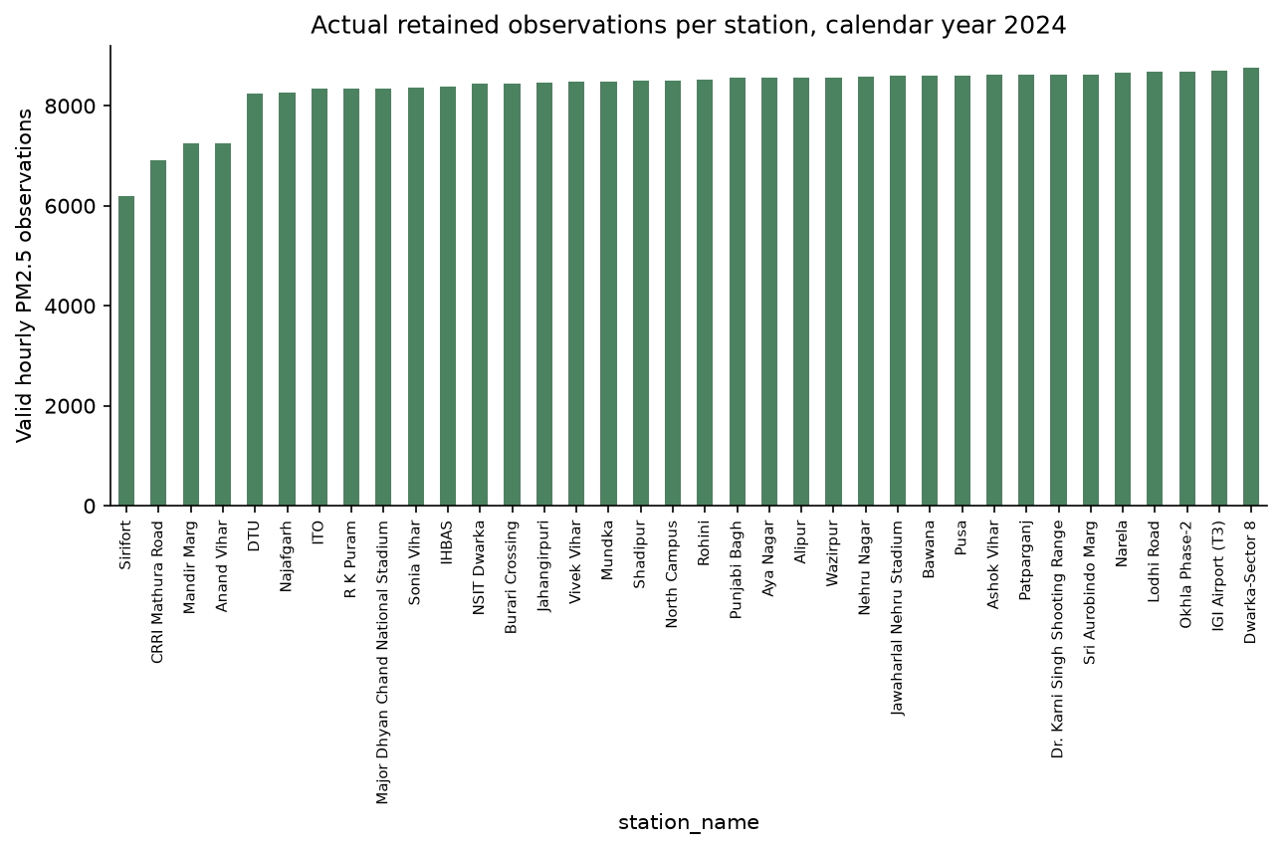

Figure 2. Actual retained hourly PM2.5 observations per Delhi station in 2024, totalling 300,355 valid labels. Source downloads contain 317,627 PM2.5 rows, with the contextual PM10/NO₂ and independent Beijing counts stated in Section 3.2. Archive duplicates and simulated readings are not additional source observations.

Delhi data are aligned to the 8,784 hours of leap year 2024 in IST. Duplicate station-hours are averaged; concentrations below zero or above 2,000 µg/m³ are excluded. Stations require at least 70% hourly coverage. Catalog coordinates within 50 m are consolidated by retaining the more complete entry, leaving 36 distinct locations. Input histories alone are forward-filled for at most three hours; reference targets are never filled or backfilled. PM inputs/labels are scaled by 100 and relative coordinates by 50 km. Geographic strips define eight clients; full-year coverage filtering is a retrospective benchmark choice. No new human or animal data are collected.

Sensor-error model and provenance. The primary faults are purely illustrative engineering stress tests. Virtual PM2.5 is max(0, gain × reference + bias + annual drift × elapsed-year fraction + Gaussian noise). Mild clients use bias 1.5 µg/m³, gain 1.02, annual drift 2 µg/m³, noise SD 3 µg/m³ and 1% dropout. Severe clients use bias 35, gain 1.25, annual drift 30, noise SD 12, 4% dropout and 12 random six-hour stuck blocks, each repeating the preceding value. Three of eight clients (37.5%) are severe. These coefficients are neither fitted nor validated against paired low-cost/reference observations in Delhi or Kanpur. Conclusions are conditional on these assumed faults.
Literature-anchored sensitivity. Zheng et al. [16] report one-hour calibrated concentration-ratio error SDs of 35% and 46% in Kanpur post-monsoon and monsoon conditions. A separate scenario uses mean-one lognormal multiplicative error with these SDs: log-scale SD is √ln(1 + s²), and log-scale mean is −½ln(1 + s²). Choosing that distribution and assigning s = 0.35/0.46 to clients are our assumptions. This sensitivity has zero added bias, drift, dropout and stuck blocks. The primary annual-drift model remains a stress test; no Delhi hardware response or humidity model is claimed.

3.3 Proposed approach
Figure 3 describes the implemented round. The server broadcasts the current state, each client runs local optimisation, and the aggregator combines parameter states using scalar weights. Model training and public-data evaluation share a simulator process; the aggregator itself accepts no raw-record argument.
- Local training. The spatial GNN uses up to three local seen-station donors, each with six past PM2.5 readings and relative coordinates. Shared 8→24→16 message layers, attention pooling and a 20→24→1 residual head produce the target prediction. Two available donors are padded by repeating the last; this changes effective multiplicity and is a limitation. The LSTM has 16 hidden units and uses a known target’s own six-hour history plus cyclic time features. It is not scored at a location without sensor history.
- Calibration confidence. A virtual sensor and its reference share identical coordinates. First-10%-period paired residuals at seen locations determine one confidence score per client. Held-out locations contribute no calibration data. For round t the fixed confidence is
c_{k}^{t} = max( exp( −RMSE_{k}^{t} / τ ), c_{min} ) (2)
where RMSEₖᵗ is the same early co-located residual at every round, τ = 35 µg/m³ and cmin = 0.05. These settings are fixed scenario choices. The time superscript does not imply a recalculated round-by-round reference score. Identical-coordinate pairing avoids penalising real gradients between different monitoring sites.
- Quality-weighted aggregation. The aggregator normalises the product of each client’s training-window count and fixed calibration confidence, then combines local parameter states:
α_{k}^{t} = n_{k} c_{k}^{t} / Σ_{j=1}^{K} n_{j} c_{j}^{t}, w^{t+1} = Σ_{k=1}^{K} α_{k}^{t} w_{k}^{t+1} (3)
where wₖᵗ⁺¹ is the locally updated model. Setting every confidence to one yields sample-weighted FedAvg; equal client averaging is a separate ablation. Graph comparisons also include coordinate median, one-tail-per-side trimmed mean [19], Krum with f = 1 [20], and instantaneous update consistency. Krum’s theoretical condition does not cover three or five corrupted clients among eight; its results here are empirical.
Temporal reputation. A separate project-defined history baseline uses r(t) = 0.8r(t−1) + 0.2exp(−d(t)/median(d(t))), initialised at one. Here d is client-update distance from the coordinate median; the scale is floored at 10⁻⁶. Weights are nₖ × max(r, 0.05). This differs from instantaneous consistency, whose weights are nₖ divided by distance to the median update. The two heuristics are labelled separately in the result files.
- Iteration and mapping. We run 20 rounds and select the global checkpoint with the lowest clean known-station validation RMSE. For a query coordinate, the selected client uses its available donor histories. The dashboard evaluates 784 points on a 28 × 28 coordinate grid. Grid cells have no observed truth or administrative-boundary mask, so the surface is a model demonstration, not certified street-level accuracy.

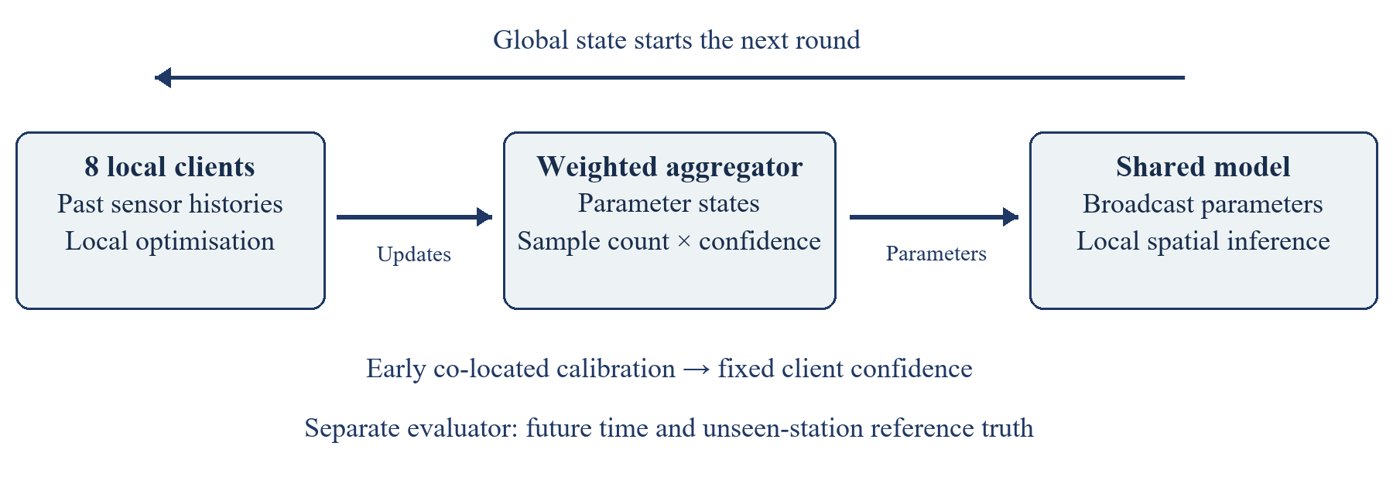

Figure 3. Implemented simulation flow. Eight local clients return parameter states; early co-located calibration supplies confidence weights; aggregation returns the next global state. Reference scoring is separate from training. The diagram describes software logic and does not imply encrypted, independent physical clients.

Training stays client-local at the algorithmic interface, while the public-data simulator and evaluator can access all reference records. The system does not implement secure aggregation or differential privacy. The hosted NumPy graph evaluator uses exported trained parameters; checkpoint-equivalence tests verify that it preserves PyTorch inference within numerical tolerance.

3.4 Experimental setup

All neural experiments use CPU PyTorch 2.13.0 and Python 3.13.7. Adam has learning rate 0.002, batches of at most 128 and gradient clipping norm 5. Each of 20 rounds uses 12 minibatch steps per client; optimiser state resets before local training. Centralised training receives eight times that step budget. The first 10% of hours are calibration-only, followed by 60% training, 15% validation and 15% test. Test begins on 7 November 2024 at 02:00 IST. Histories contain six strictly past hours with a three-hour window stride. Clean-reference validation at seen stations selects every neural checkpoint; obtaining these reference labels would have a deployment cost.

Spatial validation. The original split withholds eight whole stations, one per client. Five fixed leave-stations-out folds contain 8, 8, 8, 8 and 4 stations; each of the 36 locations is unseen once per seed. A withheld station contributes no training labels, validation labels, calibration pairs or donor inputs in its fold. The expanded evaluation uses fifteen seeds and averages the 75 fold-seed scores equally. The original three-seed files are preserved; twelve new seeds use the identical protocol. Seeds change initialisation, minibatches, synthetic faults and reserved nonmember windows, while station folds stay fixed.

Paired statistical analysis. We first average each metric across five folds within each seed, producing fifteen paired scores per method. All 36 pairs among the nine spatial methods are compared for MAE, RMSE and R², with Holm correction across the full family of 108 tests. Two-sided Wilcoxon signed-rank probabilities are computed by enumerating all sign assignments, using average ranks for ties and omitting zero differences. Interpreting this as a location test assumes symmetric paired differences. We also report mean differences, paired standardised effects and unadjusted paired t 95% intervals. The t intervals assume approximately normal seed-mean differences and concern variability conditional on the fixed Delhi data and folds; they are not simultaneous intervals or intervals over independent deployments. No equivalence margin was prespecified.

Classical baselines. IDW uses inverse squared distance. Ordinary kriging uses exponential spatial covariance, a 0.05 normalised nugget and range selected from 5, 10, 20, 40 and 80 km using early seen-station semivariances. Both receive the same available client-local previous-hour donors as the spatial GNN, not the target’s reading. A previous-value persistence baseline is included for the known-station task.

Privacy attack and threat model. An honest-but-curious aggregator observes individual final-round client updates and tests candidate-window membership. Our named individual-update loss-improvement probe ranks candidates by the decrease in noisy-label squared loss before versus after an update, motivated by loss-based membership inference [21]. Ten percent of training-era eligible windows are reserved as nonmembers and never optimised on. Attack metrics are receiver-operating-characteristic area under the curve (AUC) and maximum true-positive rate minus false-positive rate (advantage). This heuristic is not a literal reproduction of Yeom’s threshold attack; overlapping windows and limited attack strength constrain interpretation.

Input-calibration ablation. For each seen station, early co-located pairs fit a least-squares slope and intercept using only the first 10% of hours. Those coefficients correct later donor inputs and noisy training labels. Reference test truth and withheld stations remain untouched. This is a separate three-seed experiment on the original eight-station holdout, not a five-fold calibration result.

4. Results

Tables 2, 4 and 5 retain the original three-seed experiments (17, 29 and 43). Table 3 adds twelve seeds (59, 71, 89, 101, 127, 149, 173, 197, 223, 251, 277 and 307) to the spatial cross-validation protocol without changing its hyperparameters. Its means and sample standard deviations describe 75 equally weighted fold-seed scores. Statistical tests instead use fifteen seed means, each averaged over the same five folds. Correlated windows and overlapping folds are not counted as independent replications.

4.1 Early findings from data exploration

The retained network has 36 distinct sites, with 28 seen and eight unseen locations in the primary split. For seed 17, the exported audit records 35,463 training windows, 10,081 validation windows, 11,506 known-station test windows, 3,254 unseen-station windows and 3,982 reserved nonmember windows. Figures 1–2 use actual coordinates and valid record counts. Added PM10/NO₂ rows expand contextual analysis; they do not increase primary PM2.5 labels. Beijing remains a reference-grade persistence benchmark, not low-cost field data or cross-city FL.

4.2 Evaluation design and expected outcomes
Table 2 reports the original three-seed comparison on the fixed station holdout. Trust GNN unseen-station RMSE is 99.92 ± 7.05 µg/m³ and FedAvg RMSE is 98.11 ± 3.98, approximately 1.85% higher for trust using unrounded scores. Table 3 reports the expanded station cross-validation. LSTM scores in Table 2 concern known-station forecasting with target history; they provide no evidence about mapping an unseen location.

Table 2. Executed primary comparison, mean ± sample SD over seeds 17, 29 and 43. MAE/RMSE are in µg/m³. “Unseen” excludes whole target locations; “known” scores future hours at fitted locations. GNN/spatial baselines exclude target histories; LSTM and persistence use them.
System / task | MAE ± SD | RMSE ± SD | R² ± SD
Centralised GNN / unseen | 78.02 ± 5.20 | 108.95 ± 9.77 | 0.441 ± 0.103
Centralised GNN / known | 67.52 ± 3.06 | 93.19 ± 5.76 | 0.505 ± 0.060
Equal FL GNN / unseen | 69.58 ± 5.39 | 97.52 ± 4.57 | 0.554 ± 0.042
Equal FL GNN / known | 65.68 ± 2.00 | 93.60 ± 0.45 | 0.502 ± 0.005
FedAvg GNN / unseen | 69.99 ± 4.98 | 98.11 ± 3.98 | 0.548 ± 0.037
FedAvg GNN / known | 65.83 ± 2.00 | 93.71 ± 0.80 | 0.500 ± 0.009
Krum (f = 1) GNN / unseen | 69.86 ± 4.82 | 97.50 ± 4.83 | 0.554 ± 0.044
Krum (f = 1) GNN / known | 67.10 ± 2.40 | 94.85 ± 1.36 | 0.488 ± 0.015
Median GNN / unseen | 69.59 ± 5.93 | 97.53 ± 5.34 | 0.553 ± 0.049
Median GNN / known | 65.75 ± 2.20 | 93.85 ± 0.51 | 0.499 ± 0.006
Update consistency GNN / unseen | 69.59 ± 5.59 | 97.44 ± 4.96 | 0.554 ± 0.045
Update consistency GNN / known | 65.80 ± 2.26 | 93.74 ± 0.94 | 0.500 ± 0.010
Trimmed mean GNN / unseen | 69.66 ± 5.64 | 97.61 ± 4.95 | 0.553 ± 0.045
Trimmed mean GNN / known | 65.73 ± 2.27 | 93.71 ± 0.80 | 0.500 ± 0.009
Trust FL GNN / unseen | 70.87 ± 7.50 | 99.92 ± 7.05 | 0.531 ± 0.066
Trust FL GNN / known | 65.44 ± 1.74 | 94.74 ± 2.18 | 0.489 ± 0.023
Centralised LSTM / known | 46.43 ± 1.58 | 62.92 ± 1.67 | 0.774 ± 0.012
FedAvg LSTM / known | 49.73 ± 1.93 | 69.68 ± 2.77 | 0.722 ± 0.022
Trust FL LSTM / known | 49.52 ± 2.52 | 69.61 ± 4.10 | 0.722 ± 0.032
IDW SPATIAL / unseen | 72.64 ± 6.03 | 100.72 ± 9.02 | 0.522 ± 0.083
IDW SPATIAL / known | 85.00 ± 6.18 | 118.85 ± 2.35 | 0.196 ± 0.032
Ordinary kriging SPATIAL / unseen | 71.52 ± 7.10 | 99.03 ± 9.93 | 0.537 ± 0.089
Ordinary kriging SPATIAL / known | 83.28 ± 6.08 | 116.52 ± 1.99 | 0.227 ± 0.027
Persistence TEMPORAL / known | 60.78 ± 2.43 | 86.17 ± 3.32 | 0.577 ± 0.032

Spatial cross-validation. Table 3 reports five station folds and fifteen seeds, with every location withheld once per seed. Trust GNN obtains MAE 68.18 ± 8.35, RMSE 96.81 ± 11.10 and R² 0.463 ± 0.171. FedAvg RMSE is 96.08 ± 11.01. Across fifteen seed means, trust minus FedAvg RMSE was 0.73 µg/m³ (unadjusted paired 95% interval 0.17 to 1.29; two-sided signed-rank p = 0.0125, Holm-adjusted p = 0.6475). These results do not establish a trust-weighting benefit. The original three-seed scores remain in results/spatial_cv; the expanded measurements and comparisons are in results/paper_validation.
Table 3. Future-time unseen-station results over five station folds × fifteen seeds. Means/SDs weight the 75 fold-seed runs equally; these are descriptive SDs, not independent-data confidence intervals. Concentration errors are in µg/m³.
System / task | MAE ± SD | RMSE ± SD | R² ± SD
Centralised GNN / unseen | 69.80 ± 8.83 | 97.39 ± 10.56 | 0.453 ± 0.187
FedAvg GNN / unseen | 68.14 ± 8.72 | 96.08 ± 11.01 | 0.467 ± 0.185
Krum (f = 1) GNN / unseen | 68.89 ± 8.15 | 97.75 ± 10.49 | 0.453 ± 0.160
Median GNN / unseen | 68.37 ± 8.43 | 96.49 ± 10.27 | 0.463 ± 0.179
Update consistency GNN / unseen | 68.23 ± 8.55 | 96.16 ± 10.72 | 0.466 ± 0.182
Trimmed mean GNN / unseen | 68.37 ± 8.54 | 96.47 ± 10.52 | 0.463 ± 0.183
Trust FL GNN / unseen | 68.18 ± 8.35 | 96.81 ± 11.10 | 0.463 ± 0.171
IDW SPATIAL / unseen | 80.68 ± 18.83 | 109.54 ± 24.18 | 0.243 ± 0.483
Ordinary kriging SPATIAL / unseen | 80.10 ± 18.83 | 108.71 ± 24.14 | 0.253 ± 0.480
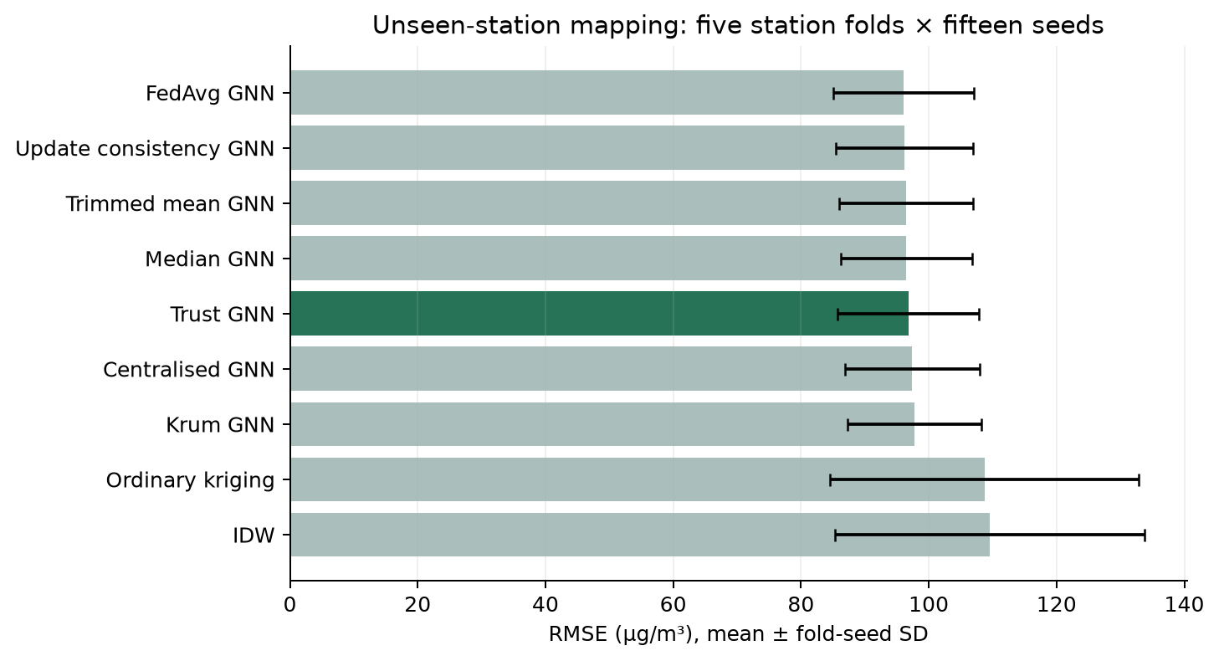
Figure 4. Unseen-station RMSE over five station folds and fifteen seeds. Error bars show descriptive fold-seed SDs. Source: results/paper_validation/summary.csv.
Input correction. Table 4 reports the independent calibration ablation. Trust GNN unseen RMSE decreases from 99.92 ± 7.05 to 78.67 ± 2.02 µg/m³ (21.27%), while corrected FedAvg reaches 78.49 ± 2.05. Corrected trust LSTM reaches 40.93 ± 0.51 at known locations. These results support early input correction under the assumed errors without establishing superiority of trust aggregation.
Table 4. Early input-calibration results on the original fixed holdout, three seeds. Reference targets remain unimputed and unchanged; all errors are in µg/m³.
System / task | MAE ± SD | RMSE ± SD | R² ± SD
Centralised GNN / unseen | 69.12 ± 5.86 | 100.49 ± 9.28 | 0.524 ± 0.086
FedAvg GNN / unseen | 53.68 ± 2.03 | 78.49 ± 2.05 | 0.711 ± 0.015
Trust FL GNN / unseen | 53.79 ± 2.00 | 78.67 ± 2.02 | 0.710 ± 0.015
Centralised LSTM / known | 28.41 ± 1.07 | 42.45 ± 1.19 | 0.897 ± 0.006
FedAvg LSTM / known | 27.26 ± 0.56 | 40.95 ± 0.44 | 0.904 ± 0.002
Trust FL LSTM / known | 27.25 ± 0.60 | 40.93 ± 0.51 | 0.904 ± 0.002
Sensor sensitivity and reputation. Table 5 reports unseen-station scores under the separate Kanpur-relative-noise scenario and the original stress scenario. For relative noise, FedAvg RMSE is 100.29 ± 5.97, temporal reputation 100.38 ± 5.87 and trust FL 101.86 ± 5.36 µg/m³. The temporal reputation stress result is 97.93 ± 4.26. These comparisons do not establish that either history weighting or calibration weighting universally improves accuracy.
Table 5. Sensor-scenario sensitivity over three seeds, unseen-station GNN task. “Relative” denotes the Kanpur-magnitude multiplicative-noise assumption; “stress” denotes the original bias/gain/drift scenario.
System / task | MAE ± SD | RMSE ± SD | R² ± SD
Relative / Centralised | 76.96 ± 6.78 | 113.03 ± 9.54 | 0.399 ± 0.102
Relative / FedAvg | 68.87 ± 3.73 | 100.29 ± 5.97 | 0.528 ± 0.057
Relative / Temporal reputation | 68.93 ± 3.67 | 100.38 ± 5.87 | 0.527 ± 0.056
Relative / Median | 68.17 ± 4.81 | 99.32 ± 7.69 | 0.536 ± 0.073
Relative / Trust FL | 69.96 ± 3.57 | 101.86 ± 5.36 | 0.513 ± 0.051
Stress / Temporal reputation | 69.88 ± 5.08 | 97.93 ± 4.26 | 0.550 ± 0.039
Robustness. The corruption sweep uses actual severe-client shares of 0%, 25%, 37.5% and 62.5%, comparing FedAvg, trust, median and trimmed mean over all three seeds. Severity is fixed while the corrupted share changes. Figure 5 reports the executed spatial errors; Krum’s f = 1 guarantee is not asserted for the larger corruption levels.
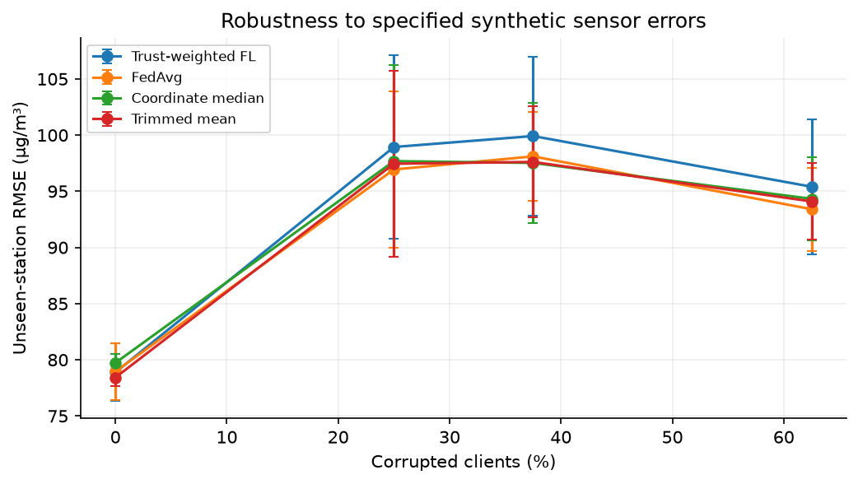
Figure 5. Executed unseen-station error versus actual corrupted-client percentage. Error bars show SD across three seeds. Source: results/robustness.csv. This varies assumed corruption, not observed failure rates of deployed devices.
Privacy and communication. In the original three-seed probe, trust GNN membership AUC is 0.502 ± 0.005 versus FedAvg 0.505 ± 0.004. AUC near 0.5 indicates near-random ranking for this attack, not a general privacy guarantee. The 1,162-parameter graph model exchanges 743,680 upload bytes plus 743,680 broadcast bytes over eight clients and 20 rounds: 1,487,360 logical float32 bytes (1.49 MB). Protocol, calibration and inference traffic are excluded. The 4.1 MB prepared-window comparator repeats raw readings across histories; no saving over a once-only raw-data upload or measured radio energy is claimed.
All-method paired comparisons. Table 6 summarises each spatial method against FedAvg using fifteen seed means. The complete 108-test family, including every pair and all three metrics, is exported as results/paper_validation/paired_comparisons.csv. The confidence intervals are unadjusted descriptive uncertainty intervals; only the Holm-adjusted probabilities determine the reported multiplicity-controlled decisions. No failure to reject is interpreted as proof of equality. Statistical precision under a fixed simulation does not validate its assumed sensor physics.
Table 6. Paired unseen-station RMSE comparisons against FedAvg, fifteen seed means. Δ = method minus FedAvg in µg/m³; negative favours the listed method. Brackets show unadjusted paired t 95% intervals. Adjusted probabilities cover all 108 pair/metric tests.
Method | Δ RMSE [95% interval] | Exact p | Holm p
Centralised | +1.31 [-0.37, +2.99] | 0.1070 | 1.0000
IDW | +13.46 [+10.82, +16.09] | 0.0001 | 0.0066
Ordinary kriging | +12.63 [+10.26, +14.99] | 0.0001 | 0.0066
Krum (f = 1) | +1.67 [+0.55, +2.80] | 0.0125 | 0.6475
Median | +0.41 [+0.06, +0.76] | 0.0151 | 0.7538
Update consistency | +0.08 [-0.07, +0.23] | 0.2769 | 1.0000
Trimmed mean | +0.39 [+0.21, +0.57] | 0.0006 | 0.0403
Trust FL | +0.73 [+0.17, +1.29] | 0.0125 | 0.6475
The adjusted RMSE comparisons favour FedAvg over IDW, ordinary kriging and trimmed-mean aggregation (Holm p = 0.0066, 0.0066 and 0.0403, respectively). The trust-versus-FedAvg comparison has unadjusted p = 0.0125 and adjusted p = 0.6475. Its unadjusted interval indicates a small increase in trust error under seed variation; it does not establish equivalence, and the family-adjusted test does not reject a zero difference. These statements concern the specified simulation, not a population of physical sensor deployments.
Reproducibility and deployed demonstration. GitHub retains source code, dependency versions, model states, split audits and per-run metrics; public-source restoration verifies SHA-256 before extraction. The Vercel site provides the complete interactive dashboard without a login. Its inference-only NumPy implementation is checked against all 12 saved graph checkpoints; the full suite passes 32 tests. Hosted sensor calculations match local values and map predictions agree within 0.001 µg/m³. Static exports include dataset and project ZIPs. Hosting is an evaluation interface rather than evidence of a physical distributed network.

5. Discussion

Calibration confidence measures the specified early synthetic error, but reducing an update’s weight leaves its noisy donor readings unchanged at inference. This distinction offers a plausible explanation for the observed difference between aggregation and input correction; it is not a proof of the causal mechanism. The calibration ablation improves both trust and FedAvg. Its benefit cannot be assigned to trust weighting.

The spatial evaluation compares FedAvg with calibration weighting, coordinate median, trimmed mean, Krum, update consistency, centralised learning, IDW and kriging. The separate temporal-reputation baseline is a project-defined heuristic, not a replication of a published reputation algorithm. The fifteen-seed analysis strengthens replication under the fixed scenario, but it does not add stations, cities, years or hardware observations. A nonsignificant comparison does not establish equivalence.

The public FastAPI dashboard provides historical maps, station histories, client confidence, convergence, original model comparisons, sensor controls and dataset exports. The hosted graph checkpoints come from the original three-seed runs; the expanded station-validation tables are reproduced offline. Lab controls change bias, gain, drift, noise and dropout for sensor diagnostics and early linear correction; they do not retrain FL. At CRRI Mathura Road, the default scenario gives raw RMSE 59.37 and calibrated RMSE 18.09 µg/m³ on 1,213 future paired hours. Increasing annual drift from 20 to 80 raises those errors to 114.05 and 64.11. These are sensor-level scores, separate from prediction errors in Tables 2–5.

The main limitations are one Delhi year, 36 retained locations and synthetic sensor faults. No paired Delhi low-cost/reference dataset was used to fit or validate the error coefficients. The Kanpur-magnitude scenario is also an illustrative sensitivity analysis, not a fitted sensor model. Humidity, real sensor ageing and independent organisations are absent. Other limitations include clean-reference checkpoint selection, retrospective coverage filtering and shared observations across station folds. Fifteen seeds measure stochastic variability conditional on this benchmark, not uncertainty across real deployments. The attack probe, logical payload and unmasked map do not establish privacy, network savings or field accuracy.

6. Conclusion

AirTrust provides a reproducible benchmark for separating calibration and aggregation in Delhi PM2.5 mapping. Five station folds and fifteen seeds give trust GNN RMSE 96.81 ± 11.10 µg/m³ and FedAvg RMSE 96.08 ± 11.01. The conditional paired analysis does not establish a trust-weighting advantage. It also does not prove equivalence or exclude benefits under other sensor conditions.

The separate fixed-holdout calibration experiment reduces trust-model RMSE by 21.27%, while calibrated FedAvg performs similarly. The evidence supports input correction under the disclosed stress model rather than a superior aggregation rule. Spatial mapping and known-station LSTM forecasting remain distinct tasks. Source data, scripts, split audits and measured outputs make these findings reproducible.

Future work should fit and validate sensor-error models with real co-located low-cost/reference measurements, evaluate new years and cities, and study seasonal calibration. Secure aggregation, differential privacy and stronger attacks require separate implementation and evaluation. The current update-sharing simulator provides no formal privacy guarantee.

Declarations
Acknowledgements. The authors thank Dr. Kalaavathi B, faculty for Design of Smart Cities (BCSE316L), for her guidance and review feedback.
Funding. This research received no specific grant from any funding agency.
Conflict of interest. The authors declare no conflict of interest.
Data availability. Delhi observations are attributed to CPCB CAAQM and India Air Quality Database, XKDR Forum [17]; Beijing observations are attributed to Song Chen/UCI [18]. Both compilations use CC BY 4.0. The repository documents cleaning, simulated modifications, data restoration, split audits and per-run metrics. The original results remain in results/spatial_cv; expanded seed results, statistical assumptions and all paired comparisons are in results/paper_validation. Code: https://github.com/rizzit17/airtrust. Demonstration: https://airtrust.vercel.app.
Author contributions. Conceptualisation, methodology, investigation and writing: R.C., S.V., J.S. and A.N. The authors are responsible for reviewing the code, analysis and manuscript. Generative AI assisted development, debugging, dataset discovery, drafting and interface design. All report plots are drawn from source data or executed results; Figure 3 is a programmatic architecture diagram. No image generator or invented experimental measurement is used.

References
[1] Abimannan, S., El-Alfy, E.-S.M., Hussain, S., Chang, Y.-S., Shukla, S., Satheesh, D., Breslin, J.G. (2023). Towards federated learning and multi-access edge computing for air quality monitoring: literature review and assessment. Sustainability, 15(18): 13951. https://doi.org/10.3390/su151813951
[2] Alwabli, A. (2024). Federated learning for privacy-preserving air quality forecasting using IoT sensors. Engineering, Technology & Applied Science Research, 14(4): 16069-16076. https://doi.org/10.48084/etasr.7820
[3] Hu, Y., Cao, N., Guo, W., Chen, M., Rong, Y., Lu, H. (2024). FedDeep: a federated deep learning network for edge assisted multi-urban PM2.5 forecasting. Applied Sciences, 14(5): 1979. https://doi.org/10.3390/app14051979
[4] Beriwal, S., Ayeelyan, J. (2025). Decoding pollution: a federated learning-based pollution prediction study with health ramifications using causal inferences. Electronics, 14(2): 350. https://doi.org/10.3390/electronics14020350
[5] Putra, K.T., Chen, H.-C., Prayitno, Ogiela, M.R., Chou, C.-L., Weng, C.-E., Shae, Z.-Y. (2021). Federated compressed learning edge computing framework with ensuring data privacy for PM2.5 prediction in smart city sensing applications. Sensors, 21(13): 4586. https://doi.org/10.3390/s21134586
[6] Feng, Y. (2024). Application of a federated learning model with incentive mechanism in air prediction. In Proceedings of the 4th International Conference on Big Data, Artificial Intelligence and Risk Management (ICBAR 2024), Chengdu, China. ACM. https://doi.org/10.1145/3718751.3718873
[7] Nguyen, V.-D., Sharma, S.K., Vu, T.X., Chatzinotas, S., Ottersten, B. (2021). Efficient federated learning algorithm for resource allocation in wireless IoT networks. IEEE Internet of Things Journal, 8(5): 3394-3409. https://doi.org/10.1109/JIOT.2020.3022534
[8] Ye, M., Fang, X., Du, B., Yuen, P.C., and Tao, D. (2023). Heterogeneous Federated Learning: State-of-the-art and Research Challenges. ACM Computing Surveys. https://doi.org/10.1145/3625558.
[9] Khan, K. (2025). Sign-entropy regularization for personalized federated learning. Entropy, 27(6): 601. https://doi.org/10.3390/e27060601
[10] Khan, K. (2025). FedEmerge: an entropy-guided federated learning method for sensor networks and edge intelligence. Sensors, 25(12): 3728. https://doi.org/10.3390/s25123728
[11] Cavaliere, A., Brilli, L., Andreini, B.P., Carotenuto, F., Gioli, B., Giordano, T., Stefanelli, M., Vagnoli, C., Zaldei, A., Gualtieri, G. (2023). Development of low-cost air quality stations for next-generation monitoring networks: calibration and validation of NO2 and O3 sensors. Atmospheric Measurement Techniques, 16(20): 4723-4740. https://doi.org/10.5194/amt-16-4723-2023
[12] Jin, X.-B., Wang, Z.-Y., Kong, J.-L., Bai, Y.-T., Su, T.-L., Ma, H.-J., Chakrabarti, P. (2023). Deep spatio-temporal graph network with self-optimization for air quality prediction. Entropy, 25(2): 247. https://doi.org/10.3390/e25020247
[13] Mishra, R., and Gupta, H.P. (2023). A Model Personalization-based Federated Learning Approach for Heterogeneous Participants with Variability in the Dataset. ACM Transactions on Sensor Networks. https://doi.org/10.1145/3629978.
[14] Ma, X., Zhang, J., Guo, S., Xu, W. (2022). Layer-wised model aggregation for personalized federated learning. In Proceedings of the IEEE/CVF Conference on Computer Vision and Pattern Recognition (CVPR), pp. 10092-10101.
[15] Ramadan, M.N.A., Ali, M.A.H., Jaber, H., and Alkhedher, M. (2025). Blockchain-secured IoT-federated learning for industrial air pollution monitoring: A mechanistic approach to exposure prediction and environmental safety. Ecotoxicology and Environmental Safety. https://doi.org/10.1016/j.ecoenv.2025.118442.
[16] Zheng, T., et al. (2018). Field evaluation of low-cost particulate matter sensors in high- and low-concentration environments. Atmospheric Measurement Techniques, 11, 4823–4846. https://doi.org/10.5194/amt-11-4823-2018.
[17] India Air Quality Database, XKDR Forum. CPCB CAAQM source observations and station metadata, Delhi 2024 snapshot. https://github.com/xKDR/Air-Quality-Database. Compilation licence: CC BY 4.0.
[18] Chen, S. (2017). Beijing Multi-Site Air Quality [Dataset]. UCI Machine Learning Repository. https://doi.org/10.24432/C5RK5G. CC BY 4.0.
[19] Yin, D., Chen, Y., Kannan, R., and Bartlett, P. (2018). Byzantine-Robust Distributed Learning: Towards Optimal Statistical Rates. ICML, PMLR 80, 5650–5659. https://proceedings.mlr.press/v80/yin18a.html.
[20] Blanchard, P., El Mhamdi, E.M., Guerraoui, R., and Stainer, J. (2017). Machine Learning with Adversaries: Byzantine Tolerant Gradient Descent. Advances in Neural Information Processing Systems, 30. https://arxiv.org/abs/1703.02757.
[21] Yeom, S., Giacomelli, I., Fredrikson, M., and Jha, S. (2018). Privacy Risk in Machine Learning: Analyzing the Connection to Overfitting. IEEE Computer Security Foundations Symposium. https://arxiv.org/abs/1709.01604.
[22] Wu, J., et al. (2024). Topology-aware Federated Learning in Edge Computing: A Comprehensive Survey. ACM Computing Surveys. https://doi.org/10.1145/3659205.
[23] Mengistu, T.M., Kim, T., and Lin, J.-W. (2024). A Survey on Heterogeneity Taxonomy, Security and Privacy Preservation in the Integration of IoT, Wireless Sensor Networks and Federated Learning. Sensors, 24, 968. https://doi.org/10.3390/s24030968.
[24] Liu, F., Zheng, Z., Shi, Y., Tong, Y., and Zhang, Y. (2024). A survey on federated learning: a perspective from multi-party computation. Frontiers of Computer Science. https://doi.org/10.1007/s11704-023-3282-7.
[25] Neo, E.X., et al. (2022). Towards Integrated Air Pollution Monitoring and Health Impact Assessment Using Federated Learning: A Systematic Review. Frontiers in Public Health, 10, 851553. https://doi.org/10.3389/fpubh.2022.851553.
[26] Le, D.-D., et al. (2022). Insights into Multi-Model Federated Learning: An Advanced Approach for Air Quality Index Forecasting. Algorithms, 15, 434. https://doi.org/10.3390/a15110434.
[27] Kim, H., Dorjgochoo, S., Park, H., and Lee, S. (2025). Personalized Federated Transfer Learning for Building Energy Forecasting via Model Ensemble with Multi-Level Masking in Heterogeneous Sensing Environment. Electronics, 14, 1790. https://doi.org/10.3390/electronics14091790.
[28] Zakzouk, S., and Said, L.A. (2025). Federated Learning for Soil Moisture Prediction: Benchmarking Lightweight CNNs and Robustness in Distributed Agricultural IoT Networks. Machine Learning and Knowledge Extraction, 7, 132. https://doi.org/10.3390/make7040132.
[29] Akram, J., et al. (2025). Privacy-Preserving Spatial Crowdsourcing Drone Services for Postdisaster Infrastructure Monitoring: A Conditional Federated Learning Approach. IEEE JSTARS, 18. https://doi.org/10.1109/JSTARS.2025.3577648.
[30] Moursi, A.S., El-Fishawy, N., Djahel, S., and Shouman, M.A. (2021). An IoT enabled system for enhanced air quality monitoring and prediction on the edge. Complex & Intelligent Systems, 7, 2923–2947. https://doi.org/10.1007/s40747-021-00476-w.
[31] Chen, L., et al. (2025). Wireless federated learning for salt-spray prediction in industrial IoT networks with delay constraint. Scientific Reports. https://doi.org/10.1038/s41598-025-28569-3.
[32] Shawkat, M., Ali, Z.H., Salem, M., and El-desoky, A. (2025). A robust and personalized privacy-preserving approach for adaptive clustered federated distillation. Scientific Reports. https://doi.org/10.1038/s41598-025-96468-8.
[33] Rentero-Trejo, R., et al. (2021). Using Federated Learning to Achieve Proactive Context-Aware IoT Environments. Journal of Web Engineering. https://doi.org/10.13052/jwe1540-9589.2113.

