Data Elements Design and Gathering

To obtain the data we needed for our RDBMS we first located tables of the desired data online.

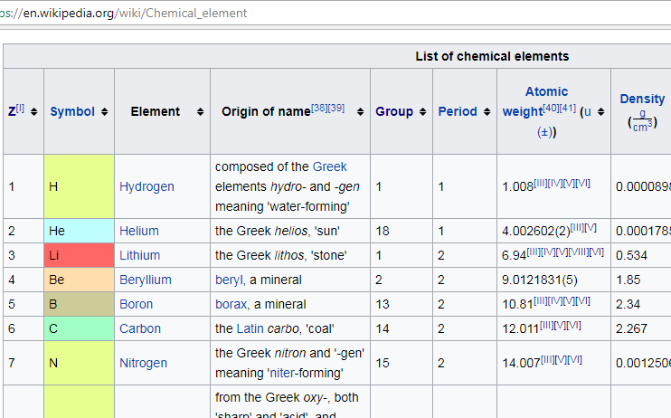

We then copied and pasted the data to Excel.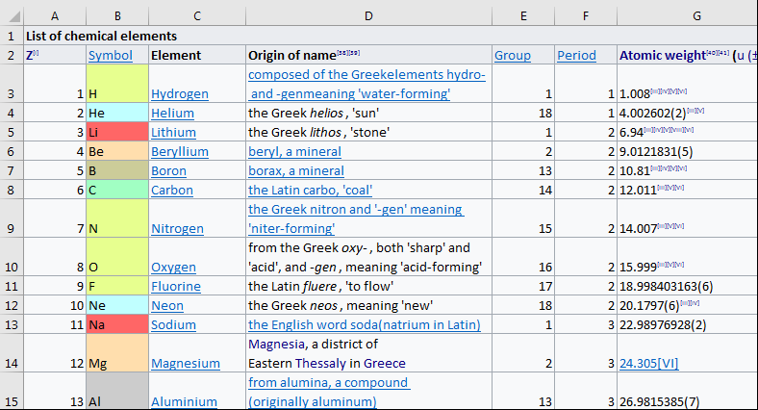

Excel allowed us to isolate the desired fields of data, which we then copied and pasted to a script in the Sierra College Linux server.

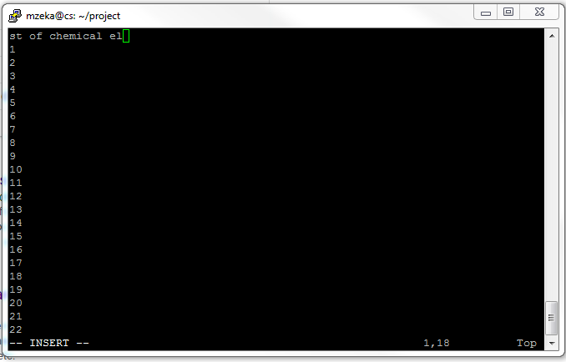

Once we had a copy of the data in a Linux script, we were able to aggregately format the data to PSQL syntax using BASH shell text transformation and formatting commands.

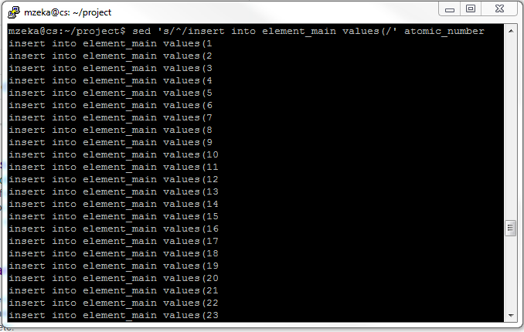

We then pasted our individual scripts of fields of data to a single script, and included a PSQL compatible CREATE TABLE command.

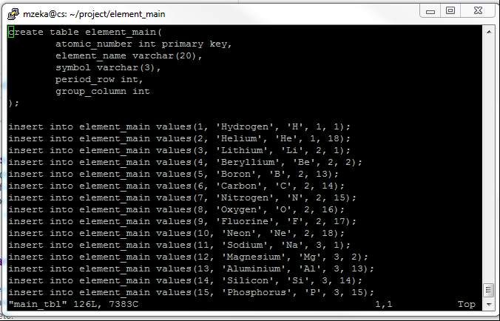

From there we logged into PSQL and imported the scrip.

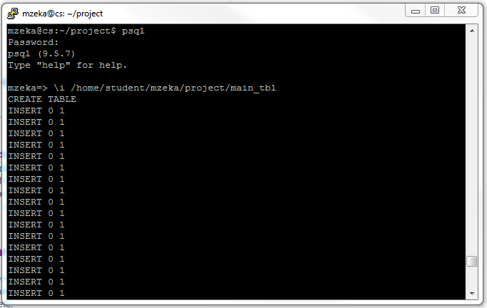

And voila! we had our table.

