Data Exploration

Data Set Overview

The table below lists each of the files available for analysis with a short description of what is found in each one.

|  |  |  |
| --- | --- | --- |
| **File Name** | **Description** | **Fields** |
| ad­clicks.csv | A line is added to this file when a player clicks on an advertisement in the Flamingo app. | timestamp: when the click occurred.  txId: a unique id for the click userSessionid: the id of the user session for the user who made the click teamid: the current team id of the user who made the click userid: the user id of the user who made the click adId: the id of the ad clicked on adCategory: the category/type of ad clicked on |
| buy­clicks.csv | A line is added to this file when a player makes an in­app purchase in the Flamingo app | timestamp: when the purchase was made. txId: a unique id (within buy­clicks.log) for the purchase userSessionId: the id of the user session for the user who made the purchase team: the current team id of the user who made the purchase userId: the user id of the user who made the purchase buyId: the id of the item purchased price: the price of the item purchased |
| users.csv | This file contains a line for each user playing the game. | timestamp: when user first played the game. userId: the user id assigned to the user. nick: the nickname chosen by the user. twitter: the twitter handle of the user. dob: the date of birth of the user. country: the two­letter country code where the user lives. |
| team.csv | This file contains a line for each team terminated in the game. | teamId: the id of the team name: the name of the team teamCreationTime: the timestamp when the team was created teamEndTime: the timestamp when the last member left the team strength: a measure of team strength, roughly corresponding to the success of a team currentLevel: the current level of the team |
| team­assignments.csv | A line is added to this file each time a user joins a team. A user can be in at most a single team at a time. | timestamp: when the user joined the team. team: the id of the team userId: the id of the user assignmentId: a unique id for this assignment |
| level­events.csv | A line is added to this file each time a team starts or finishes a level in the game | timestamp: when the event occurred. eventId: a unique id for the event teamId: the id of the team teamLevel: the level started or completed eventType: the type of event, either start or end |
| user­session.csv | Each line in this file describes a user session, which denotes when a user starts and stops  playing the game. | timestamp: a timestamp denoting when the event occurred. userSessionId: a unique id for the session. userId: the current user's ID. teamId: the current user's team. assignmentId: the team assignment id for the user to the team. sessionType: whether the event is the start or end of a session. teamLevel: the level of the team during this session. platformType: the type of platform of the user during this session. |
| game­clicks.csv | A line is added to this file each time a user performs a click in the game. | timestamp: when the click occurred. clickId: a unique id for the click. userId: the id of the user performing the click. userSessionId: the id of the session of the user when the click is performed. isHit: denotes if the click was on a flamingo (value is 1) or missed the flamingo (value is 0) teamId: the id of the team of the user teamLevel: the current level of the team of the user |

Aggregation

|  |  |
| --- | --- |
| Amount spent buying items | * 21407.0 |
| Number of unique items available to be purchased | 6 |

A histogram showing how many times each item is purchased:

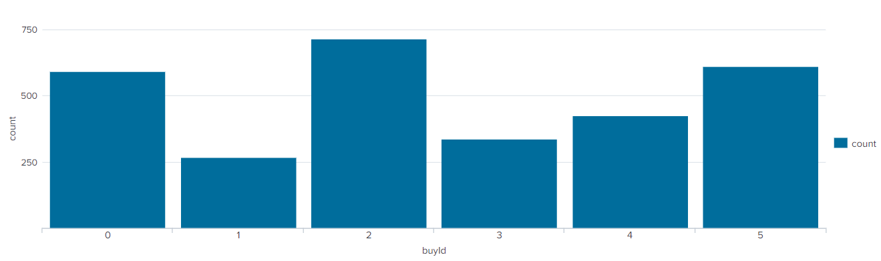

(Query: source="buy-clicks.csv" | stats count by buyId)

A histogram showing how much money was made from each item:

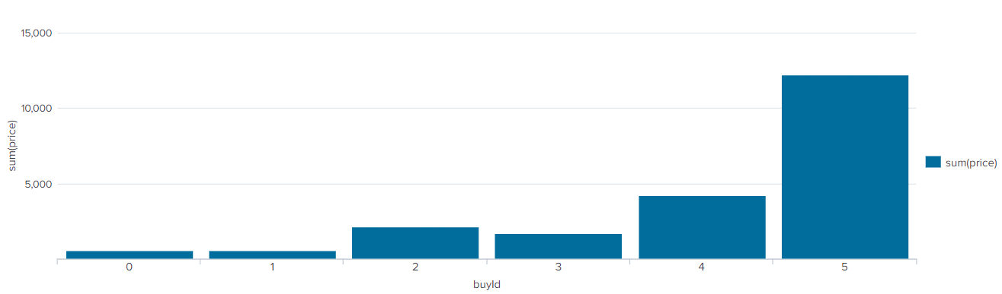

(Query: source="buy-clicks.csv" | stats sum(price) by buyId)

Filtering

A histogram showing total amount of money spent by the top ten users (ranked by how much money they spent).

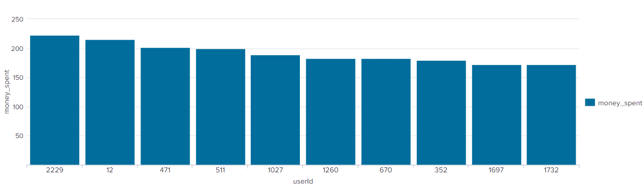

(Query: source="buy-clicks.csv" | stats sum(price) as money_spent by userId | sort 10 -money_spent)

The following table shows the user id, platform, and hit-ratio percentage for the top three buying users:

|  |  |  |  |
| --- | --- | --- | --- |
| **Rank** | **User Id** | **Platform** | **Hit-Ratio (%)** |
| 1 | 229 | iphone | 0.11596958174904944 |
| 2 | 12 | iphone | 0.13068181818181818 |
| 3 | 471 | iphone | 0.1450381679389313 |