Sprint 2 Report
Jimmy Paulson, Person E
UI Developer
The GUI for Notes2Lessons has been fully integrated with the backend components. All previously stubbed features now connect directly to live backend services. The interface supports all required interactions, including login, dashboard navigation, lesson generation, file upload, and viewing generated content. Usability, client‑side validations, and data display from backend APIs have been tested and confirmed to work correctly. Testing with proper connection to the AI service is required to see results.
All GUI components required for Sprint 2 have been completed. The interface now reflects the final design, and correctly behaves with backend logic. The Creator Dashboard includes a sidebar for generating AI content, viewing quizzes/flashcards, and utilizing all creator features. The homepage allows for navigation between the different website features. And the login page allows for account creation, with distinction between creators and learners.
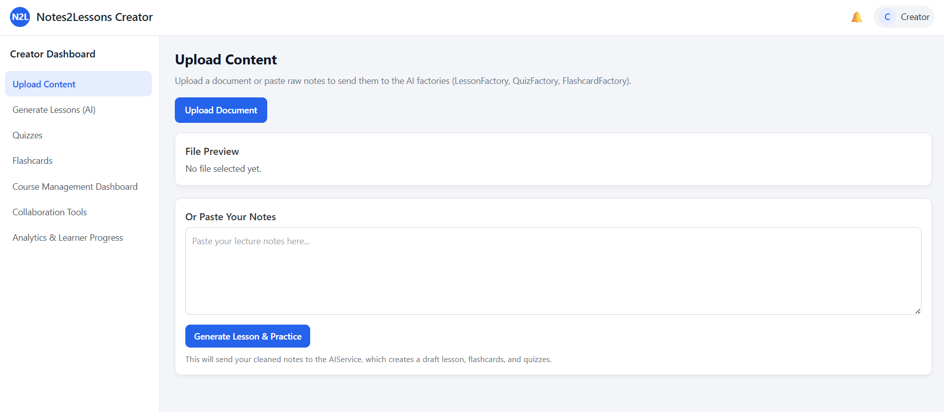
Upload Content
- Connects to backend via AIService.ts
  - Sends user data to the backend, which cleans the submission, sends it to the LLM, and returns it to the frontend
Generate Lessons
- Reads AI-generated lessons from lessonData.draftLesson and displays appropriate results
Quizzes/Flashcards
- Reads from lessonData.quizzes and lessonData.flashcards to display content created by the LLM
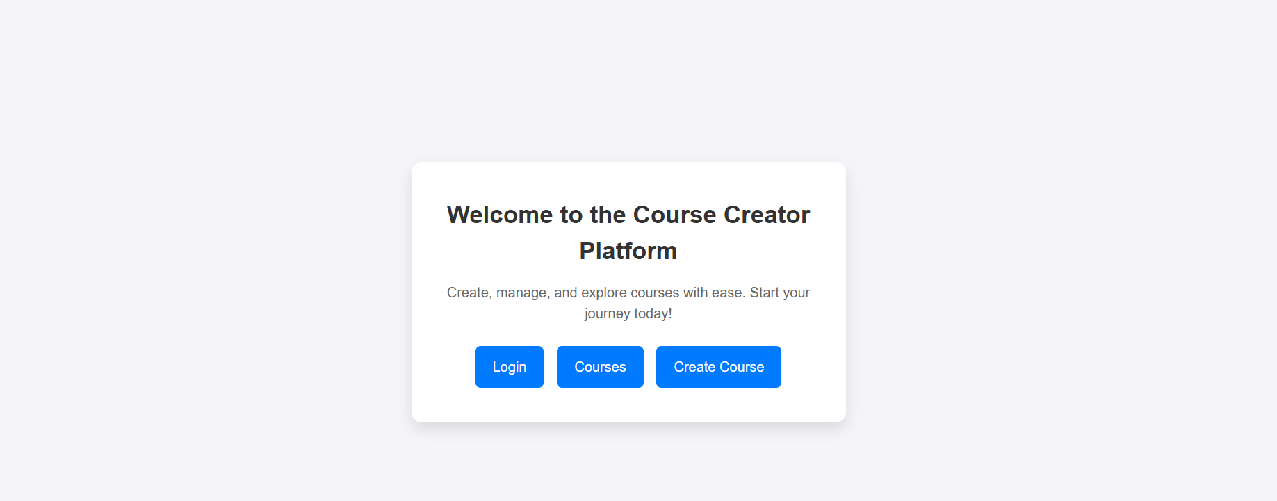
Home Page
- Uses Next.js routing to send users to backend-connected pages
  - Login button routes to /login, which uses Firebase Auth
  - Courses and Create Course buttons route to pages that connect to AIService and future course backend features
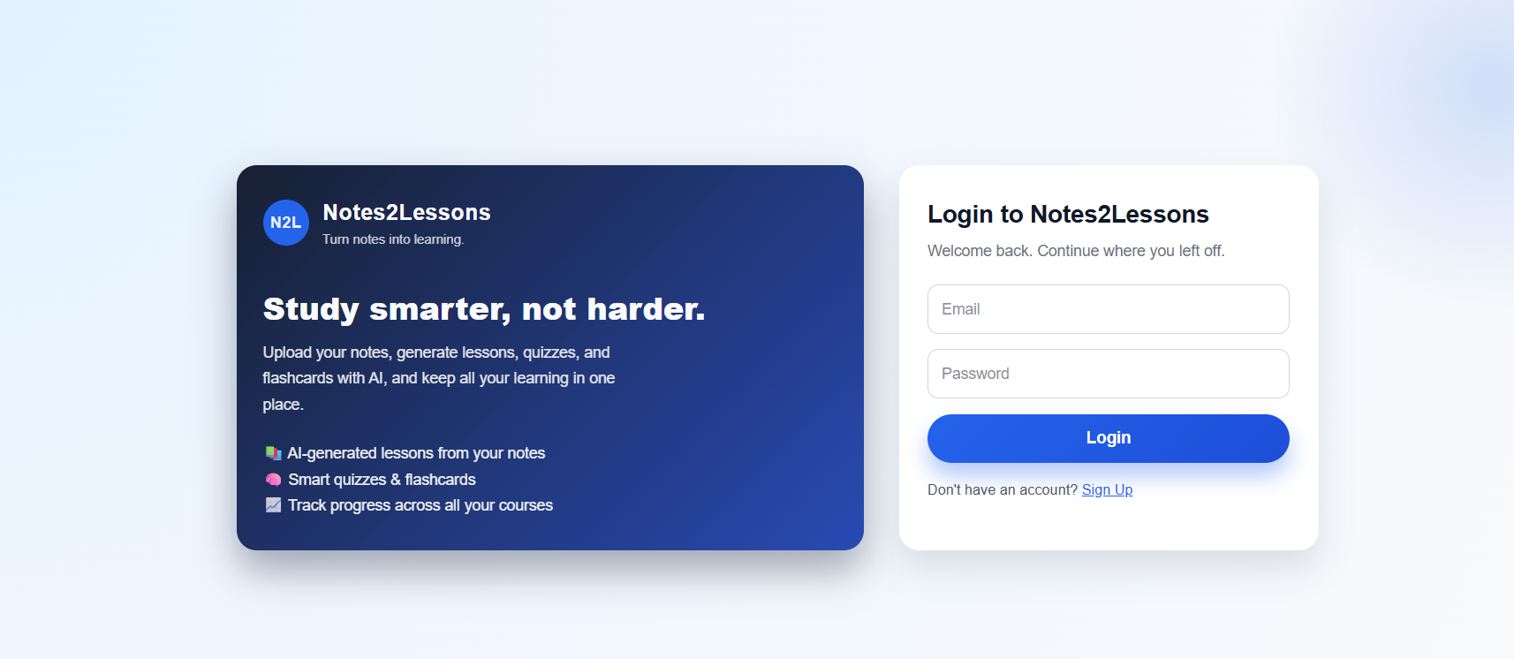
Login Page
- Connects directly to Firebase Authentication backend
  - Login form calls signInWithEmailAndPassword to authenticate the user
  - Sign Up flow calls createUserWithEmailAndPassword to register a new user
  - On success, redirects the user to the home / creator dashboard pages that use the AI and course backends

GUI Testing Results
Test Case ID: TC-UI-12
Test Name: Visual Accuracy, Final Layout
Preconditions: Application is running, user on main dashboard.
Input: Visually inspect layout consistency across all screens.
Expected Result: UI displays correctly with no misalignment or missing elements.
Status: passed
Test Case ID: TC-UI-14
Test Name: Usability, Completing Core Workflow
Preconditions: User is logged in.
Input: User uploads notes, generates lessons, views flashcards/quizzes, and navigates panels.
Expected Result: User completes all tasks without confusion; all workflows require minimal steps.
Status: passed
Test Case ID: TC-UI-17
Test Name: Client-Side Validation, Missing Form Input
Preconditions: User is logged in.
Input: User attempts to submit an empty form or invalid data.
Expected Result: UI prevents invalid submission and displays a clear error message.
Status: passed
Test Case ID: TC-UI-21
Test Name: Displaying Backend Data
Preconditions: Backend responds with valid lesson and quiz content.
Input: Submit valid notes and wait for backend response.
Expected Result: All returned JSON fields appear correctly in the correct visual sections.
Status: passed
Integration Tests
Test Case ID: IT-07
Test Name: GUI → Backend → GUI Round Trip
Preconditions: User logged in, dashboard active.
Input: Valid notes submitted using Generate Lesson.
Expected Result: GUI sends request, backend processes notes, AI generates response, GUI displays final processed output.
Status: passed
Test Case ID: IT-09
Test Name: Error Handling on Backend Failure
Preconditions: Backend temporarily offline or slow.
Input: User attempts lesson generation.
Expected Result: GUI handles error gracefully, shows user‑friendly message, and remains responsive.
Status: passed
Regression Testing Summary
All Sprint 1 GUI and integration test cases were re-run. Updated backend wiring introduced no new UI failures.

