Lifecycle Management

Step 1: Click on Add a Rule.

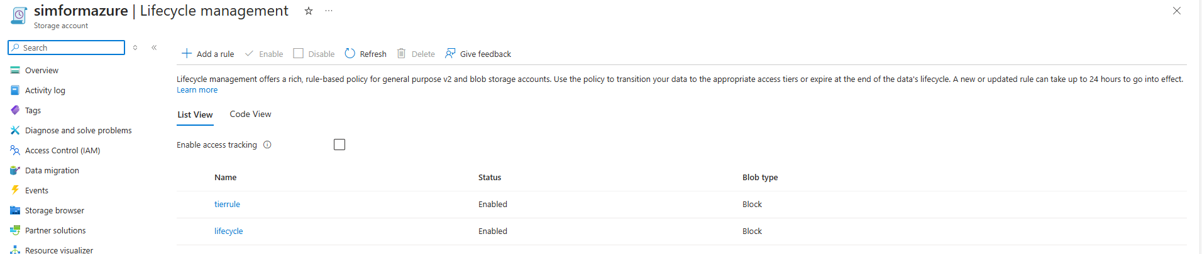

Step 2: Add details about the Rule.

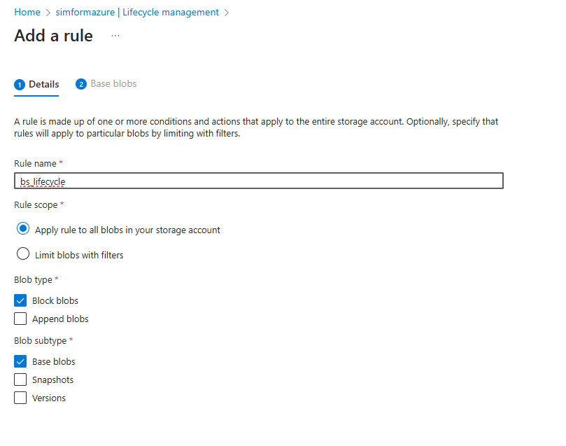

Step 3: Add the blobs.

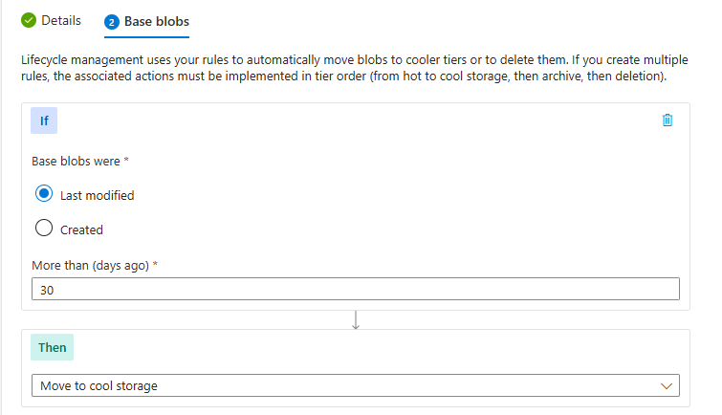

All the blobs.

