Dataset Task

1. Source dataset (CSV File)

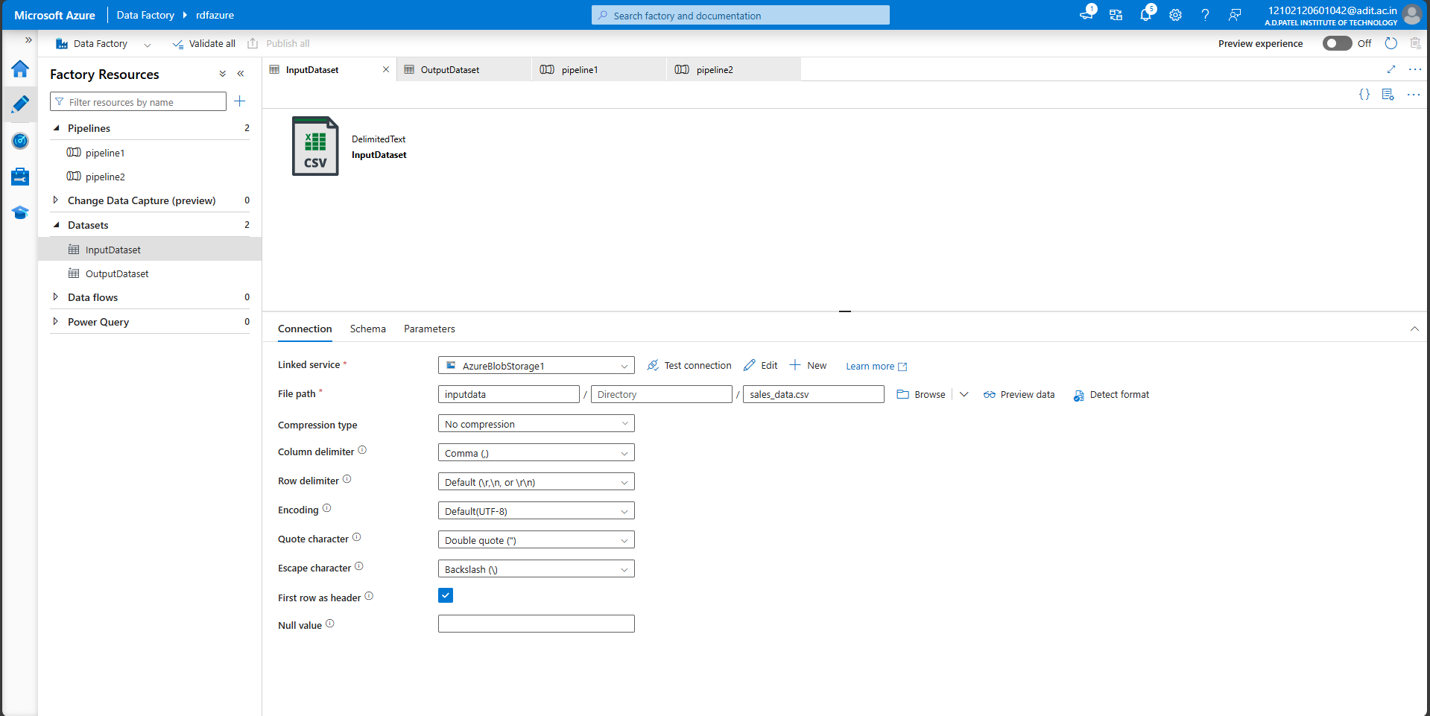

1. Destination dataset (Azure SQL Database)

