1. Create an [Azure Storage](https://lms.simformsolutions.com/mod/quiz/view.php?id=2209) account (with hierarchical namespace)

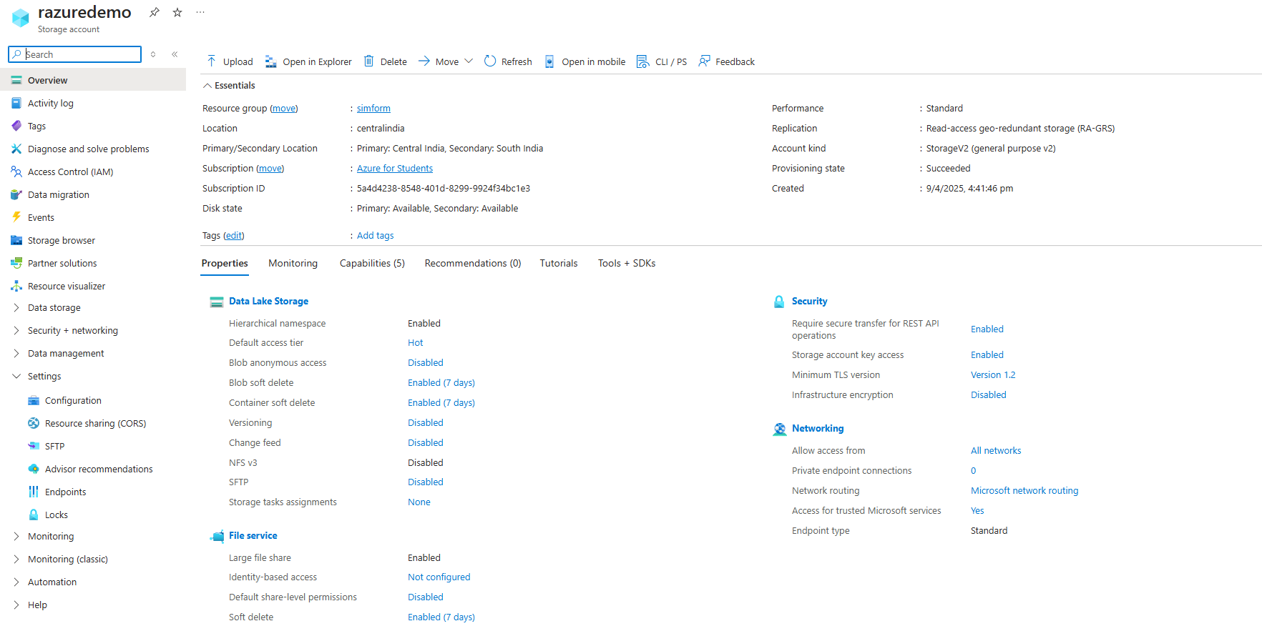

1. Upload an unstructured file inside a container (container name: -data)

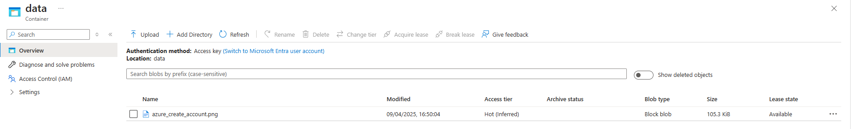

1. Delete storage account.

