TRANSACTIONS ASSIGNMENT

* TASK A: Dirty read

Isolation level - READ UNCOMMITTED:

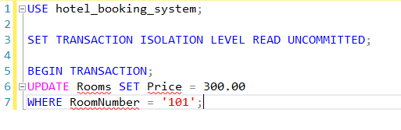

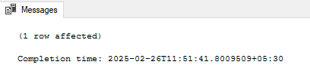

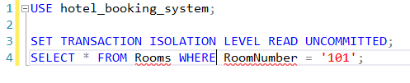

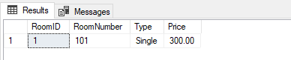

Since, READ UNCOMMITTED allows Dirty read a transaction can read uncommitted changes.

Isolation Level - READ COMMITTED

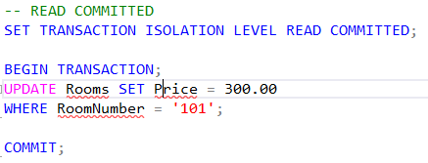



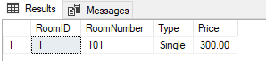

* Task B: Non-Repeatable Read

Isolation Level - READ COMMITTED

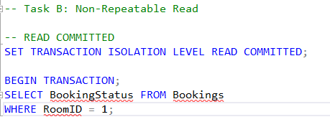

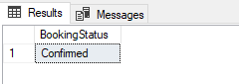

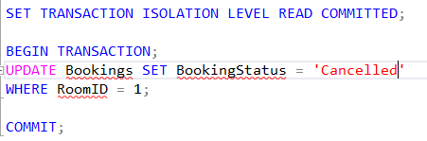

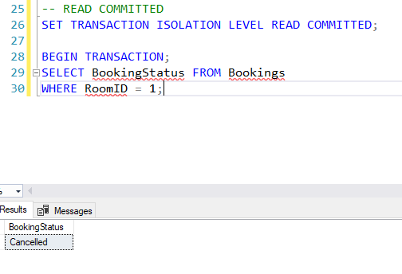

Here we can observe that first transaction returns a record and after that we perform update operation in another transaction and we can see that the data is updated in other transaction thus performing non repeatable read.

REPEATABLE READ

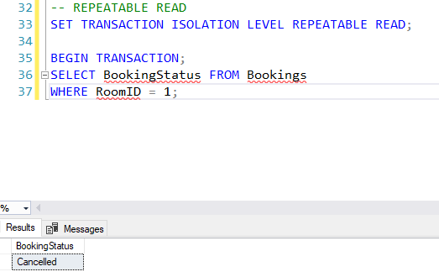

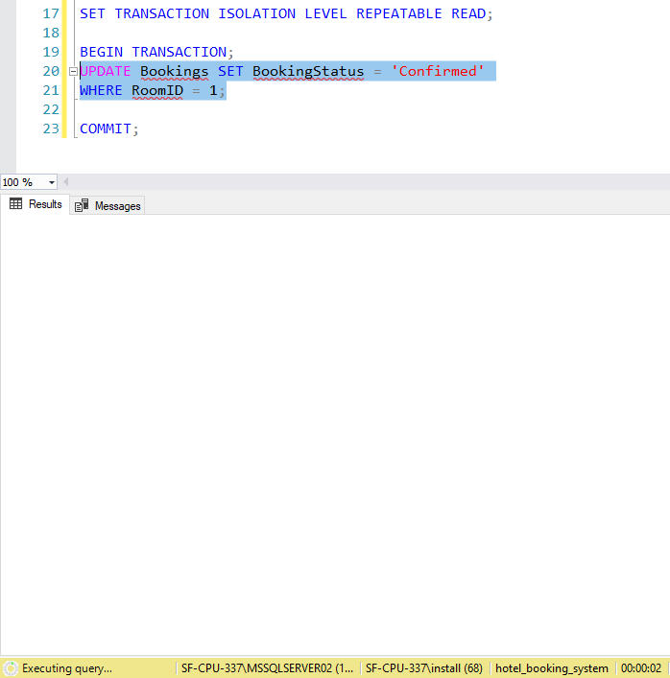

Here, Session 1 has applied lock on RoomId = 1hence session 2 cannot update the data.

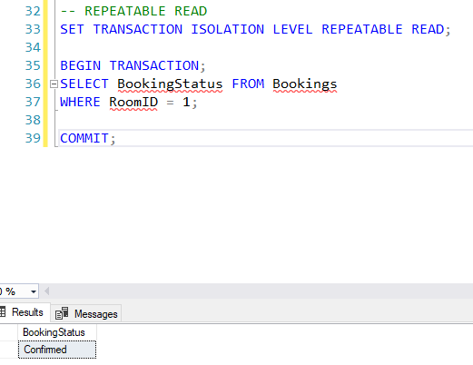

After commiting the session 1 transaction we can update the data for RoomID = 1

* TASK 4: Phantom Read

REPEATABLE READ

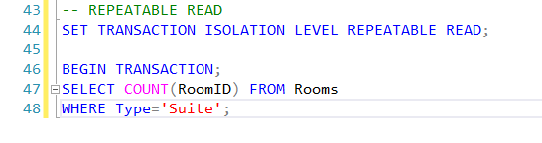

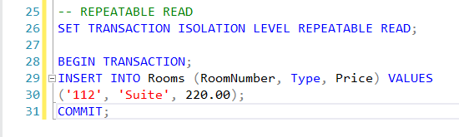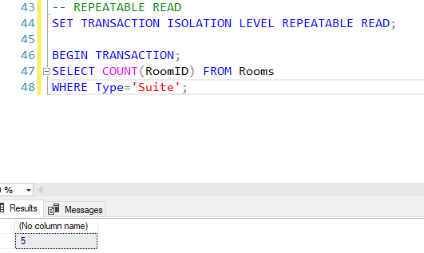

SERIALIZABLE

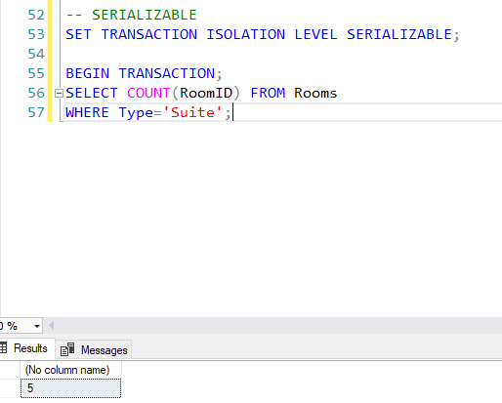

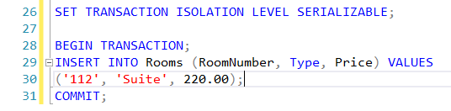

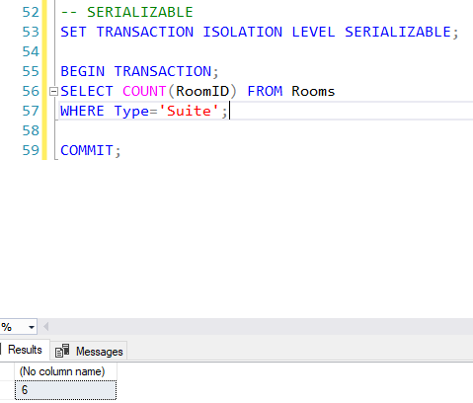

Here, as one transaction is getting executed in Session 1 another transaction cannot execute concurrently.

After commiting the data in Session 1 another transaction can execute.