一、EXT4文件系统介绍
1、磁盘布局
一个Ext4文件系统被分成一系列块组。为减少磁盘碎片产生的性能瓶颈，块分配器尽量保持每个文件的数据块都在同一个块组中，从而减少寻道时间。
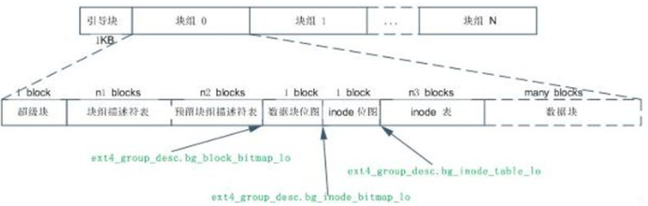
Ext4文件系统主要使用块组0中的超级块和块组描述符表，在其他一些特定块组（1、3、5、7、9）中有超级块和块组描述符表的冗余备份。如果块组中不含冗余备份，那么块组就以数据块位图开始。当格式化磁盘成为Ext4文件系统的时候，mkfs将在块组描述符表后面分配预留GDT表数据块(“Reserve GDT blocks”)以用于将来扩展文件系统。紧接在预留GDT表数据块后的是数据块位图与inode表位图，这两个位图分别表示本块组内的数据块与inode表的使用，inode表数据块之后就是存储文件的数据块了。在这些各种各样的块中，超级块、GDT、块位图、Inode位图都是整个文件系统的元数据，inode表也是文件系统的元数据，但是inode表项与文件一一对应，所以inode算是文件的元数据。实际格式化文件系统的时候，除了已经使用的十来个外，其他inode表中实际上是没有任何数据，直到创建了相应的文件才会分配inode表，文件系统才会在inode表中写入与文件相关的inode信息。
2、超块
超级块记录整个文件系统的大量信息，如数据块个数、inode个数、支持的特性、管理信息。文件系统管理器利用它们来使用和维护文件系统。对于逻辑块为4k的EXT4文件系统，超块占据0块组0号块1024至2047共1024个字节。通常安装文件系统时只读取数据块组0中的超块，但是为了防止文件系统被破坏, 1、3、5、7、9号数据块组都包含了复制拷贝。
struct ext4_super_block {
/*00*/ __le32 s_inodes_count; /* Inodes count */
__le32 s_blocks_count_lo; /* Blocks count */
__le32 s_r_blocks_count_lo; /* Reserved blocks count */
__le32 s_free_blocks_count_lo; /* Free blocks count */
/*10*/ __le32 s_free_inodes_count; /* Free inodes count */
__le32 s_first_data_block; /* First Data Block */
__le32 s_log_block_size; /* Block size */
__le32 s_log_cluster_size; /* Allocation cluster size */
/*20*/ __le32 s_blocks_per_group; /* # Blocks per group */
__le32 s_clusters_per_group; /* # Clusters per group */
__le32 s_inodes_per_group; /* # Inodes per group */
__le32 s_mtime; /* Mount time */
/*30*/ __le32 s_wtime; /* Write time */
__le16 s_mnt_count; /* Mount count */
__le16 s_max_mnt_count; /* Maximal mount count */
__le16 s_magic; /* Magic signature */
__le16 s_state; /* File system state */
__le16 s_errors; /* Behaviour when detecting errors */
__le16 s_minor_rev_level; /* minor revision level */
/*40*/ __le32 s_lastcheck; /* time of last check */
__le32 s_checkinterval; /* max. time between checks */
__le32 s_creator_os; /* OS */
__le32 s_rev_level; /* Revision level */
/*50*/ __le16 s_def_resuid; /* Default uid for reserved blocks */
__le16 s_def_resgid; /* Default gid for reserved blocks */
/*
* These fields are for EXT4_DYNAMIC_REV superblocks only.
*
* Note: the difference between the compatible feature set and
* the incompatible feature set is that if there is a bit set
* in the incompatible feature set that the kernel doesn't
* know about, it should refuse to mount the filesystem.
*
* e2fsck's requirements are more strict; if it doesn't know
* about a feature in either the compatible or incompatible
* feature set, it must abort and not try to meddle with
* things it doesn't understand...
*/
__le32 s_first_ino; /* First non-reserved inode */
__le16 s_inode_size; /* size of inode structure */
__le16 s_block_group_nr; /* block group # of this superblock */
__le32 s_feature_compat; /* compatible feature set */
/*60*/ __le32 s_feature_incompat; /* incompatible feature set */
__le32 s_feature_ro_compat; /* readonly-compatible feature set */
/*68*/ __u8 s_uuid[16]; /* 128-bit uuid for volume */
/*78*/ char s_volume_name[16]; /* volume name */
/*88*/ char s_last_mounted[64]; /* directory where last mounted */
/*C8*/ __le32 s_algorithm_usage_bitmap; /* For compression */
/*
* Performance hints. Directory preallocation should only
* happen if the EXT4_FEATURE_COMPAT_DIR_PREALLOC flag is on.
*/
__u8 s_prealloc_blocks; /* Nr of blocks to try to preallocate*/
__u8 s_prealloc_dir_blocks; /* Nr to preallocate for dirs */
__le16 s_reserved_gdt_blocks; /* Per group desc for online growth */
/*
* Journaling support valid if EXT4_FEATURE_COMPAT_HAS_JOURNAL set.
*/
/*D0*/ __u8 s_journal_uuid[16]; /* uuid of journal superblock */
/*E0*/ __le32 s_journal_inum; /* inode number of journal file */
__le32 s_journal_dev; /* device number of journal file */
__le32 s_last_orphan; /* start of list of inodes to delete */
__le32 s_hash_seed[4]; /* HTREE hash seed */
__u8 s_def_hash_version; /* Default hash version to use */
__u8 s_jnl_backup_type;
__le16 s_desc_size; /* size of group descriptor */
/*100*/ __le32 s_default_mount_opts;
__le32 s_first_meta_bg; /* First metablock block group */
__le32 s_mkfs_time; /* When the filesystem was created */
__le32 s_jnl_blocks[17]; /* Backup of the journal inode */
/* 64bit support valid if EXT4_FEATURE_COMPAT_64BIT */
/*150*/ __le32 s_blocks_count_hi; /* Blocks count */
__le32 s_r_blocks_count_hi; /* Reserved blocks count */
__le32 s_free_blocks_count_hi; /* Free blocks count */
__le16 s_min_extra_isize; /* All inodes have at least # bytes */
__le16 s_want_extra_isize; /* New inodes should reserve # bytes */
__le32 s_flags; /* Miscellaneous flags */
__le16 s_raid_stride; /* RAID stride */
__le16 s_mmp_update_interval; /* # seconds to wait in MMP checking */
__le64 s_mmp_block; /* Block for multi-mount protection */
__le32 s_raid_stripe_width; /* blocks on all data disks (N*stride)*/
__u8 s_log_groups_per_flex; /* FLEX_BG group size */
__u8 s_reserved_char_pad;
__le16 s_reserved_pad;
__le64 s_kbytes_written; /* nr of lifetime kilobytes written */
__le32 s_snapshot_inum; /* Inode number of active snapshot */
__le32 s_snapshot_id; /* sequential ID of active snapshot */
__le64 s_snapshot_r_blocks_count; /* reserved blocks for active
snapshot's future use */
__le32 s_snapshot_list; /* inode number of the head of the
on-disk snapshot list */
#define EXT4_S_ERR_START offsetof(struct ext4_super_block, s_error_count)
__le32 s_error_count; /* number of fs errors */
__le32 s_first_error_time; /* first time an error happened */
__le32 s_first_error_ino; /* inode involved in first error */
__le64 s_first_error_block; /* block involved of first error */
__u8 s_first_error_func[32]; /* function where the error happened */
__le32 s_first_error_line; /* line number where error happened */
__le32 s_last_error_time; /* most recent time of an error */
__le32 s_last_error_ino; /* inode involved in last error */
__le32 s_last_error_line; /* line number where error happened */
__le64 s_last_error_block; /* block involved of last error */
__u8 s_last_error_func[32]; /* function where the error happened */
#define EXT4_S_ERR_END offsetof(struct ext4_super_block, s_mount_opts)
__u8 s_mount_opts[64];
__le32 s_usr_quota_inum; /* inode for tracking user quota */
__le32 s_grp_quota_inum; /* inode for tracking group quota */
__le32 s_overhead_clusters; /* overhead blocks/clusters in fs */
__le32 s_reserved[109]; /* Padding to the end of the block */
};
3、组描述符
每个数据块组都拥有一个描叙它的结构。EXT4文件系统的组描述符长64个字节，占据0块组1至2号块。像超块一样，所有数据块组中的组描叙符除了存放在0号块组中，还被复制到1、3、5、7、9号块组中以防文件系统崩溃。
struct ext4_group_desc
{
__le32 bg_block_bitmap_lo; /* Blocks bitmap block */
__le32 bg_inode_bitmap_lo; /* Inodes bitmap block */
__le32 bg_inode_table_lo; /* Inodes table block */
__le16 bg_free_blocks_count_lo;/* Free blocks count */
__le16 bg_free_inodes_count_lo;/* Free inodes count */
__le16 bg_used_dirs_count_lo; /* Directories count */
__le16 bg_flags; /* EXT4_BG_flags (INODE_UNINIT, etc) */
__u32 bg_reserved[2]; /* Likely block/inode bitmap checksum */
__le16 bg_itable_unused_lo; /* Unused inodes count */
__le16 bg_checksum; /* crc16(sb_uuid+group+desc) */
__le32 bg_block_bitmap_hi; /* Blocks bitmap block MSB */
__le32 bg_inode_bitmap_hi; /* Inodes bitmap block MSB */
__le32 bg_inode_table_hi; /* Inodes table block MSB */
__le16 bg_free_blocks_count_hi;/* Free blocks count MSB */
__le16 bg_free_inodes_count_hi;/* Free inodes count MSB */
__le16 bg_used_dirs_count_hi; /* Directories count MSB */
__le16 bg_itable_unused_hi; /* Unused inodes count MSB */
__u32 bg_reserved2[3];
};
4、索引节点inode
inode结构描叙文件中数据占据哪个块以及文件的存取权限、文件修改时间及文件类型。EXT4文件系统中的每个文件用一个inode来表示且每个inode有唯一的编号。每个数据块组的inode被保存在该块组的inode表中, 同时还有一个位图被系统用来跟踪已分配和未分配的inode。
struct ext4_inode {
__le16 i_mode; /* File mode */
__le16 i_uid; /* Low 16 bits of Owner Uid */
__le32 i_size_lo; /* Size in bytes */
__le32 i_atime; /* Access time */
__le32 i_ctime; /* Inode Change time */
__le32 i_mtime; /* Modification time */
__le32 i_dtime; /* Deletion Time */
__le16 i_gid; /* Low 16 bits of Group Id */
__le16 i_links_count; /* Links count */
__le32 i_blocks_lo; /* Blocks count */
__le32 i_flags; /* File flags */
union {
struct {
__le32 l_i_version;
} linux1;
struct {
__u32 h_i_translator;
} hurd1;
struct {
__u32 m_i_reserved1;
} masix1;
} osd1; /* OS dependent 1 */
__le32 i_block[EXT4_N_BLOCKS];/* Pointers to blocks */
__le32 i_generation; /* File version (for NFS) */
__le32 i_file_acl_lo; /* File ACL */
__le32 i_size_high;
__le32 i_obso_faddr; /* Obsoleted fragment address */
union {
struct {
__le16 l_i_blocks_high; /* were l_i_reserved1 */
__le16 l_i_file_acl_high;
__le16 l_i_uid_high; /* these 2 fields */
__le16 l_i_gid_high; /* were reserved2[0] */
__u32 l_i_reserved2;
} linux2;
struct {
__le16 h_i_reserved1; /* Obsoleted fragment number/size which are removed in ext4 */
__u16 h_i_mode_high;
__u16 h_i_uid_high;
__u16 h_i_gid_high;
__u32 h_i_author;
} hurd2;
struct {
__le16 h_i_reserved1; /* Obsoleted fragment number/size which are removed in ext4 */
__le16 m_i_file_acl_high;
__u32 m_i_reserved2[2];
} masix2;
} osd2; /* OS dependent 2 */
__le16 i_extra_isize;
__le16 i_pad1;
__le32 i_ctime_extra; /* extra Change time (nsec << 2 | epoch) */
__le32 i_mtime_extra; /* extra Modification time(nsec << 2 | epoch) */
__le32 i_atime_extra; /* extra Access time (nsec << 2 | epoch) */
__le32 i_crtime; /* File Creation time */
__le32 i_crtime_extra; /* extra FileCreationtime (nsec << 2 | epoch) */
__le32 i_version_hi; /* high 32 bits for 64-bit version */
};
EXT4文件系统每个块组中有8192个inode，每个inode占256字节，逻辑块大小4k，所以每个块组的inode表占512个块。

5、数据块位图与inode位图
数据块位图跟踪块组中数据块使用情况。Inode位图跟踪块组中Inode使用情况。每个位图一个数据块，每一位用0或1表示一个块组中数据块或inode表中inode的使用情况。如果一个数据块大小是4KB的话，那一个位图块可以表示4*1024*8个数据块的使用情况，这也是单个块组具有的最大数据块个数。这样可以算出一个块组大小是128MB。当然一个位图块也可以表示4*1024*8个inode的使用情况，但是实际上一个块组中即使存满了文件，也不会用到这么多的inode，因为实际系统中基本不会出现所有文件大小都小于等于1个数据块大小的情况。通过运行下边的程序会读出，EXT4文件系统一个块组中有8192个inode，因此只需要占用8192/8=1024个字节的位图即可。
二、check_ext4fs运行说明
该程序是一个ext4文件系统查看器.可以打开镜像文件及硬盘设备文件查看具体的文件系统结构信息,如超级块，块组信息，文件inode。
1、查看主硬盘设备名、挂载目录及文件系统信息

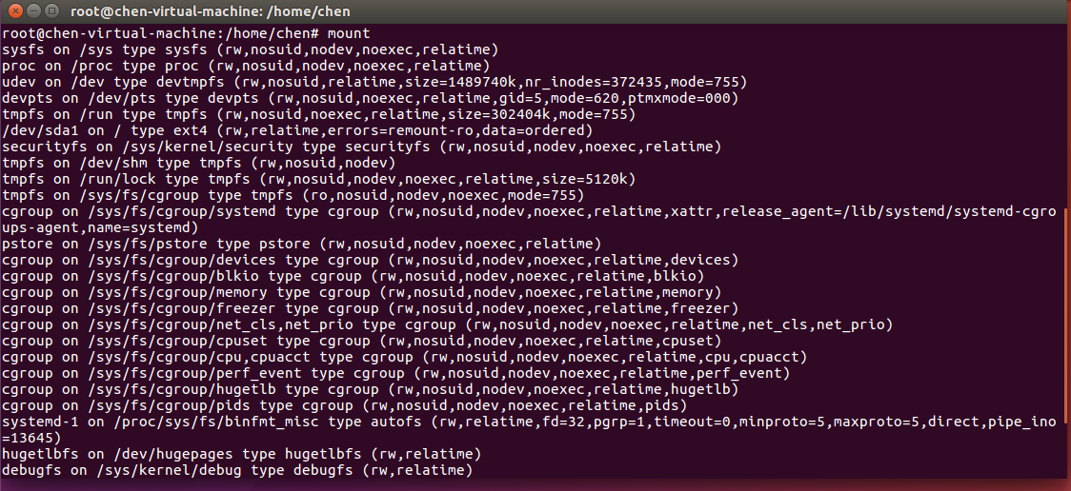
可查出是ext4文件系统，说明可以运行本程序；主硬盘对应/dev/sda1文件；挂载目录为根目录/。
2、程序编译
进入check_ext4fs目录，输入 make clean; make编译程序，生成check_ext4fs程序：
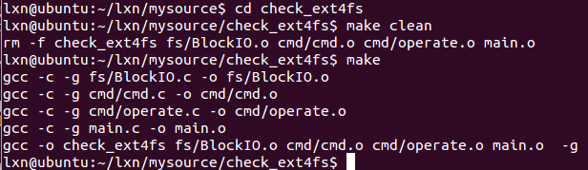
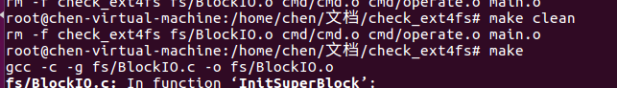
3、程序运行
#./check_ext4fs /dev/sda1
成功运行程序进入命令输入状态。
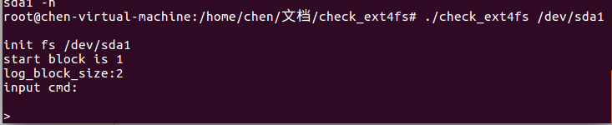
4、命令使用
共有以下命令：
info sb 查看超级块信息
info inode num 查看序号为num的inode信息
info groups [start, end] 查看inode组描述
quit 退出
三、dumpe2fs命令说明
1、命令名称
dumpe2fs - 显示ext2/ext3/ext4文件系统信息。
2、dumpe2fs命令语法
dumpe2fs [ -bfhixV ] [ -o superblock=superblock ] [ -o blocksize=blocksize ] device
3、dumpe2fs命令描述
显示device中文件系统的超级块和块组信息。
4、dumpe2fs常用命令选项
选项 | 描述
-b | 打印文件系统中的坏块
-o | 不常用，检查严重损坏文件系统时指定
-f | 强制显示所有信息，即便dumpe2fs对有些文件系统功能标识不能识别。
- i | 显示image文件系统信息。device指定image文件的路径
-h | 只显示超级块信息
-x | 将已分组的块的数量用十六进制显示
-v | 显示dumpe2fs的版本号并推出
5、dumpe2fs命令实例
dumpe2fs查看/dev/sda1的文件系统信息。如下图所示，仅是一部分信息：

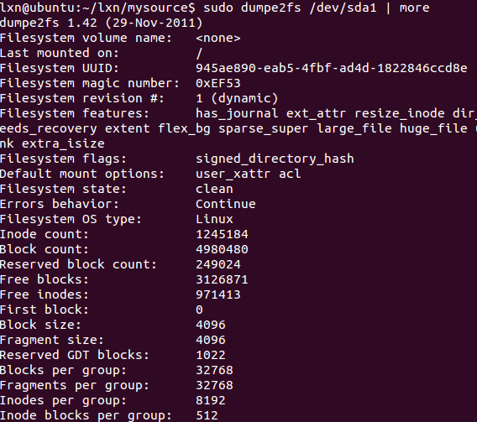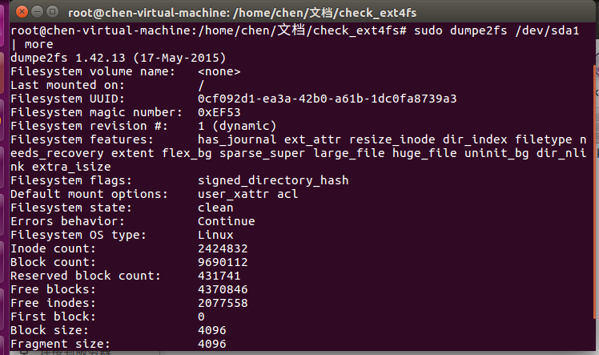
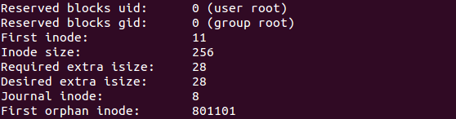
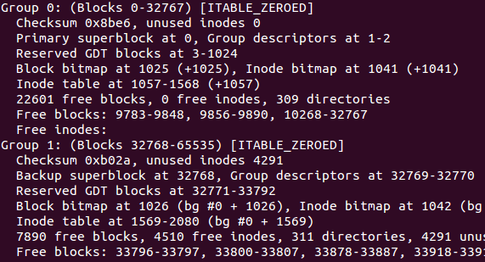
四、参考
http://blog.chinaunix.net/uid-26430381-id-4559491.html
http://blog.csdn.net/robinlovesnow/article/details/7567037
LinuxEXT4文件系统分析_陆亚文.pdf
