CS 211A Professional: Visual Computing

Yuchun Liu (71562305)

Jiawei Gu()

Part 2

The purpose of this section is to identify the calibration matrix for each set. To achieve such goal, we first hand-picked 6 known points in each picture for calibrations (attachment Map_data.txt).

For simplicity, we apply direct linear calibration using inhomogeneous equation shown as following:

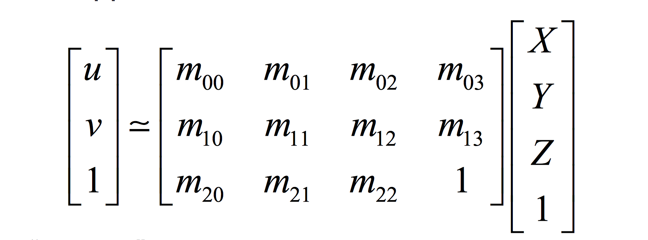

*Eq.1 : inhomogeneous equation for calibration*

By applying Eq. 1 to the data sets we have eleven linear equations which can be solved by singular value decomposition. As the results we have following calibration matrix. we compute total of 12 calibration matrices, we only showed two pairs from each set. To get all the matrices, you can check attachment: data->set1_cali_matrix, data->set2_cali_matrix;

SET1:

DSCF4177.jpg:

9.86182616871222 2.77493323392337 0.979039055781119 179.973111855798

2.38494688567054 -5.67809065158610 -7.63081865268084 1574.30102608971

0 0 0 1

DSCF4178.jpg:

4.94599369380190 7.44234807141033 -1.65655324253830 200.914975656279

3.42709348689072 -3.57895574475780 -10.0627797708194 978.582410419609

0 0 0 1

SET2:

DCCF4188.jpg

-6.54522275219185 6.86769035958565 1.27591085532591 1485.57318259880

4.52962103122424 2.05251344680348 -8.88584647096844 542.065821259157

0 0 0 1

DCCF4189.jpg

-8.42368973962904 6.55099058407332 -3.71168788774072 1652.74131408290

2.89279580917915 1.54839417178240 -9.20588447884088 743.701068289150

0 0 0 1

After getting the calibration matrix, we could perform the RQ decomposition to get the intrinsic and extrinsic matrix (Attachment: code -> cali_decompose.m, code -> part2.m). In order to test our matrices, we plot reconstruct images using the data from part three, here are the results:

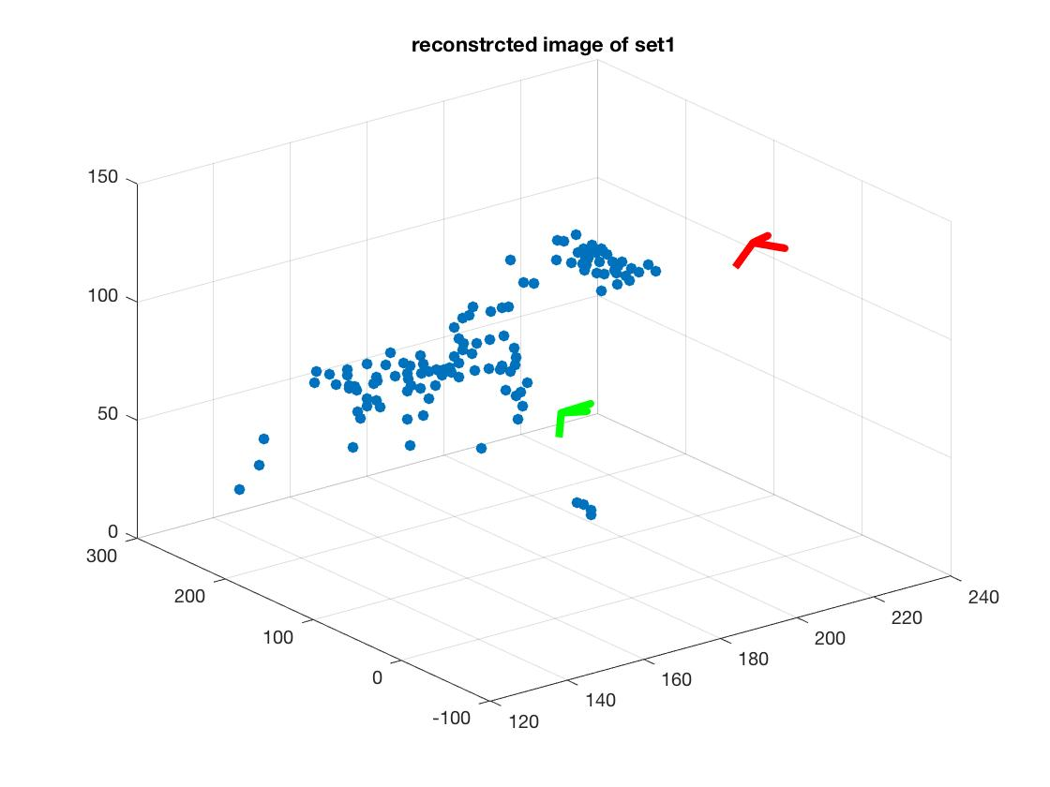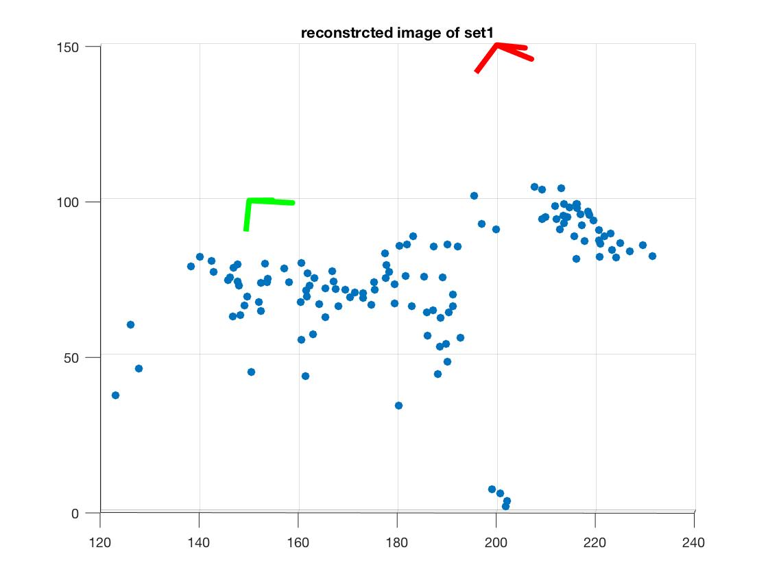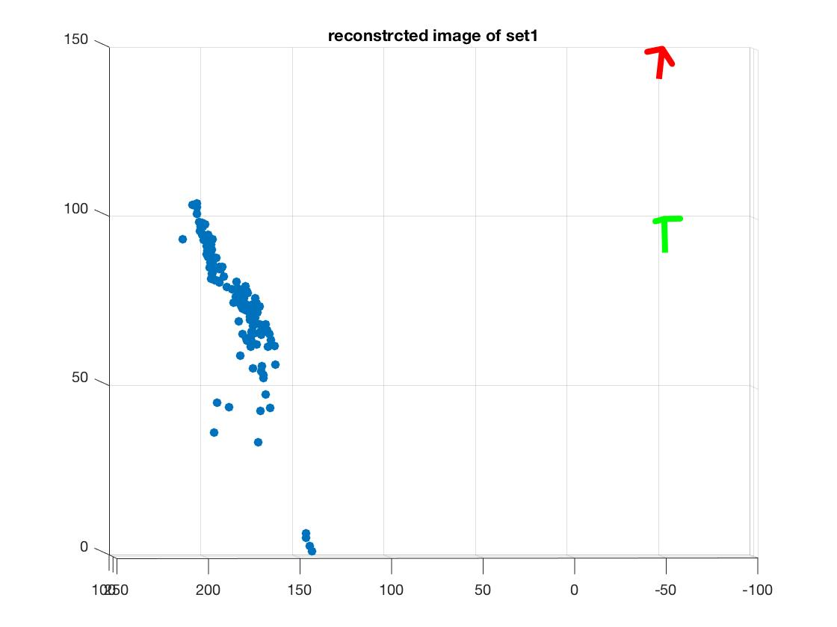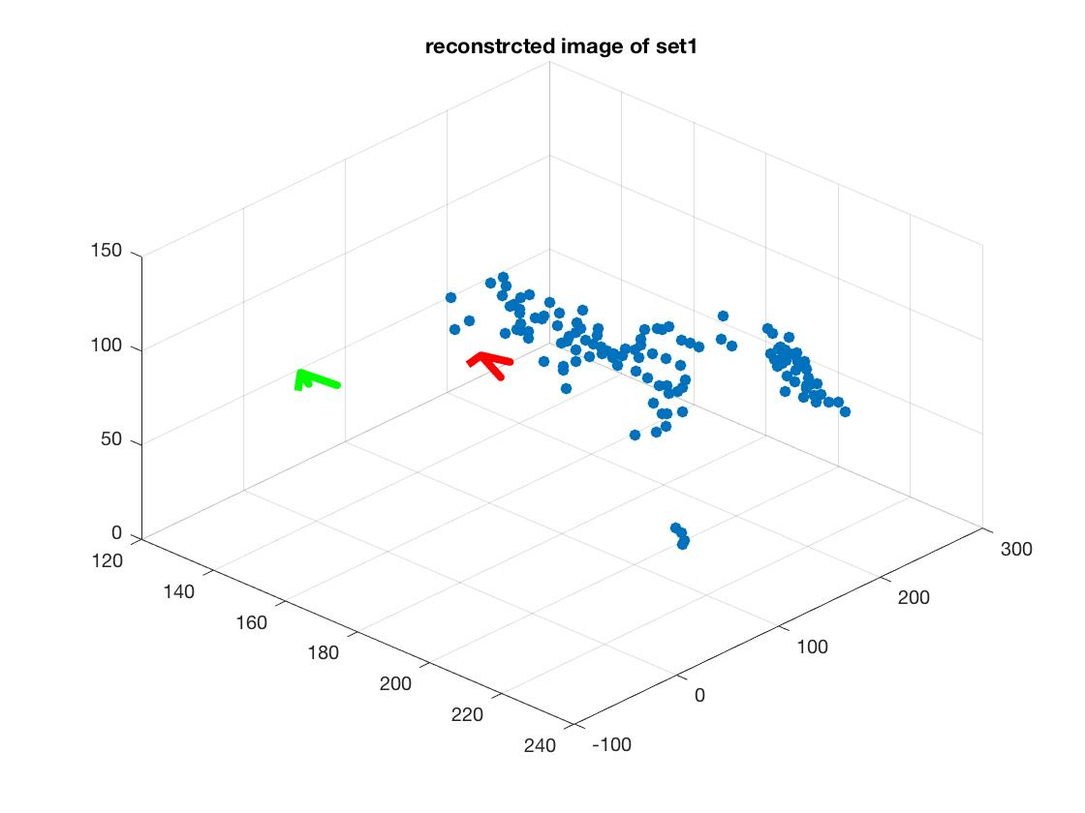

*Figure 2-1: (1,1) and (2,2) shows the overall of reconstructed image from set one. (1,2) and (2,1) shows the side view of the reconstructed images. Notice: because in this set the most corresponding points are taken from one side of the horse; therefore, we can see the pictures present the shape of half of horse contour.*

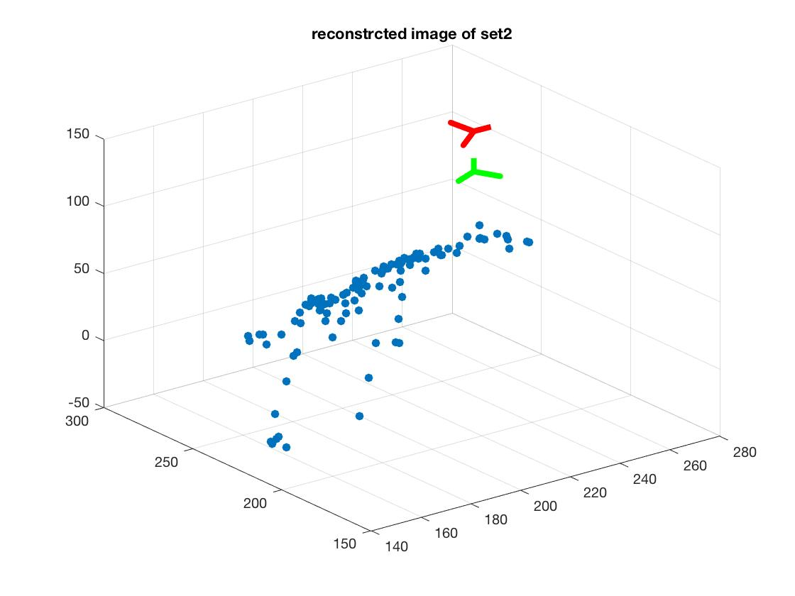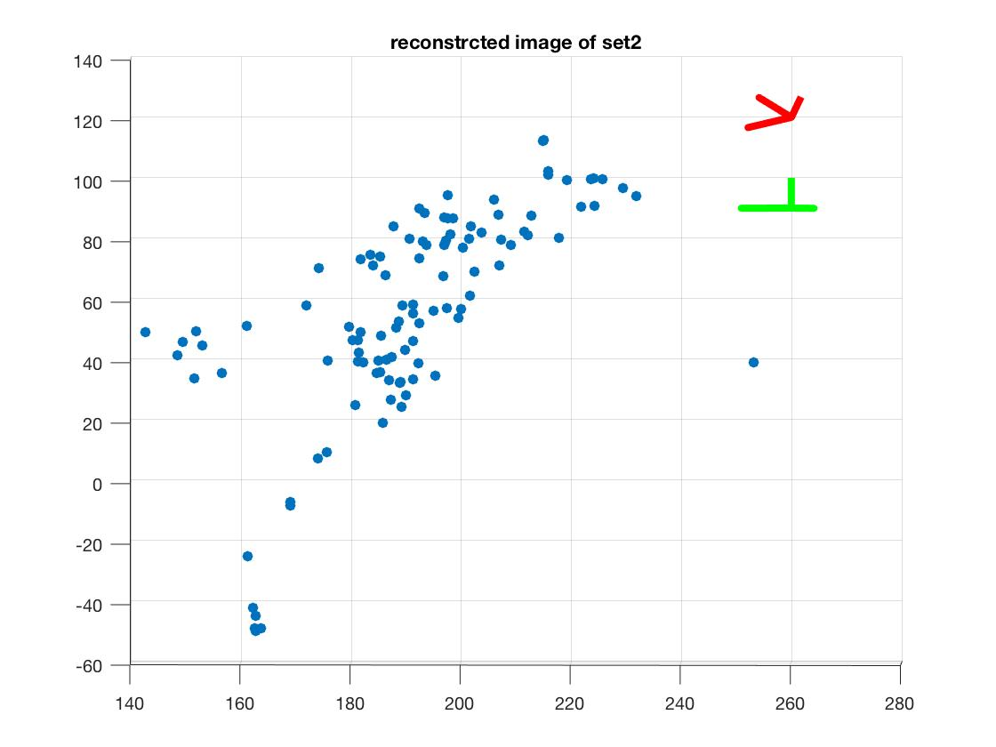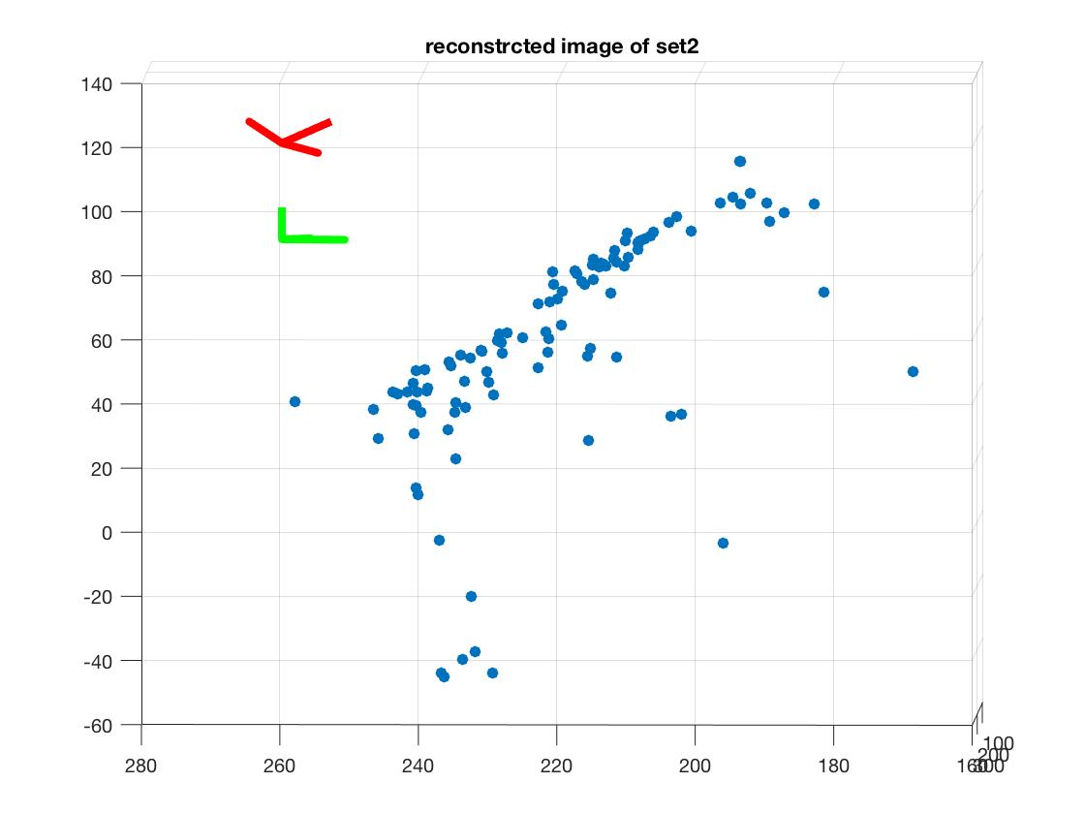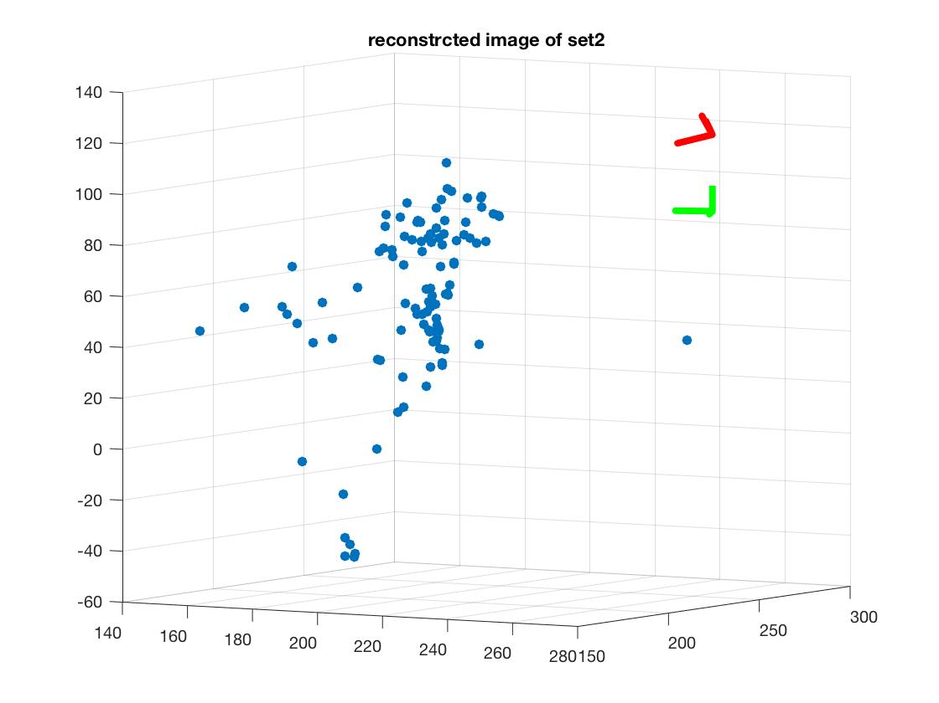

*Figure 2-2: (1,1) and (2,2) shows the overall of reconstructed image from set one. (1,2) and (2,1) shows the side view of the reconstructed images. Notice: because in this set the most corresponding points are taken from neck of the horse; therefore, we can see the pictures present the shape of horse neck.*

Part4:

The purpose of part four is to reconstruct the image from two set of the data.

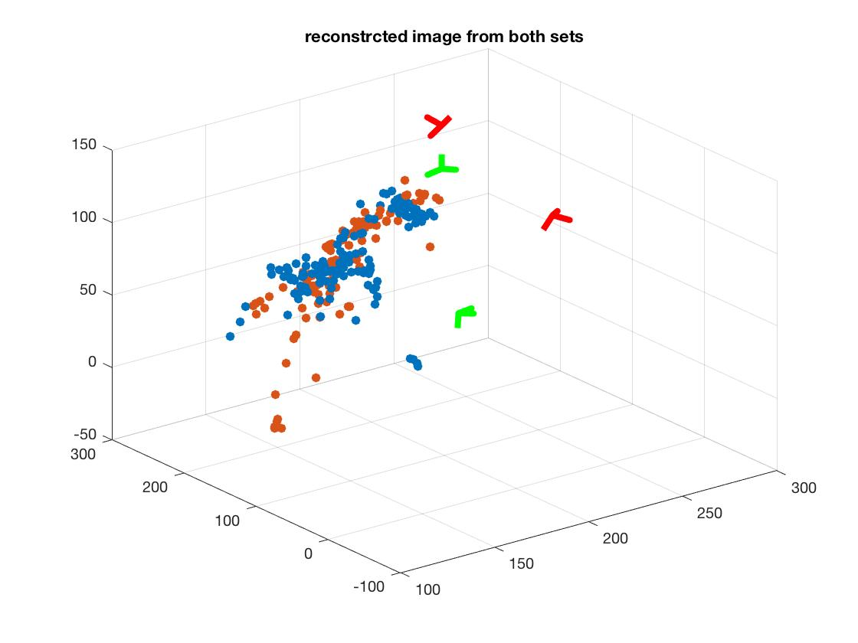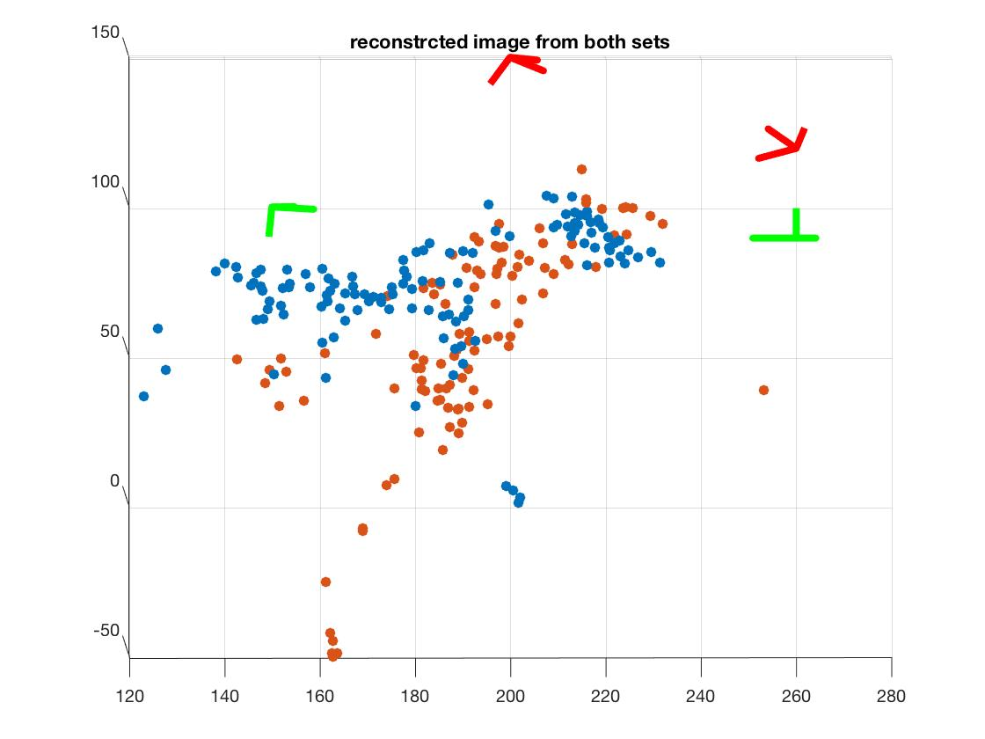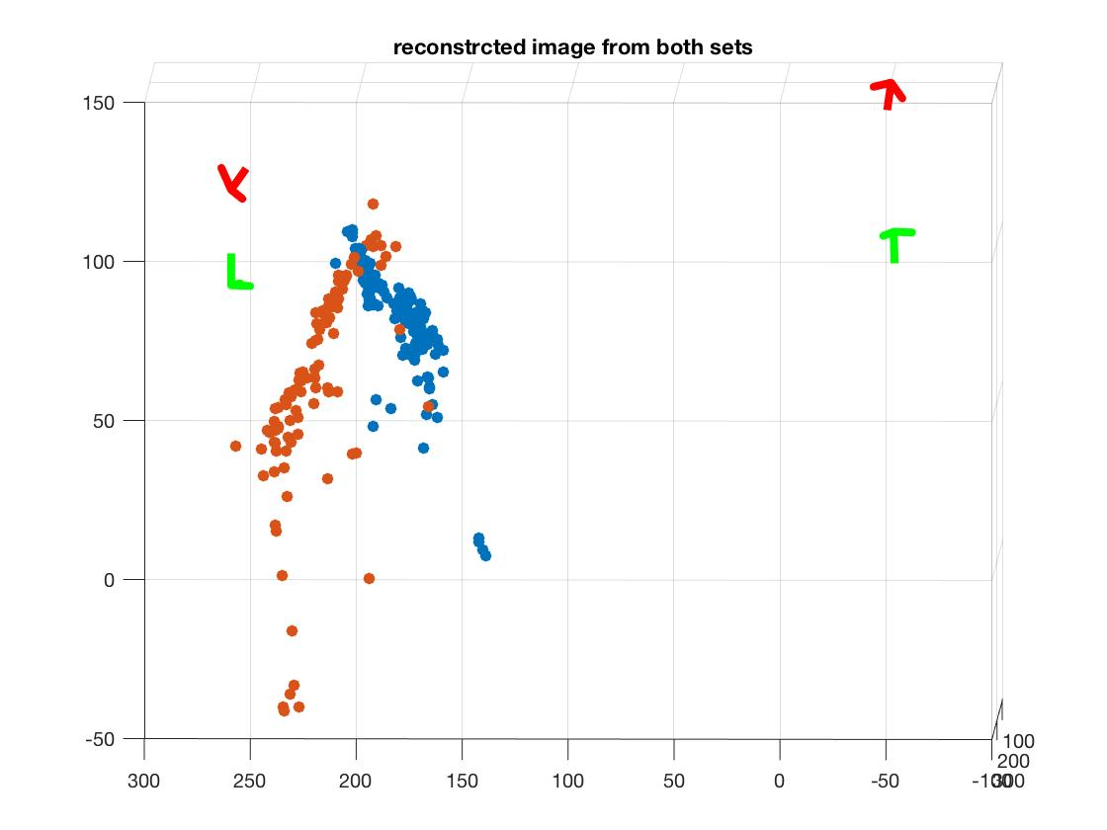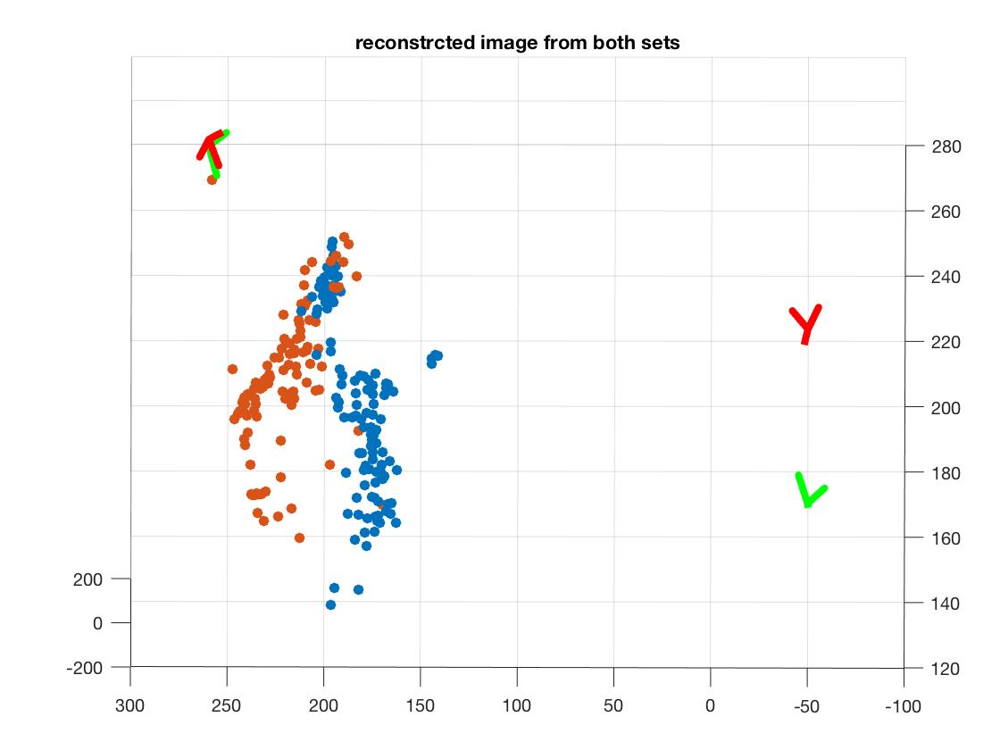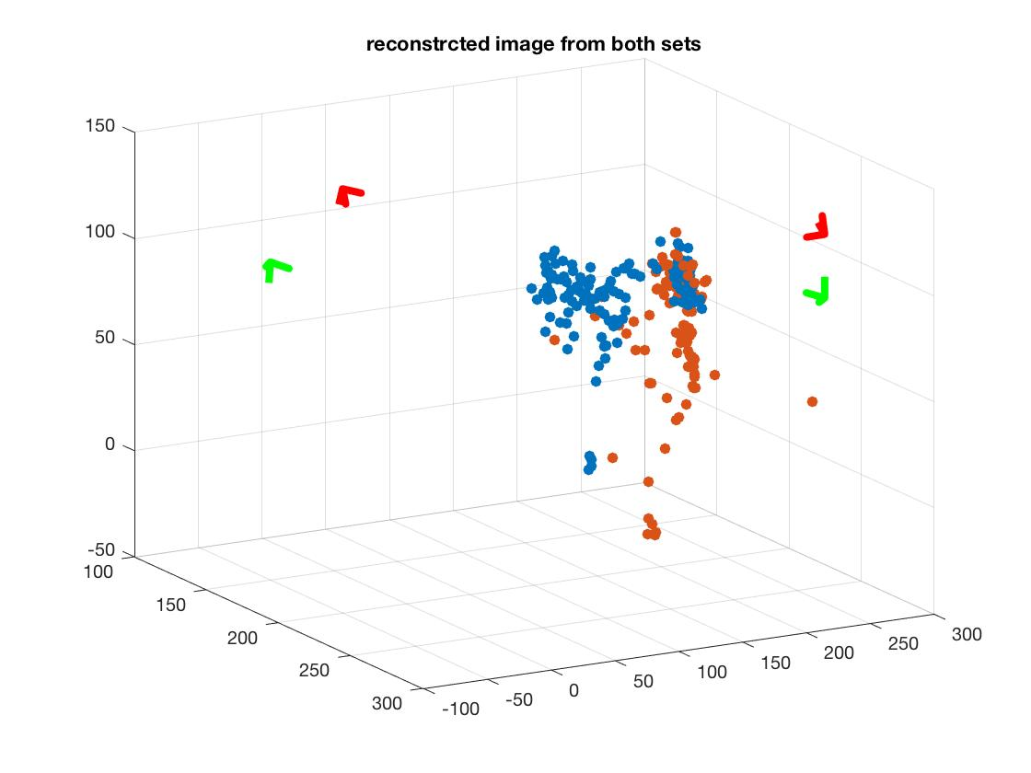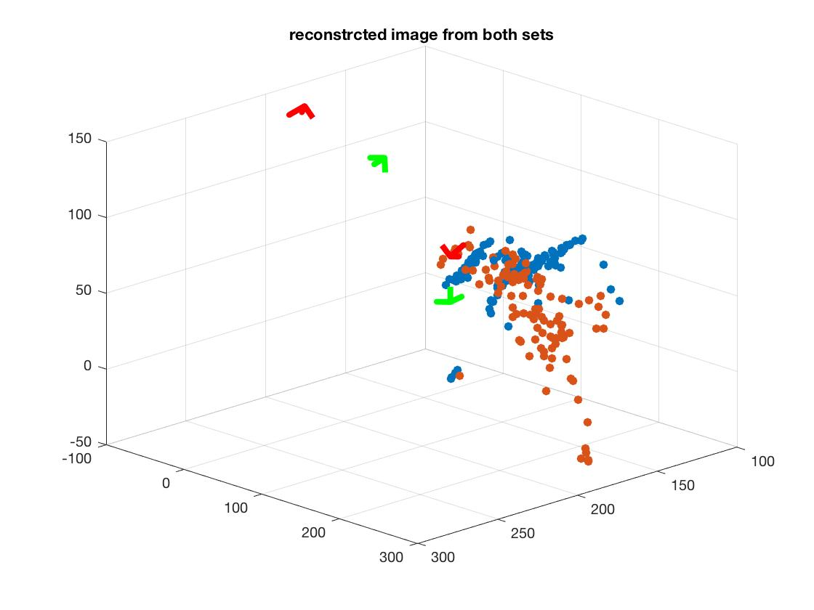

*Figure 4-1: (1,1), (3,1), (3,2) show the overall view of the reconstructed image. (1,2), (2,1), (2,2) show the sides view of the reconstructed image. Notice: because the nature of our picked picture and the we used most points from the set1’s first pair and set2’s second pair; as a side effect, we can only well present front half of the horse.*