**Islamic Finance: Needed, Wanted, but Unavailable**

**How Can Government Promote Islamic Finance in the Philippines[1]**

Jane Lynn D. Capacio[2] and Juan Carlos Rodriguez[3]

**Abstract**

We overlaid a sentiment analysis on our ongoing project on Islamic financing. We found out that the sentiments are generally positive but there are a number of negative sentiments like “risks” which implies that the literature sees risks either in the design or implementation of Islamic financing. The preliminary findings of our project and the results of our sentiment analysis underscore the important role of the government in providing information and enhancing knowledge on Islamic financing. Models of Islamic financing that have succeeded could be supported so these could scale up or expand. More importantly, the government, particularly the Bangsamoro Autonomous Region for Muslim Mindanao (BARMM) is encouraged to be proactive in developing industry plans and promoting investments and entrepreneurship so that Islamic financial institutions could be enticed to set up operations in the region. When these are in place, the needed and wanted Islamic financing might become available and accessible.

**Background**

Of the 119 million Filipinos, the Muslim population in the Philippines accounts for 6-11%[4] of the total population. Despite this number of Muslims in the country, there is a dearth of Islamic financing products and institutions. This means that there are limited opportunities for Muslims and non-Muslims to engage in financing that does not revolve around interest. “Islamic finance” refers to financial activities that conform to Islamic Law (Shari’ah). One of its principles is the prohibition of *ribā* (interest) because money and money instruments are but a medium of exchange and earning from it is *haram* (forbidden). Returns on financing should be tied to an asset where both the lender and borrower share in the profit or loss. In this way, risk-taking is also shared by both lender/investor and borrower/entrepreneur. Islamic finance likewise prohibits using money for immoral or unethically problematic businesses (e.g., arms manufacturing, alcohol production).

Islamic finance is already huge in the Middle East and North African (MENA) region but it is increasingly becoming popular in countries that are not predominantly populated by Muslims. Saudi Arabia and Iran are the largest markets with each boasting an asset of more than USD 400 billion.[5] Various Islamic finance instruments (e.g., musharaka, murabaha, ijara) are popularly used worldwide. The Philippine government launched our maiden sukuk bonds in late 2023, and it was oversubscribed, indicating a demand for it.[6]

It is thus a wonder why there are very limited Islamic finance institutions and products in the Philippines despite its growing popularity worldwide, the availability of a law that enables its rollout, the number of potential users, and the policy of government on financial inclusion of unbanked regions like the Bangsamoro Autonomous Region for Muslim Mindanao (BSP 2018). This policy brief contributes to the analysis and provides suggestions to government given its pivotal roles in the promotion, information dissemination, and regulation of Islamic finance.

**What we know so far**

One of the projects of the Escaping the Middle-Income Trap: Chains-for-Change Program of UP CIDS, in partnership with the Peace and Equity Foundation, is the conduct of an action research on Islamic finance. Our project wanted to understand the landscape of Islamic finance in the Philippines and to recommend ways to promote it. We have undertaken a review of relevant scientific and grey literature on the topic, went on fieldwork to interview Muslims from different ethnolinguistic groups (Maranao, Maguindanao, Yakan), and brainstormed with government, financial institutions, and experts on this topic. Here are some of our key findings:

1. There is a clamor for Islamic finance products and many Muslims would rather not access conventional finance,
2. A number of cooperatives had good success when they pilot tested Islamic microfinance among their members,
3. The pilot models of Islamic microfinance experienced challenges on screening, business model, and enforcement of agreement, which are problems typical of any credit transaction,
4. The Sharia Advisory Boards which were set up in the cooperative provided not just the policy guidance on lending, they also helped in enforcing agreements using religious teachings, social capital, and reputation which suggests that Islamic financing, in this set up, could help address conventional credit challenges; and
5. Many Filipino Muslims do not have a clear understanding of Islamic finance; and the need to build a Shar’ia Advisory Council in every financial institution contributes to limited agreements on acceptable products, services, and procedures (Banaga, Ray, and Tomkins 1994).

It was evident that information and education efforts, along with pilot testing of models and harvesting of lessons, could improve the appreciation for Islamic finance in the Philippines. For this policy brief, we did a sentiment analysis of a sample of available scientific literature. We wanted to have a sense of the underlying emotions behind the tone and delivery of the texts. Our sentiment analysis complements the literature review that we did in our Islamic Financing Project where the focus was on identifying themes from the literature.

**Sentiment analysis on “Islamic financing” and “Shari’ah financing:” Generally positive but with a mix of negative emotions especially around risks**

We performed a sentiment analysis, a form of a data mining procedure, on the abstracts of scientific journals that looked into “Islamic financing” and “Shari’ah financing”. We sourced our data from various journals like the International Social Science Research and Economic Journal of Emerging Markets. With 62 observations, we used the R programming language and created three models with varying complexity: NRC Word-Emotion Association Lexicon, Bing Lexicon, and the Loughran-Mcdonald Lexicon. Figure 1, which explains the methodology of our sentiment analysis, is explained in the footnote.[7]

Source Material

Title

Abstract

Keywords

Adjust to Lowercase

Transform to a Column Vector

NRC Lexicon Model

Bing Lexicon Model

Loughran-Mcdonald Lexicon Model

Figure 1. Operational Framework of the Sentiment Analysis

To mitigate sampling bias, we expanded and sourced our dataset from different journals. In this way, perspectives on Shari’ah and Islamic financing, whether positive or negative, is most likely included in the data used in the study.

From the NRC Lexicon model, it appears that Islamic or Shar’ia finance has positive connotations, which may imply its effectiveness. There is also a sense of trust at around 290 counts, something which is important in the field of banking and finance. However, despite the presence of good sentiments, there are doubts as seen in the 140 counts of negative emotions. This suggests, among others, probable shortcomings either in the design or implementation of Islamic financing. Nevertheless, the positive sentiments outweigh the negative sentiments in this model.

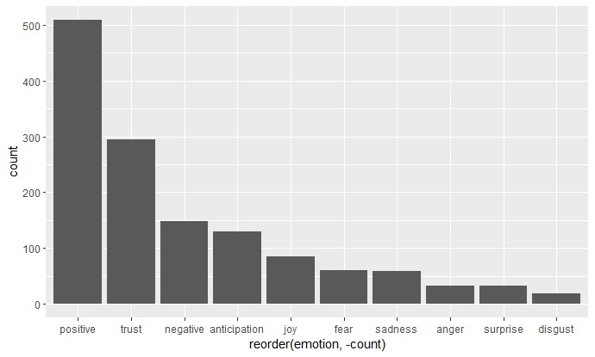

Figure 2. NRC Lexicon Model Results in a Vertical Bar Chart

The Bing model dichotomizes positive and negative sentiments and then puts other subcomponent emotions in their respective classification. The terms “significant”, “positive”, “negative”, and “regression” are ambiguous terms suggesting that these may have come from quantitative studies that created statistically significant results. However, “sustainable” and “compliant” being on top implies that the compliance of Islamic financing is a positive strength. Risk stands on top of all the negative sentiments.

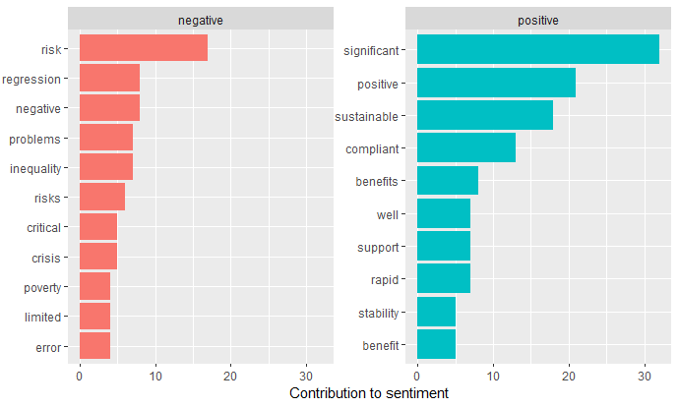

Figure 3. Bing Lexicon Model Results in a Horizontal Bar Chart

Lastly, the Loughran-McDonald model presents the sentiment analysis in a more granular approach by including other forms of emotions such as “litigious”, “constraining”, and “uncertain”. These must have been outstanding in the literature that were reviewed but these could not be seen by the earlier models. Moreover, in this model, uncertainty is led by risk while negativity is led by problems and unemployment. This entails that beyond risks of uncertainty there are other negative issues such as unemployment and crises that were not covered in the previous model. Still, positive sentiments stand out the most with profitability, satisfaction, and opportunities leading the category.

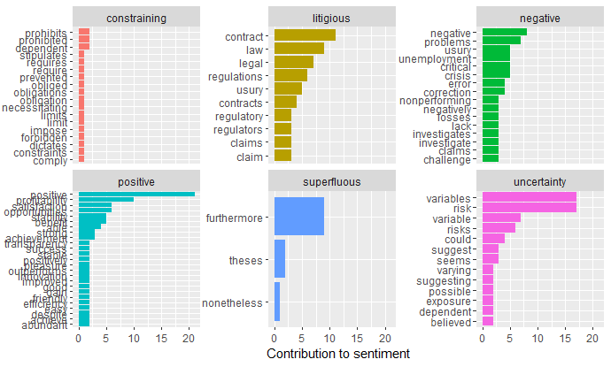

Figure 4. Loughran-McDonald Lexicon Model Results in a Horizontal Bar Chart

Overall, despite the existence of negative sentiments, there are more positive emotions in the existing literature which suggests that it is generally perceived to be good by those who studied it.

**Recommendations to government**

Government agencies played pivotal roles in enticing the development of Islamic financing in the country and it has undertaken huge strides lately. In 2023, the Sharia Supervisory Board composed of key government officials was created. In the same year, the Bangko Sentral ng Pilipinas issued USD 1B of sukuk bonds with demand almost five times oversubscribed from the offer.[8] Government agencies could proactively play its public roles in meeting this need and want for Islamic financing with these recommendations:

*Pursuit of financial literacy on Islamic financing* – Particularly in the BARMM, which is the most unbanked region in the Philippines, there is a need to disseminate information on Islamic financing. Models of Islamic microfinance that were pilot tested and have succeeded could be used as illustrative examples. Models of contracts and contracting arrangements could be fine-tuned and discussed to various public to show that contracting mechanisms have been tried and have worked under certain explicit conditions. These conversations could enhance trust and lessen uncertainties about Islamic finance.

*Support the pilot models that worked* – Formal and community-based models that work could be assisted with capacity building, public promotion, and non-distorting incentives. At present, these models tend to be small and context specific (based on sites, types of members/borrowers, ethnicity). Eventually, these should be able to meet the needed scale and be able to diversify their offerings.

*Build the capacity of key stakeholders* – There is a need to train regulators on the principles, models, and operations of Islamic finance. Training should also be made available to industry professionals as well as to religious leaders like ustadz and ulamas.

*Address the concern on taxes* – Since Islamic financing is tied to an asset and one of the schemes that is often used is profit/loss sharing, there is a concern on being imposed with a tax on the mark up on the total profit. In conventional banking, interest as a cost of doing financing is tax-free. Appropriate government agencies including the Bureau of Internal Revenue should be engaged on this.

*Engage economic activities in the BARMM* - No amount of government incentives and regulations would stimulate Islamic finance if financial institutions do not deem it attractive to operate in largely unbanked areas like Muslim Mindanao. Since the presence of economic activities is usually a good reason to set up operations or branches, the BARMM government could encourage entrepreneurial activities by developing industry plans, assisting priority sectors, and easing the ways of doing business.[9]

These recommendations could address the negative sentiments on uncertainty and risks. With Islamic financing, Muslims Filipinos would be able to access credit, engage in lease agreements, and pursue enterprises while being good Muslims.

1. The Sentiment Analysis of this policy brief is an output of the Webinar on Spatial and Text Data Mining Analytics organized by the Data Science for Public Policy of the UP Center for Integrative and Development Studies held on 29-31 July 2024. Prior to the conduct of sentiment analysis, the data, review of literature, and analysis on Islamic financing are outputs of the Islamic Financing Project of the Escaping the Middle-Income Trap: Chains for Change (EMIT C4C) Program of UP CIDS and the Peace and Equity Foundation (PEF). These are parts of forthcoming publications. Funding for the Islamic Financing Project came from PEF and UP CIDS.
2. Senior Research Analyst, EMIT C4C of UP CIDS. Corresponding author ([jdcapacio@up.edu.ph](mailto:jdcapacio@up.edu.ph)). Contribution: Design and write up of the policy brief.
3. Graduating student, Bachelor of Science in Applied Economics, De La Salle University. Contribution: Coding and insights on sentiment analysis with the guidance of the corresponding author. (Email: [juan_carlos_rodriguez@dlsu.edu.ph](mailto:juan_carlos_rodriguez@dlsu.edu.ph))
4. The low end of the range (6%) is from the 2000 census of the Philippine Statistics Authority (<https://psa.gov.ph/content/religious-affiliation-philippines-2020-census-population-and-housing>) while the high end comes from the 2012 estimate of the National Commission on Muslim Filipinos. The World Bank (2016) states that the range is due to differences in methodology. [Developing islamic finance in the Philippines (worldbank.org)](https://documents.worldbank.org/en/publication/documents-reports/documentdetail/748841468087856489/developing-islamic-finance-in-the-philippines)
5. [Islamic Finance: A Game-Changer for MENA's Banking Industry - Rasmal](https://www.rasmal.com/islamic-finance-in-the-mena-banking-sector/)
6. [PHL launches maiden offer of Sukuk bonds, eyes $500M | Jasper Y. Arcalas (businessmirror.com.ph)](https://businessmirror.com.ph/2023/11/28/phl-launches-maiden-offer-of-sukuk-bonds-eyes-500m/#:~:text=THE%20Philippines%20has%20formally%20launched%20its%20maiden%20offering,benchmark-sized%20US%20dollar-denominated%20Sukuk%20offering%20in%205.5-year%20tenor.)
7. In performing the sentiment analysis, “textdata” and “tidytext” packages were installed in the R Studio. Afterwards, data preprocessing methods like transforming all characters in the text to lowercase letters and placing them in a single vector were undertaken. From this vector, the “syuzhet” package in R provided the first visualization and data sentiments of the dataset under the NRC Lexicon Model. The process was done using the Bing and Loughran-Mcdonald Lexicons.
8. <https://www.businesstimes.com.sg/international/philippines-raises-us1-billion-maiden-sukuk-issue>
9. Gratitude for this idea is due Maharlika Alonto and Assad Baunto of DAGph.