**ECE304**

**Lab5 Memo**

**Bruce Jiang, Siwei Cai**

**Introduction**

The subjective of this week’s lab is related to use servo motor control the potentiometer in order to see the A/D output value change in terms of the torque that the servo motor performed.

**RC Servo and Potentiometer Set Up**

***Figure 1 – Physical Structure Setup, Servo Motor and Potentiometer***

From figure one, the two components were hot glued on a plain cardboard at the same level, and one end of the servo is also glued to the other end of the potentiometer for turning. Because the whole operation is not based on white board, the three pins of the potentiometers have to be soldered with extended wires to reach Arduino at a further distance that it would normally would if it is on the white board. And the whole procedure is easy to conduct and dissemble after experiment is over.

Due to the fact that the servo library is using timer 1 as default, for a timer interrupt based to read A/D from Arduino, the below code shows timer 3 is used instead, and a sweep program is performed inside of for loop. Furthermore, operator need to alter the timers specified inside of servotimer.h file, limited all timers from mega 2560 for timer 5 only.

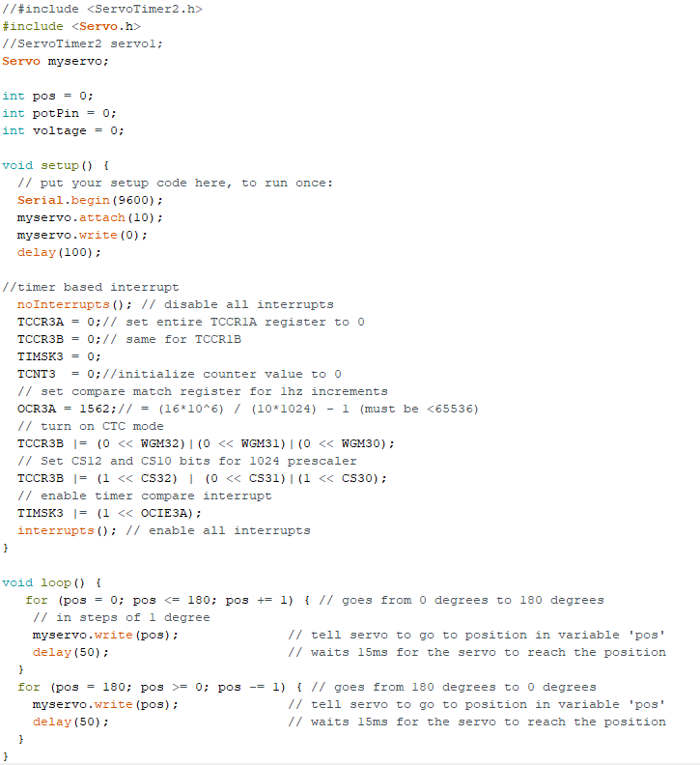

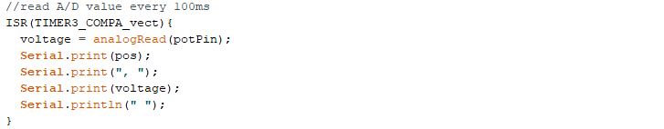

***Figure 2 – Testing Code for sweeping test every 100ms***

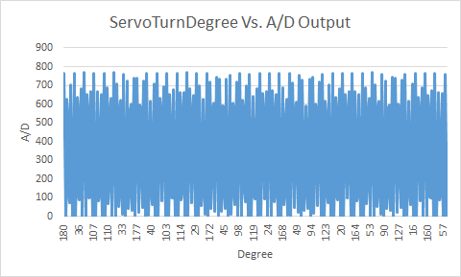

***Figure 3 - Excel OutPut For Sweeping Test Arduino 500 Data Points***

From figure three, the graph shows that the bandwidth of the servo motor can only drive a potentiometer from 0 to around 800 A/D value which is 3.8 volts. It is less than 5 volts which means the servo motor is not capable of turning a full 180 degree.

**Servo Motor Bandwidth Measurement**

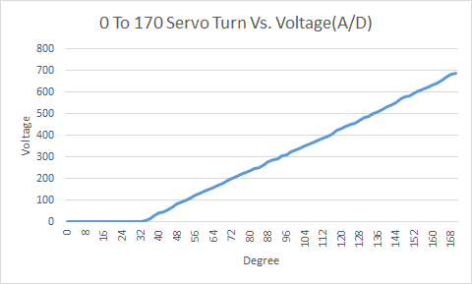

***Figure 4 - 87 Data Points Degree Turns vs. Voltage***