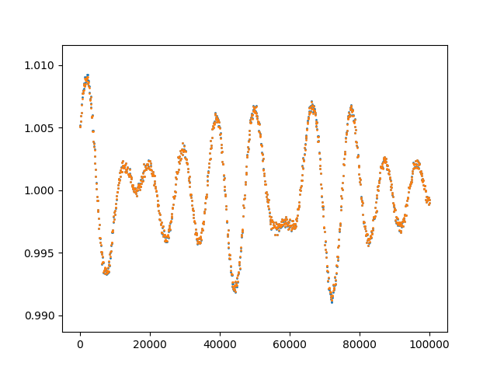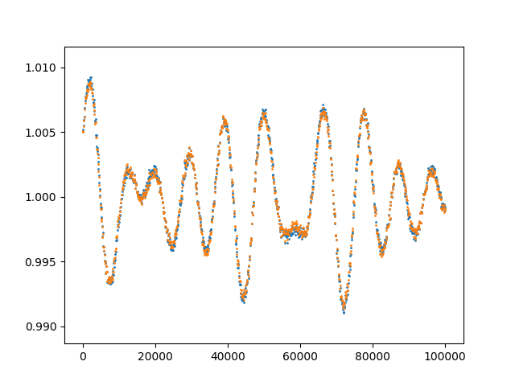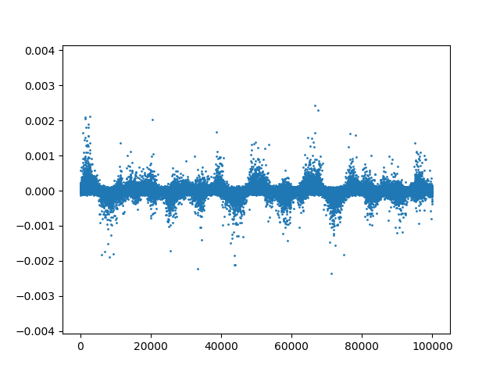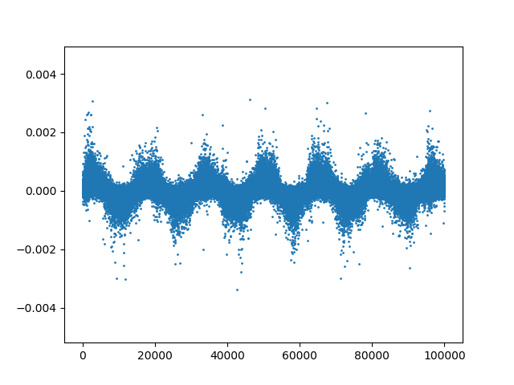

Model constructed from IDL NNBR applied to fake data.

Model constructed from Python NNBR applied to fake data.

IDL NNBR Model Residuals

Python NNBR Model Residuals