**Identifying Shopping Trends Using Data Analysis**

A Project Report

submitted in partial fulfillment of the requirements

of

AICTE Internship on AI: Transformative Learning

with

TechSaksham – A joint CSR initiative of Microsoft & SAP

by

**Rajendra, rj704260@gmail.com**

Under the Guidance of

**Jay Rathod**

**ACKNOWLEDGEMENT**

I am truly thankful for all the guidance, support, and encouragement I received during this project. I couldn’t have completed it without the help of several people and organizations, to whom I am deeply grateful.

First, I would like to sincerely thank my guide, **Jay Rathod** , for their amazing mentorship and constant support. Their helpful advice and feedback were invaluable at every step of this project. Their patience, problem-solving skills, and encouragement kept me motivated and helped me reach my full potential.

I am also very grateful to **TechSaksham** for giving me the opportunity to learn and work on innovative ideas in Data Analysis. The valuable learning experiences and resources they provided greatly improved my technical skills and professional growth. This internship allowed me to apply my knowledge in real-world situations, and I appreciate TechSaksham's effort in empowering young minds like mine.

#### **ABSTRACT**

This project, "Identifying Shopping Trends Using Data Analysis," aims to analyze customer purchasing patterns to help businesses make informed decisions. The main problem addressed is the difficulty businesses face in understanding changing consumer behaviors, which impacts inventory management, marketing strategies, and overall sales growth.

The key objectives of this project are to identify significant shopping trends, analyze customer preferences, and provide actionable insights to improve business strategies. Additionally, the project aims to develop a user-friendly web application that displays these insights in a clear and interactive manner.

The methodology involves collecting historical sales data, cleaning and preprocessing the data, and performing exploratory data analysis (EDA) to discover patterns and correlations. Various data analysis techniques, including statistical analysis and visualization tools, were used to identify trends in seasonal demand, popular product categories, and customer buying behavior. providing users with interactive trend graphs and detailed reports.

Key results show that the analysis effectively uncovered valuable patterns, such as peak shopping seasons, high-demand product categories, and customer segment preferences. These insights enable businesses to optimize inventory management, tailor marketing strategies, and enhance customer satisfaction.

In conclusion, this project demonstrates the power of data analysis in retail analytics. By accurately identifying shopping trends and customer preferences, businesses can make data-driven decisions, stay competitive in the market, and improve overall profitability.

**TABLE OF CONTENT**

**Abstract I**

**Chapter 1.**  **Introduction 1**

1.1 Problem Statement 1

1.2 Motivation 2

1.3 Objectives 2

1.4. Scope of the Project 3

**Chapter 2.**  **Literature Survey 4**

2.1 [Review relevant literature](https://docs.google.com/document/d/1LwICPQdXyTn1TdczSmWLUgoUeVNiyc8TMV_fCU6dhhw/edit#heading=h.3j2qqm3) 4

2.2 [Existing Models, Techniques, and Methodologies](https://docs.google.com/document/d/1LwICPQdXyTn1TdczSmWLUgoUeVNiyc8TMV_fCU6dhhw/edit#heading=h.qsh70q) 4

2.3 Limitation in Existing System 5

**Chapter 3.**  **Proposed Methodology 6**

**Chapter 4.**  **Implementation and Results**

**Chapter 5. Discussion and Conclusion**

**References**

**LIST OF FIGURES**

| **Figure No.** | **Figure Caption** | **Page No.** |
| --- | --- | --- |
|  | Methodology of EDA | **7** |
|  | System architecture | **8** |

**CHAPTER 1**

**Introduction**

* 1. **Problem Statement:**

Retailers collect vast amounts of data from multiple channels but struggle to analyze it effectively, leading to missed opportunities in identifying key trends, customer preferences, and seasonal buying patterns. This data overload and underutilization negatively impact revenue, inventory management, marketing efficiency, and overall competitiveness. Multiple departments, including retail operations, marketing, and inventory management, require accurate and timely insights to make informed decisions. Ultimately, retailers are data-rich but insight-poor, limiting their ability to optimize operations and seize market opportunities.

**Significance**

1. **Identification of Key Trends**
   * Helps retailers recognize emerging trends, customer preferences, and seasonal buying patterns.
   * Enables proactive decision-making to meet market demands.
2. **Optimized Inventory Management**
   * Reduces the risk of overstock and stockouts by aligning inventory with customer demand.
   * Minimizes holding costs and maximizes sales opportunities.
3. **Enhanced Marketing Efficiency**
   * Enables targeted marketing campaigns based on customer behavior and preferences.
   * Increases return on investment (ROI) for marketing initiatives.
4. **Informed Decision-Making**
   * Provides accurate and timely insights for strategic decisions in retail operations, marketing, and inventory management.
   * Enhances overall business agility and responsiveness.
5. **Competitive Advantage**
   * Empowers retailers to stay ahead of competitors by effectively utilizing data insights.
   * Drives growth, customer satisfaction, and brand loyalty.
   1. **Motivation:**

This project was chosen for its ability to transform retail data into actionable insights, driving smarter strategies and better customer experiences

1. **Solving Data Underutilization**
   * Retailers collect vast data but lack insights. This project bridges that gap.
2. **Need for Data-Driven Decisions**
   * In a competitive market, informed decisions are crucial for success.
3. **Potential Applications**
   * Identifying shopping trends and customer preferences.
   * Optimizing inventory and reducing costs.
   * Personalizing marketing and enhancing customer engagement.
4. **Impact and Benefits**
   * Boosts operational efficiency, revenue, and customer satisfaction.
   * Provides a competitive edge and drives sustainable growth.
   1. **Objective:**
5. **Identify Shopping Trends**
   * Analyze customer purchasing patterns to detect emerging trends and preferences.
6. **Optimize Inventory Management**
   * Provide insights to minimize overstock and stockouts, improving inventory efficiency.
7. **Enhance Marketing Strategies**
   * Enable targeted marketing by understanding customer behavior and preferences.
8. **Sales Forecasting**
   * Predict future sales trends to support strategic pricing and promotional decisions.
9. **Develop a User-Friendly Application**
   * Build an interactive web application for retailers to visualize trends and access insights in real-time.
10. **Support Data-Driven Decisions**
    * Empower retail operations, marketing, and inventory teams with accurate and timely insights for informed decision-making.
    1. **Scope of the Project:**
11. **Data Analysis and Trend Identification**
    * Analyzes historical sales data to identify shopping trends, customer preferences, and seasonal patterns.
    * Utilizes data visualization to present insights in a clear and interactive manner.
12. **Inventory and Marketing Optimization**
    * Provides insights to optimize inventory management and reduce overstock or stockouts.
    * Enhances marketing strategies through targeted campaigns based on customer behavior.
13. **Web Application Development**
    * Develops a user-friendly web application using the MERN stack for real-time trend analysis and visualization.
    * Integrates predictive analytics for sales forecasting.
14. **Data-Driven Decision Support**
    * Empowers retail operations, marketing, and inventory teams with actionable insights to make informed decisions.

**Limitations**

1. **Data Quality and Availability**
   * The accuracy of insights depends on the quality and completeness of historical sales data.
   * Inconsistent or incomplete data may affect trend analysis and predictions.
2. **Model Accuracy and Generalization**
   * Predictive models may have limitations in accuracy and may not generalize well to all retail environments.
   * Sudden market changes or external factors (e.g., economic downturns) may impact prediction reliability.
3. **Scalability and Performance**
   * The web application may face performance issues with extremely large datasets or high user traffic.
   * Scalability solutions may require additional resources and infrastructure.
4. **Limited External Factors Consideration**
   * The model primarily relies on historical sales data and may not account for external factors like competitor actions, economic shifts, or social trends.

**CHAPTER 2**

**Literature Survey**

* 1. **Review relevant literature or previous work in this domain.**

Retail analytics has evolved significantly, with numerous studies exploring its applications and benefits. A comprehensive review of 563 documents highlighted current trends and emerging challenges in retail analytics, emphasizing the importance of data-driven decision-making in the retail sector.

Retail analytics encompasses various approaches, including descriptive, diagnostic, predictive, and prescriptive analytics. These methods assist retailers in understanding past performance, identifying underlying issues, forecasting future trends, and determining optimal strategies.

**2.2 Existing Models, Techniques, and Methodologies**

**Several models and techniques have been developed to analyze retail data:**

* **Descriptive Analytics:** Utilizes historical data to understand past sales and customer behaviors.
* **Diagnostic Analytics**: Examines data to identify the root causes of specific outcomes or trends.
* **Predictive Analytics:** Employs statistical algorithms and machine learning to forecast future events, such as sales trends or customer purchasing behaviors.
* **Prescriptive Analytics:** Suggests actionable strategies based on data analysis to optimize decision-making.

These methodologies enable retailers to enhance inventory management, personalize marketing efforts, and improve overall operational efficiency.

**2.3 Gaps and Limitations in Existing Solutions**

**Despite advancements, current retail analytics solutions face several limitations:**

* **Data Silos:** Many retailers struggle with fragmented data sources, leading to incomplete analyses**.**
* **Real-Time Analysis:** Existing models often lack the capability to process and analyze data in real-time, hindering timely decision-making**.**
* **Scalability Issues:** Some methodologies are not scalable, making it challenging to handle large volumes of data from various channels.
* **Limited Integration:** There is often a lack of integration between different analytical approaches, resulting in isolated insights.

**Addressing the Gaps**

**This project aims to overcome these limitations by:**

* **Unified Data Integration:** Consolidating data from multiple sources to provide a comprehensive view of retail operations.
* **Real-Time Processing:** Implementing advanced analytics capable of processing data in real-time to support prompt decision-making.
* **Scalable Solutions:** Developing scalable models that can handle large datasets efficiently.
* **Holistic Approach:** Integrating descriptive, diagnostic, predictive, and prescriptive analytics to offer cohesive and actionable insights.

By addressing these gaps, the project seeks to enhance retailers' ability to leverage data effectively, leading to improved operational efficiency and competitive advantage.

**CHAPTER 3**

**Proposed Methodology**

To Address the problem of identifying shopping trends,The following Data driven Solution is proposed This solution will help businesses stay competitive by identifying and responding to shopping trends in timely,efficient and data driven manner

* 1. **System Design**

To explain the flowchart diagram for "Identifying Shopping Trends Using Data Analysis with MERN Stack Visualization,"

### 1. Data Collection

* **Input:** Historical sales data from various sources (e.g., physical stores, online platforms).
* **Process:** Collect relevant data attributes like product categories, sales dates, customer demographics, and sales volume.
* **Output:** Raw sales data stored in MongoDB.

### 2. Data Preprocessing

* **Input:** Raw sales data from MongoDB.
* **Process:**
  + Clean data by removing duplicates and handling missing values.
  + Standardize data formats (e.g., date formats, numerical values).
  + Extract relevant features for analysis.
* **Output:** Preprocessed data ready for analysis.

### 3. Exploratory Data Analysis (EDA)

* **Input:** Preprocessed data.
* **Process:**
  + Use data visualization libraries (e.g., Matplotlib, Seaborn) to explore data distributions.
  + Identify correlations, outliers, and patterns.
* **Output:** Initial insights and hypotheses about shopping trends.

### 4. Trend Identification and Analysis

* **Input: Insights from EDA.**
* **Process:**
  + Apply statistical methods and data analysis techniques to detect shopping trends.
  + Identify customer preferences, seasonal patterns, and emerging trends.
* **Output:** Identified trends and patterns stored in MongoDB for visualization.

### 5. Data Visualization

* **Input:** Identified trends and analysis results.
* **Process:**
  + Use React for the frontend and integrate charting libraries (e.g., Chart.js, Recharts).
  + Display interactive graphs, heatmaps, and category-wise sales distributions.
* **Output:** Visualized trends and insights on the web application.

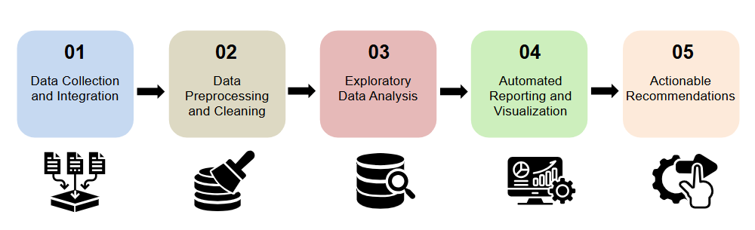

**System Architecture**

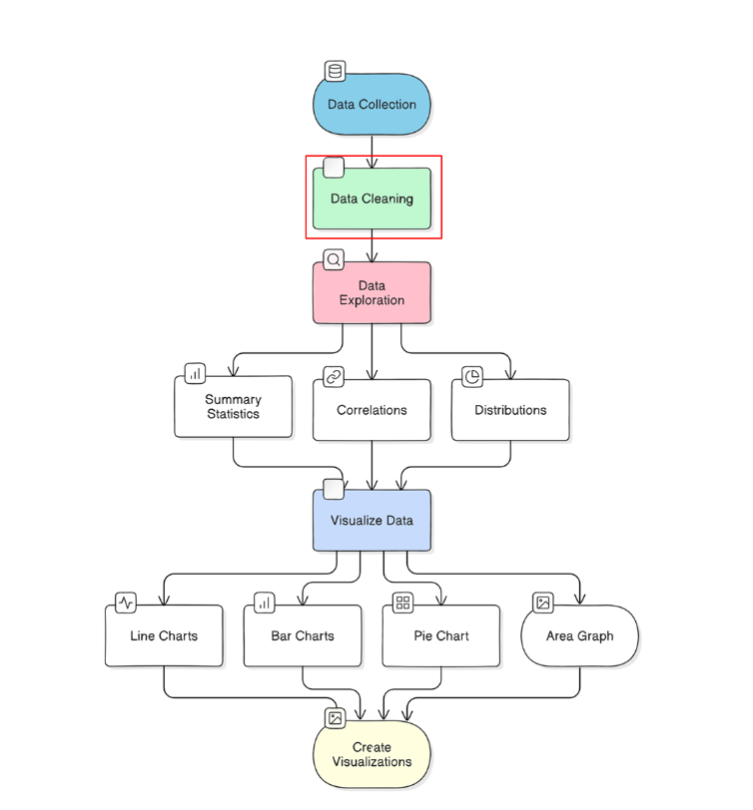

* 1. **Requirement Specification**

Mention the tools and technologies required to implement the solution.

* + 1. **Hardware Requirements:**
* **Processor:** Quad-Core (e.g., Intel i5)
* **RAM:** 8 GB (16 GB recommended)
* **Storage:** 50 GB SSD
* **OS:** Windows, macOS, or Linux
  + 1. **Software Requirements:**
* **Python 3.x:** The programming language used for data analysis.
* **NumPy:** For numerical data operations and array manipulation.
* **Pandas:** For data manipulation and analysis.
* **Seaborn:** For statistical data visualization.
* **Jupyter Notebook:** Python IDE (Integrated Development Environment)
* **Matplotlib:** For additional plotting capabilities

**CHAPTER 4**

**Implementation and Result**

* 1. **Snap Shots of Result:**

**1.Overall distribution of Customer age in the dataset.**

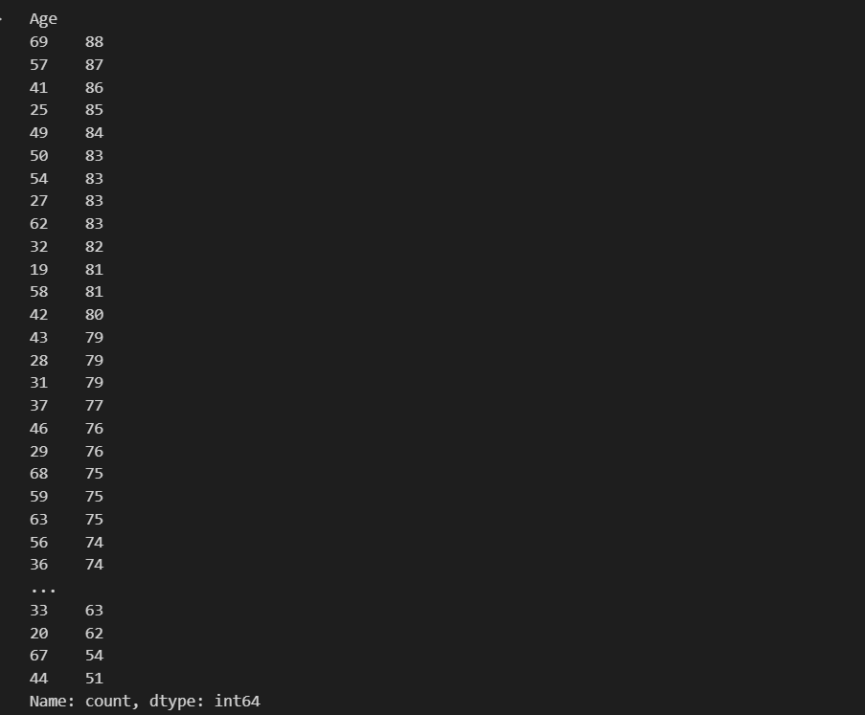

**2.How does the average purchase amount vary across different project**

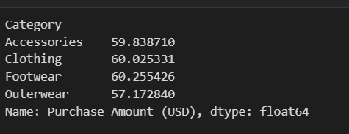

**3 Which gender has highest number of of purchase**

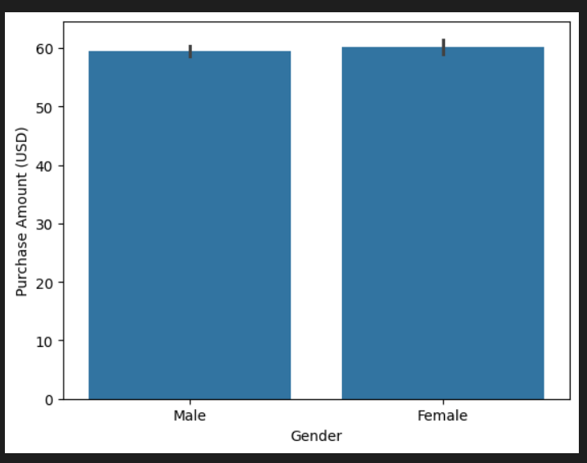

**4.Commonly Purchased item in each category**

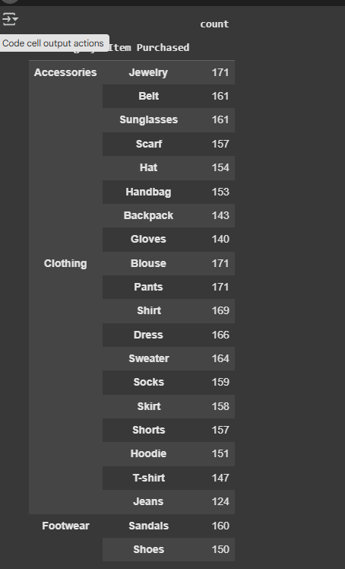

**5. This snapshot showing number of item purchaed**

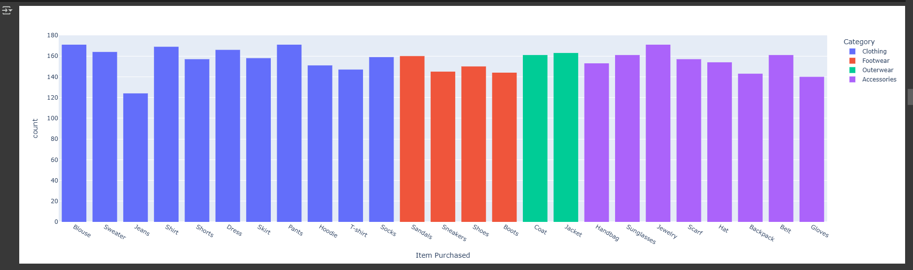

**6.This Snapshot showing the payment Method**

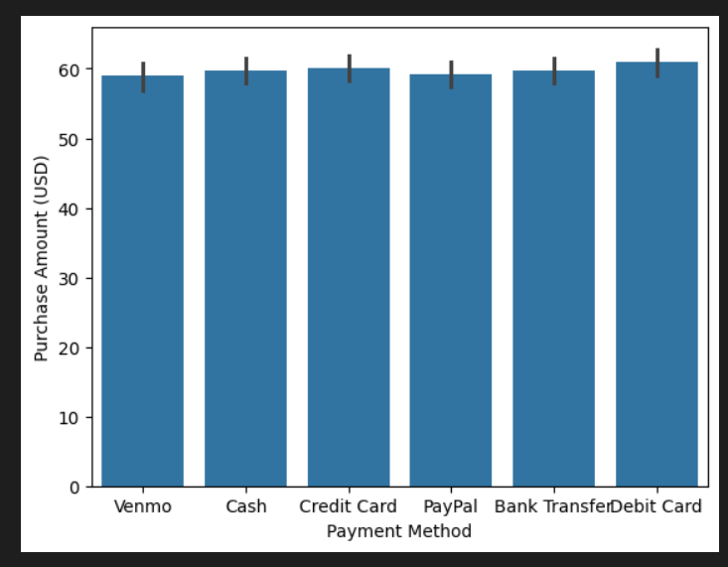

**7. This is showing Shopping Category and its Occurance**

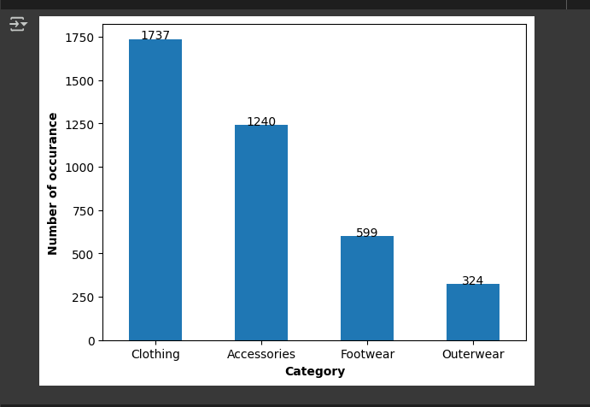

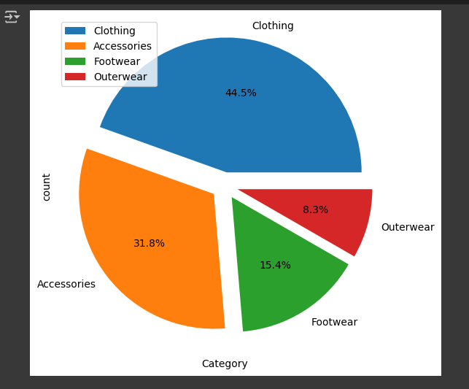

**8. This pie chart Showing the season of Shopping**

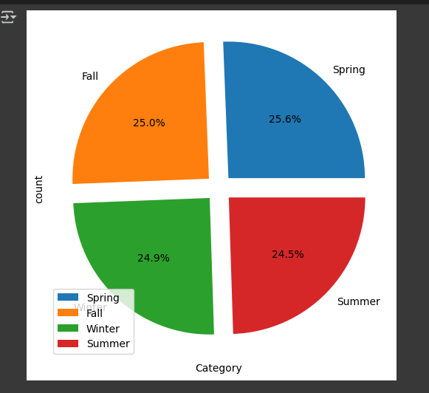

**9.heatmap of the shopping trend and review of items**

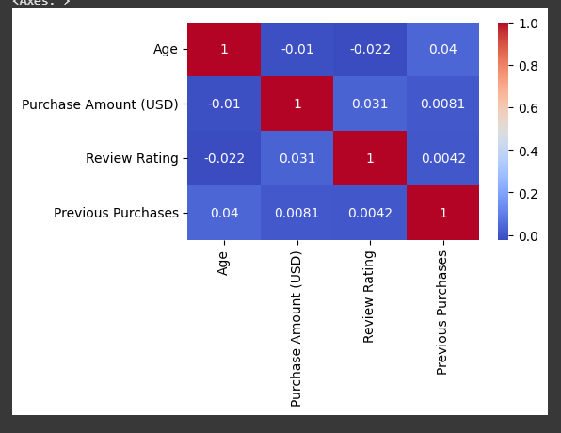

* 1. **GitHub Link for Code:**

**https://github.com/rj704260/Shopping-trend-Using-EDA.git**

**CHAPTER 5**

**Discussion and Conclusion**

* 1. **Future Work:**

**Enhanced Visualizations**: Integrate advanced charts like time series analysis and interactive dashboards.

**Machine Learning Integration:** Implement predictive models for forecasting shopping trends.

**Real-Time Analysis:** Enable real-time data processing for dynamic trend detection.

**Scalability and Performance:** Optimize for larger datasets and concurrent users.

**User Experience Improvements:** Enhance UI/UX for better data interpretation.

* 1. **Conclusion:**

This project successfully identifies shopping trends using data analysis, empowering retailers to make data-driven decisions. By leveraging Python for EDA, it bridges the gap between vast data collection and actionable insights. The system enhances inventory management, marketing strategies, and overall business efficiency. Future enhancements can further optimize trend prediction and user experience, solidifying its impact in retail analytics.

**REFERENCES**

1. Pandas Documentation – For data manipulation and analysis:<https://pandas.pydata.org/docs/>
2. Seaborn Documentation – For statistical data visualization:<https://seaborn.pydata.org/>
3. Matplotlib Documentation – For generating plots and graphs:<https://matplotlib.org/stable/contents.html>
4. Retail Data Analytics Trends – Industry insights and best practices:
   * McKinsey & Company. (2023). The Future of Retail Data Analytics.<https://www.mckinsey.com/>
   * Deloitte. (2023). Retail Trends 2023.<https://www2.deloitte.com/>

These references provide foundational knowledge and practical guidance for implementing and enhancing the shopping trend analysis project.