**Group 6 - Assignment 2**

Members:

* Timothy Chan
* Rhyle Nodnylson Guinto
* Chino Laguda
* Randall Joseph Pajaro

**Iris Prediction using Logistic Regression**

**Dataset**

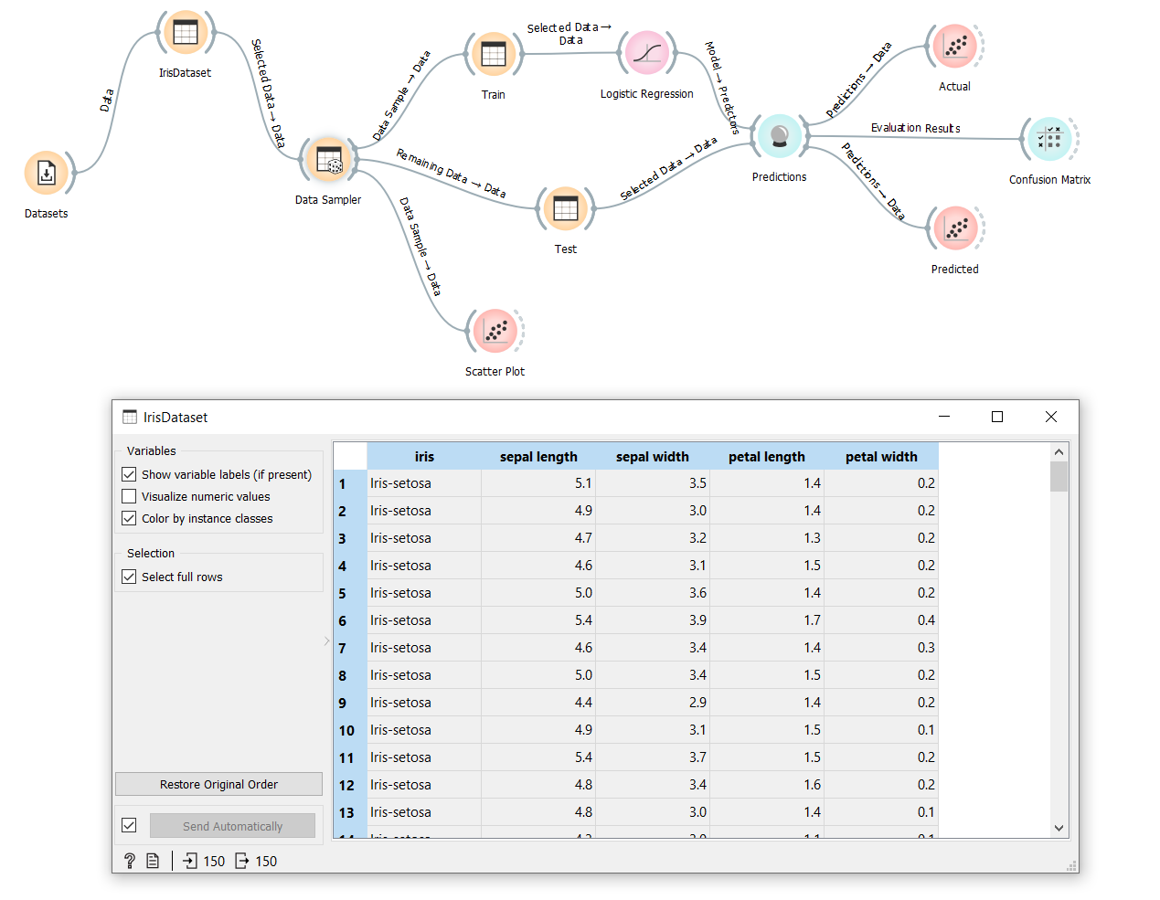

**Data Sampler (splitting data 80% for training and 20% for testing)**

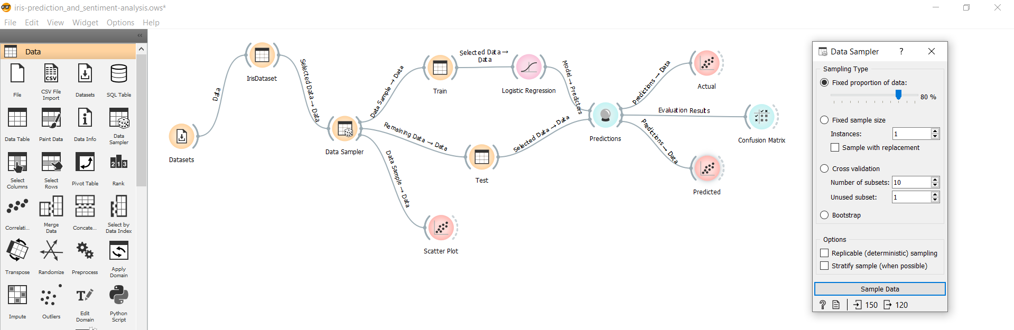

**Scatter Plot Visualization of the Entire Dataset**

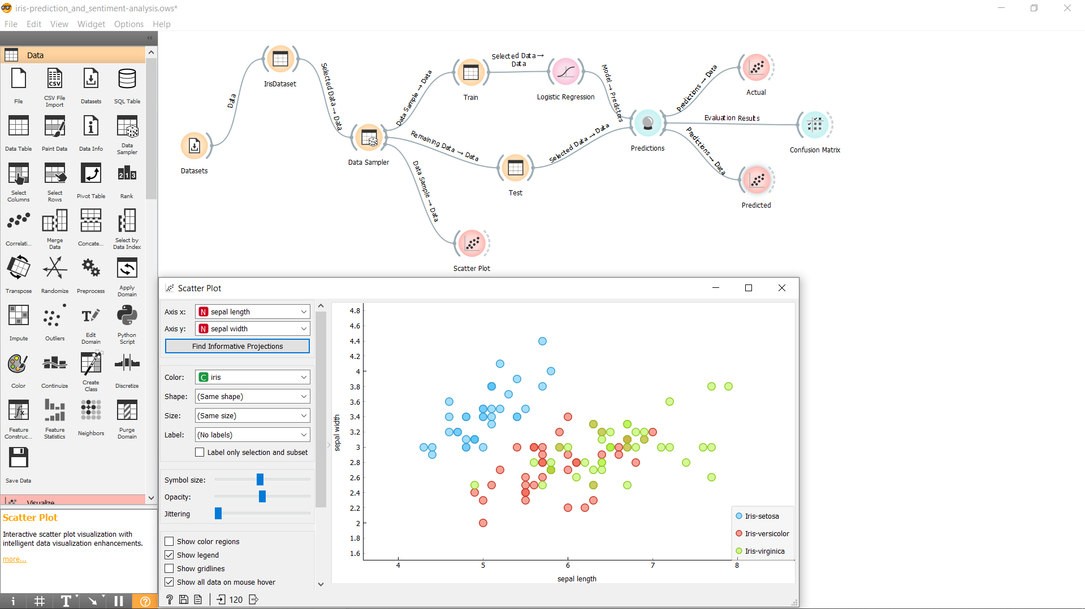

**Logistic Regression**

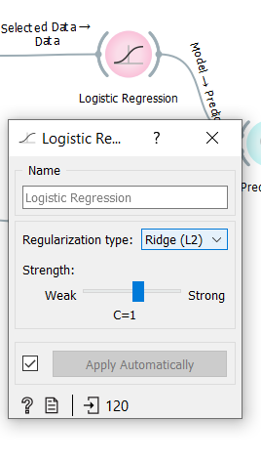

**Sample Predictions made by the logistic regression model vs its actual prediction where only 3 out of 30 test data were predicted incorrectly**

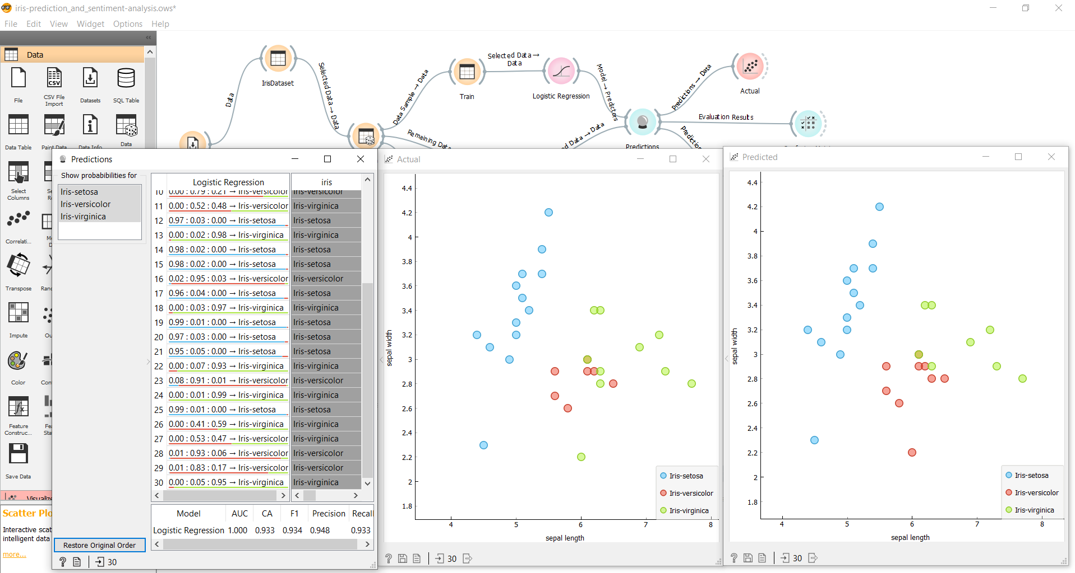

**Sentiment and Emotional Analysis using Twitter Tweets**

**Query**

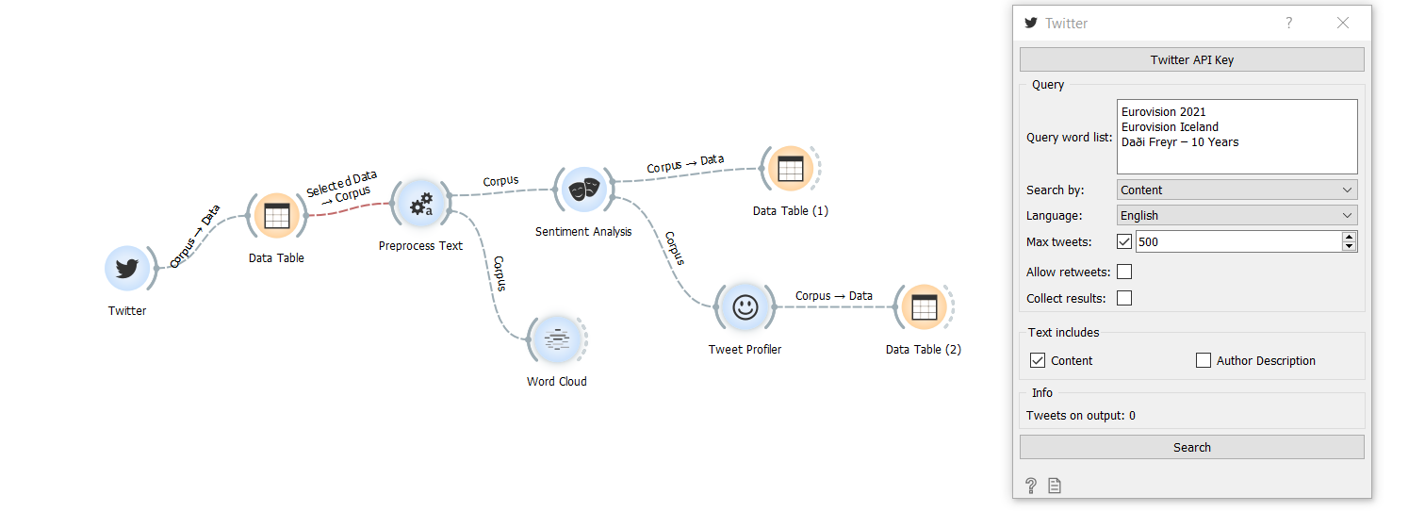

**Analyzing Tweets collected using Twitter Text Mining**

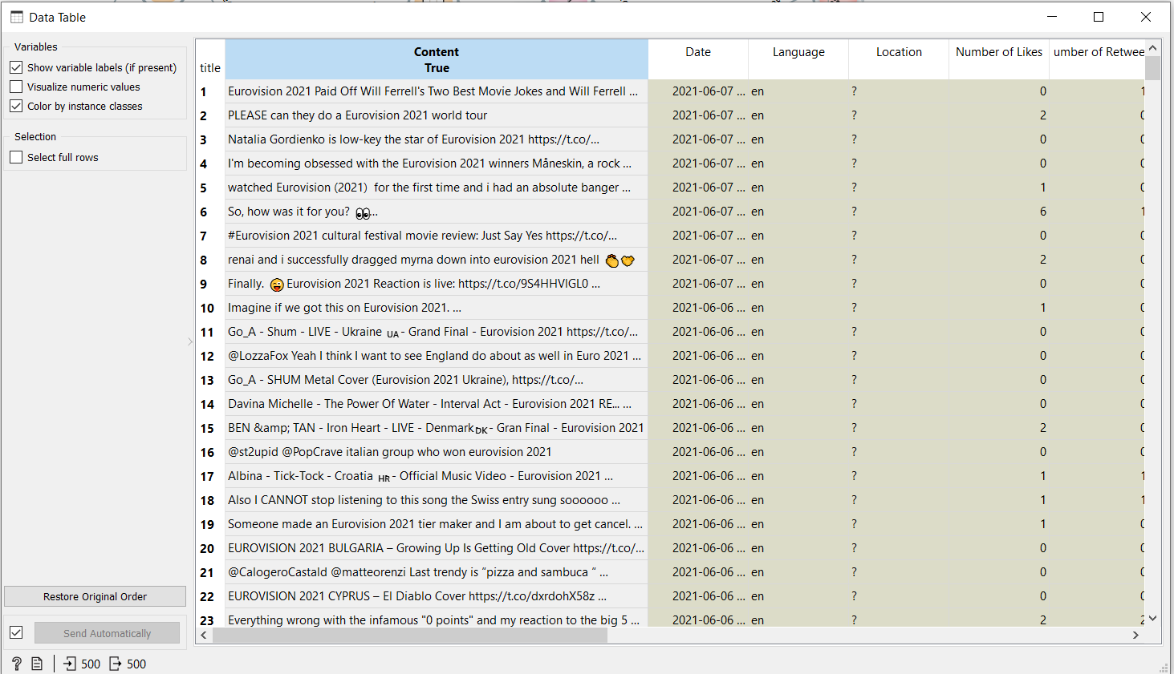

**Preprocessing Text**

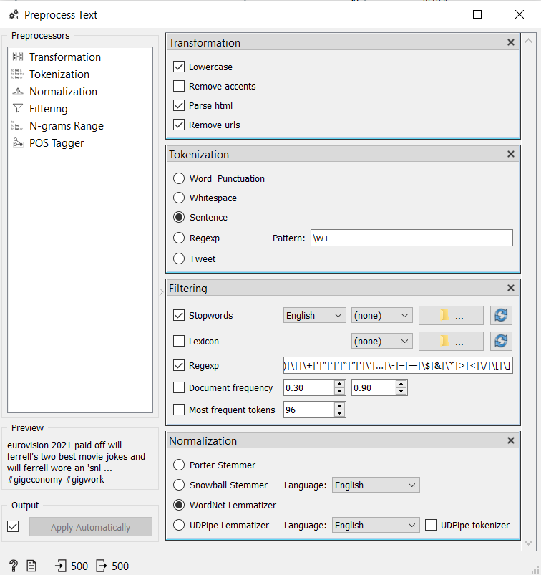

**Word Cloud Visualization**

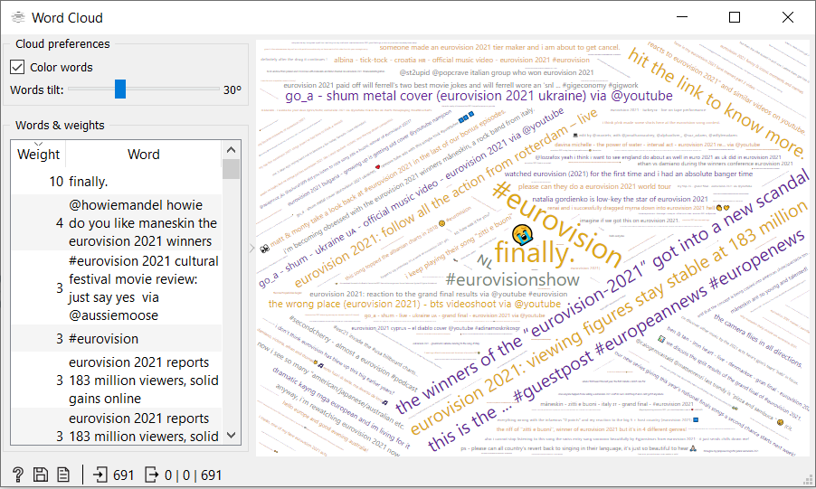

**Liu Hu Sentiment Analysis**

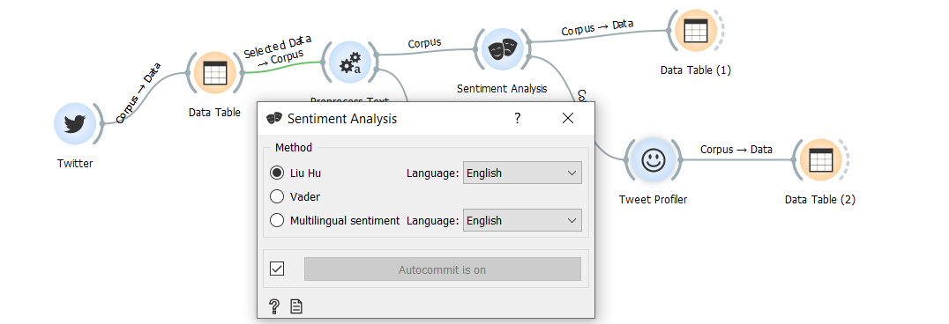

**Tweet Profiler for Emotion Analysis**

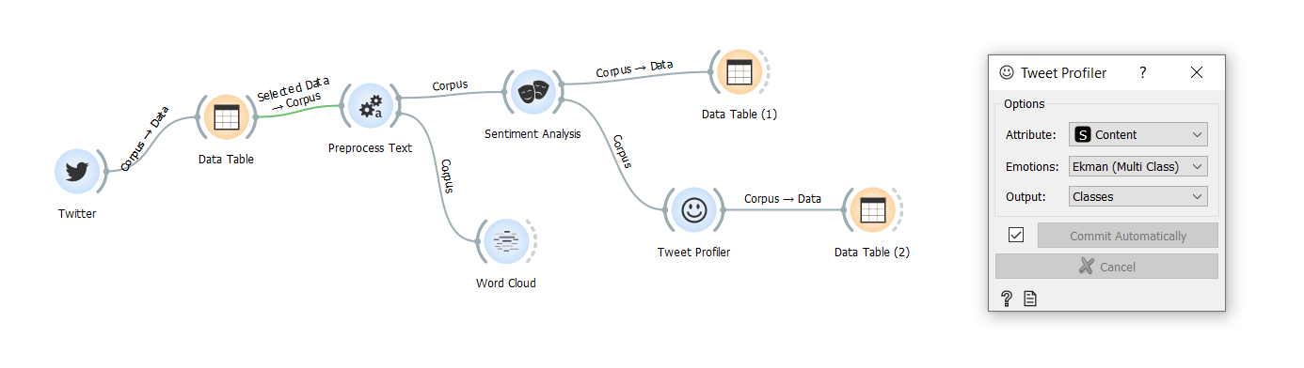

**Output**

