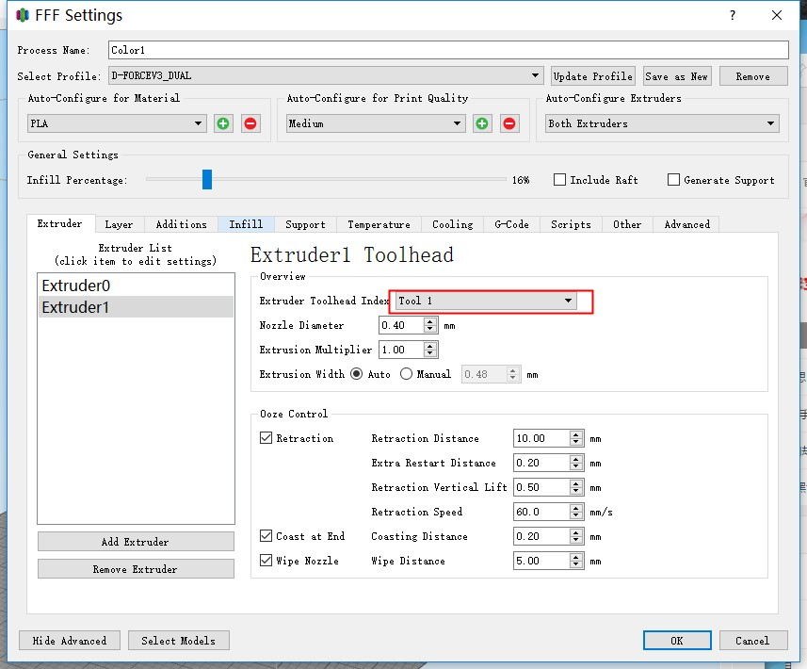

Extruder setting you have to add two Extruders . Toolhead Index is”Tool 0”and”Tool 1”

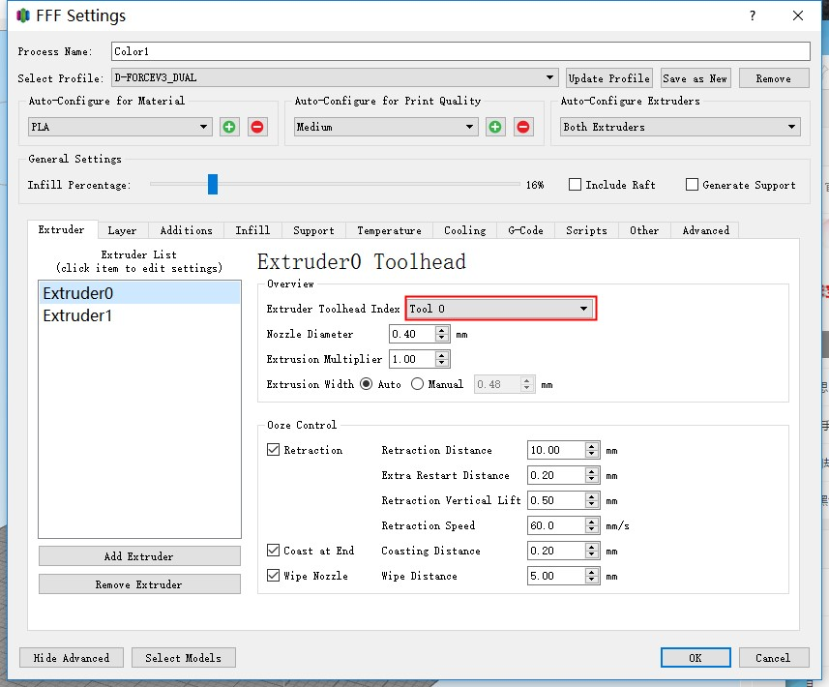

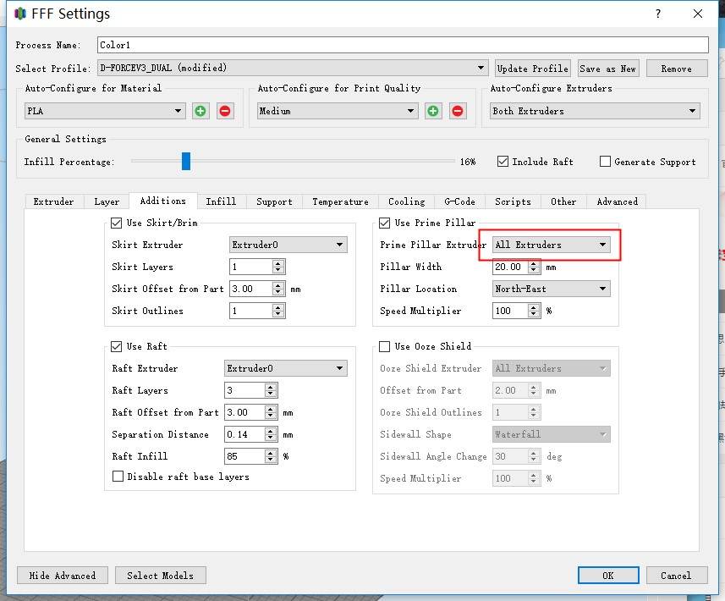

Please enable the “Use Prime Pillar” setting and select “ALL Extruders”

Pillar Width is depend on the remanet in the nozzle of last select filament

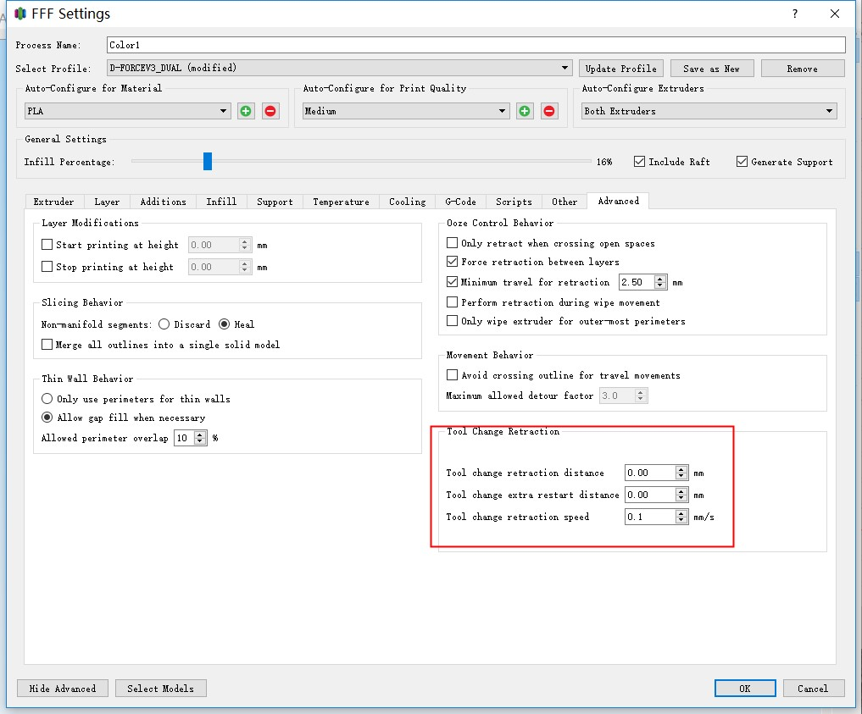

Tool change retraction please to 0

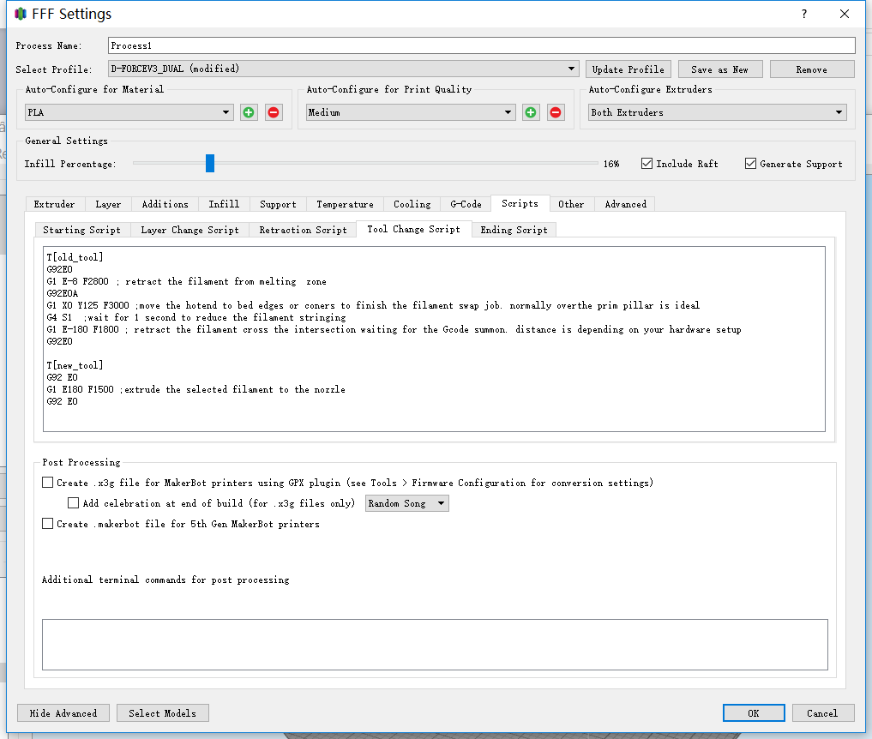 Tool change Script of same temperature (usually same same material in different colors):

T[old_tool]

G92E0

G1 E-8 F2800 ; retract the filament from melting zone

G92E0

G1 X0 Y125 F3000 ;move the hotend to bed edges or corners to finish the filament swap job. normally over the prim pillar is ideal

G4 S1 ;wait for 1 second to reduce the filament stringing

G1 E-180 F1800 ; retract the filament cross the intersection back to the it’s own tube waiting for the Gcode summon. distance is depending on your hardware setup

G92E0

T[new_tool]

G92 E0

G1 E187 F1500 ;extrude the new selected filament to the nozzle

G92 E0

Notice : Distance and speed of retraction and extrusion is depending on your hardware setup.

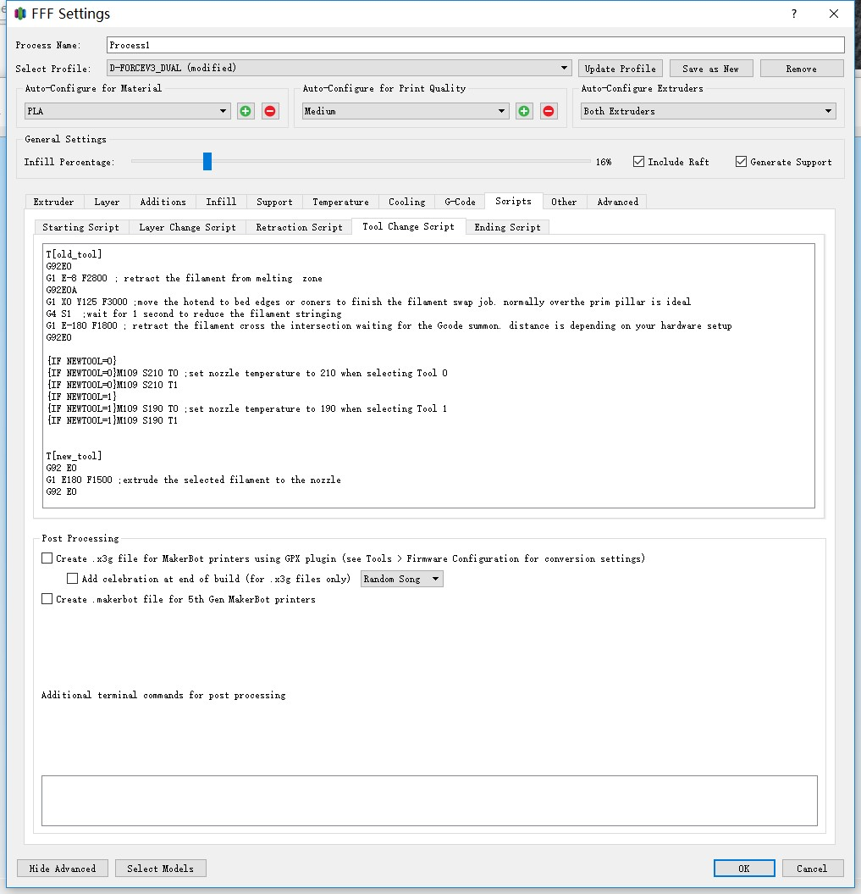 Tool change Script of different temperature filament (usually special support material e.g. PVA+PLA OR HIPS+ABS OR even ABS+PLA):

T[old_tool]

G92E0

G1 E-8 F3000

G1 X0 Y125 F6000

G4 S1

G92E0

G1 E-180 F1800

{IF NEWTOOL=0}

{IF NEWTOOL=0}M109 S210 T0 ; set nozzle temperature to 210 when select Tool 0

{IF NEWTOOL=0}M109 S210 T1

{IF NEWTOOL=1}

{IF NEWTOOL=1}M109 S190 T0;set nozzle temperature to 190 when select Tool 1

{IF NEWTOOL=1}M109 S190 T1

G92E0

T[new_tool]

G92 E0

G1 E187 F1500

G92 E0

Other setting of Simplify3D don’t need to be change basically.