**Client Side Web Design - Project**

|  |  |
| --- | --- |
| **Project Name** | Hospitality Management Chicago |
| **Description** | This website is designed to manage reservations for home stays and travel in and around Chicago region |
| **Project Guide** | Prof. Nick Hayward |
| **Author(s)** | Rohit Jagannath, Komal Shivhare, Rohini Jagannath, Parul Ameria |
| **Date** | Mar 12th, 2018 |

This is a website to provide [hospitality service](https://en.wikipedia.org/wiki/Hospitality_service) for people to lease or rent short-term [lodging](https://en.wikipedia.org/wiki/Lodging) including [apartments](https://en.wikipedia.org/wiki/Apartment), [homestays](https://en.wikipedia.org/wiki/Homestay) and hang-out destinations in and around Chicago.

There exist 3 users and their basic functionality involves,

* Customer (guest) -> Create an account, searches for apartments/homestays and books lodging based on his/her requirements
* Host-> Creates an account and upload details of his home and makes an offer for stay
* Administrator-> Manages the site and approves/rejects details provided by hosts

This website provides access to lots of useful content across the blog and other pages for hosts, customers and administrators. Different users will have their own login when they want to access the site. They all can sign up using their Username and password.

The image below displays the **Home, About and Services pages** of the website.

Home page

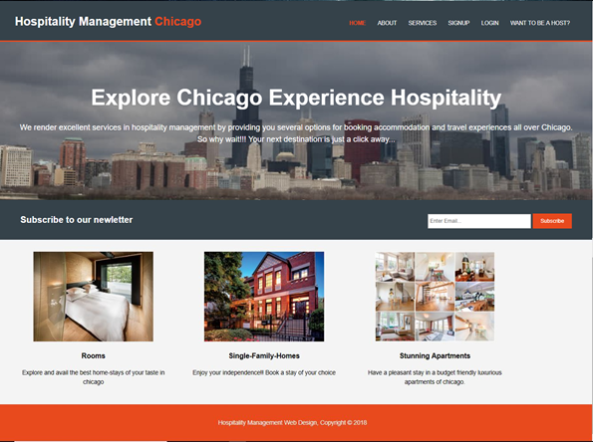

About page

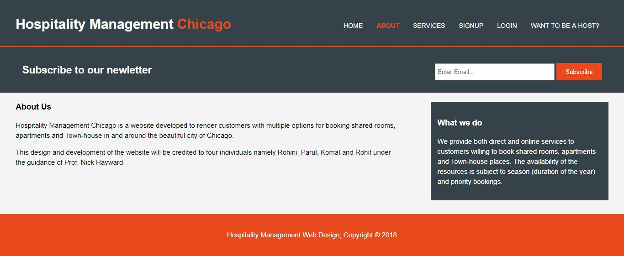

Services page

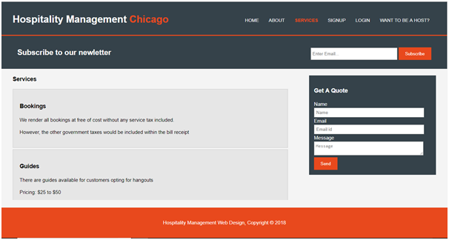

Workflow of the Website –

* Initially all the visitors to this site land in home or index page from where they can navigate to other pages.
* To gain access to login required pages user must first sign up for the website by providing appropriate details in registration form. Here the user needs to fill out the details since they are all mandatory fields. If any field is not entered appropriate error message pops up forcing the user to enter the value before registering. After successful registration user will be redirected to login page.

Sign Up page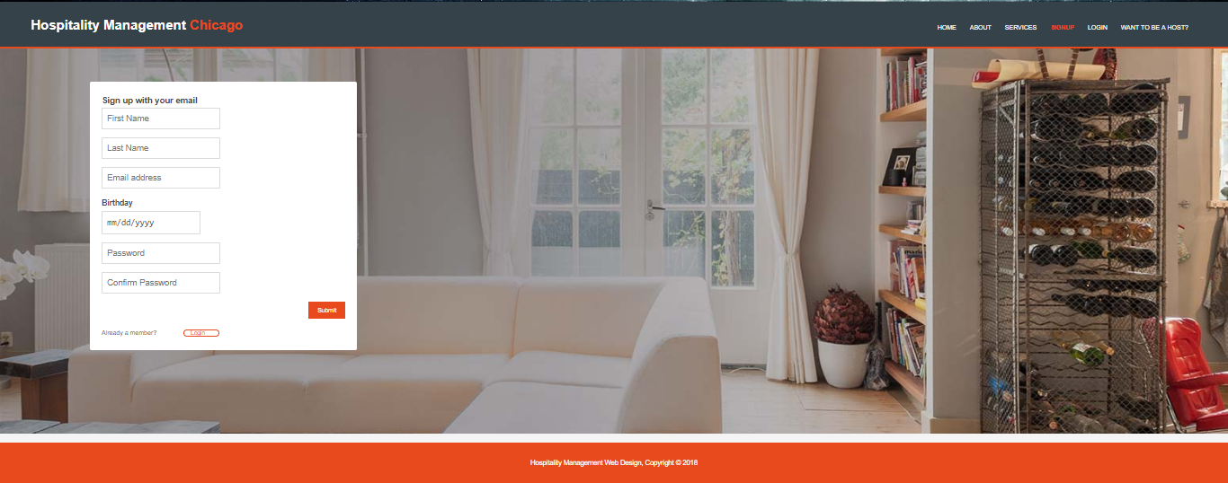

* After completing registration, the user would be registered as a customer and will be allowed to sign in to the website using his/her credentials.

Login page

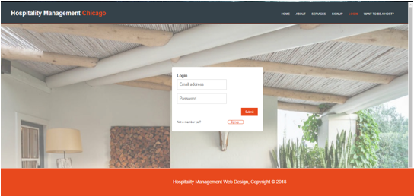

* Host –

Host is a person who will post his/her accommodation details which could be rented/leased for temporary stay. Host can do this by first clicking on the link –  on the menu bar of the website and further navigating, entering and submitting details on the below page.

Host page

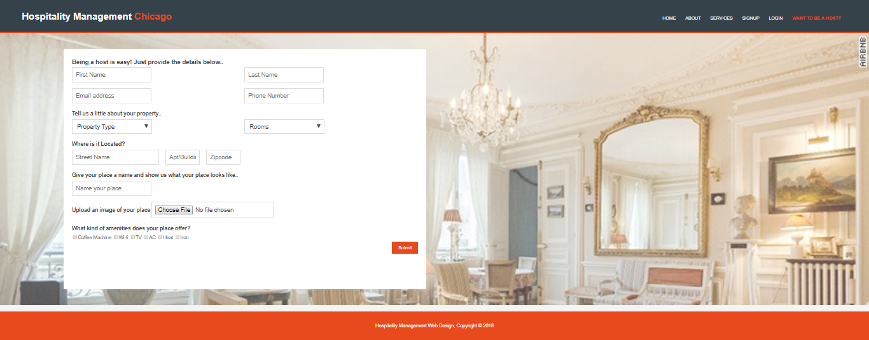

* Customer –

Customer is the individual logging into the website to book/reserve home-stays and experiences. Customer will have to select the desired homes on the website and navigate on the pages below to book for the same

Customer Home Page

After logging-in to the application, the customer will be directed to the page as shown below.

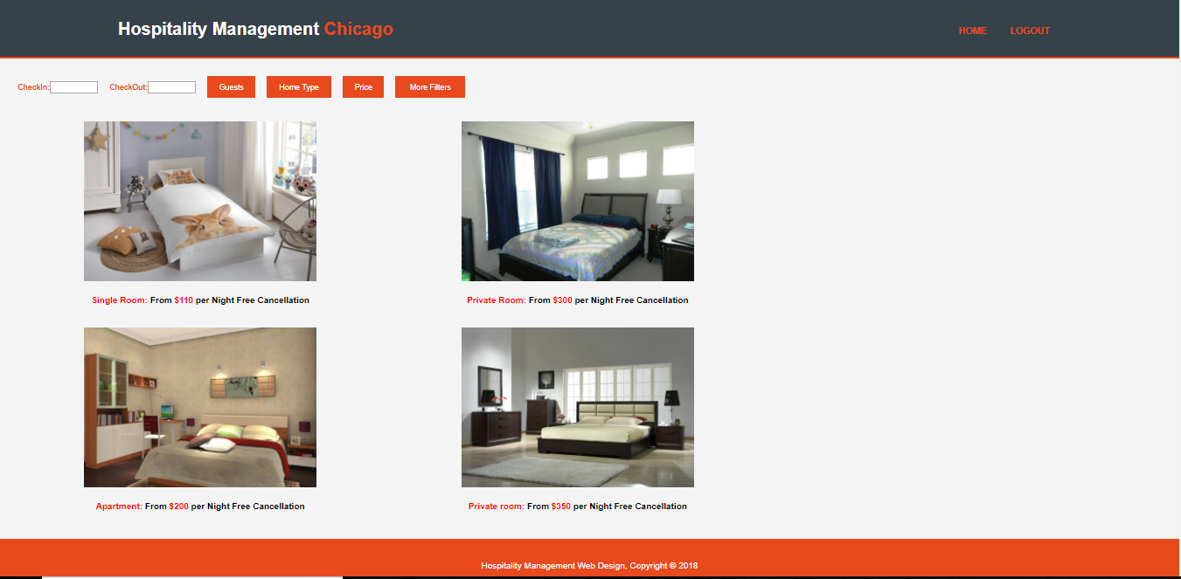

The page has various filter options in the menu bar such as check-in checkout dates, number of guests, Home Type (Apartment, private room, entire house), Price and More filters.

More filters option will contain other detailed level filters such as rooms and beds, amenities, facilities, house rules.

After applying the required filters, the houses that matches the criteria will be appeared on the page (This is not implemented as it’s a part of functionality that requires database, hence all the image and data values are dummy). Each image is a hyperlink that will redirect the customer to the respective room he/she selected, to have a broader look.

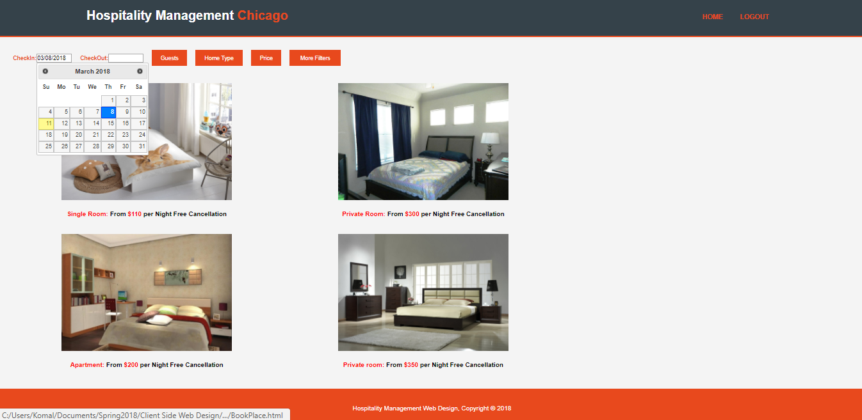

A calendar is implemented for check-in checkout date using Javascript and jquery. We tried making the font colour of check-in checkout same as other buttons, but we were unable to do it and would require guidance. For other tabs (Guests, Home Type, Price and More filter) we were trying to implement a modal and a slider (for price range) but we were not clear with its functionality and usage. We are still trying to research on it and understand its usage.

The space on the right side of the page is purposely left to implement a map showing the available places/rooms in Chicago.

Customer Reservation Pages -

On clicking on the desired image from the Guest home page, the customer will be directed to the Book Place page to have a broader look of the room he/she selected. The page is as shown below. (It was difficult to take screenshot of the entire page, so I took screenshot in two parts).

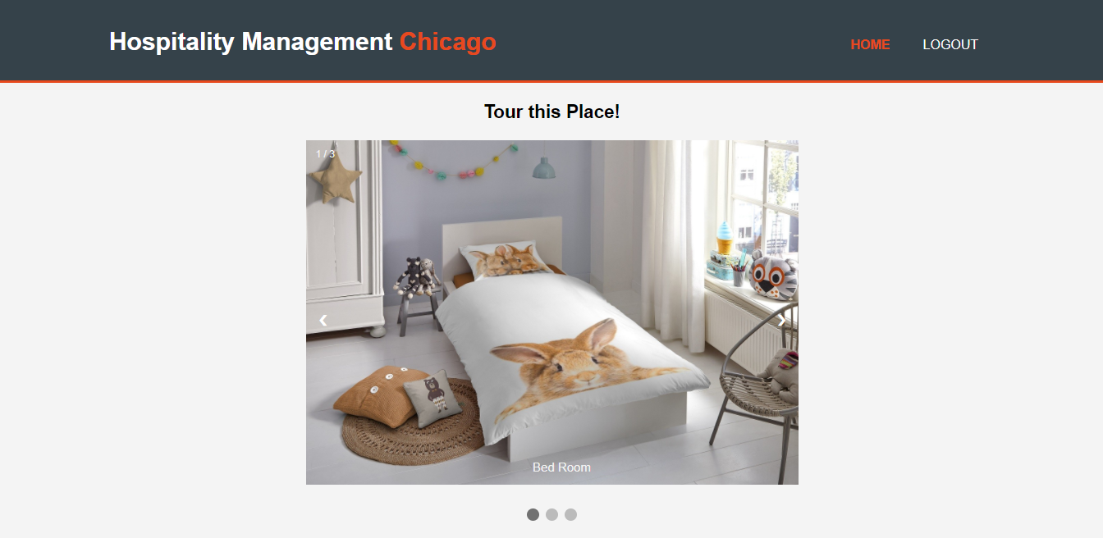

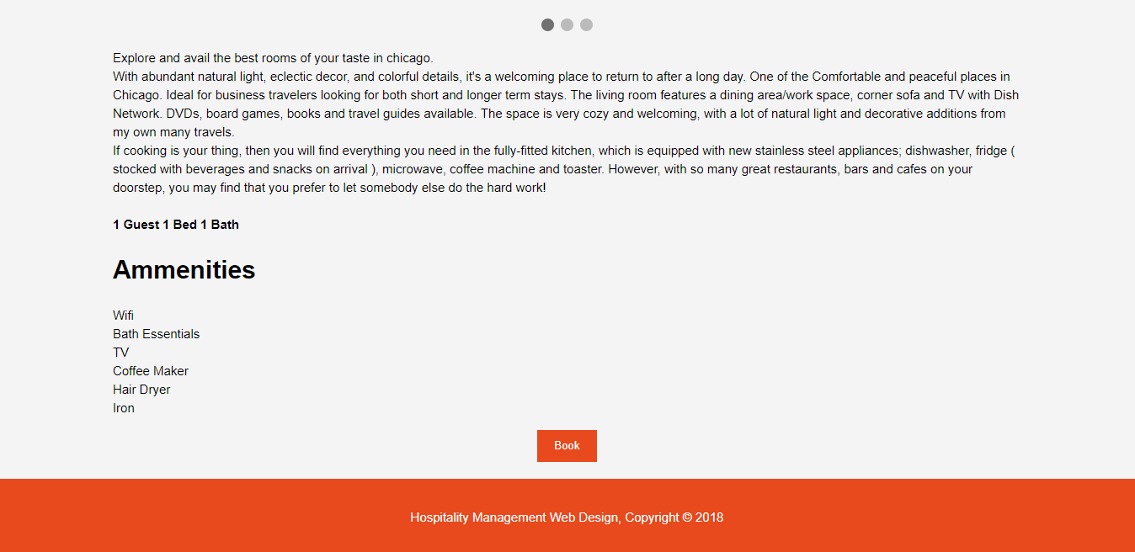

Using this page, the customer can take a virtual tour of the room/house he selected. He can view the different images of the house or can also view his room image from different angles.

Slideshow of the image is implemented using Javascript. This page contains the detailed description of the room/place including amenities and facilities (currently hard coded as no database is used).

If the customer finds the place good, he can go ahead and book the room using this page, else he can return to the home page.

Review Your Booking Page

This page allows the customer to review his booking details including the final amount breakdown. He can go through his booking once again before paying the amount.

Agree and Continue button will redirect the customer to the payment page.

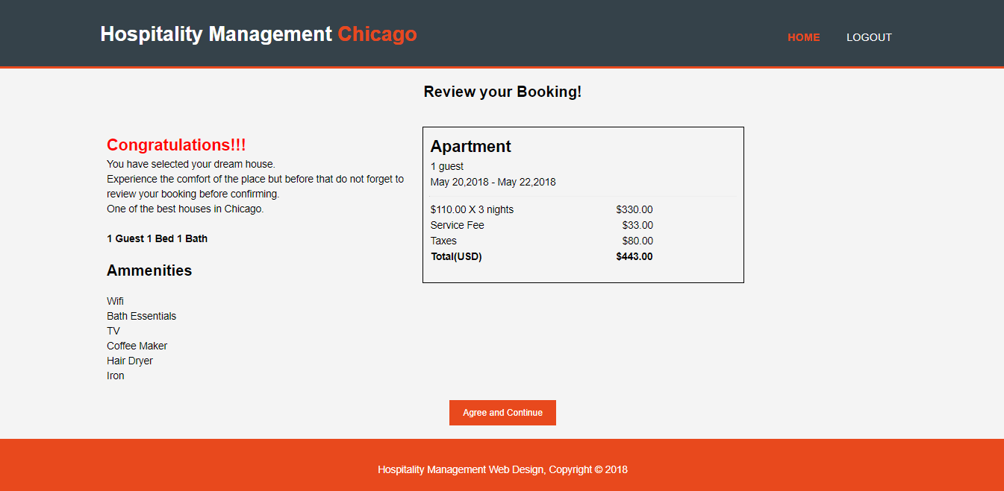

Payment Page

Using this page, the customer can make payment by providing his payment details. Mathematical calculations are temporarily hard coded as functionality is not implemented yet.

Validations are not currently applied to this page as some fields may be modified after reviews and feedback. Post feedback, changes will be implemented along with validations.

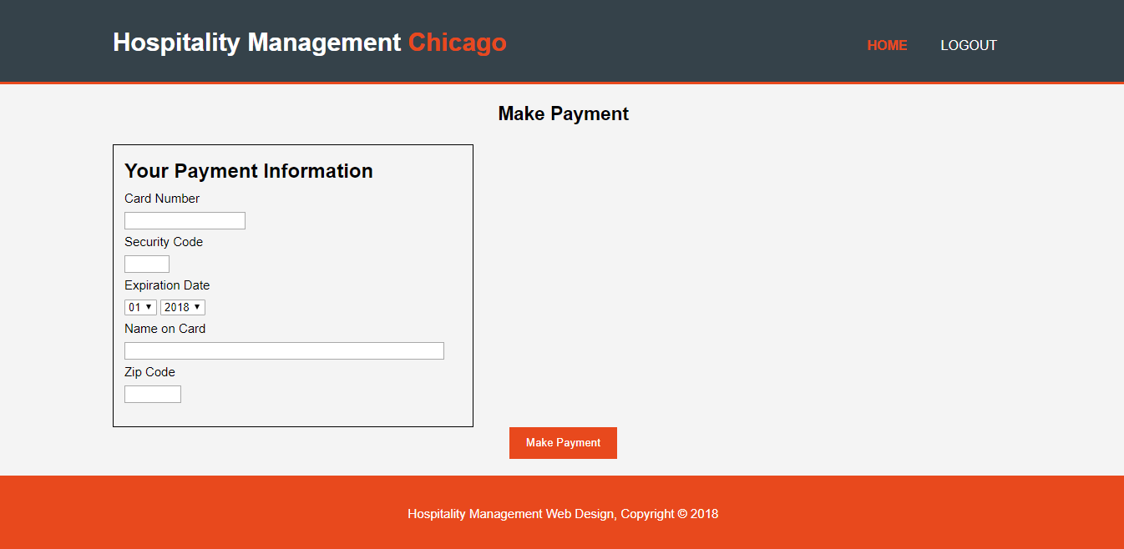

* Administrator –

Administrator is the person who would manage the entire website and also handles the requests put up by Hosts to further approve for customer visibility

Technologies Used –

* HTML5
* CSS3
* JavaScript

Tools used –

* Atom
* Notepad++
* Chrome
* Live-Server
* Windows Paint
* miniPaint – image editor
* Git Hub

**Research:**

* For signup and login pages we needed images with less opacity. To accomplish this, we used miniPaint – Image Editor to reduce the opacity to change the image to transparent which resulted in, form to be highlighted.
* In signup and login pages there were many ways to perform validation using javascript and jquery. After research we implemented javascript validation using alert messages.
* For Customer Pages, Research was done to implement a calendar. It was found that it could be implemented using javascript and jquery. The font color and format of check-in checkout did not match with other buttons in the menu. To accomplish this research was done which did not work out and need some guidance.
* In the Guest home page, for ‘More Filter’ tab, we had two options to handle it, either redirect the customer to a new page so that he can select his filters (bed and bath, amenities) or generate a pop-up. After researching, it was found that modal was one of the options for doing this and we are still working on it.

**Future Enhancements:**

* In sign up page validation is just checking if a value is entered. We will add more rules for email and check if there is a user with that email address already in system.
* We will try to implement a map in Guest home page which will show all the current available places/rooms in Chicago.
* Add more functionalities where to customer pages where customer would be able to view and/or cancel his bookings as and when required.