Karma High:
A Lesson in Empathy
by Rob Jagnow (rob@lazy8studios.com)
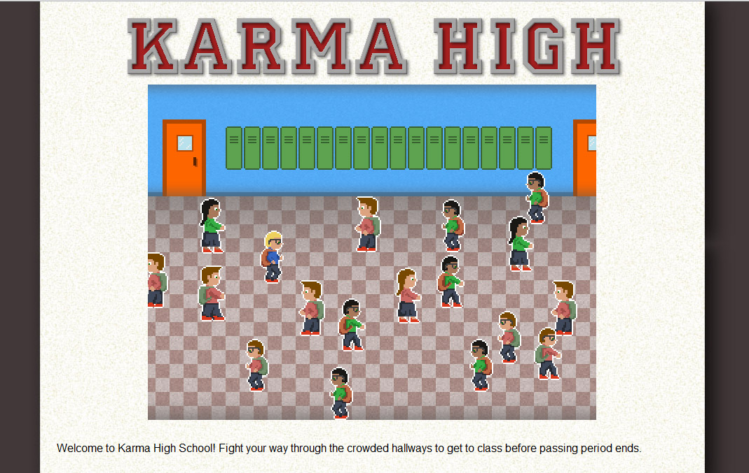
and Ryan Williams (breath@alum.mit.edu)

Karma High is an 8-bit game designed to encourage a conversation about empathy and bullying.

In the game, the users progress through three levels of increasing difficulty, as follows:

- Level 1: The player can attack with a punch to move others out of the way.
- Level 2: The player has a “verbal assault” attack.
- Level 3: The player has no attack and is instead attacked by the characters that they played earlier.

After a bit of frustration, players will likely figure out that Level 3 is impossible to win. Every time they get close to their classroom, they get attacked and have to restart. The only way to win is to restart the game completely and play through the first two levels without ever using your attack ability.

All of the source for the game is available at https://github.com/rjagnow/karmahigh. In order to work properly without security violations, the code must be served up over a local web server.
It's much easier to play the live game at http://www.karmahs.com.

