Artificial Intelligence (AI) is a broad umbrella term for computer systems designed to mimic human intelligence. Machine Learning (ML) is a specific subset of AI that trains algorithms to learn patterns from data and make predictions without being explicitly programmed to do so. [1, 2]
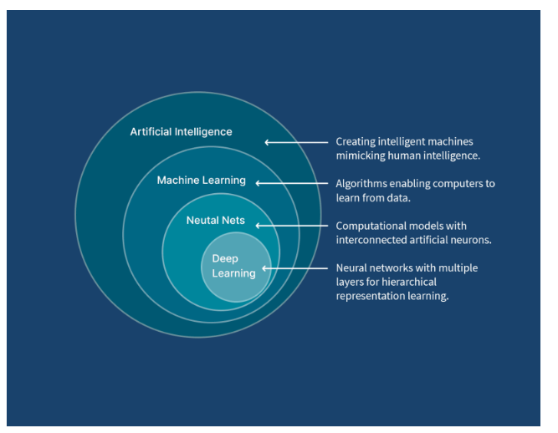

Key Differences
To understand how they work together, consider these distinctions:
- Artificial Intelligence: The overarching goal. It encompasses any technique that enables computers to "think," reason, solve problems, and understand human language. This can include traditional, hard-coded rules (like a simple chess program) or advanced data-driven systems. [1, 2, 3]
- Machine Learning: The engine that powers many modern AI applications. Instead of coding specific instructions, you feed an ML algorithm large datasets, and it figures out the underlying rules itself. [1, 2, 3]

How Machine Learning Works
ML typically operates in one of three ways:
- Supervised Learning: The model is trained on labeled data (e.g., thousands of images marked as "cat" or "dog") so it can classify new, unseen data. [1, 2]
- Unsupervised Learning: The algorithm analyzes unlabeled data to find hidden patterns or groupings on its own (e.g., segmenting customers by purchasing habits). [1, 2]
- Reinforcement Learning: The algorithm learns through trial and error, receiving rewards or penalties to optimize its behavior (frequently used in robotics and game playing). [1, 2]
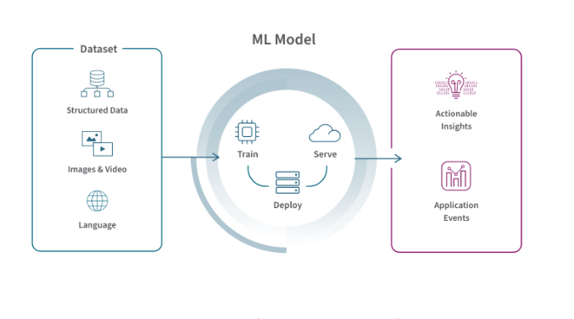
Real-World Examples
- AI: Virtual assistants (like Siri or Alexa), autonomous driving cars, and generative AI tools that create text or images.
- ML: Email spam filters, credit card fraud detection algorithms, and entertainment recommendation engines (like Netflix or Spotify)

Machine Learning Vs. Artificial Intelligence
Machine Learning and Artificial Intelligence are two closely related but distinct concepts in the field of computer science. Both aim to create intelligent systems but their scope, capabilities and applications differ significantly.
Key Points:
- AI is a broader concept, aiming to simulate human intelligence in machines.
- ML is a subset of AI, focusing on creating algorithms that allow machines to learn from data.
- AI can include rule-based systems while ML relies on statistical methods and patterns in data.
- AI can perform reasoning and problem-solving, whereas ML focuses on prediction and classification.
- 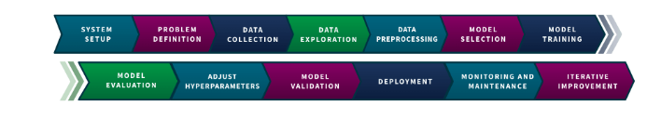
1. Understanding Artificial Intelligence (AI)
Artificial Intelligence includes designing systems that can perform tasks requiring human intelligence. These tasks include reasoning, learning, problem-solving, perception and natural language understanding. AI systems can be rule-based or data-driven and are designed to mimic human cognitive abilities.
AI can be categorised into:
- Narrow AI: Specialized systems designed for specific tasks (e.g., Siri, chatbots).
- General AI: Hypothetical systems with human-like intelligence across various tasks.
- Super AI: A theoretical form of AI that surpasses human intelligence in all aspects including creativity, decision-making and problem-solving.
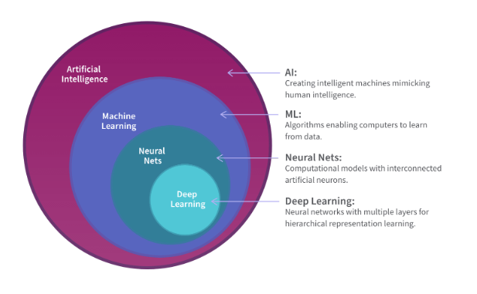
Applications of AI:
- Self-driving cars: Analyze surroundings and make driving decisions.
- Healthcare: Diagnose diseases using medical data.
- Finance: Detect fraud or predict market trends.
- Customer Service: Virtual assistants providing automated support.
Key Features of AI:
- Ability to simulate human reasoning and decision-making.
- Can combine different techniques such as ML, robotics and expert systems.
- Handles tasks that require understanding, reasoning or perception.
2. Understanding Machine Learning (ML)
Machine Learning is a branch of AI that focuses on teaching machines to learn patterns from data and improve their performance over time. Instead of explicitly programming every rule, ML systems use algorithms to analyze data, find trends and make predictions.
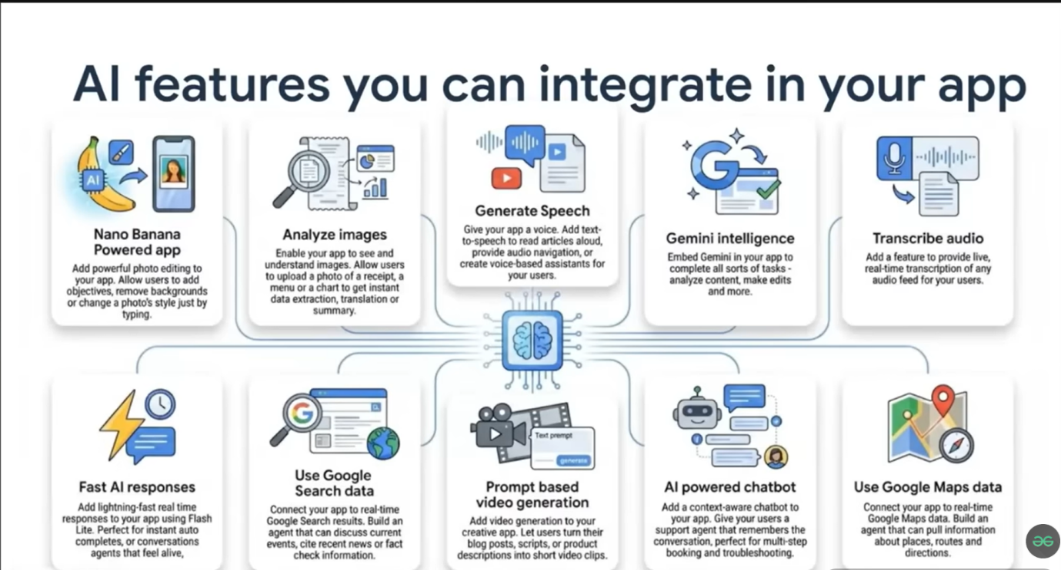
ML can be categorized into:
- Supervised Learning: Learns from labeled data to make predictions.
- Unsupervised Learning: Finds hidden patterns or groupings in unlabeled data.
- Reinforcement Learning: Learns through trial and error with feedback from the environment.
Applications of ML:
- Email spam detection: Automatically classifies emails as spam or not.
- Recommendation systems: Suggests movies, products or content based on user behavior.
- Healthcare predictions: Predicts patient outcomes using historical data.
- Stock price prediction: Uses past market data to forecast trends.
Key Features of ML:
- Learns automatically from historical data.
- Can detect trends, make predictions and improve over time.
- Primarily data-driven and focuses on pattern recognition.
Key Differences Between AI and ML
Moving ahead, now let's check out the basic differences between artificial intelligence and machine learning.
Feature | Artificial Intelligence (AI) | Machine Learning (ML)
Definition | Simulates human intelligence in machines | Enables machines to learn from data
Scope | Broader field | Subset of AI
Objective | Create intelligent systems capable of reasoning and decision-making | Predict outcomes, recognize patterns and improve automatically
Approach | Rule-based, logic-based and ML-based | Data-driven, uses algorithms and statistical methods
Data Dependency | Not always dependent on data | Highly dependent on quality and quantity of data
Output | Can perform complex reasoning, decision-making and planning | Produces predictions, classifications or pattern recognition
Complexity | Can handle both simple and highly complex tasks | Primarily handles tasks suitable for pattern learning
Types | Narrow AI, General AI and Super AI (hypothetical) | Supervised, Unsupervised and Reinforcement Learning
Applications | Self-driving cars, virtual assistants, robotics, fraud detection | Email filters, recommendation systems, predictive analytics, stock forecasting
Example Systems | IBM Watson, Google Assistant | Netflix recommendation engine, Gmail spam filter

