Experiment No.2
Array Implementation of Stack
To implement different stack functions like PUSH(), POP(), PEEK(), ISEMPTY(), ISFULL() and DISPLAY using arrays.
Date of Performance:
Date of Submission:

Experiment No. 2: Array Implementation of Stack
Aim: To implement different stack functions like PUSH(), POP(), PEEK(), ISEMPTY(), ISFULL() and DISPLAY using arrays.
Objectives:
1) Understand the Stack Data Structure and its basic operators.
2) Understand the method of defining the stack and implement the basic operators.
3) Develop functions to perform stack operations and apply them in various applications.

Theory:

Stack Implementation Using Arrays
A stack is a linear data structure that follows the Last In, First Out (LIFO) principle, meaning the last element inserted is the first one to be removed. Stacks can be implemented using arrays or linked lists, with the array-based approach being simpler and more memory-efficient in static allocation scenarios.
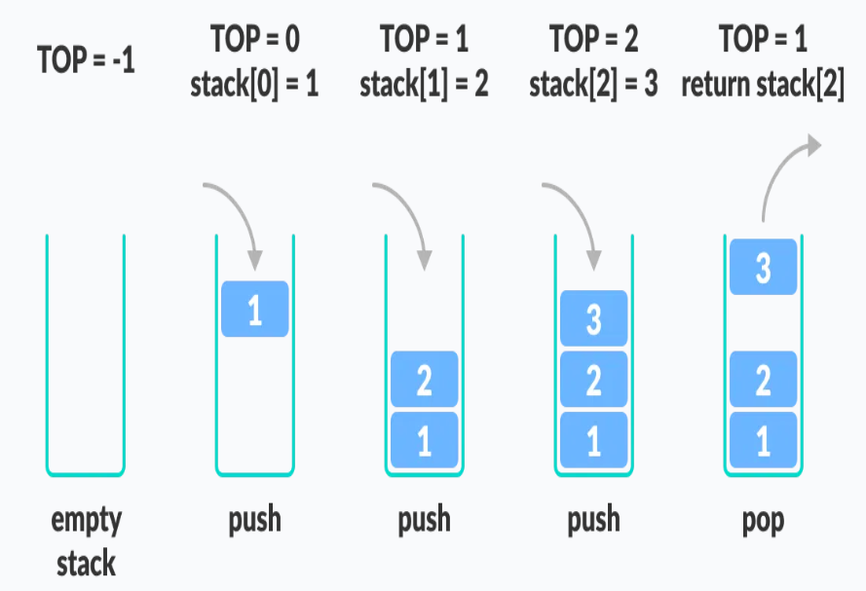

Stack Operations:
- Push (item): Inserts a new element 'item' onto the top of the stack.
- pop(): Removes and returns the topmost element from the stack.
- peek(): Retrieves the value of the topmost element without removing it from the stack.
- isEmpty(): Checks if the stack is empty by verifying if the top pointer points to a sentinel value (e.g., -1). Returns true if the stack is empty; otherwise, it is false.
- isFull(): Determines if the stack has reached its maximum capacity by checking if the top pointer is at the last valid index. Returns true if full, false if not.
- display(): Outputs all elements in the stack, typically by traversing from top to bottom.
Algorithm:
- Push Operation:
  - If the stack is not full, increment the top index and insert the element at the new top.
- Pop Operation:
  - If the stack is not empty, return the element at the top and decrement the top index.
- Peek Operation:
  - Return the element at the top index if the stack is not empty.
- isEmpty Operation:
  - Return true if top is -1, indicating the stack is empty.
- isFull Operation:
  - Return true if the top is N (capacity/size of stack), indicating the stack is full.

Code and Output:
Conclusion: Students will conclude their understanding of Implementation of Stack using Array.

