Experiment No.3
Array Implementation of Linear Queue.
To implement different queue functions like ENQUEUE(), DEQUEUE(), PEEK(), ISFULL(), ISEMPTY() and DISPLAY using arrays
Date of Performance:
Date of Submission:

Experiment No. 3:Array Implementation of Linear Queue.
Aim: To implement different queue functions like ENQUEUE(), DEQUEUE(), PEEK(), ISFULL(), ISEMPTY() and DISPLAY using arrays.
Objectives:
- Understand the Queue data structure and its fundamental operations such as enqueue, dequeue, and peek.
- Learn how to implement a queue using arrays or linked lists.
- Develop functions to perform queue operations and apply them in various real-world applications.
Theory:
A Queue is an ordered collection of items from which items may be deleted at one end (called the front of the queue) and into which items may be inserted at the other end (the rear of the queue). Queues remember things in first-in-first-out (FIFO) order. The basic operations in a queue are: Enqueue - Adds an item to the end of the queue. Dequeue - Removes an item from the front.
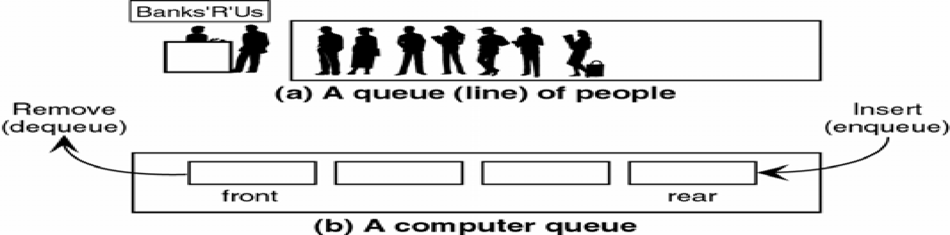
A queue is implemented using a one dimensional array. FRONT is an integer value, which contains the array index of the front element of the array. REAR is an integer value, which contains the array index of the rear element of the array. When an element is deleted from the queue, the value of front is increased by one. When an element is inserted into the queue, the value of rear is increased by one.
Queue Operations
- Enqueue(item): Inserts a new element 'item' at the rear of the queue. However, attempting an enqueue will result in an OVERFLOW ERROR if the queue is FULL.
- Dequeue(): Removes and returns the front element of the queue. If the queue is EMPTY, attempting a dequeue will trigger an UNDERFLOW ERROR.
- Peek(): Retrieves the value of the front element without removing it. If the queue is EMPTY, it indicates an ERROR STATE.
- isEmpty(): Checks if the queue is EMPTY by verifying if the front pointer is at an invalid state. Returns TRUE if the queue is EMPTY, otherwise FALSE.
- isFull(): Determines if the queue has reached its MAXIMUM CAPACITY by checking if the rear pointer is at the last valid index. Returns TRUE if FULL, otherwise FALSE.
- Display(): Outputs all elements in the queue, typically by traversing from FRONT to REAR.
Algorithm:
A linear queue can be implemented using an array with two pointers:
- Front: Points to the first element of the queue.
- Rear: Points to the last inserted element.
Front = -1, Rear = -1

Enqueue Operation (Insertion)
- If the queue is not full, insert the element at rear+1.
- If the queue was empty (front = -1 and rear = -1 ), set front = 0 , rear = 0.
- Update rear to rear + 1.

Dequeue Operation (Deletion)
- If the queue is not empty, remove the element at front.
- Increase front (front = front + 1).
- If front = rear, reset front = rear = -1 (queue is empty).

Peek Operation
- If the queue is not empty, then get queue[front].
- If the queue is empty then print “queue is empty”.

Code and Output:

Conclusion: Students will conclude their understanding of Implementation of Queue using Array.

