CALLIE WELLS
INTERIOR DESIGN
Home Office Conversion
Project Specification · Sheet Set A-101
Client Location: Rancho Santa Margarita, California
Issue Date: April 25, 2026
Scale: 1/2" = 1'-0" (1:24)
Source File: home-office.dwg · AutoCAD 2027
This document accompanies the dimensioned floor plan and 3D presentation render delivered in this package. All vendor names listed are equivalents; final selections are subject to client approval and current lead times.

1. Project Narrative
The client converted a 11'-6" × 10'-0" spare bedroom into a dedicated home office. The brief called for a focused work zone for video calls and writing, plus a separate reading nook for end-of-day decompression. Carpet was pulled and replaced with luxury vinyl plank so the chair rolls cleanly and the material is easy to vacuum on a daily basis.

Design Intent
- Daylight as side light, not backlight. The desk faces into the room rather than toward the window so the operable casement on the east wall delivers diffuse side light to the writing surface and avoids glare on the monitor and on the client’s face during video calls.
- Two zones, one room. Work zone occupies the west half of the room; the reading nook anchors the NE corner with an upholstered armchair, side table, and floor lamp grouped on a 6'×4' area rug to visually separate it from the work desk.
- A neutral envelope, warm accents. Walls, ceiling and trim stay light and quiet so the wood-tone desk, walnut bookcase, and blue-gray armchair read as the personality of the room without competing with each other.

2. Room Program
Element | Specification
Room dimensions (interior) | 11'-6" W × 10'-0" L (138" × 120")
Floor area | Approximately 115 SF
Ceiling height | 9'-0" AFF
Door | 2'-8" × 6'-8" single swing, hinged east, swings inward
Window | 4'-0" × 4'-0" operable casement, east wall, sill at 36" AFF
Floor finish | Luxury vinyl plank, warm walnut tone
Wall finish | Existing painted drywall; recommend repaint in warm white
Ceiling finish | Existing flat white

3. FF&E Schedule
Tag numbers correspond to the bubbles on the floor plan. All sizes are nominal width × depth × height in inches. Vendor names are placeholders / equivalents — final selections subject to client approval and current lead times.
Tag | Item | Size W × D × H | Material / Finish | Vendor (equiv.) | Qty
1 | Writing desk | 60 × 30 × 30 | Solid white oak, walnut stain, satin lacquer | West Elm “Mid-Century” | 1
2 | Task chair | Ø 20 × 18 swivel | Charcoal performance fabric, polished alum. base | Herman Miller Sayl | 1
3 | Bookcase | 36 × 12 × 72 | Walnut veneer, open-shelf, 5 shelves | Crate & Barrel “Aspect” | 1
4 | Armchair (reading) | 34 × 34 × 32 | Upholstered, blue-gray performance linen | Article “Sven” | 1
5 | Side table | Ø 18 × 22 | Cream lacquer top, brass tubular base | CB2 “Mill” | 1
6 | Floor lamp | Ø 12 base × 60 H | Matte dark-gray steel, linen drum shade, 3-way | Schoolhouse “Isaac” | 1
7 | Area rug (under nook) | 72 × 48 × 0.5 | Wool/poly blend, low pile, indigo / cream | Loloi “Layla” | 1

Lead-time note: items 1, 3, and 4 typically ship 4–8 weeks. Order on contract signature to keep the critical path on schedule.

4. Finish Schedule
Surface | Material | Color / Finish | Spec Note
Floor | LVP, 7" plank | Warm walnut, semi-matte | 8 mil wear layer min., underlayment incl.
Baseboard | Painted MDF, 4" colonial | Match wall trim (semi-gloss white) | Caulk + paint touch-up after install
Walls | Existing drywall | Benjamin Moore “Swiss Coffee” (OC-45), eggshell | 2 coats over primer where patched
Ceiling | Existing drywall | Benjamin Moore “Decorator’s White” (CC-20), flat | Match existing
Door & casing | Painted MDF | Match trim (semi-gloss white) | New hardware: matte black lever
Window casing & sill | Painted MDF | Match trim (semi-gloss white) | Roller shade in tan linen, top-mount

5. Lighting Plan (Notes)
The rendered drawing set does not yet include a reflected-ceiling plan. For this room the recommendation is:
- 1× recessed 6" LED downlight, centered over desk; 3000K, 800 lm, dimmable.
- 1× recessed 6" LED downlight, centered over reading nook; same spec.
- Floor lamp (FF&E #6) provides task light at the armchair; switched at the socket.
- Window provides primary daylight; recommend matching solar shade if the client experiences afternoon glare.
Switch the two recessed cans on a single dimmer at the door.

6. Power & Data (Notes)
- Existing duplex outlets at the south and west walls — verify before move-in.
- Recommend adding a quad outlet at the desk (west wall) for monitor, lamp, laptop, and phone charger.
- Cat-6 drop at desk if Wi-Fi proves unreliable for video calls.
- No outlet relocations called out on the floor plan; coordinate with electrician if added.

7. Door & Window Detail
- Door is shown swung 90° inward in the 3D presentation as a diagrammatic shortcut; the 2D plan shows the opening only. For a final construction set, the door leaf would be drawn closed with a 2D swing arc on the plan view.
- Window is a 48" × 48" operable casement, centered vertically on the east wall (sill at y=36" interior, head at y=84"). The 3D model shows glass with simple muntins, sill, apron, and a 24"-drop tan roller shade.

8. Scope Exclusions
- Structural / load-bearing changes (none needed).
- HVAC, plumbing, electrical permits (existing room only — no new circuits).
- Furniture procurement (designer specs the items; client procures or designer procures via a separate purchase agreement).
- Soft goods beyond the rug and roller shade.
- Art and accessories (left to a future styling pass).

9. Notes & Assumptions
- Existing electrical, HVAC, and structure assumed adequate for a home office without modification.
- Vendor names listed are placeholders / equivalents; final selections to be confirmed against client budget and lead times before issuing a PO.
- All dimensions are approximate — confirm in field before placing orders.

10. Floor Plan — Sheet A-101
Plan view at 1/2" = 1'-0". FF&E tags 1–7 keyed to the schedule on page 3. Door, window, and overall room dimensions called out; north arrow upper-right; designer stamp lower-left.
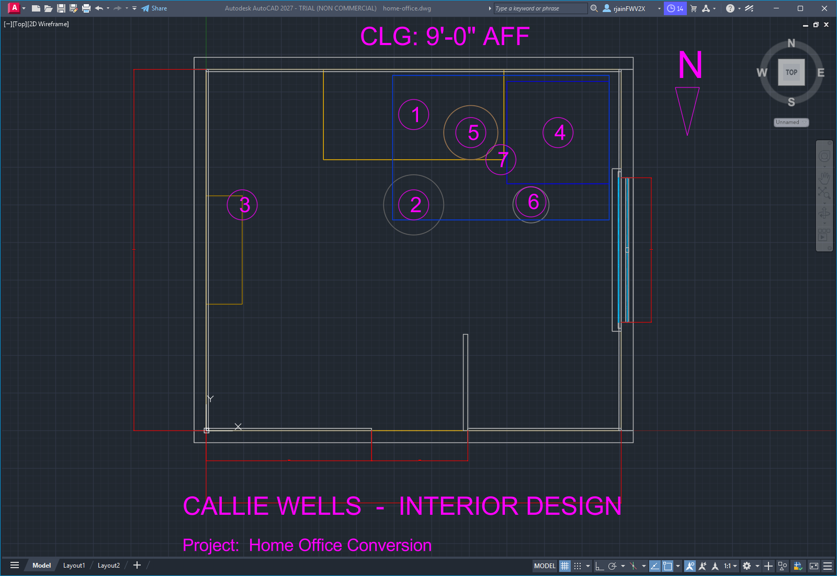
Sheet A-101 — Home Office Floor Plan & FF&E Tags

11. 3D Presentation View
Southwest isometric, AutoCAD Conceptual visual style. Ceiling layer frozen so the viewer can see into the room. Materials are shown as flat colors keyed to the finish schedule — final renders with full materials and lighting can be produced on request.
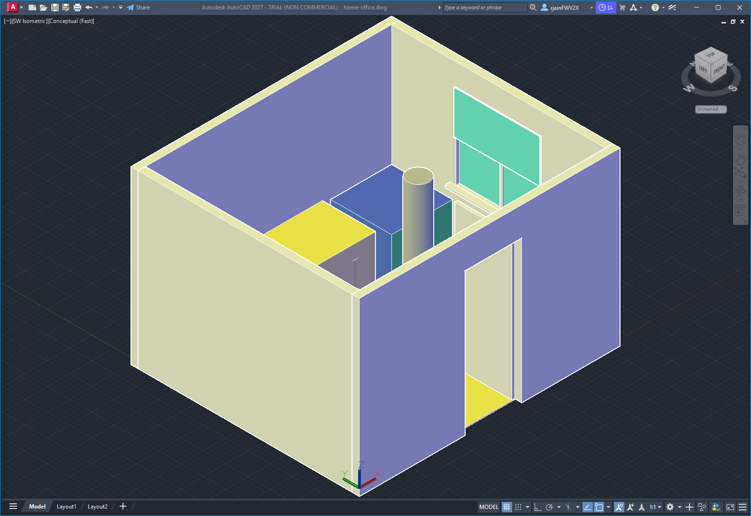
SW Isometric — Conceptual Render

