CALLIE WELLS
INTERIOR DESIGN
Kitchen Casework
Single-Wall Layout with Island · Sheet Set A-201
Client Location: Rancho Santa Margarita, California
Issue Date: April 27, 2026
Scale: 1/2" = 1'-0" (1:24)
Source File: kitchen.dwg · AutoCAD 2027
Single-wall cabinet run with a freestanding island, totaling 14'-0" of base + wall casework. Painted Shaker doors over a quartz counter, with a stainless hood, panel-ready dishwasher, and full-height pantry. Issued for client review and budget alignment.

1. Project Narrative
A clean single-wall kitchen for a coastal-California home — long-wall casework for everyday cooking, anchored by a freestanding island that doubles as the breakfast bar and the prep zone. Painted Shaker doors in a warm white over a quartz counter keep the room bright; a tall pantry on the east end disguises the dry-goods storage so the line of upper cabinets reads continuous from the dining room (visible through the west-wall opening).

Design Intent
- One wall, full work triangle. Range, sink, and the dishwasher slot all live along the south wall in a 14'-0" run. Total prep travel is under 6'-0" between work zones.
- Island as second counter. The island carries the seating overhang (12" on the north side) and provides 96" of clear counter for prep — enough for a sheet pan and two cutting boards laid out at once.
- Pantry over wall cabinets. The east-end pantry runs full 84" so it reads as architecture, not as cabinetry. Wall cabinets stop short of it for visual rhythm.
- Hood over the range. No wall cabinet over the cooktop — a 30" ducted hood vented up through the soffit. Code-compliant, and visually it gives the cooktop "breathing room."

2. Room Program
Element | Specification
Room dimensions (interior) | 14'-0" W × 10'-0" L (168" × 120")
Floor area | Approximately 140 SF
Ceiling height | 10'-0" AFF
Wall openings | 6'-0" wide × 8'-0" tall opening on west wall to dining room
Floor finish | Engineered white-oak plank, semi-matte
Wall finish | Painted drywall, semi-gloss white at backsplash zone
Ceiling | Painted drywall, flat white

3. FF&E + Casework Schedule
Tag numbers correspond to the bubbles on the floor plan. All sizes are nominal width × depth × height in inches.
Tag | Item | Size | Material / Finish | Notes | Qty
1 | Base cabinet B36 | 36 × 24 × 34.5 | Painted Shaker, soft-close | Toe kick 4×3 | 1
2 | Slide-in range R30 | 30 × 27 × 36 | Stainless / black, 5-burner gas | Anti-tip required | 1
3 | Dishwasher DW24 | 24 × 24 × 34.5 | Stainless, panel-ready front | Hidden in plan | 1
4 | Sink base SB36 | 36 × 24 × 34.5 | Painted Shaker, false drawer | Pull-out trash optional | 1
5 | Base cabinet B30 | 30 × 24 × 34.5 | Painted Shaker, drawer stack | 3 drawers | 1
6 | Pantry P12 (full ht) | 12 × 24 × 84 | Painted Shaker, 5 fixed shelves | Slim — canned goods | 1
7 | Range hood | 30 × 18 × 30 | Stainless, ducted, 600 CFM | Vents up through soffit | 1
8 | Island | 96 × 42 × 34.5 | Painted Shaker + quartz | 12" overhang seating side | 1
9 | Sink basin | 25 × 19 × 9 | Stainless under-mount, 18 ga | Single-bowl | 1
10 | Counter, long-wall | 156 × 25.5 × 1.5 | Quartz, eased edge | Single seamed slab | 1
11 | Faucet | Ø 1.2 × 13 H | Brushed nickel, single-handle | Pull-down spray | 1
— | Wall cabinets | 12 deep × 42 tall | Painted Shaker, frameless | Bottoms at 54" AFF | 4

4. Finish Schedule
Surface | Material | Color / Finish | Spec Note
Floor | Engineered white oak, 7" plank | Natural, semi-matte | Continue from living room
Cabinet doors | Painted MDF, Shaker style | BM "Simply White" (OC-117), satin | Soft-close hinges + slides
Cabinet boxes | Plywood, painted to match doors | Same as doors | Edge-banded
Counter | Quartz, 1.5" eased edge | "Calacatta Lyon" (light gray vein) | Single 8' island slab; long-wall seamed
Backsplash | Field tile (TBD) | Recommend 3×12 white matte subway | Field above counter under wall cabs
Toe kick | Painted MDF | Match cabinets | 4×3 recessed
Hood | Stainless steel, brushed | Manufacturer finish | 600 CFM minimum
Sink | Stainless, 18 ga, brushed | Under-mount | Single-bowl 25×19
Faucet | Brushed nickel | Single-handle pull-down | 360° swivel, 18" reach
Range | Stainless / black | Manufacturer finish | 30" 5-burner gas
Dishwasher | Stainless, panel-ready | Match cabinet doors | Hidden front

5. Lighting Recommendations
- 4× recessed 4" LED downlights in a staggered grid over the island and prep run (3000K, 800 lm, dimmable).
- Under-cabinet LED strip below all wall cabinets (2700K), switched at the island.
- Pendant-light cluster (3 pendants) over the island, hung at 36" above the counter.
- All zones on Lutron Caseta dimmers, scene control by the dining-room doorway.

6. Power & Data
- Code-required GFCI outlets every 4'-0" along the counter run.
- Dedicated 240V circuit for the range.
- 120V outlet under the sink for the dishwasher.
- Recommend a duplex outlet on the island (pop-up or end-cap) for countertop appliances.

7. Plumbing & Venting
- Sink rough-in centered at x = 7'-0" from the west wall (under SB36).
- Dishwasher supply + drain shared with sink supply lines.
- Range vent: 6" round duct rises through the soffit above the hood and exits through the roof or sidewall.

8. 3D Modeling Notes
The .dwg uses Project 4 curriculum commands:
Command | Use in this model
BOX | All cabinet boxes, counter, hood, range, dishwasher, sink basin, pantry
CYLINDER | Cooktop grates, faucet body and spout
SUBTRACT | Hallway opening, sink cutout, toe-kick voids (PRESSPULL substitute)
TOP / NEISO / FRONT / BACK | Plan view, presentation iso, two elevations
2DWireframe / Conceptual | Switching visual style per snapshot

Items reserved for a future GUI pass: named UCS for elevation drafting, PRESSPULL on toe kicks (replaced by SUBTRACT here), FILLETEDGE 0.25" on counter edges, FLATSHOT projection from the 3D model onto a 2D elevation, and the ARCH-D layout sheet with title block + 4 viewports. The Word doc substitutes for the plotted board.

Run-length adjustment: brief calls a long-wall run summing to 192" but the wall is 168". This package reduces to B36 + R30 + DW24 + SB36 + B30 + P12 = 168" by reassigning one base slot to the dishwasher and reducing pantry from 24" to 12". Documented in SPEC §8.

9. Scope Exclusions
- HVAC and venting design (architect/engineer scope).
- Permits (range circuit, plumbing rough-in).
- Backsplash tile selection (recommendation only).
- Refrigerator and freezer — verify location with architect.
- Pendant fixtures over the island (lighting designer scope).

10. Notes & Assumptions
- Existing electrical, gas, plumbing, and structure assumed adequate.
- Vendor names where listed are equivalents; final selections subject to client budget and lead times.
- All dimensions are nominal — confirm in field before fabricating cabinet boxes.
- This package is for client review; final fabrication drawings will be issued by the cabinet shop.

11. Floor Plan — Sheet A-201
Plan view at 1/2" = 1'-0". FF&E + casework tags 1–11 keyed to schedule on page 4. Cabinet-run chain dims along the south wall; island callouts; hallway opening on west wall.
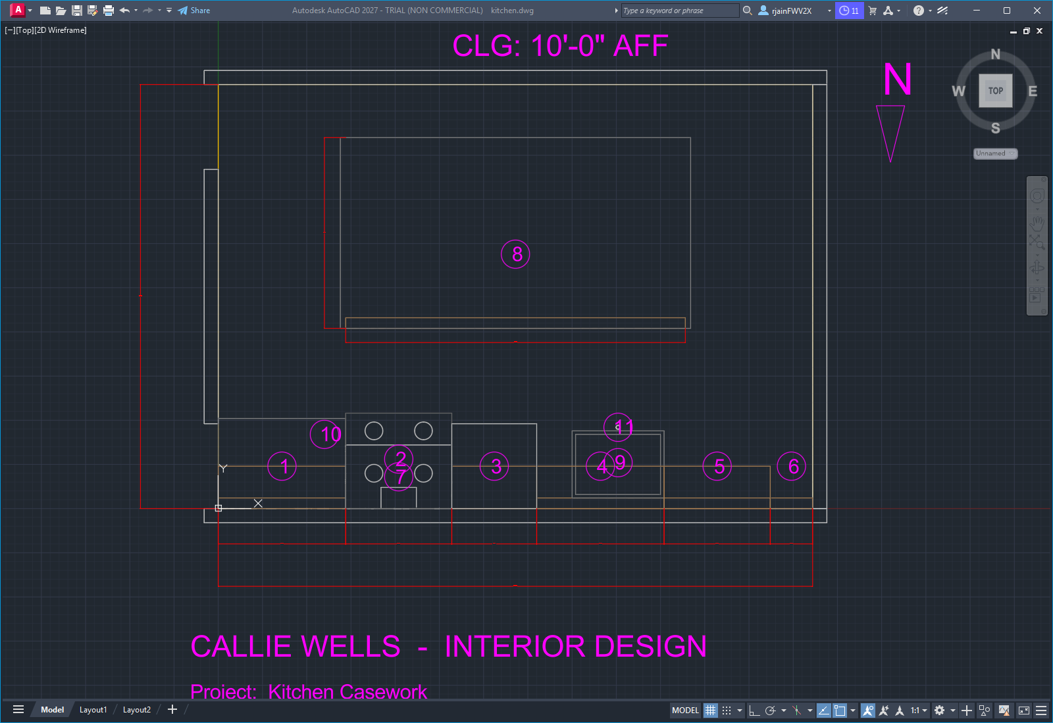
Sheet A-201 — Kitchen Plan

12. Photoreal Render — Cycles
Raytraced render produced by Blender 4.5 LTS / Cycles, 256 samples at 1920×1200. The .dwg model was exported per layer to STL, imported to Blender, mapped to PBR materials (procedural wood grain on the floor and walnut elements, marble veining on the quartz counter, brushed-metal noise on stainless and brushed-nickel hardware), lit with a soft sun + 16 ceiling cans + 3 pendant lights over the island.
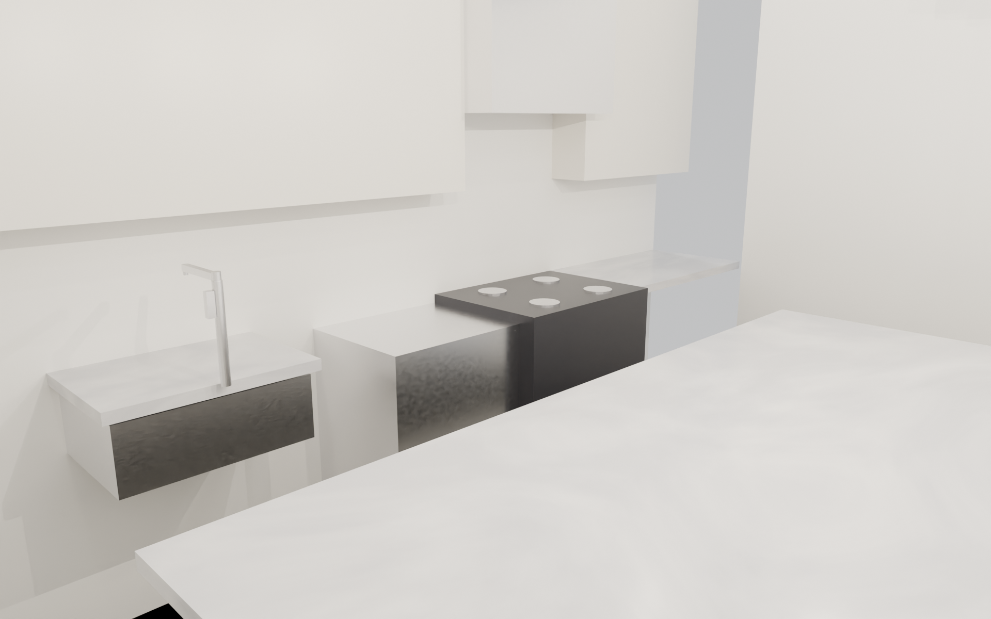
Photoreal Render — Cycles raytrace

13. 3D Presentation View — Northwest (AutoCAD)
Northwest isometric, AutoCAD Realistic visual style — the same model rendered inside AutoCAD as a real-time preview. Detail pass included: cabinet door reveals + pulls, drawer dividers, range knobs, faucet swing arm, full-height tile backsplash, crown molding on wall cabinets, three pendant cluster over the island, three counter-height bar stools at the seating side.
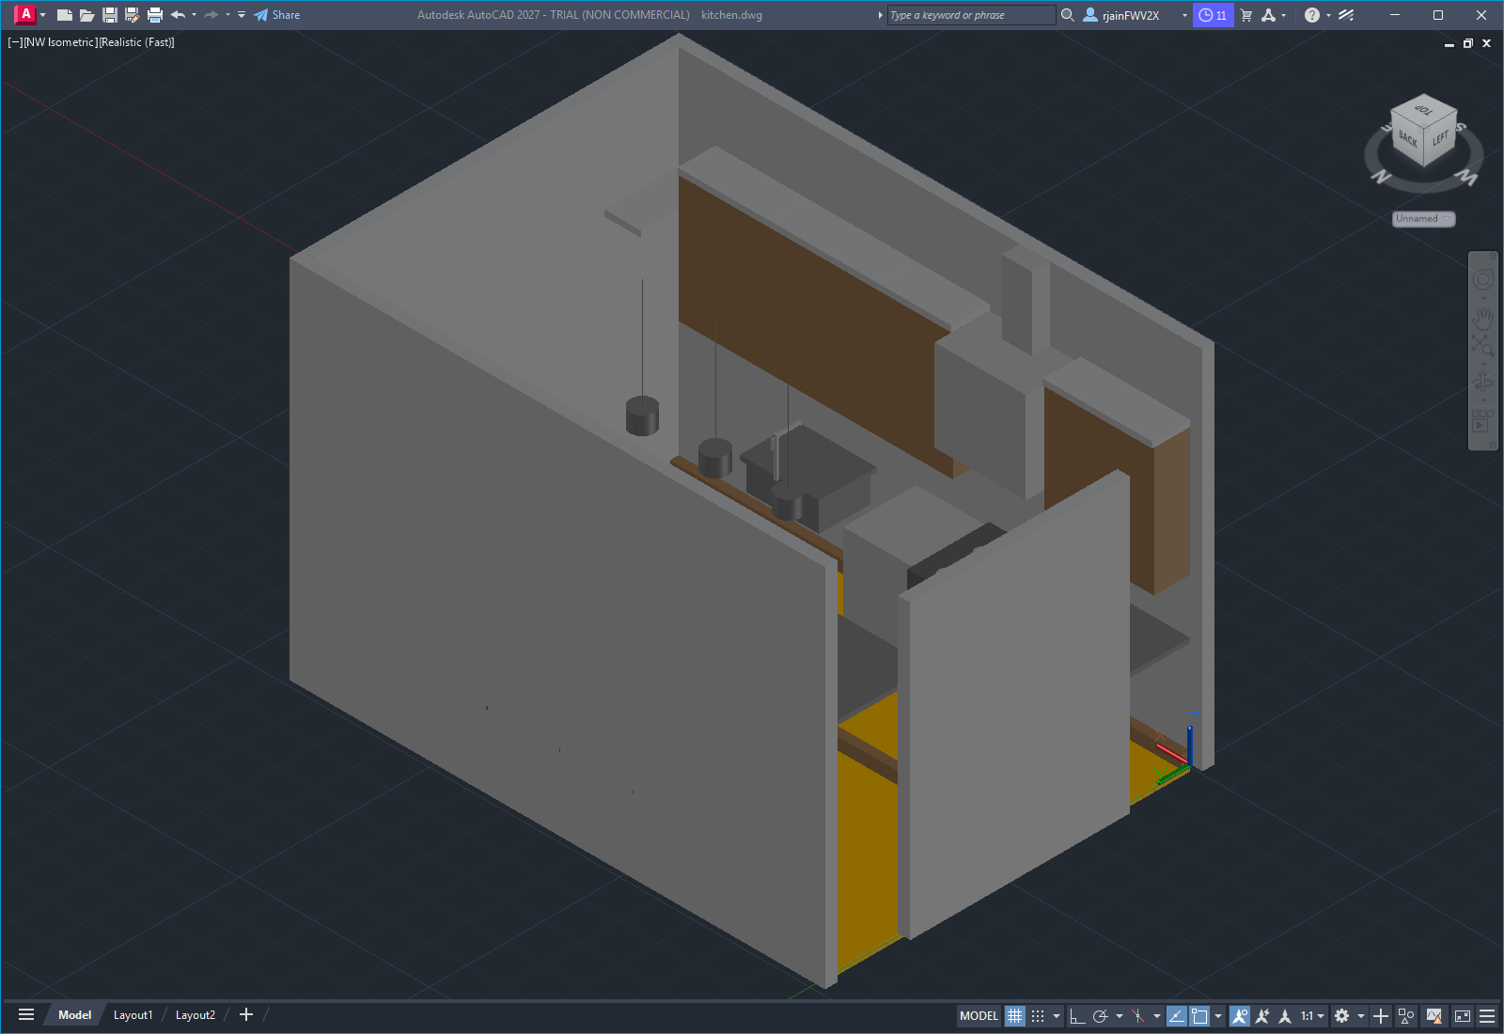
NW Isometric — AutoCAD Realistic style

14. Long-Wall Elevation
Front view of the south-wall cabinet run. Wall cabinets at 54"-96" AFF, base cabinets at 0"-36" AFF, range hood centered above the cooktop gap, sink + faucet at SB36, full-height pantry on the east end.
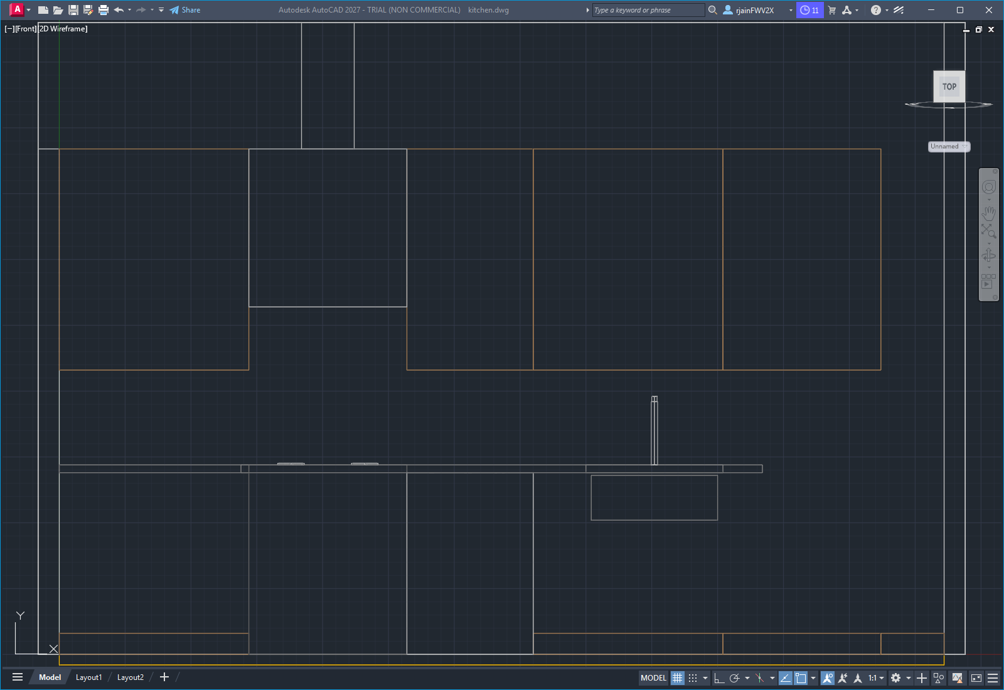
Elevation — Long Wall (south)

15. Island Elevation
Back view of the island. Cabinet body with toe kick on the storage side; counter line above with the 12" seating overhang visible at the top.
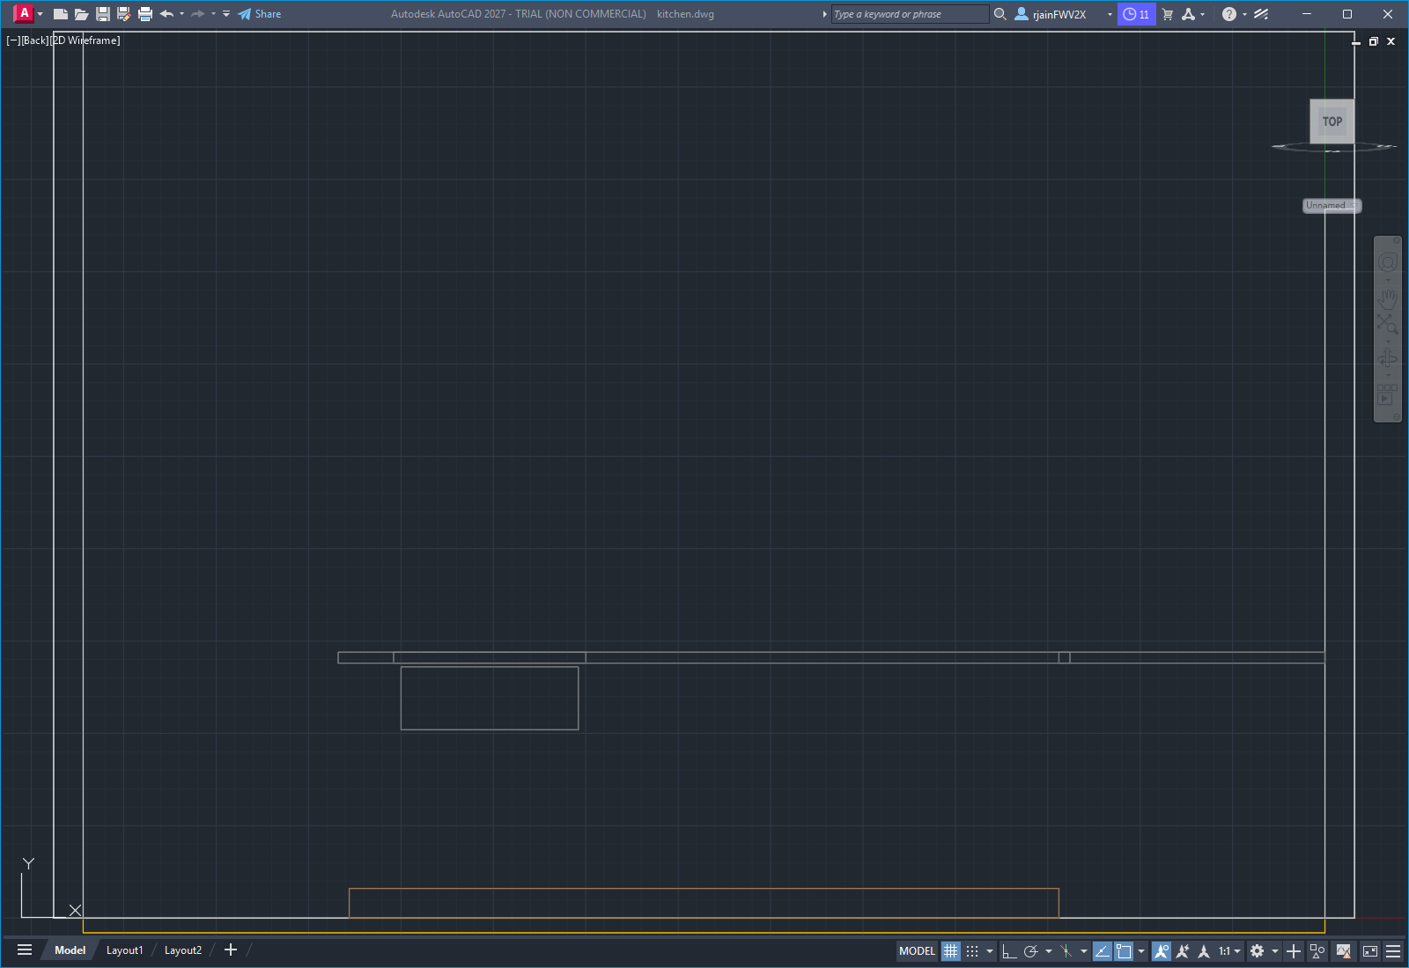
Elevation — Island (back / seating)

