**Platinum Buckle -Title Sponsor $25,000**

**VIP Perks:** VIP Parking , Special seating & 20 tickets to the event. **Recognition:** Listing as Platinum Buckle Sponsor of Event on social media, premiere placement of name/company logo on Amy’s Wish website as Platinum Buckle Sponsor, audio/visual recognition on evening of event. Company Logo prominently displayed on the event T-shirts and 6 free t-shirts. Premier Signage at Amy’s Wish barn for one year. **Event Signage:** Premier signage at event and full page ad in program. **Emcee Recognition:** Evening of event. Receive 2 Platinum Level Belt Buckles

**Diamond Buckle $15,000**

**VIP Perks:** 16 tickets to the event. **Recognition:** Listing as Diamond Buckle Sponsor of Event on social media and placement of company logo on Amy’s Wish website as Diamond Buckle Sponsor, audio/ visual recognition on evening of event. Company logo displayed on the event T-shirts. Signage at Amy’s Wish Barn for one year **Event Signage:** Signage at event and half page ad in program **Emcee Recognition:** Evening of event. Receive 1 Diamond Level Belt Buckle

**Gold Buckle $10,000**

**VIP Perks:** 10 tickets to the event. **Recognition:** Listing as Gold Buckle Sponsor of Event on social media, placement of company logo on Amy’s Wish website as Gold Level Sponsor, audio/ visual recognition on evening of event & Company name displayed on the event T-shirts. **Event Signage:** Signage at event and half page ad in program Receive 1 Gold Level Belt Buckle.

**Silver Buckle $5,000**

**VIP Perks:** 8 tickets to the event. **Recognition:** Listing as Silver Buckle Sponsor on social media and website, audio/visual recognition on evening of event & Company name displayed on the event T-shirts. **Event Signage:** name on event signage, listing in program.

**Bronze Buckle $2500**

**VIP Perks:** 6 tickets to the event. **Recognition:** Recognition as Bronze Buckle on social media, audio/visual recognition on evening of event **Event Signage:** name on event signage, listing in program

**Ruby Buckle $1,000**

**VIP Perks:** 4 tickets to the event. **Recognition:** Recognition as Ruby Buckle Sponsor on social media, audio/visual recognition on evening of event **Event Signage:** listing in program

**YES! I would like to help sponsor the 2023 BOBBYFEST MUSIC FESTIVAL. I have checked my sponsorship level below:**

|  |  |
| --- | --- |
| * $25,000 Platinum Title * $15,000 Diamond * $10,000 Gold * $5,000 Silver * $2,500 Bronze | * $1,000 Ruby * $500 Donation * $100 Donation * Other $____________________ |

Name: ________________________________________________________________________

Company Name (if applicable):

_________________________________________________________________________________

Name as you would like to be listed for publicity:

_________________________________________________________________________________

Address: ______________________________________________________________________

City/State/Zip: _______________________________________________________________

Phone(s): _____________________________________________________________________

Email: _________________________________________________________________________

**Thank You** For Your Support! The **deadline** for inclusion in the printed program and event signage is **April 17, 2023**.

Payments can be made on our secure website www.amyswishwithwings.com

Or you can enclose a check made payable to Amys Wish With Wings

**Mail to**: Amys Wish With Wings 480 West Highland Street Southlake TX 76092

Amy’s Wish With Wings is a 501(c)(3) organization and your donation is deductible to the extent allowed by law.

**BobbyFest Silent Auction or In-Kind Donation**

YES! I would like to donate a Silent Auction or In-Kind Donation item for the BOBBYFEST MUSIC FESTIVAL.

SILENT AUCTION DONATION:

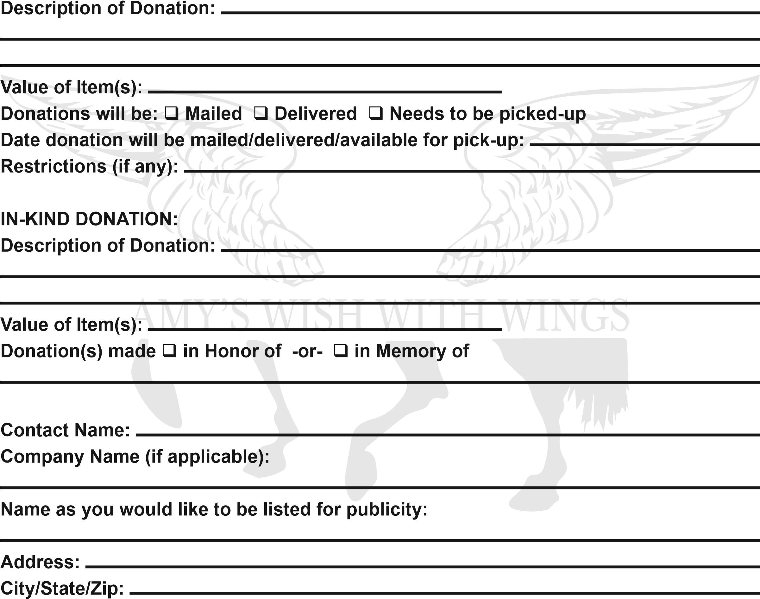

Phone(s):

Email:

Please return this form to: Amys Wish With Wings

480 West Highland Street

Southlake, TX 76092

Phone: (817)999-8332 Email: amyswishwithwings@gmail.com The deadline for inclusion in the printed program and event signage is April 17th Amy’s Wish With Wings is a 501(c)(3) organization and your donation is deductible to the extent allowed by law.