CS M151B / EE M116C
Homework #3
Due: Wednesday, April 23, 2003, before or in Class
3
Problem 1:

Design a single clock datapath for a new MIPS instruction, “load word immediate”:

lwi rs, immed21

which loads a 21-bit immediate value to the register rs.

- Define the machine code format of this instruction. Use the opcode value 110100
- Write the RTL of the instruction
- Design the simplest datapath to implement this instruction.

Do not include any control signal in this Problem

Problem 2:

Design a single clock datapath for the jal instruction in the MIPS instruction set

- Write the machine code format of this instruction
- Write the RTL of the instruction
- Design the simplest datapath to implement this instruction. Show the details of Next Address logic for the instruction fetch

Do not include any control signals in this problem

Problem 3:

- Add the jal and lwi instructions to the following datapath
- Assuming the component delays as follows:
Register 10 ns

Register file 15 ns
ALU 20 ns
Memory 50 ns
Mux 5 ns
Determine the maximum clock frequency of both the lwi and jal instructions in your datapath. Compare these values with the maximum clock frequency for lw instructions in this datapath

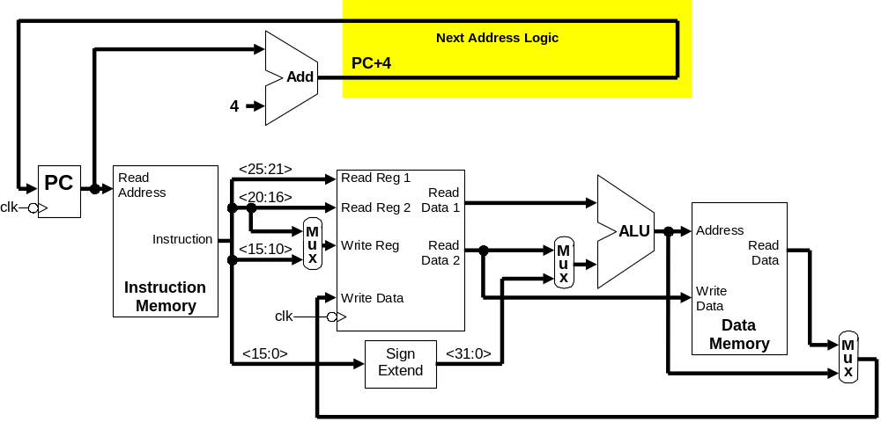

Problem 4:

Give the name, location, values, and function of each of the following control signals
- The control signals for the lwi instruction in Problems 1c
- The control signals for the jal instruction in Problem 2c
- All the control signals for the jal and lwi in the datapath of Problem 3a.
Using a different color pencil, add the control unit and control signals to your datapaths in the above figures.

Problem 5:

Assuming the datapath in Problem 4c only executes the jal, lwi , and lw instructions. Write the logic equations for all necessary control signals. Use the opcode value 110100 for the lwi instruction, 000011 for jal, and 100011 for lw.

