CS M151B / EE M116C
Homework #4
Due: Wednesday, April 30, 2003, before or in Class

Problem 1:

For the following multi-cycle data path, rewrite the single cycle RTL into multi-cycle RTL for the R-type, ori, sw, lw, beq, jump instructions

For each of the components in the data path, list the instructions that share the component. Also indicate whether the instruction fetch in each instruction uses the component

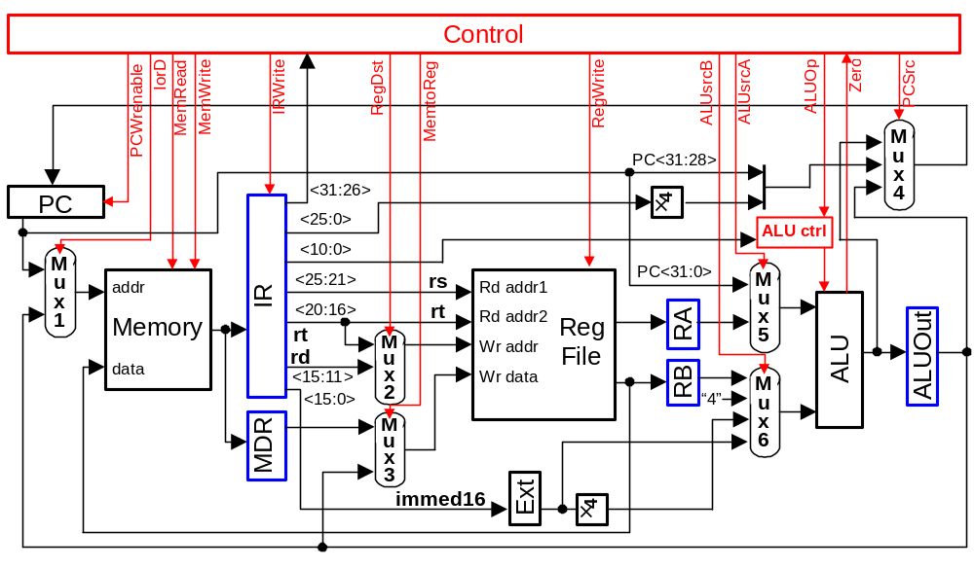

Problem 2:

The following multi-cycle data path has included the components for the jal and lwi instructions

Write the multi-cycle RTL for the jal and lwi instructions

Draw the state control diagram for the jal and lwi instructions

Draw the control unit block diagram using sequencer (see Page C-22)

Show details of the micro-sequencer and all dispatch ROM

Show the contents of the main control memory

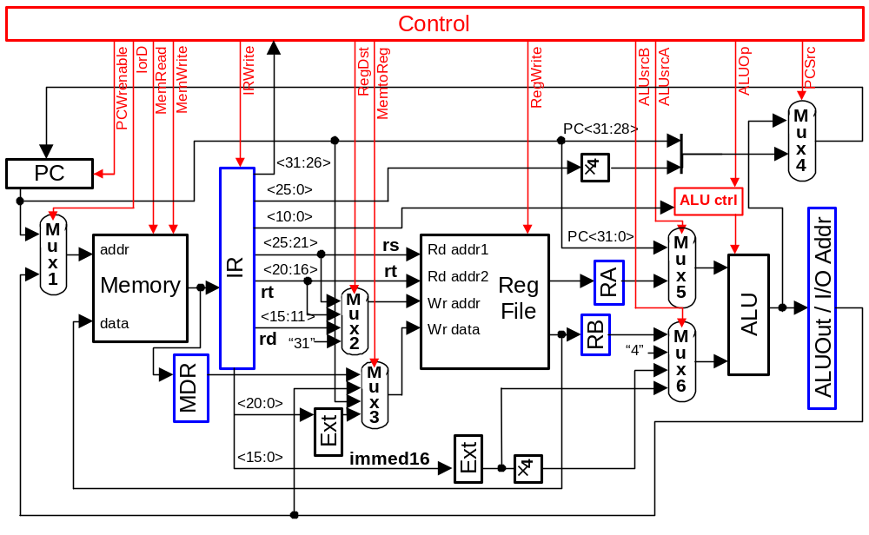

Problem 3:

Many processors do not process interrupt while the execution of an instruction is in progress. When the execution of the current instruction is completed, the control logic will examine an interrupt register to decide if any interrupt has occurred. If any bit in interrupt register has been set (i.e., interrupt occurred), the control logic will read an interrupt vector through the processor bus (i.e., same as the memory bus) and perform a procedure call that uses the interrupt vector as the address of the called procedure. Assuming only the return address need to be saved in the procedure call,
- Modify the basic instruction execution sequence to add the interrupt capability

Instruction Fetch
Operand Fetch / Decode
Execution
Store Results

- Add necessary components in the multi cycle data path to implement the procedure call for the interrupt
- Add the interrupt control to the following finite state diagram

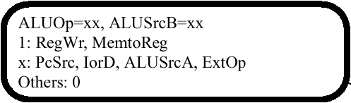
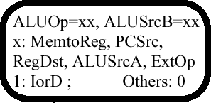
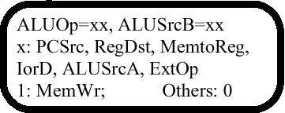
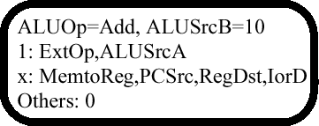

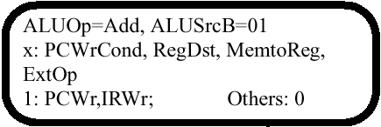
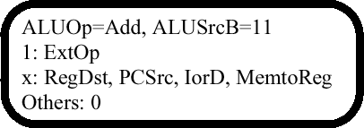

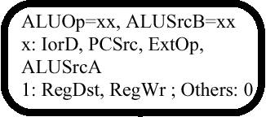

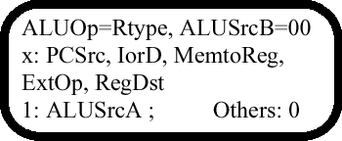

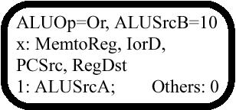

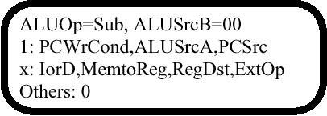

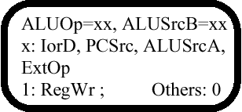
1: PCWrite
PCsrc = 10
x: others
JComplete
J

Problem 4:

- What is the maximum clock frequency of the given single cycle data path?
- What is the maximum clock frequency of the given multi cycle data path?
- For a program of with the following instruction mix, which data path is faster? Provide your explanation.

Program A: Instruction Count
lw 100
R-type 1000
sw 50

- Modify the multi-cycle data path so that it can run faster than the single cycle data path for the given program. What is the execution time of the modified data path?

Single Cycle Data Path:

PC
clk
Add
“4”
5 ns
mux
PC+4

10 ns
“00”
5 ns

ALU

Instruction Memory

Rd addr1
rs
Read = 50 ns
Write = 50 ns
mux
Rd addr2
rt
Reg File
mux
Wr addr

Data Memory
addr
rt
mux
Wr data
rd
50 ns
5 ns
Read = 20 ns
Write = 20 ns
15 ns
clk
data
5 ns
Ext
clk
immed16
5 ns
5 ns

Multi Cycle Data Path:

5 ns
PC+4
Add
“00”
“4”
mux
PC

Instruction Memory
ALU
clk
clk

Rd addr1
Rd addr2
Wr addr
Wr data
mux

Data Memory
mux
addr
data
mux
rs
rt
rd
rt
immed16
Ext
5 ns
50 ns
5 ns
Read = 20 ns
Write = 20 ns
5 ns
15 ns
Read = 50 ns
Write = 50 ns
5 ns
5 ns
10 ns
IR
ALUOut
5 ns
5 ns
clk
Reg File
RA
RB
5 ns
5 ns
MDR
5 ns

Note: All given delays for registers and memory are write delays from clock input to data output. The setup times between data input and clock input are assumed to be 0.

That is:
Data In
XXXX
Data Input

Clock Input

Dispatch ROM
Dispatch ROM
ALUsrcA
ALUsrcB1
RegWrite
MemtoReg0
IRWrite
MemWrite
MemRead
IorD
PCWrEn
Micro Program Counter
AddrCtrl0
AddCtrl1
Adder
Control Logic
Outputs
Inputs
RegDst1
RegDst0
ALUop1
ALUop0
PCSrc1
PCSrc0
MemtoReg1
Mux
Opcode
0
1
0
2
1
ALUsrcB0
ExtOp
Data In
Old data
Data Output
Delay

