Mil-Std-1553B
(Military Standard Bus)



CSM151B
UCLA Spring ‘03
R. Javier Vega
Mil-Std-1553B General Characteristics:

1. Name:

Mil-Std-1553B stands for Military Standard 1553B.

2. Applications:

MIL-STD-1553 is a military standard that defines the electrical and protocol characteristics for a data bus. A data bus is used to provide a medium for the exchange of data and information between various systems.

While the standard has been applied to satellites as well as payloads within the space shuttle (it is even being used on the International Space Station), its military applications are the most numerous and far ranging. It has been employed on large transports, aerial refuelers, and bombers, tactical fighters, and helicopters. It is even contained within missiles and serves, in some instances, as the primary interface between the aircraft and a missile. The Navy has applied the data bus to both surface and subsurface ships. The Army, in addition to its helicopters, has put the bus into tanks and howitzers.

Commercial applications have applied the standard to systems including subways, for example the Bay Area Rapid Transit (BART), and manufacturing production lines.

MIL-STD-1553B has also been accepted and implemented by NATO and many foreign governments. The UK has issued Def Stan 00-18 (Part 2) and NATO has published STANAG 3838 AVS, both of which are versions of MIL-STD-1553B.

The broad acceptance and application of MIL-STD-1553B has also fostered the development of other standardization efforts. MIL-STD-1773 is a fiber optic version of 1553B. And MIL-STD-1760A, the Aircraft/Store Interconnect, has 1553B embedded within it.

3. Mil-Std-1553B is a serial bus.

4. Mil-Std-1553B is an I/O bus.

Summary of Mil-Std-1553B Characteristics

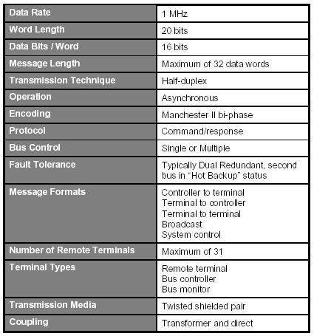

5. Protocol:

- Overview:

Transmission on the bus is managed through a 'Command--Response' protocol whereby all transactions are authorized exlusively by a master, termed the bus controller (BC). Other terminals are called remote terminasl (RTs) of which there can be between 1 and 31 (each with 31 subaddresses) or monitors (Ms). Various message formats are supported (BC to RT, RT to BC, and RT to RT, along with bradcast-type transmissions where one user can communicate with ohter users). In the vast majority of applications, connections to the bus are achieved through transformer couplers thereby providing good electrical isolation between transmit and receive circuitry.

The control, data flow, status reporting, and management of the bus are provided by three word types: Command words, Data words and Status words.

Each word type has a unique format, yet all three maintain a common structure. Each word is twenty bits in length. The first three bits are used as a synchronization field, thereby allowing the decode clock to re-sync at the beginning of each new word. The next sixteen bits are the information field and are different between the three word types. The last bit is the parity bit. Parity is based on odd parity for the single word.

A command word shall consist of a synchronization signal (sync), RT address, transmit/receive bit, subaddress/mode, data word count/mode code, and parity.

Words Format:

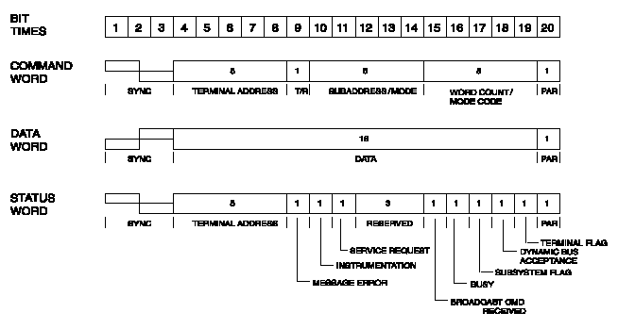

- The bus has 3 layers: Physical, Link and a Protocol layer.

- Asynchronous operation. For the purpose of this Standard, asynchronous operation is the use of an independent clock source in each terminal for message transmission. Decoding is achieved in receiving terminals using clock information derived from the message.

- The primary purpose of the data bus is to provide a common media for the exchange of data between systems. The exchange of data is based on message transmissions. The standard defines ten types of message transmission formats.

All of these formats are based on the three word types previously defined.
The message formats have been divided into two groups. These are referred to within the standard as the “information transfer formats” and the “broadcast information transfer formats”. The information transfer formats are based on the command/response philosophy in that all error free transmissions received by a remote terminal are followed by the transmission of a status word from the terminal to the bus controller.

This handshaking principle validates the receipt of the message by the remote terminal. Broadcast messages are transmitted to multiple remote terminals at the same time. The terminals suppress the transmission of their status words (not doing so would have multiple boxes trying to talk at the same time and thereby “jam” the bus). In order for the bus controller to determine if a terminal received the message, a polling sequence to each terminal must be initiated to collect the status words.

If a data bus is 60 percent loaded and each message received an error, error processing would exceed the 100 percent of available time and thereby cause problems within the system.

Information Transfer Format
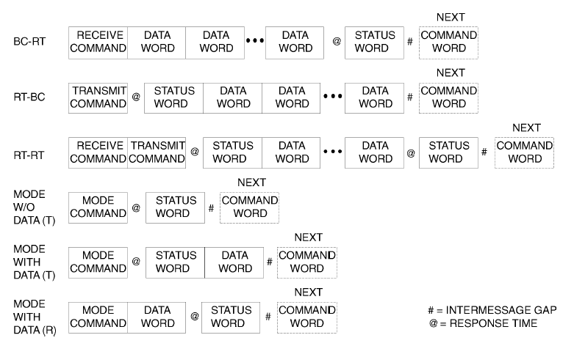

Information Transfer Format (Broadcast)

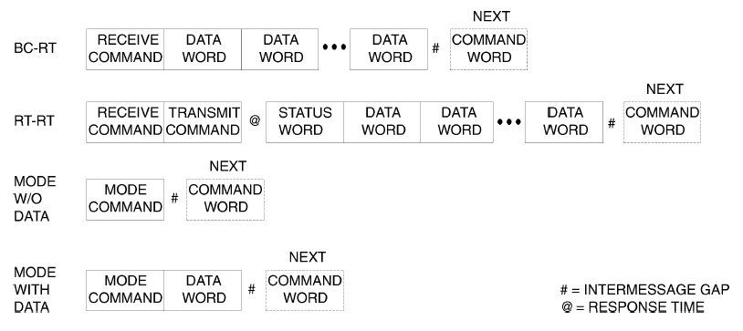

- The bus can support a maximum total of 32 nodes, 1 main node and 31 terminal nodes.

- In Mil-Std-1553B, each node has a different address that identifies them. That way the Bus Controller, the responsible for directing the flow of data in the bus, can determine the operations of each node.

- The bus controller is responsible for directing the flow of data on the data bus. While several terminals may be capable of performing as the bus controller, only one bus controller may be active at a time. The bus controller is the only one allowed to issue commands onto the data bus. The commands may be for the transfer of data or the control and management of the bus (referred to as mode commands). Typically, the bus controller is a function that is contained within some other computer, such as a mission computer, a display processor, or a fire control computer.

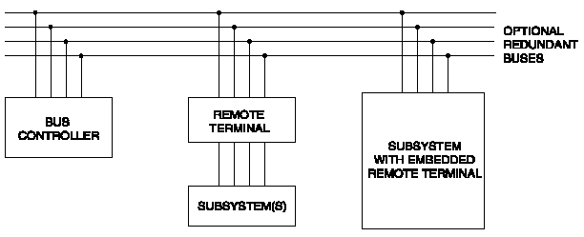

- The bus is multi-master. It operates bidirectionally on a multisource, multisink basis and each unit on the bus can communicate with all the others.

- In Mil-Std-1553B, the bus controller is responsible for directing the flow of data on the MIL-STD-1553 data bus. While several terminals may be capable of performing as the bus controller, only one bus controller may be active at a time. The bus controller is the only one allowed to issue commands onto the data bus. The commands may be for the transfer of data or the control and management of the bus (referred to as mode commands).

Remote terminals are defined within the standard as "All terminals not operating as the bus controller or as a bus monitor". Therefore if it is not a controller, monitor, or the main bus or stub, it must be a remote terminal. The remote terminal comprises the electronics necessary to transfer data between the data bus and the subsystem.
A bus monitor is a terminal that listens (monitors) to the exchange of information on the MIL-STD-1553 data bus. The standard strictly defines how bus monitors may be used, stating that the information obtained by a bus monitor be used "for off-line applications (e.g., flight test recording, maintenance recording or mission analysis) or to provide the back-up bus controller sufficient information to take over as the bus controller." A monitor may collect all the data from the bus or may collect selected data. The reason for restricting its use is that while a monitor may collect data, it deviates from the command-response protocol of the standard, in that a monitor is a passive device that doesn't transmit a status word and therefore cannot report on the status of the information transferred.
- N. A.

6. Mil-Std-1553B Physical Characteristics:

- The topology of the bus is very flexible; the next figures describe possible configurations where each node can talk to another.

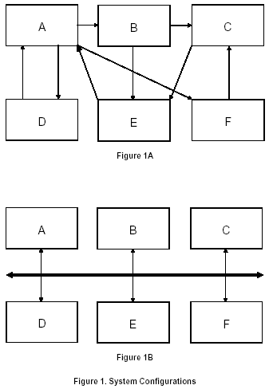

- Data rate: Up to 32 users (terminals) can be connected to the bus with data transmitted serially at 1Mbps in words of 20 bits.

- The bus media is electrical and it uses single-ended drivers.

- The line-to-line distributed capacitance shall not exceed 30.3 pF/ft (98.4 pF/m). The cable shall be formed with not less than four twists per foot (13 twists/m) where a twist is defined as a 360 degree rotation of the wire pairs.

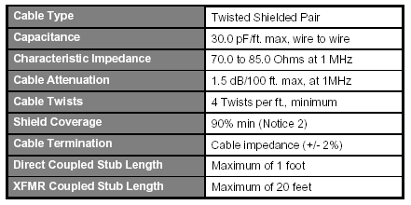

- Power consumption:

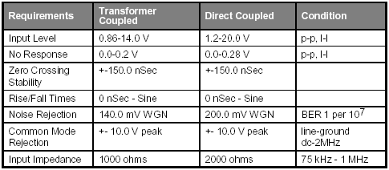

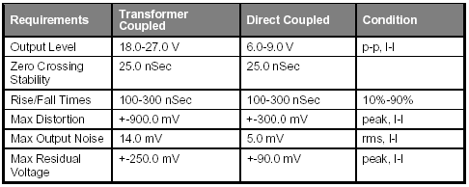

f) N. A.
7. Mil-Std-1553B Fault Handling Errors:

- The standard defines many characteristics in the data transmission that ensure that the data is properly delivered and communicated. Among these mechanisms we find these clauses:

The terminal shall ensure that each word conforms to the following minimum criteria:

(1) The word begins with a valid sync field
(2) The bits are in a valid Manchester II code
(3) The information field has 16 bits plus parity
(4) The word parity is odd

When a word fails to conform to the preceding criteria, the word shall be considered invalid.

The terminal shall contain a hardware implemented time-out to preclude a signal transmission of greater than 800.0 µs. This hardware shall not preclude a correct transmission in response to a command. Reset of this time-out function shall be performed by the reception of a valid command on the bus on which the time-out has occurred.

The purpose of the fail-safe timer is to stop a terminal from transmitting for longer than 800 µs per message and hence protect the data bus. It should be noted that the fail-safe timer under such transmitter fault conditions, will produce an 800 µs transmission every time the terminal receives a valid command. The Bus Controller must take appropriate action to overcome this problem in these circumstances.

b) The bus does not implement in the specifications a built-in mechanism for recovery. However, due to the critical operation performed by the bus, it normally has a “Typically Dual Redundant, second bus in “Hot Backup” status.”

References:

- An Interpretation of MIL-STD-1553B.
http://pccorot15.obspm.fr/COROT-ETC/Files/1553_overview.pdf

- Condor Engineering, MIL-STD-1553B Tutorial.
http://www.condoreng.com/support/downloads/ tutorials/MIL-STD-1553Tutorial.PDF

- Data Bus (MIL-STD-1553B) Components.
http://www.raychem.com/resources/documents/datasheets/Interconnect/DataBus%20-%20whole%20section.pdf

- MIL-STD-1553 Bus.
http://home.cfl.rr.com/interfacebus/mil_std_1553b.doc

- MIL-STD-1553 Bus Description.
http://www.interfacebus.com/Design_Connector_1553.html

- MIL-STD-1553B Introduction.
http://www.milestek.com/pdf/MIL1553WP.pdf

- MIL/STD-1553B Bus Overview.
http://d0server1.fnal.gov/www/online_computing/Meetings/Workshop/Jun99_Fermilab/1553_bus.ppt

