Set 1 Examples

Example 1: CPU time

What is the execution time (CPU time) of a program running on a 500 MHz computer with the following number and types of instructions?
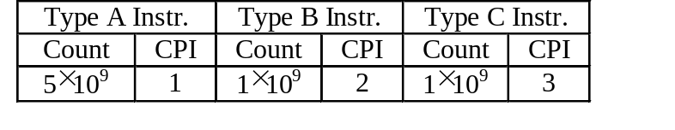
Total number of clock cycles:
1 cyc/inst × 5 × 10⁹ inst + 2 cyc/inst × 1 × 10⁹ inst + 3 cyc/inst × 1 × 10⁹ inst = 1 × 10¹⁰ cycles

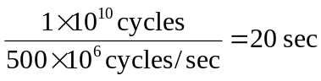Total execution time:

Example 2: CPU time versus MIPS
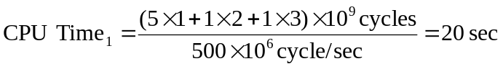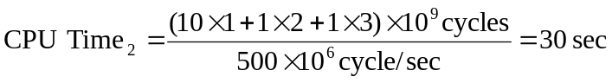

Example 3: Floating Point Operations

a) 200 = (–1)⁰ × 1.5625 × 2⁷ = (–1)⁰ × 1.1001₂ × 2^{(134 – 127)}
= [0][10000110][1.10010000000000000000000]

b) –500 = (–1)¹ × 1.953125 × 2⁸ = (–1)¹ × 1.111101₂ × 2^{(135 – 127)}
= [1][10000111][1.11110100000000000000000]

- Convert the IEEE 754 significand into regular binary format (i.e. 2’s complement for negative):

200 = (–1)⁰ × 0.781250 × 2⁸ = (–1)⁰ × 0.1100100₂ × 2⁸ ➔ [0][10000111][0.110010000000000000000]
–500 = (–1)¹ × 1.953125 × 2⁸ = (–1)¹ × 1.1111010₂ × 2⁸ ➔ [1][10000111][0.000011000000000000000]
[1][10000111][0.110101000000000000000]

Convert the result (in 2’s complement) into IEEE 754 ➔ [1][10000111][1.001011000000000000000]
The leading bit is 1, there is no need to renormalize

Check: 200 – 500 = – 300 = (–1)⁰ × 1.171875 × 2⁸ = (–1)¹ × 1.001011₂ × 2⁸

Example 4: Floating Point Operations

a) 200 = (–1)⁰ × 1.5625 × 2⁷ = (–1)⁰ × 1.1001₂ × 2^{(134 – 127)}
= [0][10000110][1.10010000000000000000000]

b) –150 = (–1)¹ × 1.171875 × 2⁷ = (–1)¹ × 1.001011₂ × 2^{(134 – 127)}
= [1][10000110][1.00101100000000000000000]

- Convert the IEEE 754 significand into regular binary format (i.e. 2’s complement for negative):

200 = (–1)⁰ × 1.562500 × 2⁷ = (–1)⁰ × 1.1001000 × 2⁷ ➔ [0][10000110][1.100100000000000000000]
–150 = (–1)¹ × 1.171875 × 2⁷ = (–1)¹ × 1.0010110 × 2⁷ ➔ [1][10000110][0.110101000000000000000]
10
10
[0][10000110][0.011001000000000000000]

Result is positive, so the format is the same as the IEEE 754. No need to convert.
Renormalize ➔ [0][10000100][1.100100000000000000000]

Check: 200 – 150 = 50 = (–1)⁰ × 1.5625 × 2⁵ = (–1)¹ × 1.1001 × 2^{(132 – 5)}

Example 5: Guard Bit

a) 200 = (–1)⁰ × 1.5625 × 2⁷ = (–1)⁰ × 1.1001 × 2^{(134 – 127)}
= [0][10000110][1.10010000000000000000000]

b) 150 = (–1)⁰ × 1.171875 × 2⁷ = (–1)⁰ × 1.001011 × 2^{(134 – 127)}
= [0][10000110][1.00101100000000000000000]

- Convert the IEEE 754 significand into regular binary format (i.e. 2’s complement for negative):

200 = (–1)⁰ × 1.562500 × 2⁷ = (–1)⁰ × 1.1001000 × 2⁷ ➔ [0][10000110][1.100100000000000000000]
150 = (–1)⁰ × 1.171875 × 2⁷ = (–1)⁰ × 1.0010110 × 2⁷ ➔ [0][10000110][1.001011000000000000000]
10.101111000000000000000
Both numbers have the same signs, do not carry the leading bit to the sign bit
Renormalize ➔ [0][10000111][1.010111100000000000000]

Check: 200 + 150 = 350 = (–1)⁰ × 1.3671875 × 2⁸ = (–1)¹ × 1. 0101111 × 2^{(135 – 8)}

Note: use the IEEE 754 calculator at http://babbage.cs.qc.edu/courses/cs341/IEEE-754.html to check you conversion

