Set 3 Examples: Combining add and lw Data Paths

RTL for add instruction
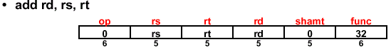

instr ← mem[PC] Instruction Fetch
rs ← instr<25:21> Define Signals (Fields) of Instr
rt ← instr<20:16>
rd ← instr<15:11>
R[rd] ← R[rs] + R[rt] Add Register Contents
PC ← PC + 4 Update Program Counter

Data Path for add instruction
PC

Instruction Memory

Register
File

Rd addr1
Rd addr2
Wr addr
Wr data
ALU
Next Address Logic
PC+4
rs
rt
rd

RTL for lw instruction

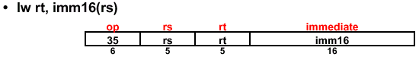

instr ← mem[PC] Instruction Fetch
rs ← instr<25:21> Define Signals (Fields) of Instr
rt ← instr<20:16>
imm16 ← instr<15:0>
addr ← R[rs] + sign_extend(imm16) Calculate Memory Address
R[rt] ← Mem[addr] Load Data into Register
PC ← PC + 4 Update Program Counter

Data Path for lw
PC+4

PC
Next Address Logic

Instruction Memory

Rd addr1
rs
addr
ALU
Rd addr2
rt
R[rs]

Data Memory

Register File
ext

Wr addr
imm16
Wr data

Wr Data = Mem[addr]

Combining Data Paths of add and lw

Blue components are common to both data paths

PC

Instruction Memory

Rd addr1
Rd addr2
Wr addr
Wr data
ALU
Next Address Logic
PC+4
rs
rd
imm16
R[rs]

Data Memory

Wr Data = ALU output or Mem[addr]
Register File
rt
mux
mux
mux
ext
R[rt]

