Set 6 Examples:

Example 1: Identify the control points of the multi-cycle data path only for the add instruction and determine their values in each clock.

PC+4
Next Address Logic
ALUctr
PCWr

PC

Clk

Instr Reg
A

Instruction Memory

Register
File

Rd addr1

rs
ALU

Rd addr2

rt

Clk

Wr addr

rd
B

Wr data

Clk

Clk

RegWr
IRWr

Control State Diagram: Multi-Cycle RTL:
Operation Clk RTL
Instruction Fetch: 1 IR ← Mem[PC]
PCwr = 1, IRwr = 1
RegWr = 0,
ALUctr = X

State # 0
(Control values Set Before Clk 1)
State # 1
(Control values Set Before Clk 2)
PCwr = 0, IRwr = 0 RegWr = 0,
ALUctr = X

State # 2
(Control values Set Before Clk 3)
PCwr = 0, IRwr = 0
RegWr = 1,
ALUctr = add

PC ← PC + 4

Operand Fetch 2 rs ← IR<25:21>
rt ← IR<20:16>
rd ← IR<15:11>
RA ← R[rs]
RB ← R[rt]

Execution and 3 Reg[rd] ← RA + RB
Store result

A Simple Control Unit Only for the add Multi-Cycle Data Path:

ROM or PLA
State Counter

00

1 1 0 XX

0 0 0 XX

0 0 1 add

01

10

PCWr
IRWr
RegWr
ALUctr

Example 2: Identify the control points of the multi-cycle data path only for the combined add and lw instructions and determine their values in each clock.

PC

Instruction Memory

Rd add1
Rd add2
Wr add
Wr data
ALU
Next Address Logic
PC+4
rs
rd
imm16
R[rs]

Data Memory

Reg File
rt
mux
mux
mux
ext
R[rt]
0
1
0
1
0
1
Instr Reg
ALU Out Reg
A
B
RegWr
ALUctr
ExtOP
RegDst
ALUSrc
MemtoReg
Op Code
To Control Logic for Decode
PCWr
IRWr

Control State Diagram:
Instruction Fetch
PCwr = 1, IRwr = 1, RegWr = 0, ALUctr = X,
ALUSrc = X, RegDst = X, ExtOp = X, MemtoReg = X

State # 0

Decode / Operand Fetch
PCwr = 0, IRwr = 0, RegWr = 0, ALUctr = X,
ALUSrc = X, RegDst = X, ExtOp = X, MemtoReg = X

PCwr = 0, IRwr = 0, RegWr = 0, ALUctr = add, ALUSrc = 1, RegDst = X, ExtOp = 1, MemtoReg = X

PCwr = 0, IRwr = 0, RegWr = 1, ALUctr = add, ALUSrc = 0, RegDst = 1, ExtOp = X,
MemtoReg = 0

PCwr = 0, IRwr = 0, RegWr = 1, ALUctr = X,
ALUSrc = X, RegDst = 0, ExtOp = X, MemtoReg = 1

State # 1
State # 3
lw Execution
Op code = lw
Op code = add
add Execution
State # 4
State # 2
Memory Read

A Control Unit for the Combined add & lw Multi-Cycle Data Path:

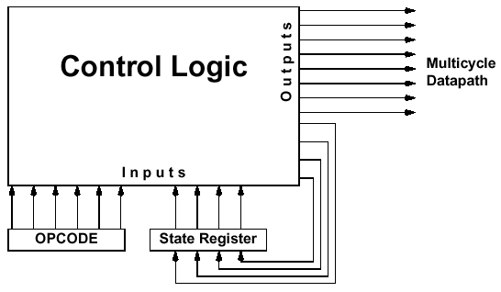

Next state number

Current state number

To Determine the Control Logic:

Step 1) Translate the State Diagram into a State Transition Table

Current State | Op Code Input | Next State
State 0 |  | State 1
State 1 | Op Code = add | State 2
State 1 | Op Code = lw | State 3
State 2 |  | State 0
State 3 |  | State 4
State 4 |  | State 0

Step 2) Determine Which Signal Should be Active in Which States

Control Signal | State in Which the Signal is Active (= 1)
PCwr | State 0
IRwr | State 0
RegWr | State 2, State 4
ALUctr | Add in State 2 and State 3
ALUSrc | State 3
RegDst | State 2
ExtOp | State 3
MemtoReg | State 4

Step 3) Implement the control logic with PLA

0000000000
PCWr
000
001
001
010
011
100
xxxxxx
000000
100011
xxxxxx
xxxxxx
xxxxxx
001
010
011
000
100
000
0000000000
1100000000
0010100100
0000101010
0010000001
RegWr
ALUctr
ALUSrc
RegDst
ExtOp
MemtoReg
Current State
Next State
Op Code Input
State Reg
Input Plane
Output Plane
IRWr

Alternatively, the control logic can be implemented with a micro-sequencer
PCWr
00
01
10
00
10
0000000000
1100000000
0010100100
0000101010
0010000001
RegWr
ALUctr
ALUSrc
RegDst
ExtOp
MemtoReg
Counter
IRWr
Next State Register
000000
100011
Add
010
011
lw
mux
Opcode
0
1
2
“0”
00 = Use counter for next state
01 = Use ROM output for next state (function of opcode)
ROM
10 = Use “0” for next state
State
000
001
010
011
100
Address Control
Meaning of Address Control Bits:

