Set 8 Example: Hazards in Pipeline Processor

Flushing of Pipeline Due to Incorrect Branch Prediction

Given the following data path, show the data and control signals in the pipeline registers for the following MIPS Program. Assuming branch prediction for the beq instruction is "not taken" but the branch is actually taken:

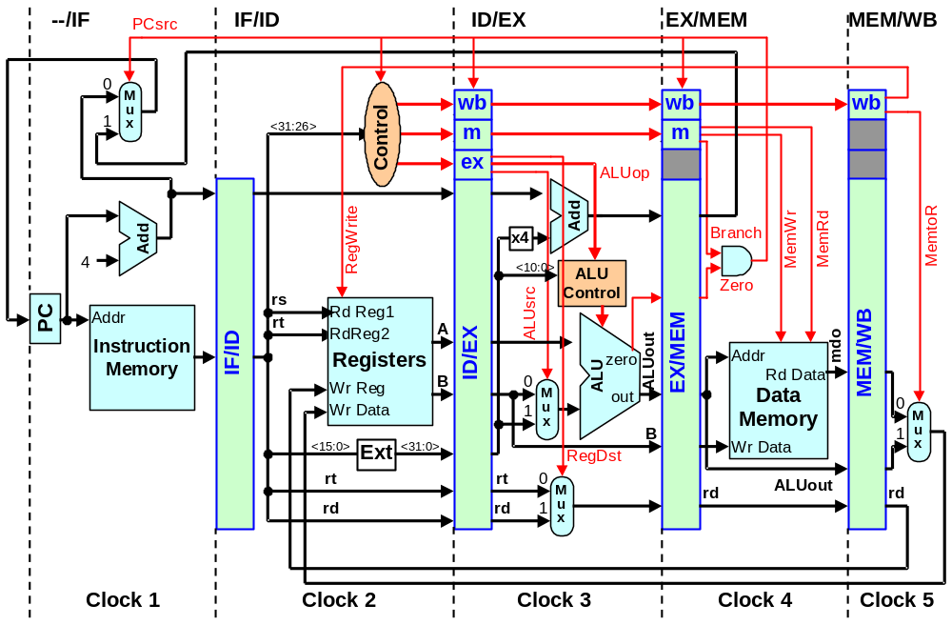

PC

00 (Clock 1) lw $2, 0($3) # lw instruction is fetched at the end of this clock
04 (Clock 2) add $4, $0, $5 # add instruction is fetched at the end of this clock
08 (Clock 3) sw $6, 4($3) # sw instruction is fetched at the end of this clock
12 (Clock 4) beq $7, $2, 5 # beq instruction is fetched at the end of this clock
16 (Clock 5) add $8, $2, $5 # add instruction is fetched at the end of this clock
20 (Clock 6) add $9, $2, $4 # add instruction is fetched at the end of this clock
24 (Clock 7) sub $10, $4, $7 # sub instruction is fetched at the end of this clock
28 (Clock 8) add $11, $7, $8 # add instruction is fetched at the end of this clock
32 (Clock 9) j 11 # j instruction is fetched at the end of this clock
36 (Clock 8) sub $8, $2, $5 # sub instruction is fetched at the end of this clock
40 (Clock 9) sub $9, $2, $4 # sub instruction is fetched at the end of this clock
44 . . .
Predicted Branch Not Taken

At the end of each clock:

 | Instruct in PC | PC | Instruct in IF/ID | IF/ID.rs | IF/ID.rt | IF/ID.rd | IF/ID.Immed16 | Instruct in ID/EX | ID/EX.A | ID/EX.B | ID/EX.Immed16 | ID/EX.rt | ID/EX.rd | ID/EX.ALUsrc | ID/EX.ALUop | ID/EX.RegDst | ID/EX.Branch | ID/EX.MemWr | ID/EX.MemRd | ID/EX.MemtoR | ID/EX.RegWrite | Instruct in EX/MEM | EX/MEM.ALUout | EX/MEM.B | EX/MEM.rd | EX/MEM.branchadd | EX/MEM.Zero | EX/MEM.Branch | EX/MEM.MemWr | EX/MEM.MemRd | EX/MEM.MemtoR | EX/MEM.RegWrite | Instruct in MEM/WB | MEM/WB.mdo | MEM/WB.ALUout | MEM/WB.rd | MEM/WB.MemtoR | MEM/WB.RegWrite
Clock 4 | add | 16 | beq | 2 | 7 | X | 5 | sw | $3 | $6 | 4 | 6 | X | 1 | add | X | 0 | 1 | 0 | X | 0 | add | $0 + $5 | X | 4 | X | X | 0 | 0 | 0 | 1 | 1 | lw | Mem[$3+0] | $3 + 0 | 2 | 0 | 1
Clock 5 | add | 20 | add | 2 | 5 | 8 | X | beq | $2 | $7 | X | 7 | X | 0 | sub | X | 1 | 0 | 0 | X | 0 | sw | $3 + 4 | $6 | X | X | X | X | 1 | 0 | X | 0 | add | X | $0 + $5 | 4 | 1 | 1
Clock 6 | sub | 24 | add | 2 | 4 | 9 | X | add | $2 | $5 | X | 5 | 8 | 0 | add | 1 | 0 | 0 | 0 | 1 | 1 | beq | $7 - $2 | X | X | 12 + 4 + 5×4 | 1 ($7=$2) | 1 | 0 | 0 | X | 0 | sw | X | X | X | X | 0
Clock 7 | sub | 36 | sub | 4 | 7 | 10 | X | add | 0 | 0 | 0 | 0 | 0 | 0 | 0 | 0 | 0 | 0 | 0 | 0 | 0 | add | 0 | 0 | 0 | 0 | 0 | 0 | 0 | 0 | 0 | 0 | beq | X | X | X | X | 0
Clock 8 | sub | 40 | sub | 2 | 4 | 9 | X | sub | 0 | 0 | 0 | 0 | 0 | 0 | 0 | 0 | 0 | 0 | 0 | 0 | 0 | add | 0 | 0 | 0 | 0 | 0 | 0 | 0 | 0 | 0 | 0 | add | 0 | 0 | 0 | 0 | 0

Reset by (Brand • Zero) No permanent change to Register File or Memory ⇒ Pipe flushed

