CS M151B / EE M116C
Homework #3 Solutions

Problem 1:

Design a single clock datapath for a new MIPS instruction, “load word immediate”:

lwi rs, immed21

which loads a 21-bit immediate value to the register rt.

- Define the machine code format of this instruction. Use the opcode value 110100
- Write the RTL of the instruction
- Design the simplest datapath to implement this instruction.

Do not include any control signal in this Problem

Solution:
6 bits
5 bits
21 bits
a)
110100
rs
immediate

b) Instr ← mem[PC] Instruction Fetch
rs ← Instr<25:21> Define Signals (Fields) of Instr
immed21 ← Instr<20:0>
R[rs] ← Sign_Extend(immed21) Move the immediate value to register R[rt]

PC ← PC + 4 Update Program Counter

c)

Add
PC
Instruction Memory

Register
File
rs
<25:21>
wr addr
data
<20:0>
clk
clk
PC+4
“4”
Next Address Logic
immed21
Sign
Extend

Problem 2:

Design a single clock datapath for the jal instruction in the MIPS instruction set

- Write the machine code format of this instruction
- Write the RTL of the instruction
- Design the simplest datapath to implement this instruction. Show the details of Next Address logic for the instruction fetch

Do not include any control signals in this problem

Solution:
26 bits
a)
000011
Target address/4
6 bits

b) Instr ← mem[PC] Instruction Fetch
immed26 ← Instr<25:0> Define Signals (Fields) of Instruction
R[31] ← PC + 4 Save next address to return address register
PC ← PC<31:28> : immed26 : ”00” Forming the jump target address by concatenating higher 4 bits of PC with the 26-bit immediate value. Left shift the target address by 2 bits (i.e., target address *4) and then load it to the PC.

c)
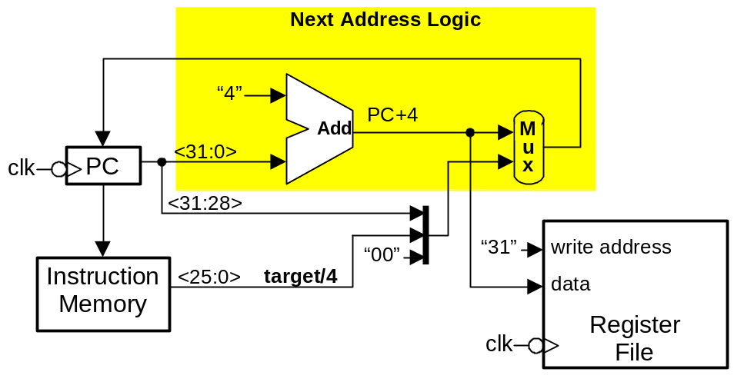

Problem 3:

- Add the jal and lwi instructions to the following datapath
- Assuming the component delays as follows:
Register 10 ns

Register file 15 ns
ALU 20 ns
Memory 50 ns
Mux 5 ns
Determine the maximum clock frequency of both the lwi and jal instructions in your datapath. Compare these values with the maximum clock frequency for lw instructions in this datapath

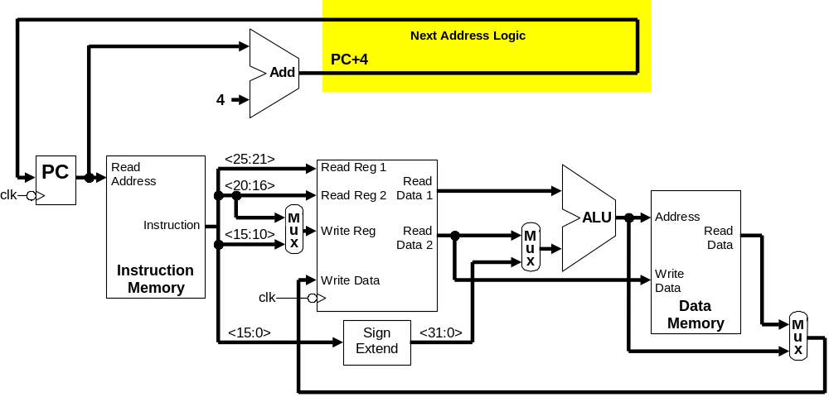

Solution:

a)
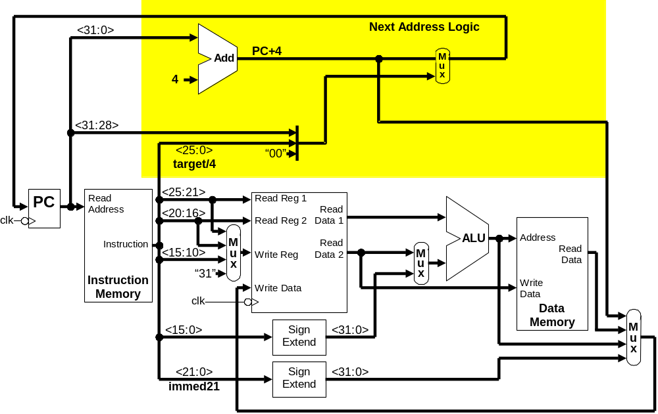

b) In a processor datapath, registers and memory addresses are updated on the falling clock edge (Note: This class uses falling clock edge. Other designs may use rising edge). We will assume zero hold time for all registers (the time the data input must be asserted before the falling clock edge). The register delay is the amount of time from the falling clock edge until a register output is valid with the new data. The register file delay is the amount of time from the read register value changing until the output is valid with the new register’s data.

The minimum clock period is the time duration from falling clock edge to falling clock edge in the processor’s slowest path. For our datapath, the only register that changes on every falling clock edge is the PC. Therefore, we start calculating component delays with the PC register delay. We find the maximum delay until all register inputs are valid; this means the PC Input, the Register Write Address input to the register file, and the Register Write Data input to the register file.

(We could calculate delays from the register delay at the Read Data output of the register file, but since the instruction memory delay is always greater than the register delay, the data value will be valid long before the instruction is valid.)

Path delays for lwi instruction:
Clock Edge to PC Input through Mux Control:
Clock Edge to PC Valid 10 ns
PC to Instruction<31:26> Valid 50 ns
Control Logic Delay 0 ns
PCSrc Mux (control to output) 5 ns
65 ns
Clock Edge to PC Input through Mux Input:
Clock Edge to PC Valid 10 ns
Adder: Add 4 to PC 20 ns
PCSrc Mux 5 ns
35 ns
Clock Edge to Register Write Address through Mux Control:
Clock Edge to PC Valid 10 ns
PC to Instruction<31:26> Valid 50 ns
Control Logic Delay 0 ns
RegDst Mux (control to output) 5 ns
65 ns
Clock Edge to Register Write Address through Mux Input:
Clock Edge to PC Valid 10 ns
PC to Instruction<25:21> Valid 50 ns
RegDst Mux (input to output) 5 ns
65 ns
Clock Edge to Register Write Data through Mux Control:
Clock Edge to PC Valid 10 ns
PC to Instruction<31:26> Valid 50 ns
Control Logic Delay 0 ns
MemtoReg Mux (control to output) 5 ns
65 ns
PC Valid to Register Write Data through Mux Control:
Clock Edge to PC Valid 10 ns
PC to Instruction<20:0> Valid 50 ns
Sign Extension 0 ns
MemtoReg Mux (input to output) 5 ns
65 ns
Max clock frequency for lwi instruction datapath = 15.4 MHz

Path delays for jal instruction:
Clock Edge to PC Input through Mux Control:
Clock Edge to PC Valid 10 ns
PC to Instruction<31:26> Valid 50 ns
Control Logic Delay 0 ns
PCSrc Mux (control to output) 5 ns
65 ns
Clock Edge to PC Input through Mux Input:
Clock Edge to PC Valid 10 ns
PC to Instruction<25:0> Valid 50 ns
PCSrc Mux (input to output) 5 ns
65 ns
Clock Edge to Register Write Address through Mux Control:
Clock Edge to PC Valid 10 ns
PC to Instruction<31:26> Valid 50 ns
Control Logic Delay 0 ns
RegDst Mux (control to output) 5 ns
65 ns
Clock Edge to Register Write Address through Mux Input:
Fixed value “31” Valid 0 ns
RegDst Mux (input to output) 5 ns
5 ns
Clock Edge to Register Write Data through Mux Control:
Clock Edge to PC Valid 10 ns
PC to Instruction<31:26> Valid 50 ns
Control Logic Delay 0 ns
MemtoReg Mux (control to output) 5 ns
65 ns
Clock Edge to Register Write Data through Mux Input:
Clock Edge to PC Valid 10 ns
Adder: Add 4 to PC 20 ns
MemtoReg Mux (control to output) 5 ns
35 ns
Max clock frequency for jal instruction datapath = 15.4 MHz

Path delays for lw instruction:
Clock Edge to PC Input through Mux Control:
Clock Edge to PC Valid 10 ns
PC to Instruction<31:26> Valid 50 ns
Control Logic Delay 0 ns
PCSrc Mux (control to output) 5 ns
65 ns
Clock Edge to PC Input through Mux Input:
Clock Edge to PC Valid 10 ns
Adder: Add 4 to PC 20 ns
PCSrc Mux 5 ns
35 ns
Clock Edge to Register Write Address through Mux Control:
Clock Edge to PC Valid 10 ns
PC to Instruction<31:26> Valid 50 ns
Control Logic Delay 0 ns
RegDst Mux (control to output) 5 ns
65 ns
Clock Edge to Register Write Address through Mux Input:
Clock Edge to PC Valid 10 ns
PC to Instruction<20:16> Valid 50 ns
RegDst Mux (input to output) 5 ns
65 ns

Clock Edge to Register Write Data through Mux Control:
Clock Edge to PC Valid 10 ns
PC to Instruction<31:26> Valid 50 ns
Control Logic Delay 0 ns
MemtoReg Mux (control to output) 5 ns
65 ns
Clock Edge to Register Write Data through Mux Input:
Clock Edge to PC Valid 10 ns
PC to Instruction<25:21> Valid 50 ns
Read Register (Register file delay) 15 ns
Slower than:
Instruction <15:0> to Sign Extension to ALUSrc Mux Input (5 ns)
Instruction <31:26> to Control Logic to ALUSrc Mux Control (5 ns)
Instruction <31:26> to Control Logic to ALUOp Control (0 ns)
ALU Delay (input to output) 20 ns
Memory Read Delay 50 ns
MemtoReg Mux (input to output) 5 ns
150 ns
Max clock frequency for lw instruction datapath = 6.67 MHz

The lw instruction has the slowest clock frequency at 6.67 MHz; therefore, the maximum clock frequency of the combined lwi / jal / lw data path is 6.67 MHz.

Problem 4:

Give the name, location, values, and function of each of the following control signals
- The control signals for the lwi instruction in Problems 1c
- The control signals for the jal instruction in Problem 2c
- All the control signals for the jal and lwi in the datapath of Problem 3a.
Using a different color pencil, add the control unit and control signals to your datapaths in the above figures.

Solution:

a) Write Enable = 1 to enable the writing of immed21 into R[rt].

PC

Instruction Memory
Register
File
rt
<25:21>
wr addr
data
<20:0>
clk
clk
PC+4
Add
“4”
Next Address Logic
immed21
Write Enable
Control Unit
<31:26>

b) Write Enable = 1 to enable the writing of the value PC+4 into $ra.
Jump = 1 to enable the loading of target address to PC

PC
Instruction Memory
Register
File
wr addr
data
<25:0>
PC+4
Add
<31:0>
“00”
“4”
“31”
Next Address Logic
clk
clk
<31:28>
mux
Control Unit
<31:26>
Jump
Write
Enable

c)
PC+4
Add
“00”
“4”
Next Address Logic
mux
PC
<31:0>

Instruction Memory
ALU
<25:21>
<15:0>
clk
clk

Register
File

Rd addr1
Rd addr2
Wr addr
Wr data
<20:16>
mux

Data Memory
mux
addr
data
mux
<31:28>
“31”
rs
rt
rd
rt
immed16
immed21
Ext
RegDst
RegWr
Jump
ExtOP
ALUSrc
MemWr
MemtoReg
ALUctr
1
0
1
0
0
1
2
3
Control Unit

The control signals for lwi instruction:
Jump = 0, MemtoReg = 3, RegDst = 0, RegWr = 1, MemWr=0, all others = x

The control signals for jal instruction:
Jump = 1, MemtoReg = 0, RegDst = 2, RegWr = 1, MemWr=0, all others = x

(As a reference: the control signals for the lw instruction in this datapath are:
Jump = 0, MemtoReg = 1, RegDst = 0, RegWr = 1, MemWr=0,
ExtOP = 1, ALUSrc = 1, ALUctr = 010 (add))

Problem 5:

Assuming the datapath in Problem 4c only executes the jal, lwi , and lw instructions. Write the logic equations for all necessary control signals. Use the opcode value 110100 for the lwi instruction, 000011 for jal, and 100011 for lw.

Solution

 | lwi | jal | lw
 | 110100 | 000011 | 100011
Jump | 0 | 1 | 0
MemtoReg<1> | 1 | 0 | 0
MemtoReg<0> | 1 | 0 | 1
RegDst<1> | 0 | 1 | 0
RegDst<0> | 0 | 1 | 1
RegWr | 1 | 1 | 1
MemWr | 0 | 0 | 0
ALUSrc | X | X | 1
ExtOP | X | X | 1
ALUctr<2> | X | X | 0
ALUctr<1> | X | X | 1
ALUctr<0> | X | X | 0

Logic Equations:

Jump = !opcode<5> & !opcode<4> & !opcode<3> & !opcode<2> & opcode<1> & opcode<0>
MemtoReg<1> = opcode<5> & opcode<4> & !opcode<3> & opcode<2> & !opcode<1> & !opcode<0>
MemtoReg<0> = opcode<5> & opcode<4> & !opcode<3> & opcode<2> & !opcode<1> & !opcode<0> + opcode<5> & !opcode<4> & !opcode<3> & !opcode<2> & opcode<1> & opcode<0>
RegDst<1> = !opcode<5> & !opcode<4> & !opcode<3> & !opcode<2> & opcode<1> & opcode<0>
RegDst<0> = !opcode<5> & !opcode<4> & !opcode<3> & !opcode<2> & opcode<1> & opcode<0>
+ opcode<5> & !opcode<4> & !opcode<3> & !opcode<2> & opcode<1> & opcode<0>
RegWr = opcode<5> & opcode<4> & !opcode<3> & opcode<2> & !opcode<1> & !opcode<0>
+ !opcode<4> & !opcode<3> & !opcode<2> & opcode<1> & opcode<0>
MemWr = 0
ExtOP = opcode<5> & !opcode<4> & !opcode<3> & !opcode<2> & opcode<1> & opcode<0>
ALUctr<2> = 0
ALUctr<1> = opcode<5> & !opcode<4> & !opcode<3> & !opcode<2> & opcode<1> & opcode<0>
ALUctr<0> = 0

