CS M151B / EE M116C
Homework #4 Solutions

Problem 1:

For the following multi-cycle data path, rewrite the single cycle RTL into multi-cycle RTL for the R-type, ori, sw, lw, beq, jump instructions

For each of the components in the data path, list the instructions that share the component. Also indicate whether the instruction fetch in each instruction uses the component

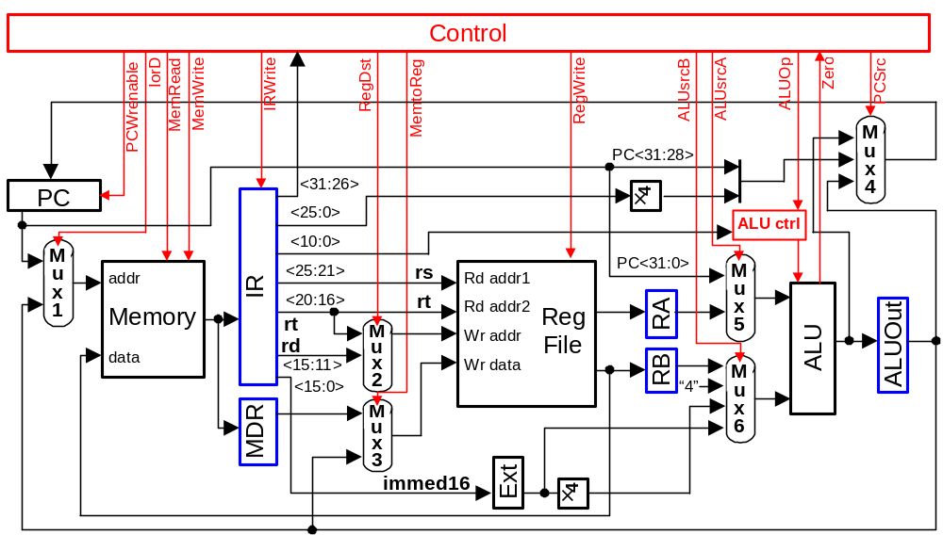

Solution:

We can examine the RTL for each instruction to find out which components are used:

Instruction Clock RTL

R-Type Instruction:
Instruction Fetch: 1 IR ← Mem[PC]
PC ← PC + 4
Decode/Operand Fetch 2 rs ← IR<25:21>
rt ← IR<20:16>
rd ← IR<15:11>
RA ← R[rs]

RB ← R[rt]

Execution 3 ALUOUT ← RA + RB
Store Results 4 Reg[rd] ← ALUOUT

Ori Instruction
Instruction Fetch: 1 IR ← Mem[PC]
PC ← PC + 4
Decode/Operand Fetch 2 rs ← IR<25:21>
rt ← IR<20:16>
imm16 ← IR<15:0>
RA ← R[rs]
Execution 3 ALUOUT ← RA or zero_extend(imm16)

4 R[rt] ← ALUOUT
sw Instruction
Instruction Fetch: 1 IR ← Mem[PC]
PC ← PC + 4
Decode/Operand Fetch 2 rs ← IR<25:21>
rt ← IR<20:16>
imm16 ← IR<15:0>
RA ← R[rs]
Execution 3 ALUOUT ← RA + sign_extend(imm16)

Store Results/Mem Write 4 Mem[ALUOUT] ← R[rt]

lw Instruction
Instruction Fetch: 1 IR ← Mem[PC]
PC ← PC + 4
Decode/Operand Fetch 2 rs ← IR<25:21>
rt ← IR<20:16>
RA ← R[rs]
imm16 ← IR<15:0>
Execution 3 ALUOUT ← RA + sign_extend(imm16)
Memory Read 4 MDR ← Mem[ALUOUT]
Store Results 5 R[rt] ← MDR

beq Instruction:
Instruction Fetch: 1 IR ← Mem[PC]
PC ← PC + 4
Decode/Operand Fetch 2 rs ← IR<25:21>
rt ← IR<20:16>
imm16 ← IR<15:0>
RA ← R[rs]
RB ← R[rt]
ALUOUT ← PC + sign_extend(imm16)
Execution 3 If RA = RB ( Zero ← “1” )
Update PC 4 PC ← ALUOUT
3 Else ( Zero ← “0” )
4 PC ← PC
jump Instruction
Instruction Fetch: 1 IR ← Mem[PC]
Decode 2 next_addr ← PC<31:28> : IR<25:0> : “00
Update PC 3 PC ← next_addr

Using the RTL above, and omitting shifters (×4 multipliers) and concatenators:

PC: beq, jump Instruction Fetch
Mux1 (any Mem): sw, lw Instruction Fetch
Memory: sw, lw Instruction Fetch
IR: All Instructions Instruction Fetch
MDR: lw
Mux2 (any Reg2): R-type, ori, lw, beq
Mux3 (Reg write): R-type, ori, lw
Reg File: R-type, ori, sw, lw, beq
Sign Ext: ori, sw, lw, beq
RA: R-type, ori, sw, lw, beq
RB: R-type
Mux4 (any PC): beq, jump Instruction Fetch
Mux5 (any ALU): R-type, ori, sw, lw, beq Instruction Fetch
Mux6 (any ALU): R-type, ori, sw, lw, beq Instruction Fetch
ALU: R-type, ori, sw, lw, beq Instruction Fetch
ALUOut: R-type, ori, sw, lw, beq

Problem 2:

The following multi-cycle data path has included the components for the jal and lwi instructions

Write the multi-cycle RTL for the jal and lwi instructions

Draw the state control diagram for the jal and lwi instructions

Draw the control unit block diagram using sequencer (see Page C-22)

Show details of the micro-sequencer and all dispatch ROM

Show the contents of the main control memory

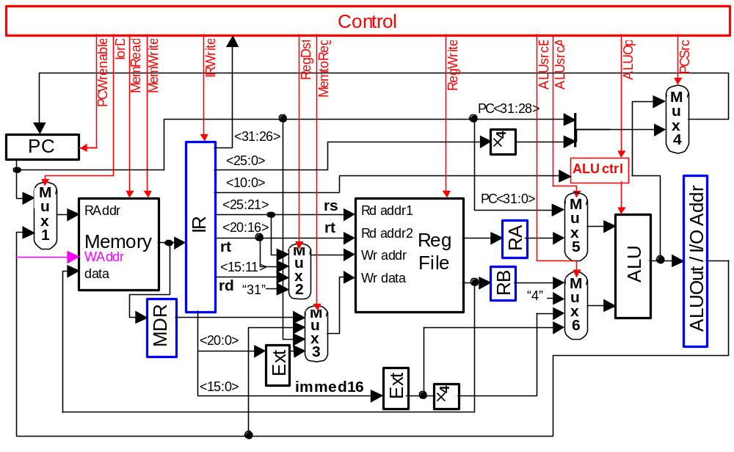

Solution:

a) lwi instruction:
Clk1: IR ← mem[PC] Instruction fetch
PC ← PC + 4 Update Program Counter
Clk2: imm21 ← IR<20:0> Operand fetch
rs ← IR<25:21> Decode: Set up Register File write address
Clk3: R[rs] ← imm21 Move the immediate value to register R[rt]

jal Instruction
Clk1: IR ← mem[PC] Instruction Fetch
PC ← PC + 4 Automatic update of Program Counter
Clk2: imm26 ← IR<25:0> Operand fetch
Clk3: R[31] ← PC Save next address to return address register
PC ← PC<31:27>:imm26:”00” Forming the jump target address by concatenating higher 4 bits of PC with the 26-bit immediate value. Left shift the target address by 2 bits (i.e., target address *4) and then load it to the PC

d)
ALUOp= Add, ALUSrcA= 0, ALUSrcB= 01
x: RegDst, MemtoReg, ExtOp
1: PCWrEn, IRWr; PCSrc=00, Others: 0
Instruction Fetch
ALUOp= Add, ALUSrcA= 0, ALUSrcB= 11
x: RegDst, PCSrc, IorD, MemtoReg
1: ExtOp; Others: 0
Instruction Decode/
Operand Fetch
0
1
lwi
ALUOp= xx, ALUSrcB= xx
x: PCSrc, IorD, ExtOp, RegWr=1
RegDst=00, MemtoReg =10, Others: 0

ALUOp= xx, ALUSrcB= xx
x: PCSrc, IorD, ExtOp
1: PCWrEn, RegWr; RegDst=11,
PCsrc =10, MemtoReg =00, Others: 0

jal
21
22

e) and f)
Dispatch ROM
Dispatch ROM
ALUsrcA
ALUsrcB1
RegWrite
MemtoReg0
IRWrite
MemWrite
MemRead
IorD
PCWrEn
Micro Program Counter
AddrCtrl0
AddCtrl1
Adder
Control Logic
Outputs
Inputs
RegDst1
RegDst0
ALUop1
ALUop0
PCSrc1
PCSrc0
MemtoReg1
Mux
Opcode
0
1
0
2
1
ALUsrcB0
ExtOp

Opcode | Instruction | State
110100 | lwi | 10101
000011 | jal | 10110

g) Main Control (see the order of the control logic block diagram output signals in (e) and (f))

State | Control Signals | AddrCtrl
00000 | 100010000000001000 | 10
00001 | 000000010000011000 | 01
10101 | 000001000000000100 | 00
10110 | 100000001000000111 | 00

Problem 3:

Many processors do not process interrupt while the execution of an instruction is in progress. When the execution of the current instruction is completed, the control logic will examine an interrupt register to decide if any interrupt has occurred. If any bit in interrupt register has been set (i.e., interrupt occurred), the control logic will read an interrupt vector through the processor bus (i.e., same as the memory bus) and perform a procedure call that uses the interrupt vector as the address of the called procedure. Assuming only the return address need to be saved in the procedure call,
- Modify the basic instruction execution sequence to add the interrupt capability

Instruction Fetch
Operand Fetch / Decode
Execution
Store Results

- Add necessary components in the multi cycle data path to implement the procedure call for the interrupt
- Add the interrupt control to the following finite state diagram

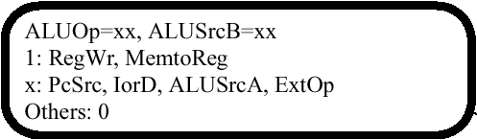
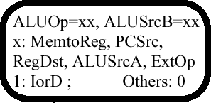
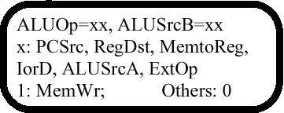
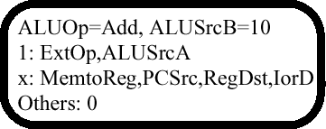

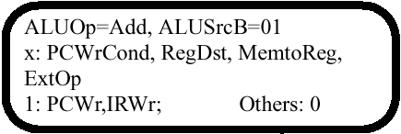
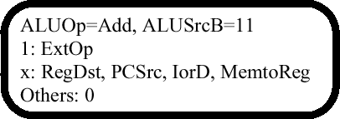

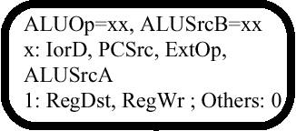

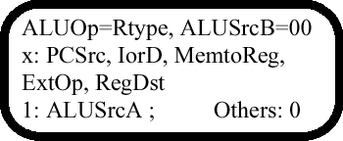

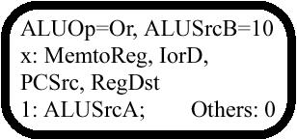

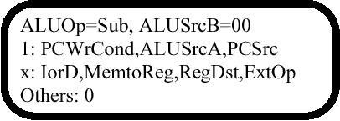

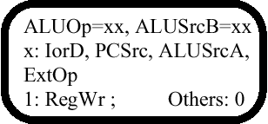
1: PCWrite
PCsrc = 10
x: others
JComplete
J

Solution:

a)
Instruction Fetch
Operand Fetch / Decode
Execution
Store Results
Interrupt?
Get Interrupt Vector
Y
N

b)
Interrupt Signal
Interrupt Vector

Control
Zero
PCSrc
ALUsrcA
ALUsrcB
RegWrite
MemtoReg
RegDst
IRWrite
MemWrite
MemRead
IorD
PCWrenable
ALUop
IrqToPC
IRQ
IRQReset

IRQ Reg

mux4
1
0
mux
PC<31:28>
×4
PC
IR
ALU ctrl
<25:0>
<5:0>
mux5
mux1

Memory
<25:21>

Reg
File

addr
rs
ALU
RA
ALUOut
Rd addr2
<20:16>
rt
mux2
Wr addr
rd
rt
<15:11>
Mux6
RB
data
31
“4”
mux3
MDR
Ext
×4
<15:0>
immed16

c)
J
0
2
3
4
5
6
7
8
11
12
9
100
If IRQ=0:
ALUOp= Add, ALUSrcB= 01
x: PCWrCond, RegDst, MemtoReg, ExtOp
1: PCWr, IRWr; Others: 0
else:
IRQToPC = 1, MemToReg = 10,
RegDst = 10, IRQReset = 0
Ifetch if no IRQ, else jump to interrupt vector
IRQ=0
ALUOp= Add, ALUSrcB= 01
x: PCWrCond, RegDst, MemtoReg, ExtOp
1: PCWr, IRWr, IRQReset
1: IRQToPC, Others
RegDst = X, IRQReset = 1
1
IRQ=1
JComplete
1: PCWrite
PCsrc = 10
x: others

Problem 4:

- What is the maximum clock frequency of the given single cycle data path?
- What is the maximum clock frequency of the given multi cycle data path?
- For a program of with the following instruction mix, which data path is faster? Provide your explanation.

Program A: Instruction Count
lw 100
R-type 1000
sw 50

- Modify the multi-cycle data path so that it can run faster than the single cycle data path for the given program. What is the execution time of the modified data path?

Single Cycle Data Path:

PC
clk
Add
“4”
5 ns
mux
PC+4

10 ns
“00”
5 ns

ALU

Instruction Memory

Rd addr1
rs
Read = 50 ns
Write = 50 ns
mux
Rd addr2
rt
Reg File
mux
Wr addr

Data Memory
addr
rt
mux
Wr data
rd
50 ns
5 ns
Read = 20 ns
Write = 20 ns
15 ns
clk
data
5 ns
Ext
clk
immed16
5 ns
5 ns

Multi Cycle Data Path:

5 ns
PC+4
Add
“00”
“4”
mux
PC

Instruction Memory
ALU
clk
clk

Rd addr1
Rd addr2
Wr addr
Wr data
mux

Data Memory
mux
addr
data
mux
rs
rt
rd
rt
immed16
Ext
5 ns
50 ns
5 ns
Read = 20 ns
Write = 20 ns
5 ns
15 ns
Read = 50 ns
Write = 50 ns
5 ns
5 ns
10 ns
IR
ALUOut
5 ns
5 ns
clk
Reg File
RA
RB
5 ns
5 ns
MDR
5 ns

Note: All given delays for registers and memory are write delays from clock input to data output. The setup times between data input and clock input are assumed to be 0.

That is:
Data In
XXXX
Data Input

Clock Input

Data In
Old data
Data Output
Delay

Solution:

a) For single cycle data path, lw has the longest path delay

PC 5 ns
Instruction Memory 50 ns
Mux 5 ns
Register File 20 ns
Mux 5 ns
ALU 15 ns
Data Memory 50 ns
Mux 5 ns
Register File 10 ns
Total 165 ns ➔ Max Clock Frequency = 6.06 MHz

b) For multi cycle data path, need to find the longest path between registers
From PC clock input to IR data input = 5 ns + 50 ns = 55 ns (longest path)
From IR clock input to RA/RB data input = 5 ns + 5 ns + 20 ns = 30 ns
From RA/RB clock input to ALUOUT data input = 5 ns + 5ns + 15 ns = 25 ns
From ALUOUT clock input to MDR data input = 5 ns + 50 ns = 55 ns (longest path)
From MDR to Register File data input = 5 ns + 5 ns = 10 ns
From ALUOUT clock input to Register File data input = 5 ns + 5 ns = 10 ns

The maximum clock frequency of the multi-cycle data path = 1/ 55 ns = 18.18 MHz

c) For single cycle data path, all instructions have the same execution time. Therefore, the total execution time of the program is:
155 ns × (100 + 1000 + 50) = 178.25 μs

For multi cycle data path:
The lw requires 5 cycles. Execution time for all lw = 100 × 5 × 55 ns = 27.5 μs
The R-type requires 4 cycles. Execution time for all R-type = 1000 × 4 × 55 ns = 220 μs
The sw requires 4 cycles. Execution time for all sw = 50 × 4 × 55 ns = 11 μs
Total execution time = 27.5 μs + 220 μs + 11 μs = 258.5 μs

The single cycle data path is faster. The reason that the multi-cycle data path is slow is because the clock cycle is constrained by the memory sections. Therefore, more sections in the data path means more clock cycles are required and thus increase the execution time.

- To improve the multi-cycle data path, the immediate registers have to be changed so that the number of sections can be reduced and the delays in all sections are as balanced as possible. This is shown in the following:

5 ns
PC+4
Add
“00”
“4”
mux
PC

Instruction Memory
ALU
clk
clk

Rd addr1
Rd addr2
Wr addr
Wr data
mux

Data Memory
mux
addr
data
mux
rs
rt
rd
rt
immed16
Ext
5 ns
50 ns
5 ns
Read = 20 ns
Write = 20 ns
5 ns
15 ns
Read = 50 ns
Write = 50 ns
5 ns
5 ns
10 ns
IR
ALUOut
5 ns
5 ns
clk
Reg File
5 ns
MDR
5 ns

The clock cycle of the modified multi-cycle data path:
From PC clock input to IR data input = 5 ns + 50 ns = 55 ns
From IR to ALUOUT data input = 5 ns + 5ns + 20 ns + 5 ns + 15 ns = 50 ns
From ALUOUT clock input to MDR data input = 5 ns + 50 ns = 55 ns
From IR to Register File data input = 5 ns + 5ns + 20 ns + 5 ns + 15 ns + 5 ns = 55 ns

Therefore, the maximum clock frequency = 1/55 ns = 18.18 MHz

Execution time of the given program:
The lw requires 4 cycles. Execution time for all lw = 100 × 4 × 55 ns = 22 μs
The R-type requires 2 cycles. Execution time for all R-type = 1000 × 2 × 55 ns = 110 μs
The sw requires 3 cycles. Execution time for all sw = 50 × 3 × 55 ns = 8.25 μs
Total execution time = 22 μs + 110 μs + 8.25 μs = 140.25 μs

The modified data path is (1 – 140.25/178.25) × 100% = 21 % faster than the single cycle data path

