U C L A

Computer Science Department

CS 180 Algorithms & Complexity Fall 04-05

Instructor: Majid Sarrafzadeh
3532C Boelter Hall
majid@cs.ucla.edu
www.cs.ucla.edu/~philip/cs180

HWK 1: assigned 10/21, due 10/28 (in class; 10 am)
Solution Set

- Analyze the time complexity of the bucket sort. Devise an algorithm that uses both quick sort and bucket sort.

The worst-case running time of bucket sort occurs when all elements in the unsorted list are placed into the same bucket. When this occurs, insertion sort is called, it must sort exactly one bucket containing n elements. Since it is known that the worst-case running time of insertion sort is O(n²), the worst-case running time of bucket-sort is O(n²) as well. We can reduce the worst-case running time of bucket sort by employing an O(nlogn) sorting algorithm (Merge Sort or Heap Sort) to sort the buckets instead of insertion sort. Refer to the textbook for an average-case analysis, if you are interested.

The basic idea behind our algorithm is as follows: use Quicksort to partition the array into sub-arrays of length k. When quicksort is called on a subarray with fewer than k elements, let it simply return without sorting the subarray. Instead of performing Insertion Sort on the entire array, we perform bucket sort on each partition alone.

The average-case time complexity of this application of Quicksort is O(nlg(n/k)). The expected time of performing bucket sort on each sub-array is O(k). Since this must be done for O(n/k) subarrays, the total time complexity of Bucket Sorting all of the sub-arrays becomes O(n). Therefore, the total time complexity is O(n + nlg(n/k)) = O(nlg(n/k)).

This algorithm only works well if k is chosen such that the values of each sub-array are uniformly distributed over some interval [a, b), a < b. Additionally, we must normalize each value x in [a, b) to the range [0, 1) (required for Bucket Sort).

- Problem 7-5, a, b, c on page 162.

Median-of-3 Partition
One way to improve the RANDOMIZED-QUICKSORT procedure is to partition around a pivot that is chosen more carefully than by picking a random element from the subarray. One common approach is the median-of-3 method: choose the pivot as the median of a set of 3 elements randomly selected from the subarray. For this problem, let us assume that the elements in the input array A[1..n] are distinct and that n > 3. We denote the sorted output array by A’[1..n]. Using the median-of-3 method to choose the pivot element x, define p_{i} = Pr{x = A’[i]}.

a. Give an exact formula for P_{i} as a function of n and i for i = 2, 3, …, n – 1. Note that P₁ = P_{n} = 0.

To do this, we will use an argument based on combinations. First and foremost, observe that the total number of combinations of 3 values (taken from a list of n) is:

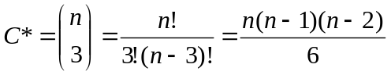

Let C_{i} represent the number of combinations of values that select A[i] as the median of 3. Obviously, A[i] must be chosen. Similarly, exactly one value from A[1..i-1] must be chosen, as well as one value from A[i+1..n]. Only under these circumstances, will A[i] be selected as the best-of-3 median. Therefore:

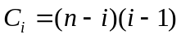

There are (i-1) values in the range A[1..i-1], and there are (n-i) values in the range A[i+1..n].

The probability that element A[i] is selected as the best-of-3 median, P_{i}, is therefore computed as follows:

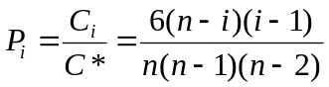

Observe that this formula satisfies P₁ = P_{n} = 0.

b. By what amount have we increased the likelihood of choosing the pivot as 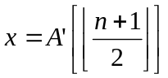. Assume that n →, and give the limiting ratio of these probabilities.

To simplify the math, we drop the ceiling/floor notation.

P_{(n+1)/2} = 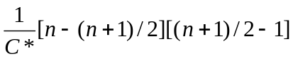
= 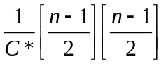
= 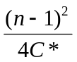

When using standard Quicksort, P_{i} = 1/n for all i. Therefore, the limiting ratio is computed as follows:

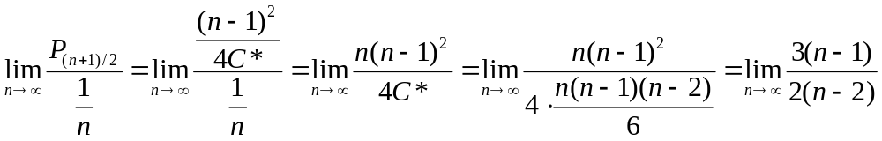

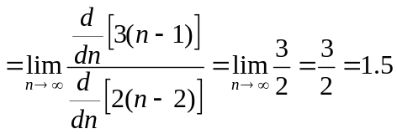

The likelihood of choosing the pivot as has increased 1.5 times.

c. If we define a “good” split to mean choosing the pivot as A’[i], where n/3 < i < 2n/3, by what amount have we increased the likelihood of getting a good split compared to the ordinary implementation. (Hint: Approximate the sum by an integral.)

Let P* be the likelihood of selecting pivot A’[i] as defined above. Then:

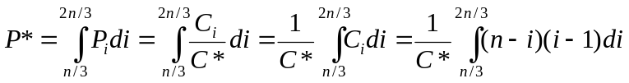

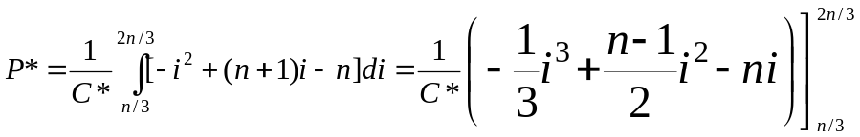

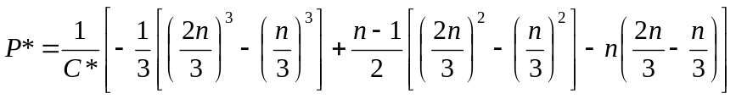
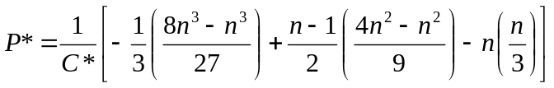

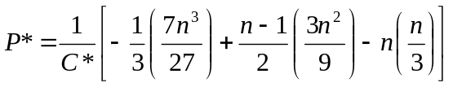
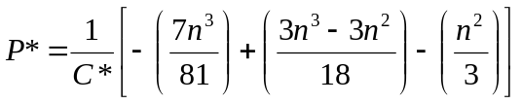
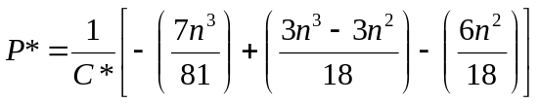
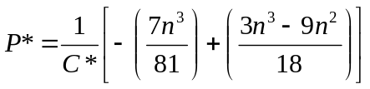
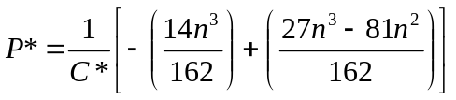
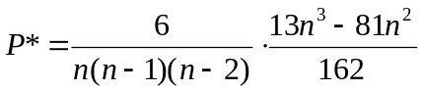
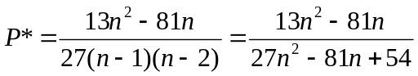

For normal Quicksort, the probability of selecting a pivot A’[i] as defined above is 1/3. Therefore, the limiting ratio is:

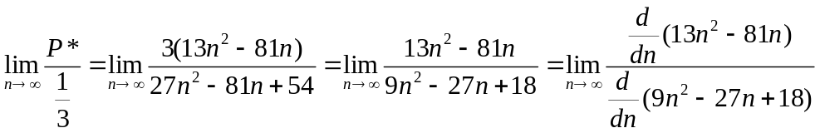
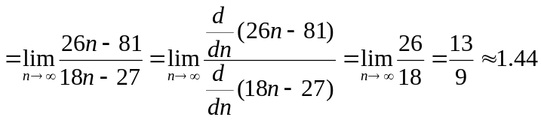
The likelihood of achieving a good split has been increased 1.44 times.

- Problem 2 on Page 194 at the end of Median and Order Statistic Chapter (weighted median) parts a, b, d.

Weighted Median
For n distinct elements x₁, x₂, …, x_{n} with positive weights w₁, w₂, …, w_{n} such that 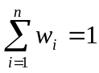, the weighted (lower) median is the element x_{k} satisfying:

(1) 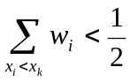
(2) 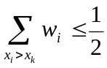
- Argue that the median of x₁, x₂, …, x_{n} is the weighted median of the x_{i} with weights w_{i} = 1/n for i = 1, 2, …, n.

Since all x_{i} have the same weight, the median of x₁, … , x_{n}, the median will be x_{ceiling(n/2)}.

If n is even, then n = 2k. Summing the first k x_{i}-values followed by the second k values yields the same weighted sum for each set:

k/n = k/2k = 1/2

The weighted lower median is thus x_{k} = x_{n/2}.

If n is odd, then n = 2k + 1. Summing the first k x_{i}-values followed by the second set of k + 1 x_{i}-values yields the following two equations:

First k x_{i}: k/n = k/(2k+1) < 1/2
Second k+1 x_{i}: (k+1)/n = (k+1)/(2k+1) > (k+1)/(2k+2) = 1/2

The weighted lower median is thus thus x_{k} = x_{n/2} = x_{ceiling(n/2)} since n is odd.

- Show how to compute the weighted median of n elements in O(nlgn) worst-case time using sorting.

- Sort the x_{i} such that w₁< … < w_{n}.
- sum ← 0
- for j ←1 to n
sum ← sum + w_{j}.
if sum > ½
return x_{j-1}

Complexity: Sorting can be accomplish in O(nlogn) time using your favorite O(nlogn) sorting algorithm. Initializing the sum variable can be done in O(1) time. In the worst case, the for loop iterates n times. All of the operations inside of the for loop are O(1). Therefore, the total time complexity is:

T(n) = O(nlogn) + O(1) + O(n)O(1) = O(nlogn)

- [NOT ASSIGNED]

The post-office location problem is defined as follows. We are given n points p₁, p₂, …, p_{n} with associated weights w₁, w₂, …, w_{n}. We wish to find a point p (not necessarily one of the input points) that minimizes the sum 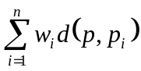, where d(a, b) is the distance between points a and b.

- Argue that the weighted median is a best solution for the 1-dimensional post-office location problem, in which points are simply real numbers and the distance between points a and b is d(a, b) = |a – b|.

Note: In the original weighted mean problem, element x_{i} had one attribute: weight w_{i}. In the one-dimensional weighted median problem, post office (element) pi has two attributes: weight w_{i}, and one-dimensional position coordinate p_{i}. Weighted median is a property that depends only on weights. Our goal is to find a value for p that minimizes:

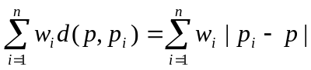

This value indicates the optimal coordinate at which to place post office p.

We are asked to show that the p that minimizes the objective function is the weighted median. The weighted median one of the p_{i}, which we can see from the definition of weighted median.

Suppose the weighted median of the post offices is p_{k}. Assume to the contrary that the value for p that minimizes the weighted distance is not p_{k}.

We must consider two cases:

      - p = p_{k} + δ
      - p = p_{k} – δ

Let D be the weighted distance when p = p_{k}, D₁ be the weighted distance when p = p_{k} + δ, and D₂ be the weighted distance when p = p_{k} – δ.

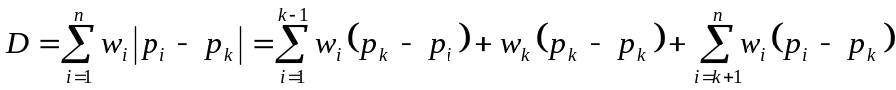

Since w_{k}(p_{k} – p_{k}) = 0, D becomes:

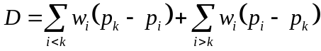

Now, consider D₁.

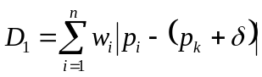
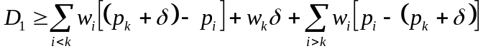

The application of the > inequality needs to be explained. We are assuming that the p_{i} are listed in sorted order. That is:

In general:

p_{k} – p_{i} > 0 for i < k, and
p_{i} – p_{k} > 0 for i > k.

However, we must consider (p_{k} + δ) – p_{i} and p_{i} – (p_{k} + δ). We have no idea what the value of δ is. Consequently, we could have a situation such as the following:

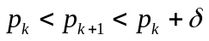

If this occurs, then the term p_{k+1} – (p_{k} + δ) is actually negative; this justifies the use of the > operator instead of strict equality (=).

Now, we continue manipulating our equation for D₁:

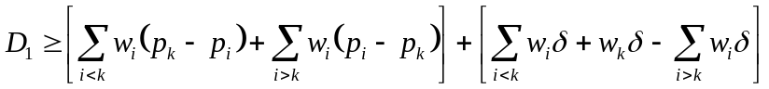
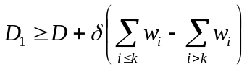
We know from the definition of weighted median that:

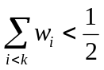 and 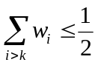

If we include the kth weight, w_{k}, on the left-hand-side, we get:

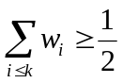 since 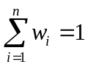

Hence:

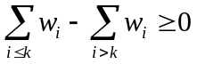

Consequently, we conclude that D₁ > D. Therefore D is at least as good a solution as D₁. By an analogous argument, we can show that D₂ > D as well. Therefore, D is at least as good a solution as D₂. Taken together, these results show that D is the only guaranteed optimal solution. (or equivalently, D = D₁ = D₂ are optimal solutions if and only if δ = 0).

- Problem 9.1-1 on page 185.

Show that the second smallest of n element can be found with 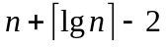 comparisons in the worst-case. (Hint: Also find the smallest element)

The smallest of n numbers can be found with n – 1 comparisons by conducting a tournament as follows: Compare all the numbers in pairs. Only the smaller of each pair could possibly be the smallest of all n, so the problem has been reduced to that of finding the smallest of 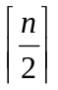 numbers. Compare those numbers in pairs, and so on, until there’s just one number left, which is the answer.

The first part of the algorithm does exactly n – 1 comparisons. Notice that each number, except for the smallest, loses exactly once. To show this more formally, draw a binary tree of the comparisons the algorithm performs. The n numbers are the leaves, and each number that came out smaller in a comparison in the parent of the two numbers that were compared. Each non-leaf node of the tree represents a comparison. There are n-1 internal nodes in an n-leaf full binary tree, so exactly n – 1 comparisons are made.

In the search for the smallest number, the second smallest number must have come out smallest in every comparison made with it until it was eventually compared with the smallest. So the second smallest is among the elements that were compared with the smallest during the tournament. To find it, conduct another tournament (as above) to find the smallest of these numbers. At most 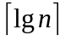 (the height of the tree of comparisons) elements were compared with the smallest, so finding the smallest of these takes 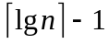comparisons in the worst case. The total number of comparison made in the two tournaments, in the worst case, was:

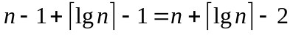

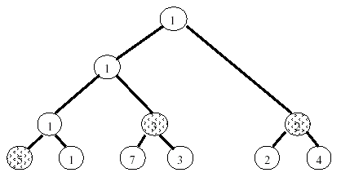

Example: A tree of comparisons made in the tournament to find the smallest of 6 numbers. The shaded numbers are the candidates for the second-smallest number.

- Consider an array of intergs A[1..n] such that for all i, |A[i] – A[i+1]| <= 1. Let A[1] = x and A[n] = y such that x<y. Design an efficient search algorithm that finds j such that A[j] = z, for a given value z (x < z < y)

Explanation: Suppose that A[i] = c. By the constraint listed above, the are three possible values for A[i+1]: c-1, c, or c+1 (the same is true for A[i-1]). This ensures that value z exists at least once within A.

Consider A[1] = x. If z = x, we are done, and we return j = 1. If z > x, we do not need to consider A[1]. Now, suppose that z – x = k. By the constraint listed above, the smallest index j* such that A[j*] =k must be j* = 1+k. The smallest such j* occurs when the sequence A[1..j*] is strictly increasing. In other words:

A[1] = x
A[2] = x + 1
A[3] = x + 2
…
A[k] = x + (k-1) = z – 1 (k = j*-1)
A[k+1] = x + k = z (k = j*)

Therefore, we can trivially eliminate A[2..k] from further consideration.

A similar argument can be made for A[n] moving downward. If we assume z < y (recall that A[n] = y), and let k’ = y – z, then next array element that we must consider is A[n-k’]. In other words, we can eliminate A[n-k’+1.. n-1] from further consideration. We can recursively reply this argument to A[k+1..n-k’]

This yields the following recursive procedure.

Find_J(A, left, right, z)
- x ← A[left]
- y ← A[right]
- If x = z
- Return left
- Else If y = z
- Return right
- Else
- k ← |z – x|
- k’← |y – z|
- Return Find_J(A, left+k, right-k’, z)

The initial call to the procedure would be: Find_J(A, 1, n = length[A], z)

This algorithm runs in O(n) time in the worst case. The reason is as follows. Suppose that we are given a list A = [1, 1, …, 1, 2, 3, 3, …, 3], where x = 1, y = 3, and z = 2. After each recursive call, we will have k = k’ = 1. Initially, we will call Find_j on A[1..n], then A[2..n-1], A[3..n-2] … A[n/2..n/2]. This is a total of n/2 = O(n) recursive calls to Find_j.

An O(lgn) solution to this problem also exists. The solution is quite similar in spirit to binary search. Recall that the problem constraints dictates that there is at least one index j* for which A[j*] = z.

Let 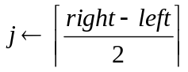

Therefore, we simply check the value of A[j]. If A[j] = z, we are obviously done. If A[j] < z, then at least one value in A[j+1..right] = z. If A[j] > z, then at least one value in A[left..j-1] = z. For either of the latter two cases, a recursive call is all that is needed to solve the problem. If left = right, then A[left] = A[right] = z.

Find_J’(A, left, right, z)
- If left = right
- Return left
- If A[j] = z
- Return j
- Else If A[j] < z
- Return Find_J’(A, j+1, right, z)
- Else
- Return Find_J’(A, left, j-1, z)

To see that the algorithm runs in O(lgn) time, observe that half of the array is effectively eliminated from consideration by each recursive call. After lgn calls, only one element will remain. At this point, further bisection of the array is impossible. Therefore the algorithm will terminate after at most lgn recursive calls.

- Prove that the sum of heights of all nodes in a balanced binary tree with n nodes is at most n-1.

For this problem, a balanced binary tree is defined to be one that can be represented in a contiguous array A[1..n] without any gaps. This is similar to the binary tree structure of a heap. For example, the tree shown in the example for problem 4 is balanced.

Let n be a node, and child(n) be the set of children nodes of n. The height of n is denoted H(n). If n is a leaf node, H(n) = 0. If n is not a leaf node:

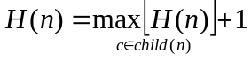

In our proof, we will use the fact that a binary tree T that contains n nodes has 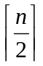 leaves. We prove this statement by induction. (This proof is simply for the benefit of the students; it is not required for full credit on this problem).

Basis. Let T be a tree consisting of a single node, i.e. n = 1. Since this node has no children, it is also a leaf. Since 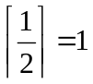, T contains leaves.
Induction Hypothesis: Let T be a tree containing n < k nodes. Then T has leaves.

Now, let T be a tree containing n = k+1 nodes, represented as an array A[1..k+1]. Let T’ be the sub-tree represented as array A[1..k]. By the induction hypothesis T’ contains 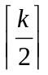 leaf nodes.

Recall that the children of a node in a binary tree in array location A[i] can be found in locations A[2i] and A[2i+1]. We consider two separate possibilities:

  - k+1 is even

Then k+1 = A[2i] for some i. Let A[i] be the parent of A[k+1]. Since k+1 is the largest index of a tree node, A[k+1] is the only child of A[i]. By the induction hypothesis, A[k+1] is not contained in T’. Therefore, A[i] is a leaf in T’; however, A[i] is not a leaf in T—instead, A[k+1] is a leaf. Therefore, T and T’ contain the same number of leaves. Since k+1 is even, 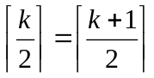. Therefore T contains leaves.

  - k+1 is odd

Since k+1 is odd, k+1 = 2i + 1, for some i. Consider tree T consisting of nodes in A[1..k+1], and consider a sub-tree T’ consisting of nodes A[1..k]. By the induction hypothesis, T’ contains nodes. Observe that A[k] and A[k+1] must have the same parent node: A[i]. Therefore T has exactly one more leaf vertex than T’. Since k+1 is odd:
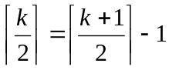
The number of leaves of T is therefore given by:
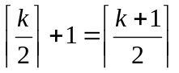
Therefore T contains leaves.

Now, we prove that the sum of the heights of the vertices in a balanced tree with n vertices is at most n – 1.

Similar to the previous proof, we use induction on the number of nodes in the tree.

Basis: Let n = 1. A single-node tree consists of a single root, i.e. n = 1. Since the root is also a leaf, its height is 0 < n – 1 = 1 – 1 = 0.

Induction Hypothesis: Assume that for a tree T containing n < k nodes, the sum of the heights of the vertices is at most n – 1.

Let T be a tree containing n = k+1 vertices. As established earlier, T contains 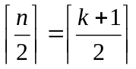 leaves. Therefore, 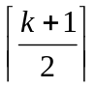 nodes have height 0.

Consider the subtree T’ that results from removing all of the leaves from T. The number of nodes in T’ is therefore:
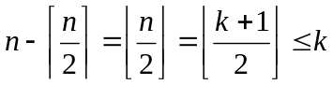

By the induction hypothesis, the sum of the heights of the nodes in T’ is at most 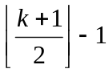

Now, let us rebuild T from T’ by adjoining all leaves in T to all leaves in T’. This increases the height of every node by 1. Since there are 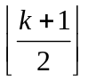 nodes in T’, the sum of the heights of the nodes in T is given by:

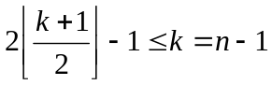

Therefore, the sum of the heights of the vertices in a balanced tree with n vertices is at most n – 1.

A brief intuitive argument to show that 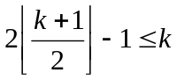 comes from the following table:

