EE115C HW1 solution

Problem 2.
- I_{D}=0, V_{D}=-V_{S}=-3.3V
- Reverse biased
- 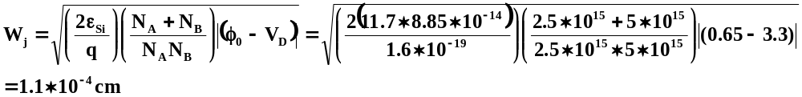
- 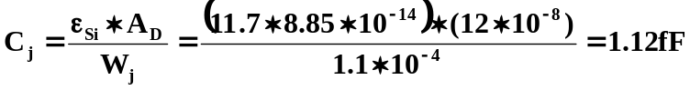
- Since Vs decreases from 3.3V to 1.5V, from the equation used in (c) we know that the depletion width will decrease. As we know from the equation used in (d), if depletion width decreases, the capacitance will increase.

Problem 4.
(a)

VD 3 0 2.5v
VG 2 0 2.5v
M1 3 2 0 0 nmos W=1.2u L=0.25u AS=0.75p AD=0.75p PS=2.45u PD=2.45u
*LD=LS=0.625u
*AD=W*LD AS=W*LS PD=W+2*LD PS=W+2*LS
.LIB C:\115c\025um_PSPICE_BSIM3.txt
.PROBE
.DC VD 0 2.5 0.1 VG 0 2.5 0.5
.TRAN 10n 100n
.END
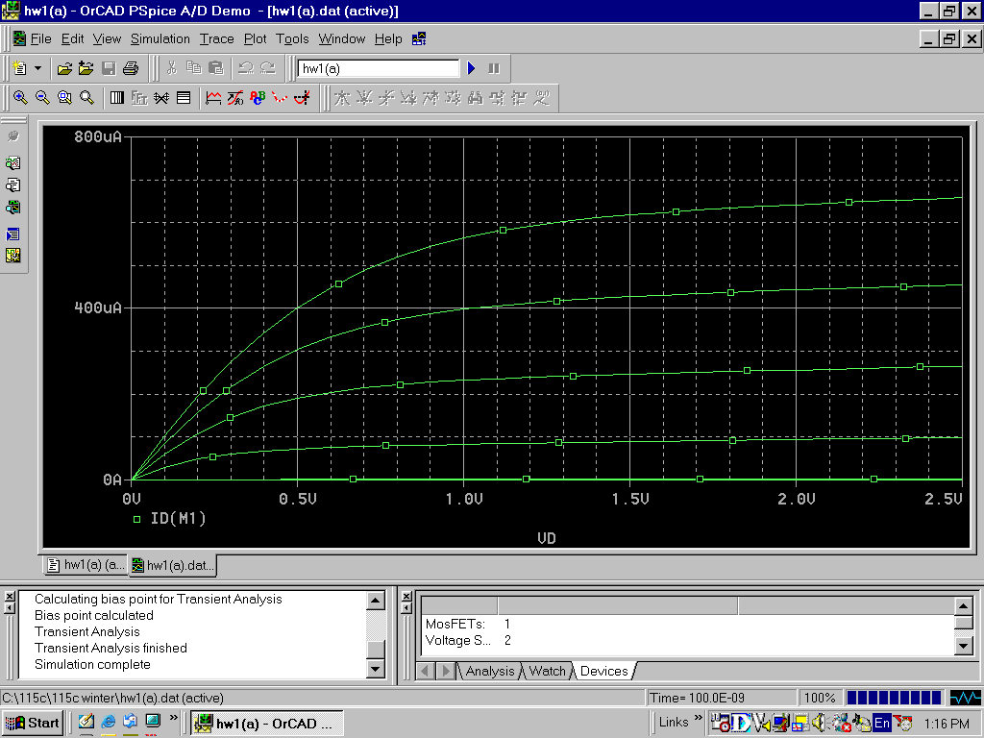

(b)
VD 3 0 2.5v
VG 2 0 2.5v

M1 3 2 0 0 nmos W=4.8u L=0.5u AS=3p AD=3p PS=6.05u PD=6.05u
.LIB C:\115c\025um_PSPICE_BSIM3.txt
.PROBE
.DC VD 0 2.5 0.1 VG 0 2.5 0.5
.TRAN 10n 100n
.END

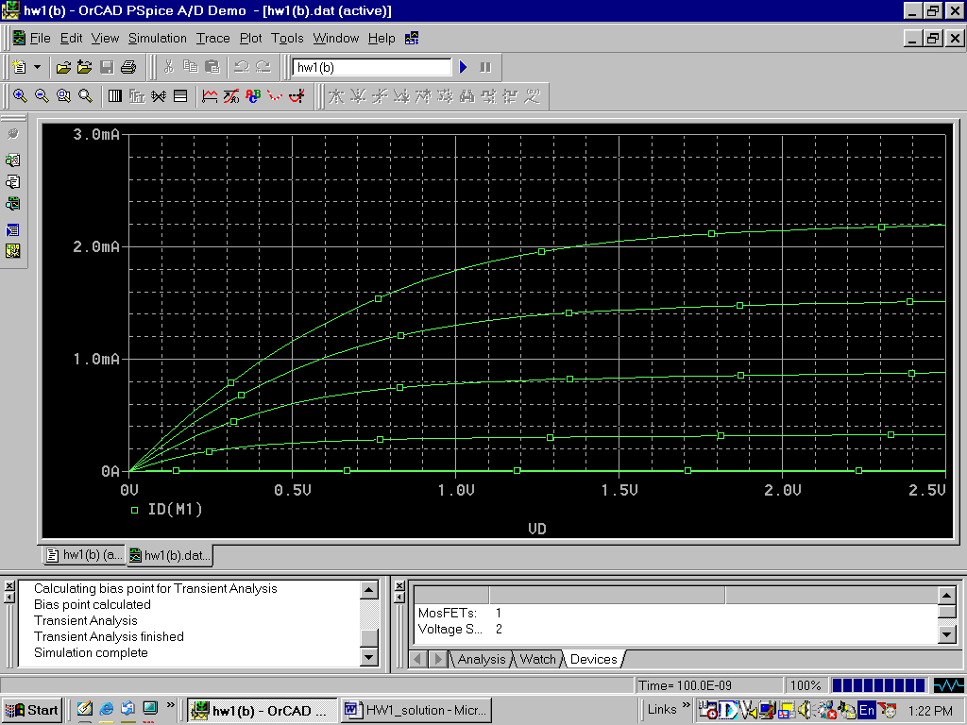

(c)
VS 3 0 0
VG 2 0 -2.5v
VD 1 0 -2.5V
M1 1 2 3 3 pmos W=1.2u L=0.25u AS=0.75p AD=0.75p PS=2.45u PD=2.45u
.LIB C:\115c\025um_PSPICE_BSIM3.txt
.PROBE
.DC VD 0 -2.5 -0.1 VG 0 –2.5 -0.5
.TRAN 10n 100n
.END
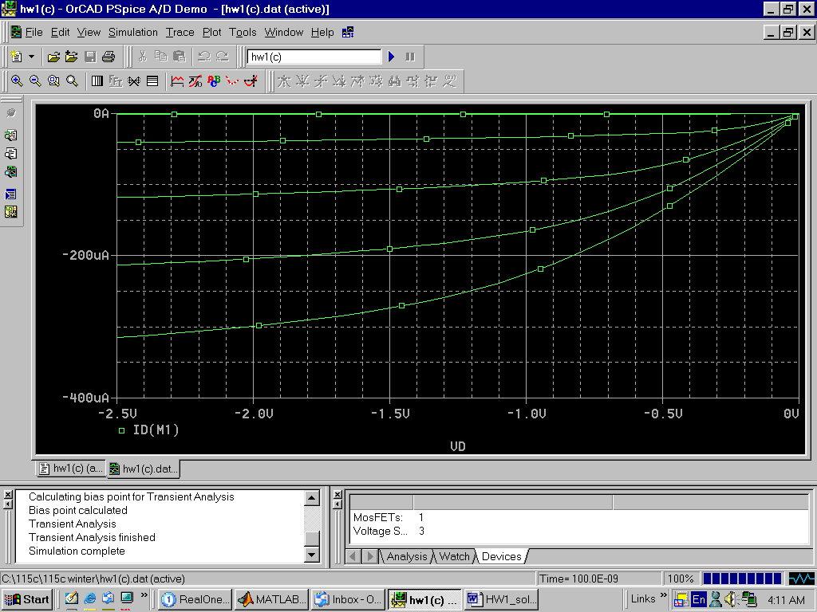

(d)
VS 3 0 0
VG 2 0 -2.5v
VD 1 0 -2.5V

M1 1 2 3 3 pmos W=4.8u L=0.5u AS=3p AD=3p PS=6.05u PD=6.05u
.LIB C:\115c\025um_PSPICE_BSIM3.txt
.PROBE
.DC VD 0 -2.5 -0.1 VG 0 -2.5 -0.5
.TRAN 10n 100n
.END

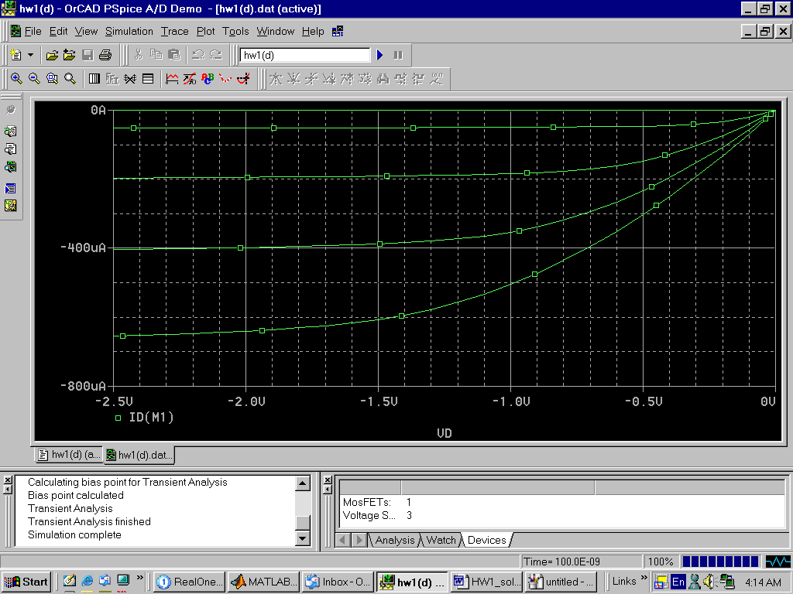

Problem 6.
For short-channel NMOSFET, we should use the following equation to calculate the drain-source current:
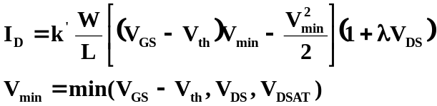
From any of the data of Table 0.1 to have this NMOSFET working at saturation region,
V_{GS}-V_{th}=2-V_{th}<V_{DSAT}=0.6
⇒ 1.4<V_{th}, which is unacceptable which deep-submicron devices.
Thus we can safely assume that this device is operating at the velocity saturation region, which means that 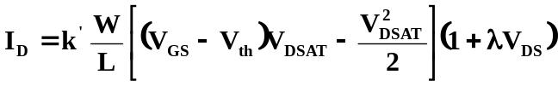
- Use row 1 and 2 to calculate V_{th}:
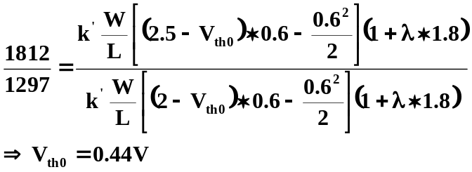
- Use row 2 and 3 to calculate λ:
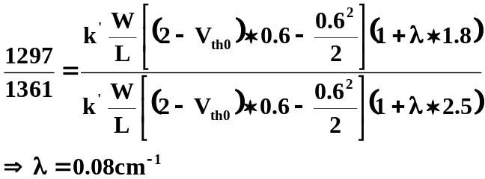

- Use row 1 to calculate W/L:
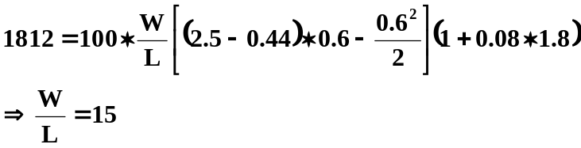

- Use row 4 and 5 to calculate γ, 2|φ_{f}|:
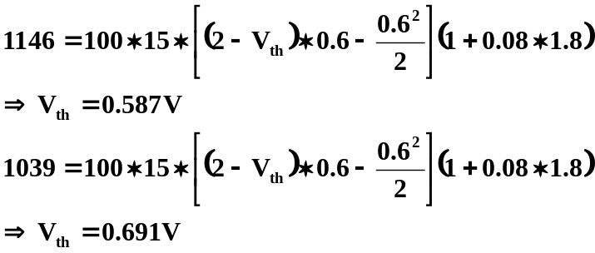
Since 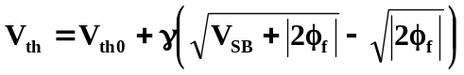
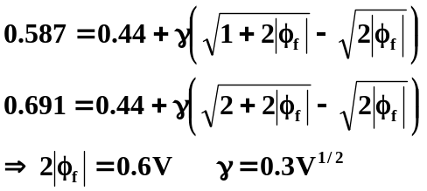

Problem 8.
- When R=10kΩ,
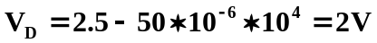
First we guess that M1 is operating at saturation region,
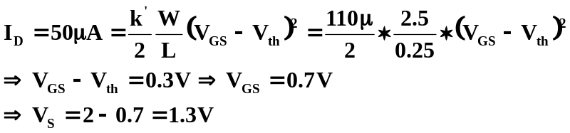
Since V_{GS}<V_{DSAT}=0.6V and V_{DS}=2-1.3=0.7>V_{GS}-V_{th}=0.3V, M1 is operating at saturation region which our guess is correct.

- When R=30kΩ,
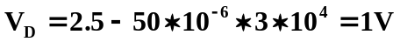
First we guess that M1 is operating at linear region,
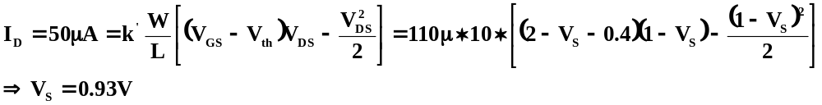
Since V_{GS}-V_{th}=2-0.93-0.4=0.67V>V_{DS}=1-0.93=0.07V, M1 is in the linear region which our guess is correct.

If λ≠0, M1 suffers from channel length modulation effect.
We should use 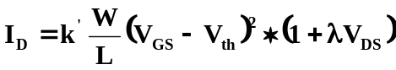 to calculate the M1 current. Since current is fixed because of the current source and (1+λV_{DS}) is greater than 1, the (V_{GS}-V_{th}) term should decrease in other word, V_{S} should increase.

