Homework 2

Hand out on Lecture 5
Due: Lecture 8 Tue. Feb. 3, 2004

Text Rabaey 2nd Edition,

Read Methodology Insert, Sections 4.2, 4.3, 5.2, 5.3
Problems 3.11 (with spice), 3.17, 3.18, 3 problems handed out

Clarification for 3.11:
Part A: For simplicity ignore channel length modulation, EXCEPT for Vin = 1.5 V
Part C: the hand calculations should use the velocity saturation equations. In essence this will provide the same answer as part (a) for hand calculations, but the SPICE will be different.

Clarification for 3.17:
The problem refers to Table 3-5 not Example 3-5
Note: for a 0.25 micron process L+2x_{d} = 0.25 μm.

Handout Problem No. 1:

1a. Put the following processing steps in order
- Metal deposition
- N-well creation
- Polysilicon deposition
- Creation of the diffusion areas

1 b. Briefly explain why design rules are needed

Handout Problem No. 2:
Sketch the circuit diagram for the layout given below. Also give the sizes of all transistors in terms of lambda. All transistors are NMOS devices.

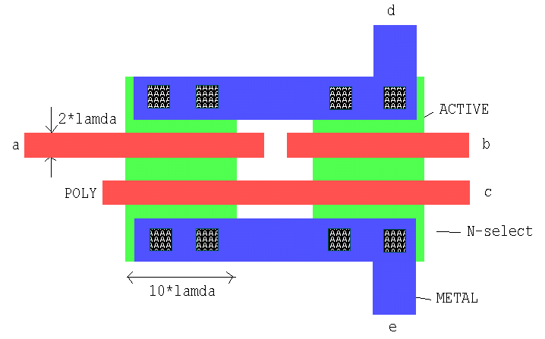

Handout Problem No. 3:

Using Ledit layout the smallest possible Inverter. All transistors (PMOS and NMOS) should be minimum size. Run DRC and include the DRC report. Extract the layout and using spice measure the propagation delay when the input goes from logic-1 to logic-0 and from logic-0 to logic-1. For this problem please hand in
- A copy of your layout
- The total area of your gate, not including the well regions
- Measured delay

