Homework 2
Solution
3.11
a) Ignoring channel length modulation,
In saturation
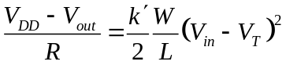
In triode
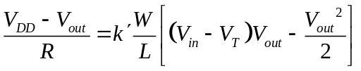
In Vel-saturation
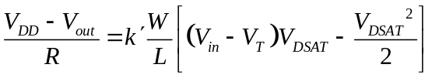
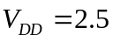, 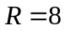kΩ, 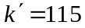μA/V², 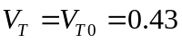V, 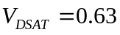V
When 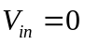V→ cut-off, 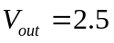V
When 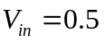V, 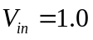V → Saturation
When 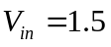V → Vel-saturation
When 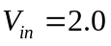V, 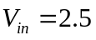V → Triode
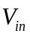 | 0.0 | 0.5 | 1.0 | 1.5 | 2.0 | 2.5
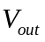 | 2.5 | 2.49 | 1.90 | 0.74 | 0.42 | 0.31

b) SPICE
*3.11 SPICE part b
Vdd vdd 0 2.5
Vin in 0 0
R vdd 2 8k
M2 in 0 0 nmos W=1u L=0.25u AS=0.5p AD=0.5p PS=2u PD=2u

.lib C:\...\0.25um_PSPICE_BSIM3.txt
.op
.dc Vin 0 2.5 0.1
.probe
.print dc v(2)
.end

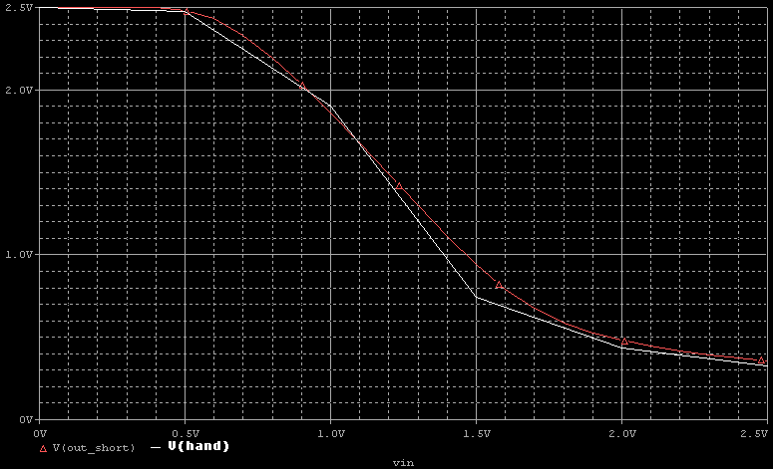
c) When V→ cut-off, V
When V, V → Saturation
When V, V, V → Triode
 | 0.0 | 0.5 | 1.0 | 1.5 | 2.0 | 2.5
 | 2.5 | 2.49 | 1.90 | 0.68 | 0.42 | 0.31

SPICE
*3.11 SPICE part c
Vdd vdd 0 2.5
Vin in 0 0
R vdd 2 8k
M2 in 0 0 nmos W=4u L=1u AS=2p AD=2p PS=5u PD=5u

.lib C:\...\0.25um_PSPICE_BSIM3.txt
.op
.dc Vin 0 2.5 0.1
.probe
.print dc v(2)
.end

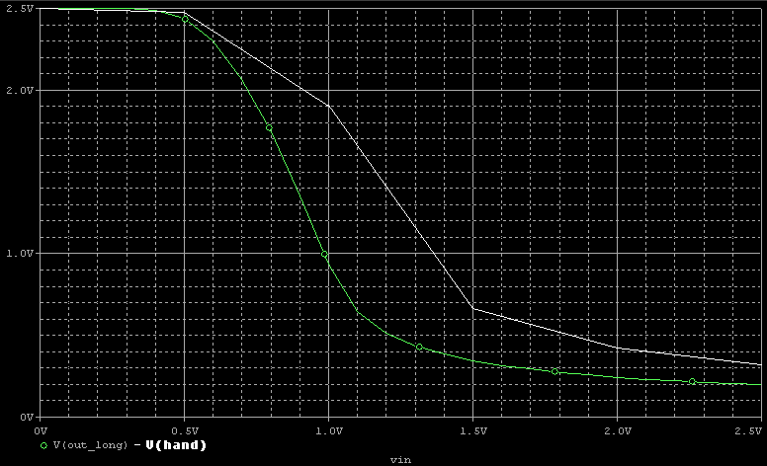

Discrepancy is larger for the long channel. Because:
- The short-channel equations and model that we have used for L=0.25u case is not appropriate for the L=1u case.
- Our Spice library file is especially designed for the range of L between 0.24u and 0.51u. And hence we should expect some degradation.

3.17) 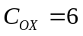fF/μm², 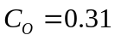fF/μm, 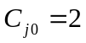fF/μm², fF/μm², 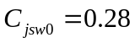fF/μm
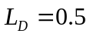μm, 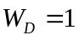μm, 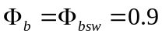V
 | 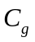
Cut-off | 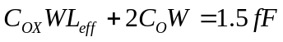
Linear | 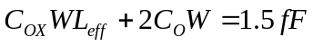
Sat - Vel Sat | 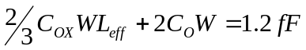
Diffusion Capacitance (C_{d}) for Drain (same method is applicable for the source diff. cap.)
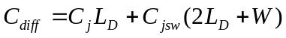

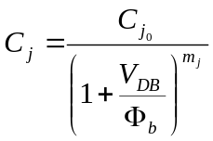, 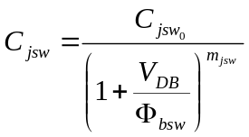

a) V
V → Saturation
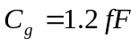, 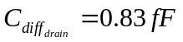, 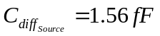, 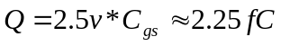
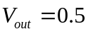V → Linear Region
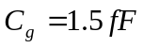, 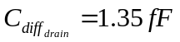, ,
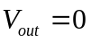V → Linear Region
, 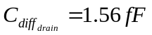, , 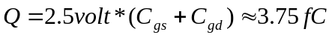

b) V → Cut-off
Regardless of 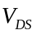,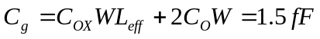, 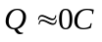(~as we are neglecting overlap cap effect)
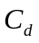is the same as part a).
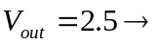,
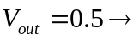,
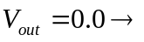,

3.18)

a) The value of 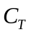 can change after 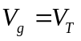 for
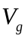: 0 → 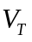➔ 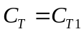
: → 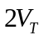➔ 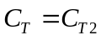
then 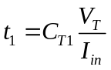, 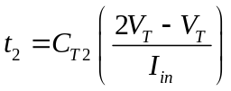
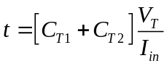 Or we can also say 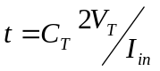 as in this part as we are not asked to consider the variation of C_{T}.

b) 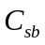, 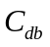 do not contribute to the total gate capacitance.
Until, device is off and only 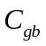 and overlap capacitances contribute to . Between 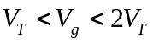, falls down to zero and transistor is in Saturation, 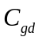 and 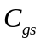 add up to . Thus,
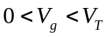 ➔ 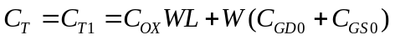
➔ 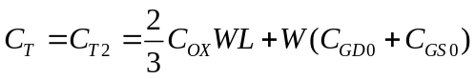

c) This time the device is completely off at all times.
, , do not have any connection to drain node. Thus they don’t contribute.
Only overlap component of and the diffusion make up in this case.

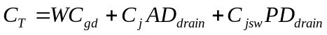

where, AD_{drain} = Drain bottom plate area = L_{D}*W and
PD_{drain} = Drain Perimeter excluding the channel side = 2*L_{D}+W
And,
,

Problem 1)
1a
    - N-well creation
    - Polysilicon deposition
    - Creation of the diffusion areas
    - Metal deposition
1b
The goal of defining a set of design rules is to allow for a ready translation of a circuit concept into an actual geometry in silicon. The design rules act as the interface or even the contract between the circuit designer and the process engineer. Circuit designer in general want tighter, smaller designs, which lead to higher performance and higher circuit density. The process engineer, on the other hand, wants a reproducible and high-yield process. Design rules are, consequently, a compromise that attempts to satisfy both sides.

Problem 2)
The goal of defining a set of design rules is to allow for a ready translation of a circuit. Lambda is the minimum considerable length for each technology and is equal to L/2. Hence for 0.25u CMOS lambda is approximately 0.125u.

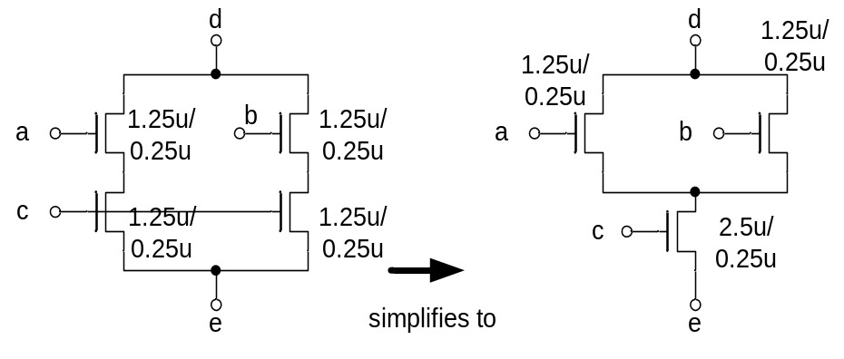

Problem 3)

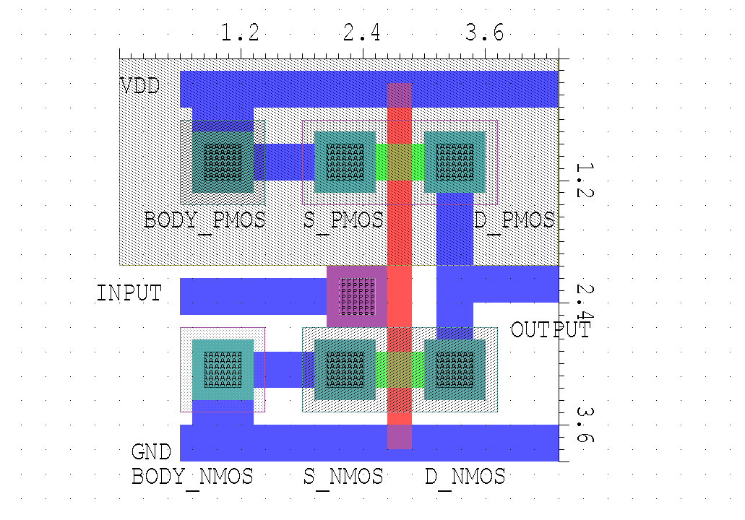

The Stick Diagram:

input
output

Metal 1

Contact

poly

diffusion area

N-Well

Layer definition:
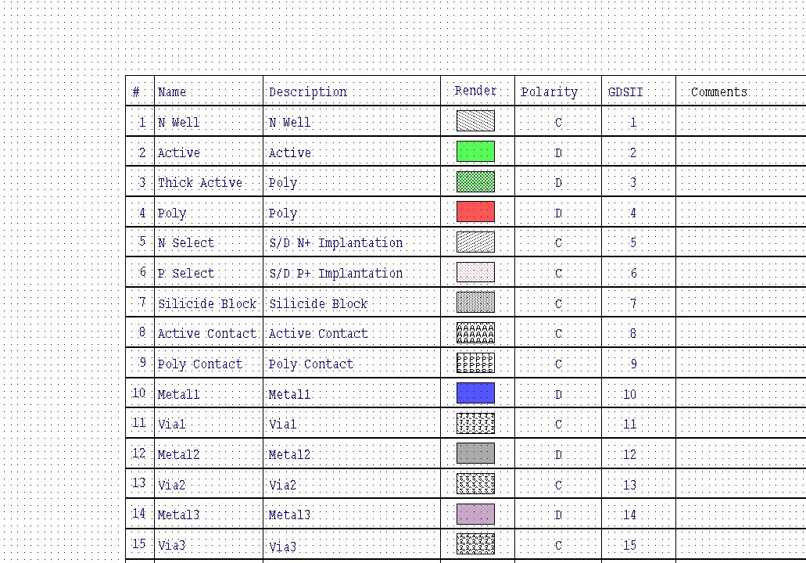

0.25um Technology DRC rules (round to nearest multiple of 0.12um)

Active-active, spacing: 0.36 um
Active size, 0.36 um (determin MOS’s minimum width)

Poly, spacing 0.36um

Poly size: 0.24um (determin MOS’s minimum length)

Active Contact, spacing: 0.36um
Active Contact- transistor: 0.24um
Active Contact size: 0.36um

P-Select/N-Select, spacing 0.48um
P-Select/N-Select size:0.48um
P-Select- N-Select, spacing 0.12um

Metal1/Metal2, spacing: 0.36um
Metal1/Metal2 size:0.36um

Poly-transistor overlap: 0.36um

Active-Well boundary: 0.6um

NMOS-Nwell:0.6um

Area (overall): 4.32um (width) *3.96um (height)
Area (excluding N-Well): 3.72um (width) *3.84um (height)

Minimum Width=0.36um,
Length=0.24um

Measure delay :
*DELAY
mp out in vdd vdd PMOS L=0.24u W=0.36u AD=0.36p AS=0.36p PS=2.36u PD=2.36u
* Ld is around 1um, width=0.36um
mn out in 0 0 NMOS L=0.24u W=0.36u AD=0.36p AS=0.36p PS=2.36u PD=2.36u
* Ld is around 1um, width=0.36um

Vin in 0 pulse 0 2.5 10p 10p 10p 1n 2n
Vdd vdd 0 2.5

.lib psmodel.txt
.probe
.tran 10p 2n
.end

Delay: T_{pLH} = 40 psec.
T_{pHL} = 20 psec.
