Homework 3

Hand out on: Thu. Feb. 5 (Lect 9)
Due: Thu. Feb. 12 (lect. 11)

Text Rabaey 2nd Edition, | Read Sections 5.4, 5.5, 6.2 of Text
Text Rabaey 2nd Edition, | Problems All are handout problems

Problem 1.
Find the transistor schematic for the CMOS logic circuit realized by the layout shown in Figure 1. Give the widths of all the transistors. Assume L=2λ where λ=0.12μm. In tabular form, give the area and perimeter of each junction that is not connected to V_{DD} or ground.

Note: In the figure, 8l and 6l means 8λ and 6λ.
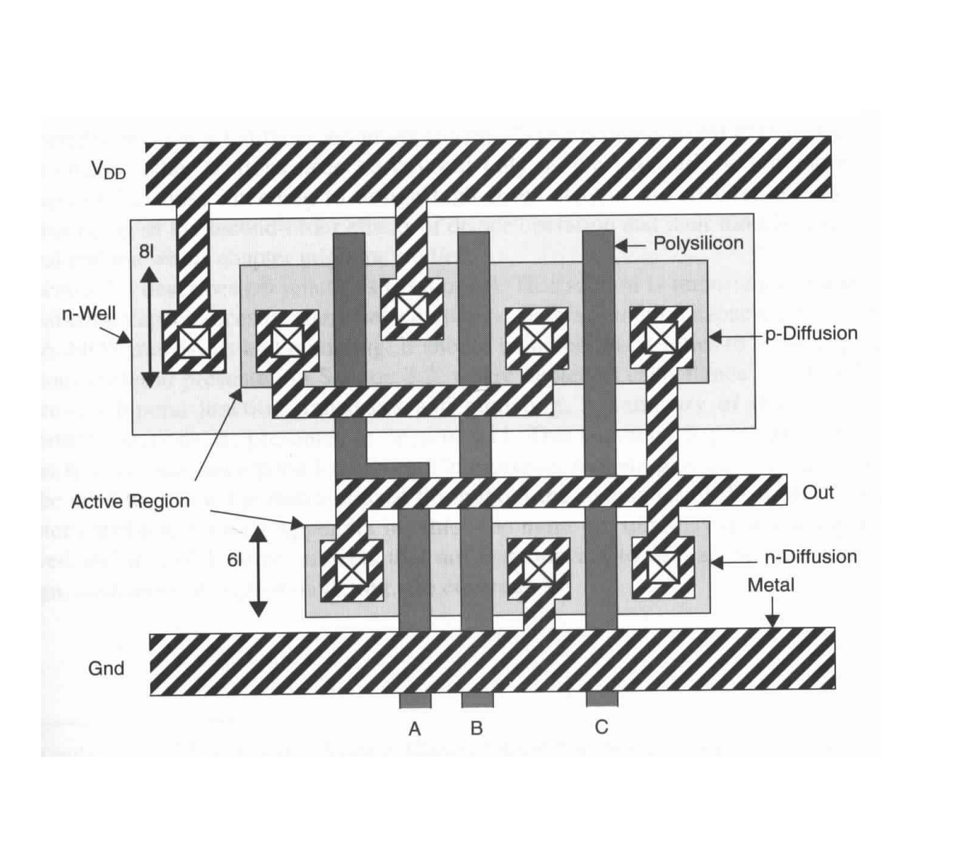

Problem 2.
You are designing a clock distribution network in which it is critical to minimize skew between local clocks (CLK1, CLK2, CLK3). You have extracted the RC network of Figure 2 which models the routing parasitics of your clock line. Initially, you notice that the path to CLK3 is shorter than to CLK1 or CLK2. In order to compensate for this imbalance, you insert a transmission gate in the path of CLK3 to eliminate the skew.
- Write expressions for the time-constants associated with the nodes CLK1, CLK2, and CLK3. Assume the transmission gate can be modeled as a resistance R₃.
- If R₁=R₂=R₄=R₅=R and C₁=C₂=C₃=C₄=C₅=C, what value of R₃ is required to balance the delays to CLK1, CLK2 and CLK3.
- For R=750Ω and C=200fF, simulate the network using SPICE, and compare the obtained results with the manually obtained numbers. For the transmission gate you can assume that the width of the NMOS and PMOS are equal, but you need to find the width that the delays to match as best as possible. You can start with both the NMOS and PMOS widths at 0.7 microns
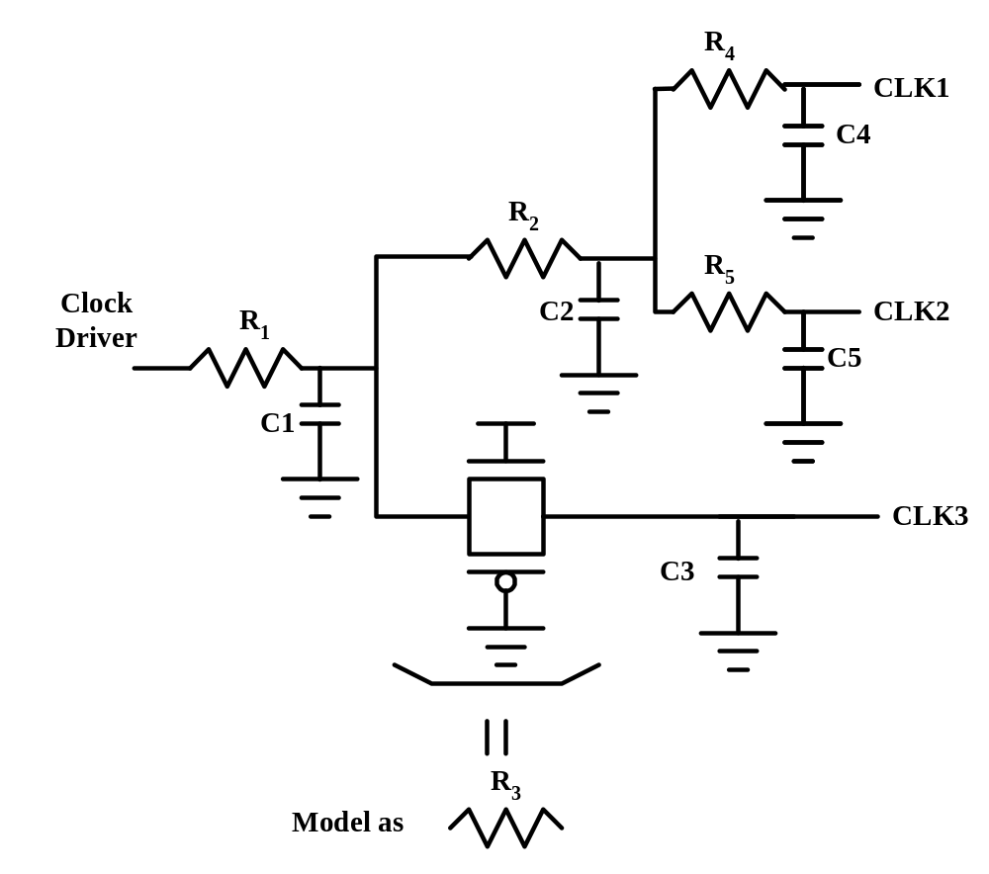

Figure 2.

Problem 3.

Ohmic voltage drops are particularly troublesome in power distribution networks. Figure 3 shows a schematic of such a network that distributes V_{DD} and GND to four processing modules. The numbers annotated on the figure are wire length in μm. Assume both supplies are distributed in metal1 (Al) wires 5.4μm in width.
- Sketch a single-resistor network capable of modeling the actual V_{DD} and GND voltages of the four modules. You can model the modules themselves as current sources drawing worst-case currents of I_{peak}.
- Find the effective worst-case V_{DD} and GND voltages seen by each of the four modules using I_{peak}=20mA.

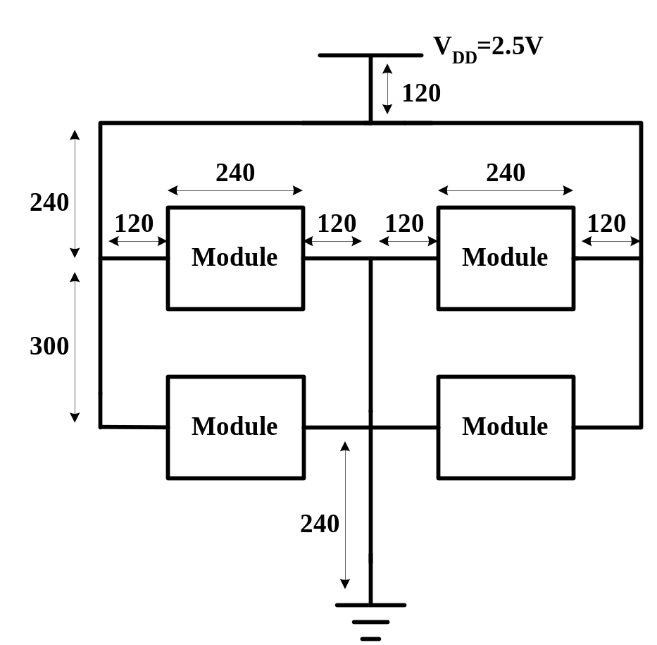

Figure 3.

