Homework 3

Problem 1.
Find the transistor schematic for the CMOS logic circuit realized by the layout shown in Figure 1. Give the widths of all the transistors. Assume L=2λ where λ=0.12μm. In tabular form, give the area and perimeter of each junction that is not connected to V_{DD} or ground.

Note: In the figure, 8l and 6l means 8λ and 6λ.

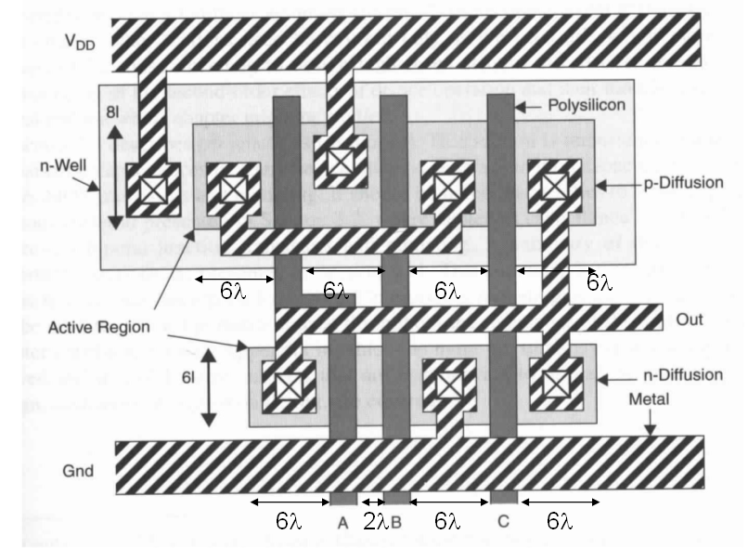

Solution:

λ=0.12 μm, width of NMOS is 6λ=6*0.12= 0.72μm and width of PMOS is 8λ=8*0.12=0.96 μm.
Poly line width is 2λ=2*0.12=0.24μm.
The distance between poly is 2λ=2*0.12=0.24μm.
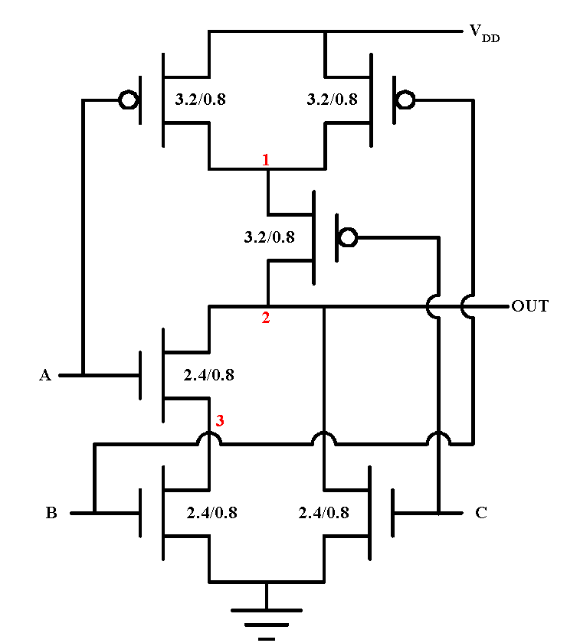
0.96/0.24
0.96/0.24
0.96/0.24
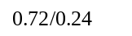
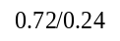
0.72/0.24
The simplified junction diagram is:
J1 J2 J3 J4
J8 J7 J6 J5

Junction | Area (μm²) | Perimeter (μm)
J1 | (0.96*0.72)= 0.6912 | (0.96+0.72*2)=2.4
J3 | (0.96*0.72)= 0.6912 | 0.72*2=1.44
J4 | (0.96*0.72)= 0.6912 | (0.96+0.72*2)=2.4
J5 | (0.72*0.72)= 0.5184 | (0.72+0.72*2)=2.16
J7 | (0.72*0.24)=0.1728 | 0.24*2=0.48
J8 | (0.72*0.72)= 0.5184 | (0.72+0.72*2)=2.16

Junction J2 ties to Vdd and junction J6 ties to ground. We don’t count these two.

Problem 2.
Solution:
a)

b)

So R₃ needs to be 4R in order to have τ₁=τ₂=τ₃.

c)
For this part, you can use R3=3000. The Spice netlist should have two parts: one part uses the resistance model (R3), the other part uses the transmission gate model (i.e. use the NMOS and PMOS transistors). Both parts should contain all other components like R1, C1, R2, C4, etc. In other words, you describe the above diagram twice, the first time you use R3 but for the second time you replace R3 with two transistors. The two transistors should have the same length and width. Make sure your PMOS’s gate is tied to GND and NMOS’s gate is tired to VDD as shown in the diagram. You should add voltage sources to drive the two parts. You can use PULSE as shown in hw2, or use PWL. For example,
Vin1 input 0 PWL(0 0 5n 0 5.0001n 2.5).
The format for PWL is (time1, value1, time2, value2, ….)
So the above example means at time 0, input is 0, at time 5ns, input is still 0, but after 5.0001ns, the input is 2.5v.

Compare the output of the two parts as shown in below figure.
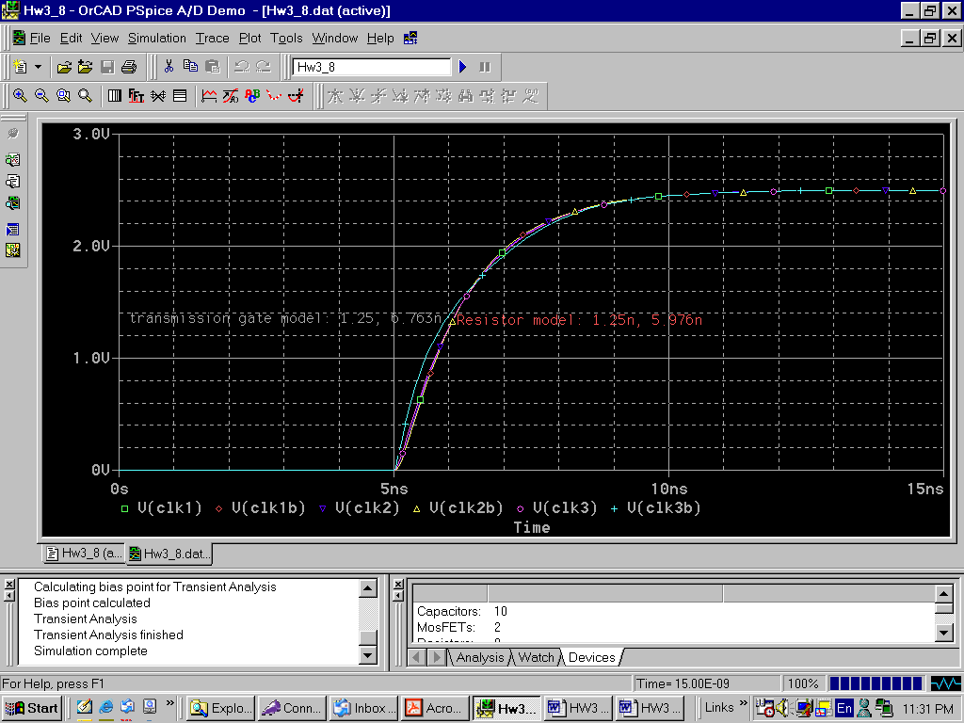

You should adjust the width of the NMOS and PMOS (do not touch the width, keep them 0.24μm) to make the two outputs’ delays match as closely as possible (less than 1ns or 2ns).

* hw3 problem 2
R1 in 1 750
R2 1 2 750
R3 1 clk3 3K
R4 2 clk1 750
R5 2 clk2 750
C1 1 0 200f
C2 2 0 200f
C3 clk3 0 200f
C4 clk1 0 200f
C5 clk2 0 200f
R1b inb 1b 750
R2b 1b 2b 750

M1 1b vdd clk3b 0 nmos l=0.24u w=1.2u
M2 1b 0 clk3b vdd pmos l=0.24u w=1.2u
R4b 2b clk1b 750
R5b 2b clk2b 750
C1b 1b 0 200f
C2b 2b 0 200f
C3b clk3b 0 200f
C4b clk1b 0 200f
C5b clk2b 0 200f

vdd vdd 0 2.5
Vin in 0 pwl(0 0 5n 0 5.00001n 2.5)
Vinb inb 0 pwl(0 0 5n 0 5.00001n 2.5)

.LIB psmodel.txt

.TRAN 0.01n 15n
.PROBE
.END

The above figure is obtained when w=1.2μm.

Problem 3.
Solution:
Metal 1 Aluminum sheet resistance is R_{SH}=0.075Ω/.
W=5.4μm 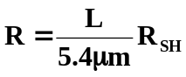
R₁₂₀=1.67Ω
R₂₄₀=3.33Ω
R₃₀₀=4.17Ω

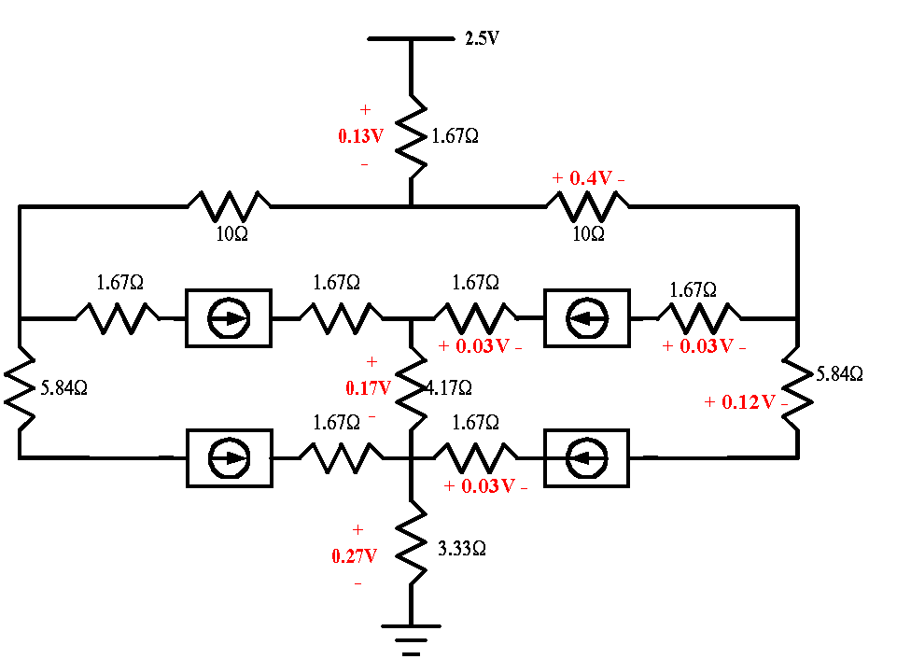
For I=20mA at each module:
Voltage across 1.67 Ω as shown in the figure above: I*R=(0.08)*1.67=0.13
Voltage across 1.67 Ω as shown in the figure above: I*R=(0.02)*1.67=0.03
Voltage across 5.84 Ω as shown in the figure above: I*R=(0.02)*5.84=0.12
Voltage across 4.17 Ω as shown in the figure above: I*R=(0.04)*4.17 =0.17
Voltage across 3.33 Ω as shown in the figure above: I*R=(0.08)*3.33 =0.27

The worst case of I=20mA at each module from V_{DD} and GND:
Module | V_{DD} | GND
1,2 | (2.5-0.13-0.4-0.03)=1.94V | (0.27+0.17+0.03)=0.47V
3,4 | (2.5-0.13-0.4-0.12)=1.85V | (0.27+0.03)=0.3V

