Homework 4

Hand out on: Feb. 12 (Lect 11).
Due: Thu Feb. 19th (Lect. 13)

Text Rabaey 2nd Edition, | Read Sections 6.3 of Text
Text Rabaey 2nd Edition, | Problems: All are handout problems

Problem 1.
For the circuit shown below:

- Derive the values of all parasitic capacitances, assuming that the supply voltage is set at 2.5V, The value Ls for the diffusion area is equal to 0.5 microns
- Calculate an effective output-loading capacitance based on these parasitics
- Find t_{PLH} and t_{PHL} for the basic inverter (the first inverter)
- What is the fan out of identical basic inverters that can be driven before the delay becomes larger than 1.5 ns?
- Derive the propagation delay using SPICE, comment on the difference if any.

You may use the default values for Cox, etc. given in the text.
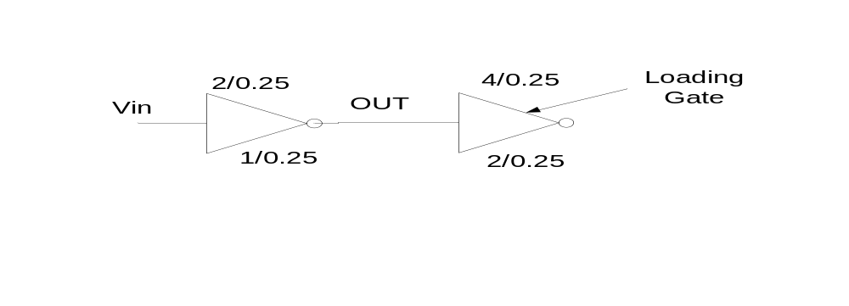

Problem 2.
Using a chain of inverters, it is desired to drive a 0.5 pF load capacitor with an average propagation delay that is as close to 0.25 ns as possible. The initial driving CMOS inverter has both the PMOS and the NMOS inverters sized the same
Wn = Wp = 0.7 microns
Ln = Lp = 0.25 microns

Find the desired number of inverter stages and their sizing.

Problem 3.
For the circuit of Problem 1. Assume that the input signal Vin is a clock of frequency 1 GHz, and has a transition time (from 0-100%) of 0.1 ns. For the first inverter in the figure
- Find the dynamic power consumption
- Find the short circuit power consumption
  - Note that to find the peak of the short circuit current you need to know Vout when Vin = Vdd/2 during transition. For this you can assume that the load capacitance is being charged through the equiv. res of the PMOS. Then using the equations for an RC circuit calculate the voltage Vout at ts/2 = 0.05 ns.
  - Once you have the right Vout then calculate the PMOS and the NMOS currents using the MOS current equations. The smaller of the two should be the short circuit current (validate this using SPICE)
- Compare your answers to part a & b using SPICE
  - For hints as to how SPICE can be used to measure power consumption, please refer to section 5.5.4 of the text (p. 227)

